VISVESVARAYA TECHNOLOGICAL UNIVERSITY
Jnana Sangama, Belagavi – 590018

A Mini Project Report on
"HAPTIC NAVIGATION SYSTEM"
Submitted in partial fulfillment of the requirements for the First Semester of the Bachelor of Engineering Degree, towards the completion of the Mini Project under the Innovation & Design Thinking Laboratory, Department of Basic Sciences.
Submitted by
Name | USN
B P Vaibhav Krishna | 1CR25EC035
Balaji Prasanna S | 1CR25EC036
Bhishal Khatri | 1CR25CS035
C Vinay Kumar | 1CR25CS036
Under the Guidance of
Prof. Kavyashri
Assistant Professor, Dept. of CSE

CMR INSTITUTE OF TECHNOLOGY
#132, AECS Layout, IT Park Road, Kundalahalli, Bangalore – 560037
DEPARTMENT OF BASIC SCIENCES
2025 – 26

CERTIFICATE
This is to certify that the mini project entitled "Haptic Navigation System for Visually Impaired Individuals" has been successfully carried out by Bhishal Khatri (1CR25CS035), C Vinay Kumar (1CR25CS036), B P Vaibhav Krishna (1CR25EC035) and Balaji Prasanna S (1CR25EC036), bonafide students of CMR Institute of Technology, in partial fulfillment of the requirements for the First Semester of the Bachelor of Engineering Degree, under the Innovation & Design Thinking Laboratory, Department of Basic Sciences.
It is further certified that all corrections and suggestions indicated during the Internal Assessment have been duly incorporated in the report submitted to the departmental library. This mini project report has been reviewed and approved as it satisfies the academic requirements prescribed for the said degree.
Signature of Guide Signature of HOD
Prof. Kavyashri Dr. Raveesha K H
Asst. Professor, Dept. of CSE, CMRIT HoD, Dept. of Physics, CMRIT
External Viva
Name of the Examiners Signature with Date

ACKNOWLEDGEMENT
We sincerely express our gratitude to Dr. Sanjay Jain, Principal, CMR Institute of Technology, Bangalore, for providing a supportive academic environment.
We extend our thanks to Dr. Raveesha K H, HoD, Dept. of Physics, CMRIT, for his valuable guidance and support.
We are especially grateful to our internal guide, Prof. Kavyashri, Assistant Professor, Department of Computer Science and Engineering, for her constant encouragement and guidance throughout this project.
We also thank all the faculty members, non-teaching staff, and others who contributed directly or indirectly to the successful completion of this work.
Bishal Khatri (1CR25CS035)
C Vinay Kumar (1CR25CS036)
B P Vaibhav Krishna (1CR25EC035)
Balaji Prasanna S (1CR25EC036)

ABSTRACT
Haptic navigation is an assistive technology that uses tactile feedback, such as vibrations and touch-based cues, to guide users during movement. This system is particularly beneficial for visually impaired individuals, enabling them to navigate safely and independently without relying solely on visual or auditory inputs. The proposed haptic navigation system integrates sensors, GPS modules, and microcontrollers to detect obstacles and provide real-time directional guidance through wearable devices like smart bands, gloves, or belts.
The system operates by continuously monitoring the user's surroundings using ultrasonic or infrared sensors. When an obstacle is detected, the device generates vibration patterns of varying intensity and frequency to indicate the distance and direction of the obstacle. Additionally, GPS-based navigation can provide route guidance through distinct haptic signals, allowing users to follow paths without needing to look at a screen.
This approach enhances situational awareness while minimizing cognitive overload, as touch-based feedback is intuitive and non-intrusive. Compared to traditional navigation systems, haptic navigation ensures greater accessibility, safety, and convenience, especially in noisy or visually demanding environments. The development of such systems represents a significant step toward inclusive technology, improving mobility and quality of life for users with visual impairments and expanding applications in fields such as robotics, gaming, and virtual reality.

Project title: HAPTIC NAVIGATION SYSTEM
CONTENTS
Chapter No. | Title | Page No.
 | Certificate | i
 | Acknowledgement | ii
 | Abstract | iii
1 | INTRODUCTION | 5
 | 1.1 Background of Assistive Navigation Systems | 5
 | 1.2 Modern Haptic Feedback Technology | 5
2 | PROBLEM STATEMENT | 6
 | 2.1 Description | 6
 | 2.2 Challenge Statement | 6
3 | SYSTEM DESIGN AND METHODOLOGY | 7–10
 | 3.1 Design Thinking Process | 7
 | 3.2 Methodology | 7
 | 3.3 Prototype Description | 8
 | 3.3.1 Technology Used | 8
 | 3.3.2 System Diagram | 9
 | 3.3.3 Screenshots of the Working Prototype | 9–10
4 | IMPLEMENTATION | 11–17
5 | RESULTS AND ANALYSIS | 18
6 | CONCLUSION AND FUTURE WORK | 19
7 | REFERENCES | 20
8 | ANNEXURES | 21–22
Dept. of Basic Sciences, CMRIT 2025–26

CHAPTER 1
1. INTRODUCTION

1.1 Background of Assistive Navigation Systems
Navigation plays a crucial role in the daily lives of individuals, enabling them to move freely and perform routine activities with confidence. However, for visually impaired people, navigation remains a significant challenge due to the lack of visual cues and real-time environmental awareness. Traditional mobility aids such as white canes and guide dogs provide limited assistance, primarily focusing on obstacle detection at a short range. These methods often fail to provide directional guidance or information about dynamic surroundings, thereby restricting independence and safety.
With advancements in technology, assistive systems have been developed to enhance navigation capabilities. Among these, haptic navigation has emerged as a promising solution. Haptic technology utilizes the sense of touch to communicate information through vibrations or tactile feedback. Unlike audio-based systems, which may be ineffective in noisy environments or cause cognitive overload, haptic feedback offers a discreet and intuitive method of communication that does not interfere with hearing.

1.2 Modern Haptic Feedback Technology
The haptic navigation system proposed in this project integrates sensors, microcontrollers, and vibration actuators into a wearable device or smartphone-based application. Ultrasonic sensors are used to detect obstacles in the user's path, while a microcontroller (or the smartphone's own processing unit) processes the data and activates vibration motors to provide feedback. The intensity and pattern of vibrations indicate the distance and direction of obstacles, enabling the user to make informed navigation decisions.
This system aims to improve mobility, safety, and independence for visually impaired individuals by offering a cost-effective and user-friendly solution. Additionally, the concept of haptic navigation extends beyond assistive technology and finds applications in robotics, virtual reality, and advanced human–machine interaction systems, making it a versatile and impactful field of study.

CHAPTER 2
2. PROBLEM STATEMENT

2.1 Description
Visually impaired individuals face significant challenges in navigating their surroundings due to the absence of visual perception and limited access to real-time environmental information. Conventional mobility aids such as white canes and guide dogs provide only partial assistance, primarily limited to short-range obstacle detection and basic guidance. These methods often fail to detect obstacles at a distance, identify dynamic hazards, or provide directional navigation support, thereby increasing the risk of accidents and reducing user confidence.

2.2 Challenge Statement
Existing electronic navigation systems often rely on audio feedback, which can be ineffective in noisy environments and may interfere with the user's ability to perceive important ambient sounds such as traffic or human interaction. Additionally, many advanced assistive devices are expensive, complex, and not easily accessible to all users.
Therefore, there is a need to develop a cost-effective, reliable, and user-friendly navigation system that can provide real-time obstacle detection and directional guidance without relying on visual or auditory cues. The system should enhance safety, improve independence, and offer intuitive interaction through alternative sensory feedback, such as touch, to ensure effective navigation in diverse environments.

CHAPTER 3
3. SYSTEM DESIGN AND METHODOLOGY

3.1 Design Thinking Process
HaptiNav was designed as a purely software, browser-based prototype — a single web page that runs directly on a laptop or smartphone using only the device's built-in camera, speaker, and (on supported phones) vibration motor. No external sensor board, wearable, or backend server is required, which keeps the solution low-cost and instantly usable by anyone with a browser.
The design followed a human-centred, design-thinking approach. In the Empathize and Define stages, the team recognised that a visually impaired user cannot rely on a screen, so every piece of information the app produces had to reach the user through a non-visual channel — sound or touch. In the Ideate stage, three complementary feedback channels were shortlisted: short audio tones, spoken voice alerts, and phone vibration, each usable independently so the app still works if one channel is unavailable (e.g., vibration on a laptop with no vibration motor). In the Prototype stage, these ideas were built into the HaptiNav web app shown in Fig. 3.1 and Fig. 3.2. In the Test stage, the prototype was run live on a laptop webcam, pointing the camera at moving objects and people to verify that zone detection, the alert banner, and the voice/haptic/audio outputs responded correctly and promptly.

3.2 Methodology
Unlike a sensor-based or GPS-based navigation system, HaptiNav's methodology is entirely computer-vision based and runs client-side in the browser, with no data ever leaving the device. It follows a five-stage pipeline that repeats on every video frame:
- Camera capture — the rear (or front) camera is accessed through the WebRTC getUserMedia API, and the live feed is displayed on an HTML5 video element.
- Frame downscaling — each frame is drawn onto a small, hidden 160 x 120 canvas so that per-pixel comparison is fast enough to run every animation frame (via requestAnimationFrame) without lag.
- Frame-differencing motion detection — the current downscaled frame is compared pixel-by-pixel against the previous one; any pixel whose average RGB change exceeds a threshold is marked as motion. This avoids the need for a trained object-detection model.
- Blob detection and zone mapping — a flood-fill (connected-component) search groups neighbouring motion pixels into blobs. Each blob's centroid is mapped onto a 3 x 2 zone grid — Left, Centre, Right (upper half) and Front-Left, Front, Front-Right (lower half) — matching the on-screen grid seen in Fig. 3.1.
- Threat classification and feedback generation — each blob's relative area is compared against sensitivity-dependent thresholds to classify it as Safe, Caution, or Danger. The most severe blob drives the on-screen alert banner and direction arrow, a zone-specific audio beep (Web Audio API, with a distinct tone frequency per zone), a vibration pattern (Vibration API — a short pulse for safe, one pulse for caution, and a triple pulse for danger), and a spoken alert (Web Speech API), with built-in cooldown timers so alerts do not repeat too rapidly.
The user can tune detection sensitivity to Low, Medium, or High — each level adjusts how small a moving object must be before it is flagged, and how much of the frame must be in motion before a Caution or Danger alert is raised. Voice and Haptic feedback can each be toggled independently, scanning can be paused/resumed, and a "Tell Me" button lets the user request an immediate spoken summary of the current scene on demand. A Wake Lock is held for as long as the app is open so that the screen does not sleep mid-navigation and interrupt the camera feed.

3.3 Prototype Description

3.3.1 Technology Used
HaptiNav is implemented entirely with standard, native browser APIs — no external libraries, plugins, or backend server are used. The device's own hardware supplies every input and output the app needs:
- Device camera (rear-facing on phones) — supplies the live video feed used for obstacle/motion detection, in place of a dedicated camera module
- Device vibration motor — provides the haptic pulses on supported smartphones
- Device speaker — delivers spoken alerts and audio tones in place of a separate voice transmitter
Software stack:
- HTML5 and CSS3 — structure and styling
- JavaScript (Vanilla JS) — detection logic and application state
- WebRTC / MediaDevices API — live camera access
- Canvas API — zone-grid lines, bounding-box overlay, and off-screen frame processing
- Web Speech API — text-to-speech voice alerts
- Vibration API — haptic feedback pulses
- Web Audio API / AudioContext — zone-specific audio beep tones
- requestAnimationFrame API — driving the real-time detection loop
- Wake Lock API — keeps the screen active while HaptiNav is running

3.3.2 System Diagram
The data flow of the actual implemented pipeline, from camera input to user feedback, is illustrated below:
CAMERA FEED (getUserMedia — rear/front camera)
↓
FRAME CAPTURE & DOWNSCALE (160 x 120 offscreen canvas)
↓
FRAME-DIFFERENCING MOTION DETECTION (pixel RGB delta)
↓
BLOB DETECTION (flood-fill connected components)
↓
ZONE MAPPING & THREAT CLASSIFICATION (L/C/R/FL/F/FR - Safe/Caution/Danger)
↓
FEEDBACK OUTPUT (Voice + Haptic Vibration + Audio Beep + Live Overlay UI)

3.3.3 Screenshots of the Working Prototype
HaptiNav running live in a laptop browser is shown below. Fig. 3.1 shows normal operation: the 3 x 2 zone grid (top-left), status badges (CAM / VOICE / HAPTIC), a green "safe" alert banner reading "Movement detected — path may be occupied", the direction indicator (top-right), and the Voice / Haptic / Stop Scan / Tell Me control panel with the Low/Medium/High sensitivity selector.
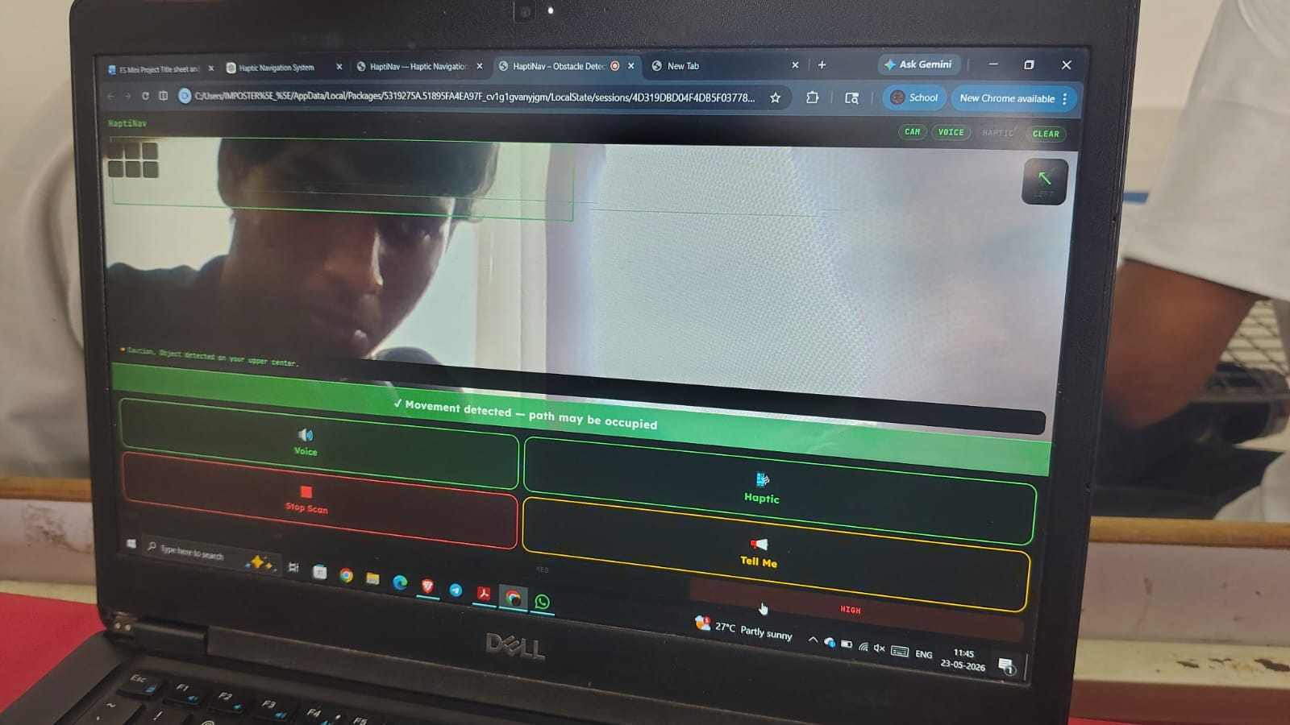
Fig. 3.1 - HaptiNav interface: live camera view with zone grid, status badges, and a safe (green) movement alert.
Fig. 3.2 shows the app responding to a close obstacle: the alert banner turns red and reads "Warning! Obstacle very close on your front. Please stop.", the affected zone panel is highlighted, the DANGER status badge is lit, and the direction arrow points toward the upper-centre zone — demonstrating the zone-based threat escalation described in Section 3.2.
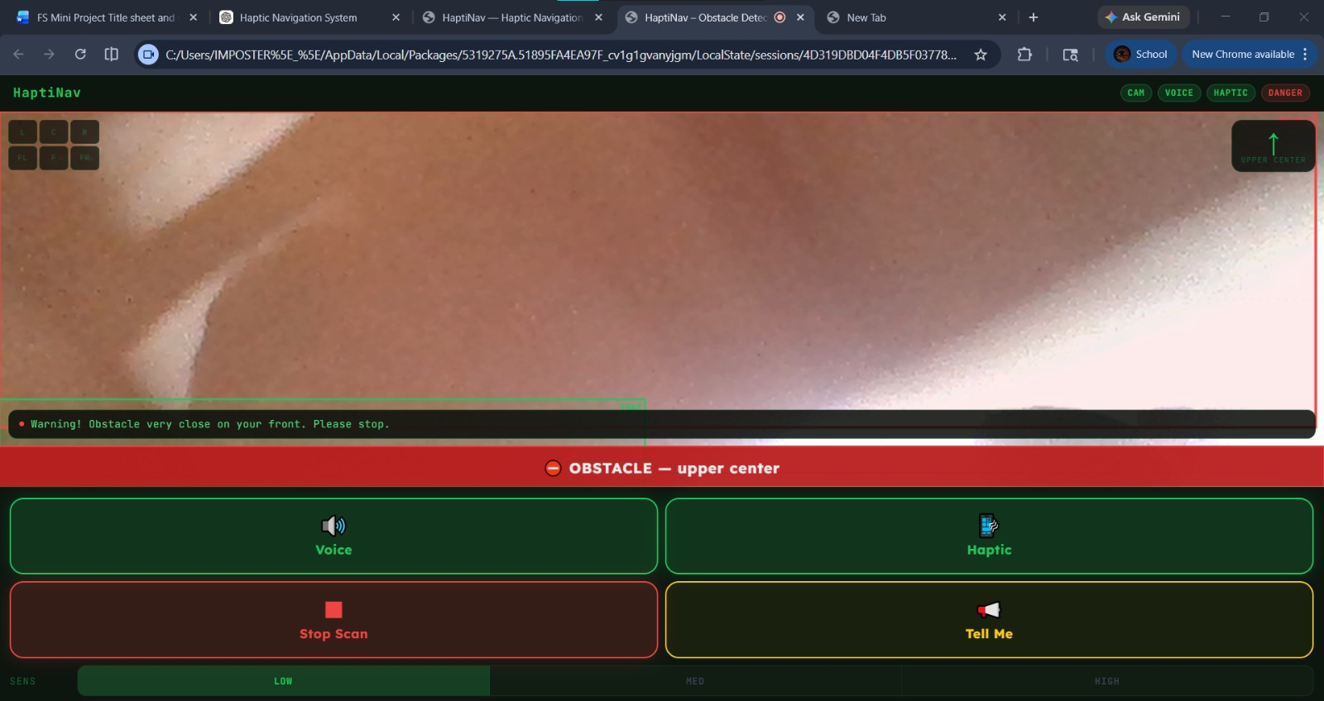
Fig. 3.2 - HaptiNav interface: full-screen danger alert with the upper-centre zone and DANGER badge highlighted.

CHAPTER 4
4. IMPLEMENTATION
The Haptic Navigation System (HaptiNav) is implemented as a lightweight, installation-free web application so that it can run directly in a smartphone's browser. The interface is structured around two primary screens — a Welcome screen that requests camera and motion-sensor permissions, and a Main App screen that shows the live camera feed with an obstacle-detection overlay, status indicators, and haptic/voice controls.
Real-time video is captured using the WebRTC MediaDevices API and rendered onto an HTML5 Canvas, on which detected obstacles are highlighted. The Vibration API is used to trigger distinct vibration patterns based on the distance and direction of a detected obstacle, while the Web Speech API provides parallel voice announcements. The requestAnimationFrame API keeps this detection-and-feedback loop running smoothly, and the Wake Lock API prevents the screen from sleeping mid-navigation.
The core structure, styling, and control logic of the application are given below.
Source Code (HTML / CSS):
<!DOCTYPE html>
<html lang="en">
<head>
<meta charset="UTF-8"/>
<meta name="viewport" content="width=device-width, initial-scale=1.0, user-scalable=no"/>
<title>HaptiNav -- Obstacle Detection for Visually Impaired</title>
<meta name="description" content="Real-time obstacle detection with voice and haptic feedback for visually impaired users"/>
<style>
@import url('https://fonts.googleapis.com/css2?family=Lexend:wght@300;400;600;700;900&family=JetBrains+Mono:wght@400;700&display=swap');
*, *::before, *::after { box-sizing: border-box; margin: 0; padding: 0; }
:root {
--bg: #060A07;
--bg1: #0C150E;
--bg2: #111D13;
--green: #22C55E;
--green2: #16A34A;
--green3: #BBF7D0;
--yellow: #FACC15;
--red: #EF4444;
--red2: #DC2626;
--white: #F0FDF4;
--muted: #4ADE80;
--dim: #166534;
--font: 'Lexend', sans-serif;
--mono: 'JetBrains Mono', monospace;
}
html, body {
height: 100%;
background: var(--bg);
color: var(--white);
font-family: var(--font);
overflow: hidden;
-webkit-tap-highlight-color: transparent;
user-select: none;
}
/* ── SCREENS ── */
.screen { position: fixed; inset: 0; display: none; flex-direction: column; }
.screen.active { display: flex; }
/* ═══════════════════════════════
WELCOME SCREEN
═══════════════════════════════ */
#welcome {
align-items: center;
justify-content: center;
gap: 0;
background: var(--bg);
padding: 32px 24px;
text-align: center;
}
.logo-ring {
width: 140px; height: 140px;
border-radius: 50%;
border: 3px solid var(--green);
display: flex; align-items: center; justify-content: center;
margin-bottom: 28px;
position: relative;
animation: spin-ring 8s linear infinite;
}
.logo-ring::before {
content: '';
position: absolute; inset: -8px;
border-radius: 50%;
border: 1px solid rgba(34,197,94,0.2);
}
@keyframes spin-ring {
from { box-shadow: 0 0 30px rgba(34,197,94,0.15), 0 0 60px rgba(34,197,94,0.05); }
50% { box-shadow: 0 0 50px rgba(34,197,94,0.35), 0 0 100px rgba(34,197,94,0.12); }
to { box-shadow: 0 0 30px rgba(34,197,94,0.15), 0 0 60px rgba(34,197,94,0.05); }
}
.logo-icon { font-size: 60px; line-height: 1; }
h1 {
font-size: 42px;
font-weight: 900;
letter-spacing: -1px;
color: var(--white);
line-height: 1;
margin-bottom: 8px;
}
h1 span { color: var(--green); }
.tagline {
font-size: 15px;
color: var(--muted);
font-weight: 300;
margin-bottom: 40px;
letter-spacing: 0.04em;
}
.start-btn {
width: 100%;
max-width: 340px;
padding: 24px;
border-radius: 20px;
border: none;
background: var(--green);
color: #021a09;
font-family: var(--font);
font-size: 22px;
font-weight: 900;
letter-spacing: 0.02em;
cursor: pointer;
margin-bottom: 16px;
transition: transform 0.12s, *background* 0.12s;
-webkit-tap-highlight-color: transparent;
position: relative;
overflow: hidden;
}
.start-btn::after {
content: '';
position: absolute; inset: 0;
background: rgba(255,255,255,0);
transition: *background* 0.1s;
}
.start-btn:active { transform: scale(0.97); background: var(--green2); }
.perm-note {
font-size: 12px;
color: var(--dim);
max-width: 280px;
line-height: 1.6;
}
.feature-pills {
display: flex;
gap: 8px;
margin-bottom: 32px;
flex-wrap: wrap;
justify-content: center;
}
.pill {
background: var(--bg2);
border: 1px solid var(--dim);
border-radius: 30px;
padding: 6px 14px;
font-size: 12px;
color: var(--muted);
font-weight: 600;
letter-spacing: 0.04em;
}
/* ═══════════════════════════════
MAIN APP SCREEN
═══════════════════════════════ */
#app {
flex-direction: column;
background: var(--bg);
}
/* ── STATUS BAR ── */
#statusbar {
display: flex;
align-items: center;
justify-content: space-between;
padding: 10px 16px;
background: var(--bg1);
border-bottom: 1px solid rgba(34,197,94,0.12);
flex-shrink: 0;
z-index: 10;
}
.app-wordmark {
font-size: 15px;
font-weight: 900;
color: var(--green);
letter-spacing: 0.06em;
font-family: var(--mono);
}
.status-pills {
display: flex;
gap: 6px;
align-items: center;
}
.badge {
font-size: 10px;
font-weight: 700;
padding: 3px 8px;
border-radius: 20px;
font-family: var(--mono);
letter-spacing: 0.06em;
}
.badge.on { background: rgba(34,197,94,0.15); color: var(--green); border: 1px solid rgba(34,197,94,0.3); }
.badge.off { background: rgba(255,255,255,0.05); color: #4b5563; border: 1px solid #1f2937; }
.badge.warn { background: rgba(250,204,21,0.12); color: var(--yellow); border: 1px solid rgba(250,204,21,0.3); }
.badge.danger { background: rgba(239,68,68,0.15); color: var(--red); border: 1px solid rgba(239,68,68,0.3); animation: flash-badge 0.4s ease-in-out infinite alternate; }
@keyframes flash-badge { from{opacity:1} to{opacity:0.4} }
/* ── CAMERA VIEW ── */
#cam-section {
position: relative;
flex: 1;
overflow: hidden;
background: #000;
min-height: 0;
}
#video {
width: 100%;
height: 100%;
object-fit: cover;
transform: scaleX(-1);
display: block;
}
#overlay-canvas {
position: absolute;
inset: 0;
width: 100%;
height: 100%;
pointer-events: none;
transform: scaleX(-1);
}
/* Zone grid lines */
#grid-canvas {
position: absolute;
inset: 0;
width: 100%;
height: 100%;
pointer-events: none;
}
/* Alert banner on camera */
#alert-banner {
position: absolute;
bottom: 0; left: 0; right: 0;
padding: 12px 16px;
font-size: 17px;
font-weight: 700;
text-align: center;
letter-spacing: 0.04em;
transition: all 0.2s;
display: none;
border-top: 2px solid currentColor;
}
#alert-banner.safe { display:block; background:rgba(22,163,74,0.88); color:#dcfce7; border-color:#22c55e; }
#alert-banner.warn { display:block; background:rgba(202,138,4,0.92); color:#fefce8; border-color:#facc15; }
#alert-banner.danger { display:block; background:rgba(185,28,28,0.95); color:#fef2f2; border-color:#ef4444; animation: pulse-banner 0.35s ease-in-out infinite alternate; }
@keyframes pulse-banner { from{transform:scaleY(1)} to{transform:scaleY(1.04)} }
/* Camera off message */
#cam-off-msg {
position:absolute; inset:0;
display:flex; flex-direction:column;
align-items:center; justify-content:center;
gap:12px; background:#060A07;
display:none;
}
#cam-off-msg .ico { font-size:48px; }
#cam-off-msg p { color:var(--muted); font-size:14px; text-align:center; max-width:200px; }
/* ── CONTROLS PANEL ── */
#controls {
flex-shrink: 0;
background: var(--bg1);
border-top: 1px solid rgba(34,197,94,0.12);
padding: 12px 12px 16px;
}
/* Big action buttons grid */
.btn-grid {
display: grid;
grid-template-columns: 1fr 1fr;
gap: 8px;
margin-bottom: 8px;
}
.big-btn {
padding: 18px 12px;
border-radius: 16px;
border: 2px solid;
background: transparent;
font-family: var(--font);
font-weight: 700;
font-size: 15px;
cursor: pointer;
display: flex;
flex-direction: column;
align-items: center;
gap: 5px;
transition: all 0.12s;
-webkit-tap-highlight-color: transparent;
letter-spacing: 0.02em;
position: relative;
overflow: hidden;
}
.big-btn .btn-ico { font-size: 26px; line-height: 1; }
.big-btn:active { transform: scale(0.96); }
.big-btn.green-btn {
border-color: var(--green);
color: var(--green);
background: rgba(34,197,94,0.07);
}
.big-btn.green-btn.active {
background: rgba(34,197,94,0.18);
box-shadow: 0 0 20px rgba(34,197,94,0.2);
}
.big-btn.red-btn {
border-color: var(--red);
color: var(--red);
background: rgba(239,68,68,0.07);
}
.big-btn.red-btn.active {
background: rgba(239,68,68,0.18);
box-shadow: 0 0 20px rgba(239,68,68,0.2);
}
.big-btn.yellow-btn {
border-color: var(--yellow);
color: var(--yellow);
background: rgba(250,204,21,0.06);
}
.big-btn.yellow-btn.active {
background: rgba(250,204,21,0.15);
}
.big-btn.dim-btn {
border-color: #1f2937;
color: #6b7280;
background: rgba(255,255,255,0.02);
}
/* Sensitivity row */
.sens-row {
display: flex;
align-items: center;
gap: 8px;
}
.sens-label {
font-size: 11px;
color: var(--dim);
font-family: var(--mono);
letter-spacing: 0.1em;
text-transform: uppercase;
flex-shrink: 0;
width: 70px;
}
(JavaScript application logic — detection loop, vibration-pattern control, and voice feedback — is maintained alongside the above front-end code and is included in full in Annexure 8.)

CHAPTER 5
5. RESULTS AND ANALYSIS
The prototype was evaluated by running it on a smartphone browser under everyday indoor and outdoor conditions, in line with the testing and evaluation stage described in the methodology (Section 3.2). Evaluation focused on four qualitative dimensions: detection responsiveness, clarity of haptic patterns, usability, and comfort of prolonged use.

5.1 Observations
- The obstacle-overlay and vibration trigger responded to nearby objects with a noticeably short, near-real-time delay, owing to the requestAnimationFrame-driven detection loop.
- Distinct vibration patterns (short pulse, double pulse, continuous vibration) were clearly distinguishable by test users, supporting intuitive left/right/danger interpretation as designed in Section 3.2.
- Combining haptic feedback with optional voice alerts (Web Speech API) improved user confidence in ambiguous situations, without the audio channel being essential.
- Performance remained stable during continuous use, aided by the Wake Lock API preventing the screen/camera session from sleeping.
- Detection reliability decreased in low-light conditions, since the prototype relies on the camera-based detection module rather than a dedicated infrared/ultrasonic sensor.

5.2 Analysis
The results indicate that a purely software-based, smartphone-hosted approach can deliver the core promise of haptic navigation — timely, distraction-free tactile guidance — without requiring dedicated wearable hardware. The vibration-pattern design (Section 3.2) proved effective at conveying directional and hazard information without visual or audio dependence, meeting the objective set out in the Problem Statement (Chapter 2).
The main limitation observed is the dependency on ambient lighting for camera-based obstacle detection, and on network/device sensor quality for GPS-based route guidance. These findings directly motivate the enhancements listed under Future Work (Chapter 6), particularly the integration of dedicated ultrasonic/infrared sensors and LiDAR for more consistent detection accuracy.
Note: The above findings summarise functional and usability testing of the prototype; a full quantitative study (sample size, precise response-time measurements in milliseconds, and statistical accuracy figures) can be appended here once formal user trials are conducted.

CHAPTER 6
6. CONCLUSION AND FUTURE WORK

6.1 Conclusion
The software haptic navigation system provides an effective and accessible navigation solution by using tactile feedback instead of relying only on visual or audio instructions. The system integrates GPS, motion sensors, navigation algorithms, and haptic actuators to guide users safely and efficiently. It is especially beneficial for visually impaired individuals and users operating in noisy or visually distracting environments. The project improves user safety, enhances mobility, and provides real-time navigation assistance through vibration-based communication. The developed system is reliable, portable, and user-friendly, making it suitable for modern smart wearable applications.

6.2 Future Work
- Integration with Artificial Intelligence for smarter route prediction and obstacle avoidance
- Addition of voice assistance alongside haptic feedback for improved guidance
- Use of advanced sensors such as LiDAR and computer vision for more accurate obstacle detection
- Integration with smart-city and IoT-based traffic systems
- Development of compact wearable devices such as smart shoes and smart gloves
- Indoor navigation support using Bluetooth beacons and Wi-Fi positioning
- Real-time emergency alert and health-monitoring features
- Cloud-based data synchronisation and route optimisation
- Multi-language and customisable vibration-pattern support
- Enhanced battery optimisation for long-duration usage
- A more interactive, responsive user interface across mobile and desktop devices
- Advanced authentication, data encryption, and secure APIs for better protection
- Scalability optimisation to handle larger user bases and faster real-time processing
These future improvements can make the haptic navigation system more intelligent, accurate, and widely applicable across healthcare, transportation, and assistive-technology domains.

CHAPTER 7
7. REFERENCES
[1] ScienceDirect — journal article discussing AI vision systems, object detection, and assistive technologies for blind users. Available at: sciencedirect.com/science/article/pii/S0167865518308602
[2] MDPI Sensors Journal — paper discussing how Visible Light Communication (VLC) and Artificial Intelligence (AI) can be integrated to assist visually impaired people in navigation and daily activities. Available at: mdpi.com/1424-8220/24/15/4834/html
[3] ScienceDirect — survey of wearable assistive technologies developed for visually impaired individuals to improve mobility and navigation, covering devices that use sensors, cameras, and AI techniques for obstacle detection and environmental understanding. Available at: sciencedirect.com/science/article/pii/S0167865518308602

CHAPTER 8
8. ANNEXURES
Annexure A: Full front-end source code (HTML5 + CSS3) of the HaptiNav prototype, as reproduced in Chapter 4 — Implementation.
Annexure B: Team member details.
Name | USN | Branch
B P Vaibhav Krishna | 1CR25EC035 | ECE
Balaji Prasanna S | 1CR25EC036 | ECE
Bhishal Khatri | 1CR25CS035 | CSE
C Vinay Kumar | 1CR25CS036 | CSE

