
u|Lg ;f];fO6L klAns :s'n
D-12
/Tggu/–&, ;f}/fxf lrtjg
jflif{s परीक्षा — @)*@
sIff M– Ps समय - @ 306f= k"0f{fÍM– %) ljifoM– ;]/]fkm/f]
gfd : ====================================================/f]n g+=============;]S;g M ================
_________________________ ______________________ s'n k|fKtfÍ :
lg/LIfssf] ;xL k/LIfssf] ;xL
!_ l7s pQ/df l7s - $√$ _ lrx\g nufpg'xf];\ M -$_
s_ of]un] xfd|f] z/L/nfO{ s:tf] agfpF5 <
- km'lt{nf] sdhf]/
v_ xfdL hf8f] dlxgfdf s:tf] n'uf nufpF5f}F <
- Gofgf] lr;f]
u_ snd s:tf] j:t' xf] <
- ;hLj lghL{j
3_ af3 / l;+xn] s] vfG5g\ <
- df;' ;fu

@_ zAbsf] cy{ n]Vg'xf];\ M -$_
a}7s —
;+/If0f —
zLtn —
clego —
#_ sf]i7sdf lbOPsf zAbx? k|of]u u/L vfnL 7fpF eg{'xf];\ M -%_
-dfof, km/s, a;, rfprfp, jfo' _
s_ axg] xfjfnfO{ elgG5 .
v_ j:t'sf] cfsf/ x'G5 .
u_ oftfoftsf] ;fwg xf] .
3_ kq' vfg]s'/f xf] .
ª_ d cfkm"eGbf ;fgfnfO{ u5'{ .

$_ l7s pQ/df - $√$ _ / a]l7s pQ/df - × _ lrx\g nufpg'xf];\ M -%_
s_ kf]v/L kfgLsf] ;|f]t xf] .
v_] hldg dflg;sf] dfq xf] .
u_ v]naf6 v';L kfO{G5 .
3_ g[Ton] dgf]/~hg lbG5 .
ª_ xfdL gfsn] x]5f}{F .
%_ ;"rL tof/ kfg'{xf];\ M -^_
oftfoftsf ;fwg ;~rf/sf ;fwg

^_ tn lbO{Psf k|Zgsf pQ/ n]Vg'xf];\ M -!)_
s_ k|sfzsf] ;a}eGbf 7'nf] ;|f]t s'g xf] <

v_ xfdLnfO{ afRgsf nflu s] rflxG5 <

u_ tkfO{FnfO{ dg kg]{ rf8 s'g xf] <

3_ Wjlg eg]sf] s] xf] <

ª_ dfG5], hgfj/ / r/f s:tf j:t' x'g\ <

&_ s'g} @÷@ cf]6f gfd n]Vg'xf];\ M -*_
s_ kfgLsf ;|f]tsf gfd M
v_ z/L/sf cª\usf gfd M
u_ t/sf/Lsf gfd M
3_ ;ª\uLtsf ;fwgsf gfd M
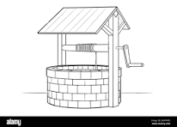
*_ lrqsf] gfd n]Vg'xf];\ M -$_

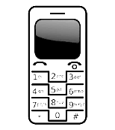
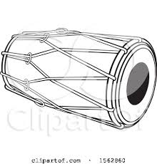

(_ 6«flkms aQLsf] lrq agfO{ /ª eg'{xf]; M -$_

