**Class: L.K.G. F.M.: 50**

**Subject: Maths P.M.: 18**

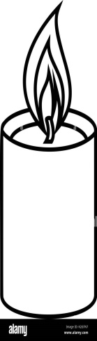**1. Look at the pictures and tick (√) the long objects. (2)**

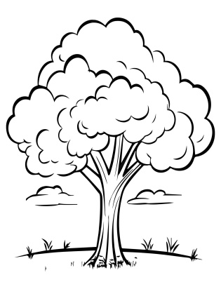

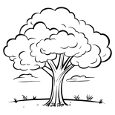Romance candle icon, outline style Stock Vector Image & Art - Alamy

**2. Count and write. (5)**

**=**

**=**

**=**

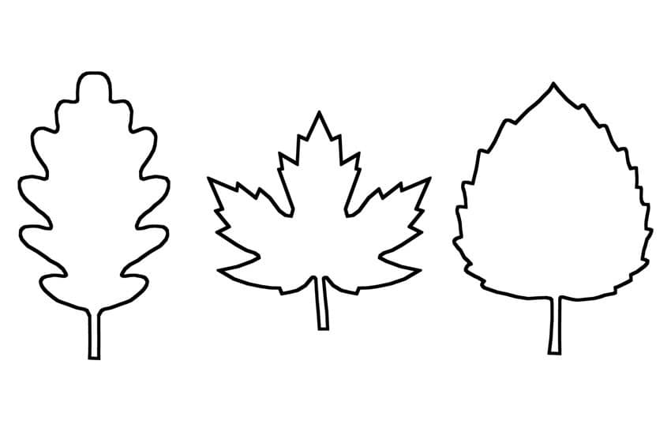**3. Circle the biggest number. (4)**

 10 15 12 20

19 6 17 8

**4. Draw the balls as per given numbers. (4)**

5 =

6 =

7 =

8 =

**5. What comes after? (5)**

25 _________ 42 _________ 32 _________

45 _________ 37 _________

**6. What comes before?**

_________ 15 _________ 27 _________ 18

_________ 38 _________ 23

**7. What comes in between? (5)**

15 ________ 17 43 ________ 45

24 ________ 26 48 ________ 50

32 ________ 34

**8. Write the first letter of the given shapes. (5)**

**9. Compare the numbers and put ‘>’ or ‘<’ or ‘=’. (5)**

12 8 29 37 20 15

16 42 18 18

**10. Write the missing numbers. (12)**

30 _______ _______ 33 _______ _______ 36 _______ _______ 39 40 _______

_______ 43 _______ _______ 46 _______

48 _______ 50

***The End***