Green Society Public School
Ratnanagar-7, Sauraha, Chitwan
First Achievement Test-2082
Class:3 Time: - 1hrs. F.M.:25
Sub: Computer P.M.:09
Name: Roll No.: Sec.:
OBT.MARKS:

- Fill in the blanks [ 4x1=4 ]
[ Text, Automatic, Word Pad, Cursor ]
  - Computer is ……………..
  - ……………. is the blinking line on the screen.
  - The ……………. tool is used to write text on the Paint screen.
  - …………….. allows you to create simple letters and documents.
2. Write True or False [ 4x1=4 ]
- A device that prints text or illustrations on the paper. [____]
- The round shaped button on the left of the taskbar is the start menu. [____]
- Curve tool is used to draw curved shaped objects. [____]
- Fonts refers to the way text is set with respect to the margins. [____]
3. Match the following [ 4x1=4 ]
- word wrap used to erase a drawing
- Eraser tool Automatic placement of word in next line
- Data A work area in Windows
- Desk top The collection of raw-facts
4. Identify the pictures. [ 5x1=5 ]
b)
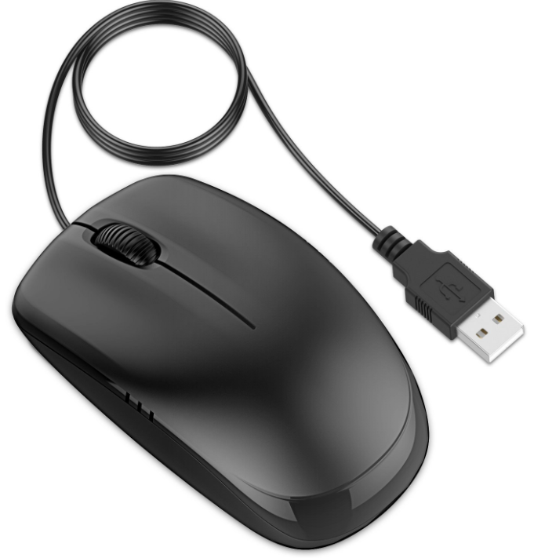
c)
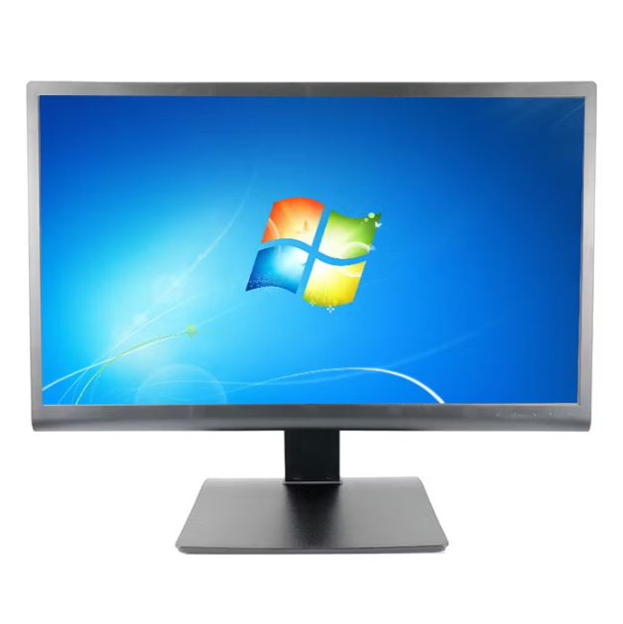
a)
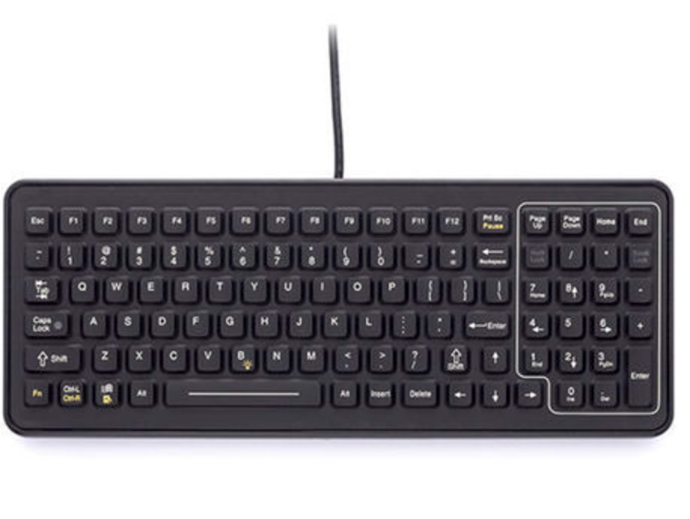
e)
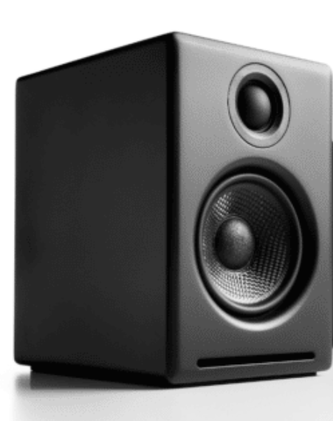
d)
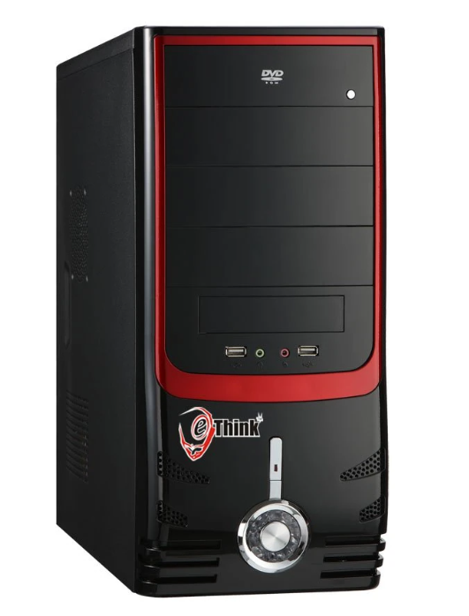

5. Answer the following questions. [ 4x2=8 ]
- Write any two features of computer.
:……………………………………………………………………………………………………………….
………………………………………………………………………………………………………………..
………………………………………………………………………………………………………………..
- What is a Paint program?
:……………………………………………………………………………………………………………….
……………………………………………………………………………………………………………….
………………………………………………………………………………………………………………..
- Why do we use Zoom tool?
:……………………………………………………………………………………………………………….
………………………………………………………………………………………………………………..
………………………………………………………………………………………………………………..
- What is a word wrap?
:……………………………………………………………………………………………………………….
………………………………………………………………………………………………………………..
………………………………………………………………………………………………………………..

