
Green Society Public School
D-
Ratnanagar-7, Sauraha, Chitwan
Third Terminal Examination-2082
Class: One Time: 1:00 hrs. F.M.: 25
Sub: Eng II P.M.: 9

- Match the following. (2)
boy a or an
article ?
question mark feminine
girl masculine
- Write past form of these verbs. (2)
- play =
- jump =
- Re-arrange the words and write the sentences. (2)
- are / They / reading.
___________________________
- What / your / is/ name?
____________________________
- Fill in the blanks . (3)
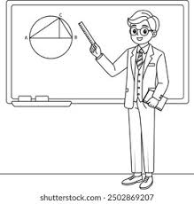
- Mahesh teaches in school.
He is a ______________.

- I write with it. I am a _______________.
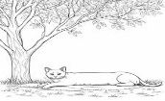
- The ______is under the tree.
- Complete the name of occupations. (4)
- A n__r__e cares for sick people.
- A d__n c __ r dances on the stage.
- A b__r b __ r cuts our hair.
- A c__ __ k cooks food.
- Circle the correct words. (4)
a. | aple | apple | aplle
b. | orange | ornge | oranje
c. | blak | black | blck
d. | gote | goet | goat

- Tick ( )the correct opposite words. (4)
- always [ ever , never ]
- hot [ cold , sold ]
- open [ late , close ]
- question [ answer , comma ]
- Answer the questions. (4)
- What are replaced by pronouns?
__________________________________________
- How many vowel letters are there in english alphabet?
____________________________________________

