Part 1: solving the process problem

## Step 1: Analysis

A local animal shelter is looking for automated pet feeder which can be built at a low cost and with the following **features:**

Features of feeder which must include:

* Dispense food for pets at scheduled time each day
* Give the right amount of food
* Check if food was consumed or amount of food that is consumed.
* Warn staff if something is wrong.
* It must be affordable and must use low-cost components.

**Assumptions:**

* Only one type of food is used.
* The system supports two feeding times per day.
* internet/wifi available to send signals.

**Inputs and outputs:**

**Inputs:**

* Feeding schedule (time of the day)
* Real time clock (to check time of the day)
* Food Container level sensor (before/after feeding)
* Bowl level sensor (food level to check whether they eat or not)
* Motor
* Buttons for manual feed and alert reset.

**Outputs:**

* Servo motor to drop food
* Alerts (food not taken, food container empty, food not dispensed)
* Log entry (Feeding time)

**Block diagram of the system**

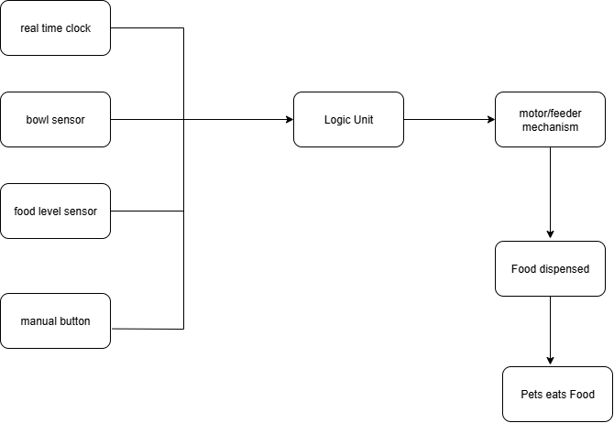

Figure 1: Pet feeder system block diagram