# **3.Design**

## **Introduction**

Design is one of important phases as how the product/software will look and work is determined. Most of the design is done according to customer requirement and needs. Design is a key aspect of impressing the customer as it shows the layout of the software.

Benefits and importance of designing:

Helps the customer to visualize the product.

Easier for making changes in design phase rather this in implementing phase.

Easier for describing the features and function of the software to the customer.

Helps I describing the work process of the software.

## **3.1 Structural design**

Structural design is a methodology to determine design specification of a software. This also helps in determining the strength, stability and rigidity of the software. This shows the static view of the system. For this tool such as class diagram and Data flow diagram are used.

Class diagram

This represents the relation between entities in the system and how they interact with one-another. It shows the structure of the system showing entities, attributes, operations and relation among one-another.

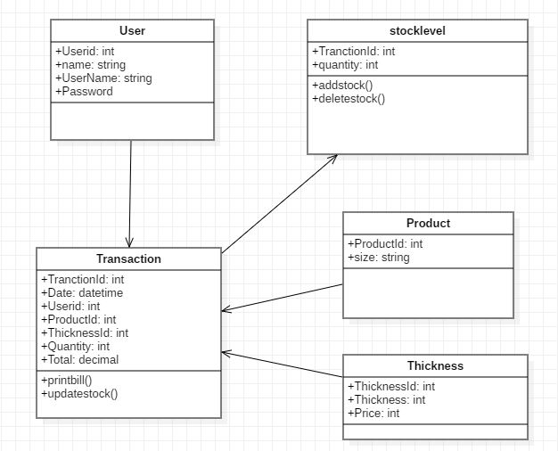

Justification

Model, controller and view of the system are shown in the above diagram. Also called MVC designed pattern I have used aggregation, composition and dependency in order to show relationship between each component. Controllers are dependent in Models and each controller implements interface.

**Data flow diagram**

Data Flow Diagram is used to represent the flow of data throughout the system. It provides information about inputs, how each input is processed and what is the expected output from the system.

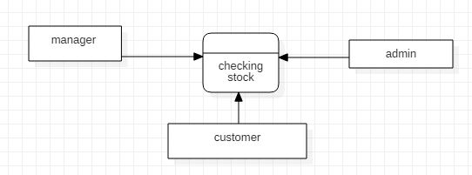

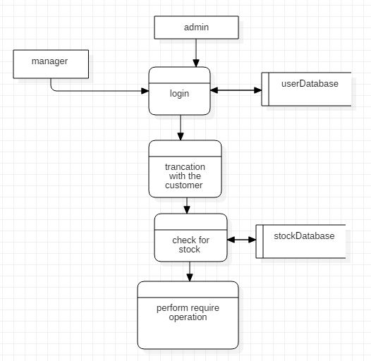

**Notation Used**

1. External Entity

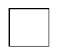

1. Data Flow



1. Data Store



1. Process



## **Behavioral design**

Behavioral design mainly provides information on dynamic behavior of the system. Changes in the requirements may result in over view and functionality of the system. For this purpose, tools such as Activity diagram, Sequence diagram and Use Case Diagram are used.

**Activity diagram**

Using activity diagram, flow of logic from one activity to another activity as it is the advance version can be shown in form of flow chart.

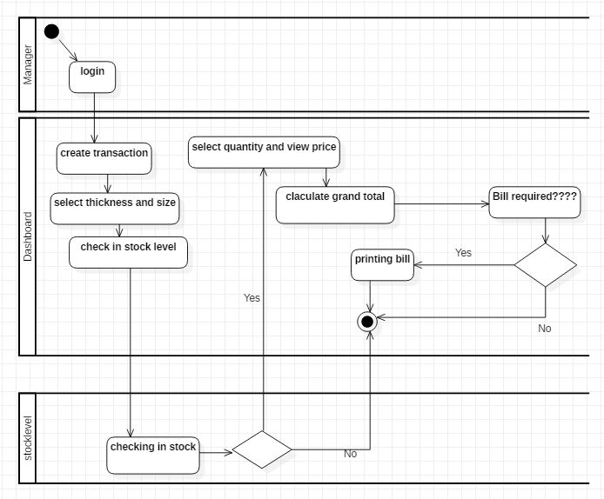

Fig: Activity diagram.

**Notations Used**

1. Start/ Initial Node



1. Activity



1. Control Flow



1. Activity Final Node



1. Decisions Node



## **Database Design**

**Entity relationship diagram**

Entity Relationship Diagram, also known as ER Diagram, is a type of structural diagram for use in database design. Following is the ER diagram of the project.

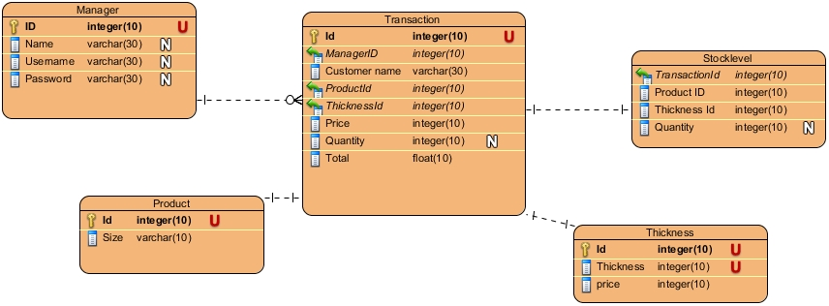

Fig: ER diagram

**Data dictionary**

Data dictionary is a vital component in relational database. A data dictionary is a file or set of files that contains metadata.

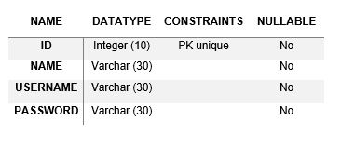

Fig: data dictionary of manager

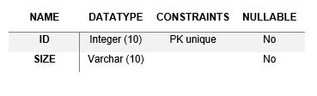

Fig: data dictionary of product

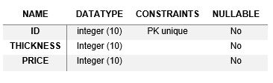

Fig: data dictionary of thickness

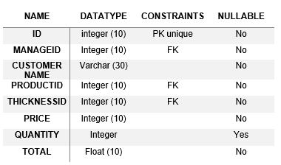

Fig: data dictionary of transaction

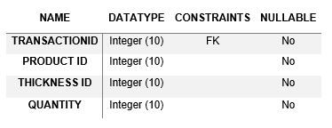

Fig: data dictionary of stock level

## **UI design**

Paper prototype

