## **1. Introduction**

The Board-ply management system was developed to check the stock level of the materials in the company, keeping day to day records. This application features technologies like:

Microsoft Visual studio (Programming Language, C#)

SQL Server (Database management system)

Microsoft Visual studio:

Microsoft Visual Studio is an [integrated development environment](https://en.m.wikipedia.org/wiki/Integrated_development_environment) (IDE) from [Microsoft](https://en.m.wikipedia.org/wiki/Microsoft). It is used to develop [computer programs](https://en.m.wikipedia.org/wiki/Computer_program) for [Microsoft Windows](https://en.m.wikipedia.org/wiki/Microsoft_Windows), as well as [web sites](https://en.m.wikipedia.org/wiki/Web_site), [web apps](https://en.m.wikipedia.org/wiki/Web_app), [web services](https://en.m.wikipedia.org/wiki/Web_service) and [mobile apps](https://en.m.wikipedia.org/wiki/Mobile_app). Visual Studio uses Microsoft software development platforms such as [Windows API](https://en.m.wikipedia.org/wiki/Windows_API), [Windows Forms](https://en.m.wikipedia.org/wiki/Windows_Forms), [Windows Presentation Foundation](https://en.m.wikipedia.org/wiki/Windows_Presentation_Foundation), [Windows Store](https://en.m.wikipedia.org/wiki/Windows_Store) and [Microsoft Silverlight](https://en.m.wikipedia.org/wiki/Microsoft_Silverlight). It can produce both [native code](https://en.m.wikipedia.org/wiki/Native_code) and [managed code](https://en.m.wikipedia.org/wiki/Managed_code).

SQL Server:

SQL Server is a Microsoft product used to manage and store information. Technically, SQL Server is a “relational database management system” (RDMS). Broken apart, this term means two things. First, that data stored inside SQL Server will be housed in a “relational database”, and second, that SQL Server is an entire “management system”, not just a database. SQL itself stands for Structured Query Language. This is the language used to manage and administer the database server.

## **Background**

There are basically 3 different thickness and furthermore, different sizes. All three different thickness has all the same sizes. These sizes are measured in feet or inch and all prices range are very much different as well. This project has been planned to reduce some repeating issues and missing stock the hampers the company.

## **Problem statement**

The company wants to maintain and record the ups and downs in the stock level. Due to different thickness the usage of different sizes also varies. This may help in determine which size is mostly used in the company.

## **Aims**

* The aims of this project are as follow:
* Help to maintain stock level.
* Help to determine the most used size.

## **Objectives**

* The objectives of that will be applied to achieve are as follow:
* To perform analysis and gather related data.
* To document profit or loss
* To create a working database design
* To produce information ready to be used based on the analysis
* To implement the code and maintain the system afterwards
* To record all the activities of the usage of the material.

## **Overview of the scope**

The aim is to create an application that allows to check stock level in the company. Which material is widely consumed/used.

# **2. Introduction to analysis**

Analysis is the process of defining the needs and necessity of certain functions of the users for an application that is to be built. Analysis is one of the important stages of the software development process. Analysis helps to determine the feasibility of the project. Analysis is the process of collecting data, finding requirements for the project, problems in the system to insure a feasible new system.

Conducting the analysis to produce the best results for the decisions to be made is an important part of the process, as is appropriately presenting the results. It is very important to not overcomplicate the analysis and to clearly and succinctly present results.

There are various types of analysis that can be conducted such as PEST analysis, SWOT analysis, CATWOE analysis and more. For this project I applied SWOT analysis

### **SWOT analysis**

What makes SWOT particularly powerful is that, with a little thought, it can help you uncover opportunities that you are well-placed to exploit. And by understanding the weaknesses, you can eliminate threats that would otherwise harm the company. You can start to craft a strategy that helps you distinguish yourself from your competitors, so that you can compete successfully in your market.

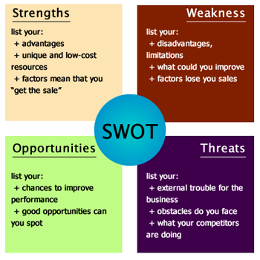

*Fig 1: SWOT*

### **Strengths**

What advantages does your organization have?

What do you do better than anyone else?

### **Weaknesses**

What could you improve?

What should you avoid?

### **Opportunities**

What good opportunities can you spot?

What interesting trends are you aware of?

### **Threats**

What obstacles do you face?

Could any of your weaknesses seriously threaten your business?

# **Feasibility study**

A feasibility study is an analysis that takes all of a project's relevant factors into account—including economic, technical, legal, and scheduling considerations to complete the project successfully. Feasibility studies also can provide a company's management with crucial information that could prevent the company from falling apart.

Types of feasibility study that are performed during analysis are:

Economic feasibility

Generally, it means whether a business or a project feasible cost wise. A project is considered economically feasible when profit can be observer for the project.

Technical feasibility

In technical feasibility issues such as; - whether the required technology is available or not, whether the required resources like software, hardware, programmers and testers are available or not.

Schedule feasibility

**Schedule Feasibility** is defined as the probability of a project to be completed within its scheduled time limits, by a planned due date. If a project has a high probability to be completed on-time, then its schedule feasibility is appraised as high.

Operational Feasibility

Operational feasibility is mainly concerned with issues like whether the system will be used if it is developed and implemented. Whether there will be resistance from users that will affect the possible application benefits.

Legal Feasibility

It includes study concerning contracts, liability, violations, and legal other traps frequently unknown to the technical staff.

# **Requirement analysis**

Requirements Analysis is the process of defining the expectations of the users for an application that is to be built or modified. Requirements analysis involves all the tasks that are conducted to identify the needs of different stakeholders as different stakeholders might have different ideas and needs.

## Functional:

Functional requirements describe the desired end function of a system operating within normal parameters, so as to assure the design is adequate to make the desired product and the end product reaches its potential of the design in order to meet user expectations. The system will have a proper interface, authentication.

Non-functional:

Nonfunctional requirements are vital to the success of software systems. **Non-functional requirements describe how the system works.** There are **four examples of Non-Functional requirement groups**; reusability, performance, usability, and security.

### **Reusability**

Any system should be designed in such a way that it’s code could be re-used in any further programs that may come in future.

**Usability:**

Prioritize the important functions of the system based on usage patterns.  
**Frequently used functions should be tested for usability.**

**Reliability:**

**Users have to trust the system**, even after using it for a long time. It’s a good idea to also include requirements that make it easier to monitor system performance.

**Security:**

These are security related architectural requirements, like robustness or minimal performance and scalability. This requirement type is typically derived from architectural principals and good practice standards.

**Moscow Priotization**

MoSCoW prioritization, also known as the MoSCoW method or MoSCoW analysis, is a popular prioritization technique for managing requirements. The method is commonly used to help key stakeholders understand the significance of initiatives in a specific release. MoSCoW, stands for 4 different categories: must-haves, should-haves, could-haves, and won’t have this time.

Must have: Function which are necessary such as price list are at the top of priority list and will be included in the first version.

Should have: Function such as login that determine the person that sold the goods are listed as should have.

Could have: function such as “change language” could be added in future updates.

Won’t have: functions such as” play music” won’t be added any time soon.

|  |  |  |
| --- | --- | --- |
| Id | Title | Priority |
| F001 | Price list | Must have |
| F002 | Login | Should have |
| F003 | Change language | Could have |
| F004 | Music player | Won’t have |

*Table: Moscow Priotization*

Software requirements specification

Software requirements

1. Visual studios
2. sql Server 2014 Management Studio

Hardware requirements

1. Processor: i5 or above.
2. Memory: 4 GB RAM.

## **NLA (natural language analysis)**

|  |  |
| --- | --- |
| Potential classes | Potential method |
| admin | Add manager, update, sell stock level. |
| manager | Check stock level, sell stock |
| Print bill | Admin/manager name, sizes, thickness, |
| Thickness | 6mm,10mm,18mm |
| Size | 3ft*6 ft,3 ft *7 ft,3 ft *8 ft,4 ft *6 ft,4 ft *7 ft, 4 ft *8 ft |

# **Use case:**

Use case is a methodology used on system analysis to identify and clarify the requirements

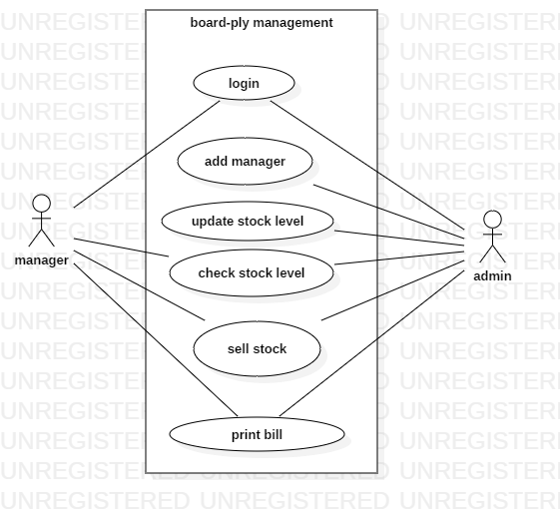

# **Design**

Design is one of important phases as how the product/software will look and work is determined. Most of the design is done according to customer requirement and needs. Design is a key aspect of impressing the customer as it shows the layout of the software.

Benefits and importance of designing:

Helps the customer to visualize the product.

Easier for making changes in design phase rather this in implementing phase.

Easier for describing the features and function of the software to the customer.

Helps I describing the work process of the software.

## **Dynamic modelling**

Behavioral design mainly provides information on dynamic behavior of the system. Changes in the requirements may result in over view and functionality of the system. For this purpose, tools such as Activity diagram, Sequence diagram and Use Case Diagram are used.

**Activity diagram**

Using activity diagram, flow of logic from one activity to another activity as it is the advance version can be shown in form of flow chart.

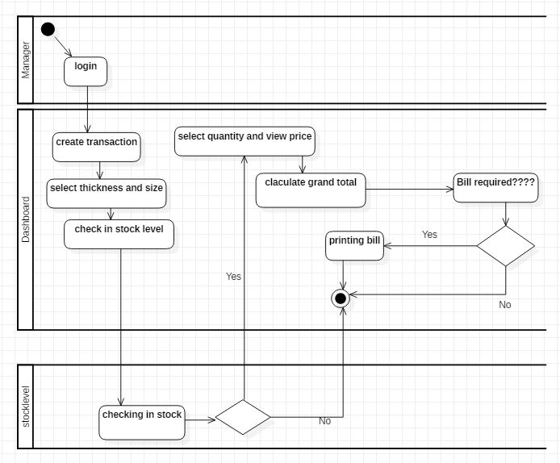

Fig: Activity diagram.

## **Structural modelling**

Structural design is a methodology to determine design specification of a software. This also helps in determining the strength, stability and rigidity of the software. This shows the static view of the system. For this tool such as class diagram and Data flow diagram are used.

Class diagram

This represents the relation between entities in the system and how they interact with one-another. It shows the structure of the system showing entities, attributes, operations and relation among one-another.

## **Data flow diagram**

Data Flow Diagram is used to represent the flow of data throughout the system. It provides information about inputs, how each input is processed and what is the expected output from the system.

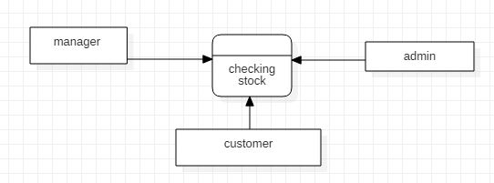

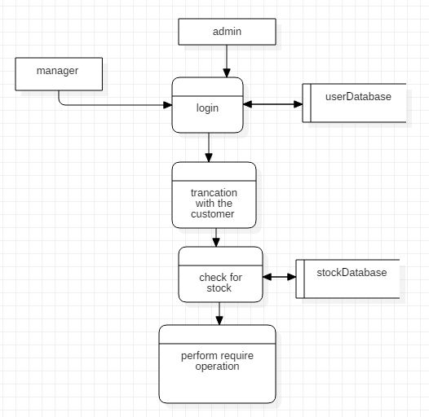

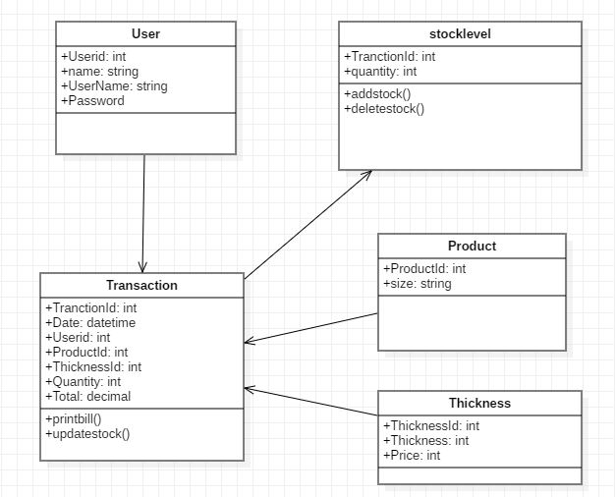

Justification

Model, controller and view of the system are shown in the above diagram. Also called MVC designed pattern I have used aggregation, composition and dependency in order to show relationship between each component. Controllers are dependent in Models and each controller implements interface.

## **Database modelling**

## **Entity relationship diagram**

Entity Relationship Diagram, also known as ER Diagram, is a type of structural diagram for use in database design. Following is the ER diagram of the project.

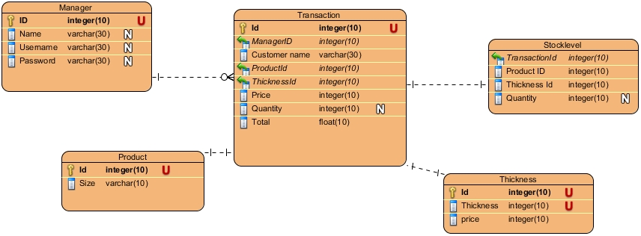

Fig: ER diagram

## **Data dictionary**

Data dictionary is a vital component in relational database. A data dictionary is a file or set of files that contains metadata.

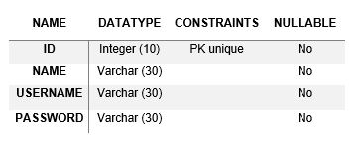

Fig: data dictionary of manager

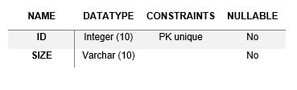

Fig: data dictionary of product

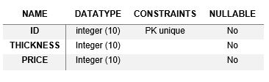

Fig: data dictionary of thickness

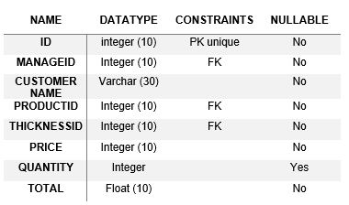

Fig: data dictionary of transaction

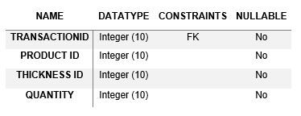

Fig: data dictionary of stock level

# **UI design**

Paper prototype

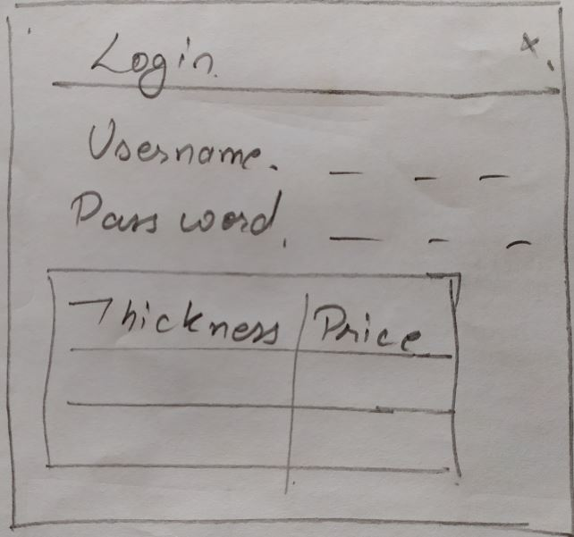

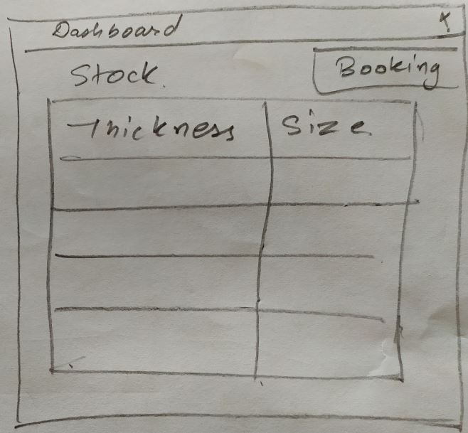

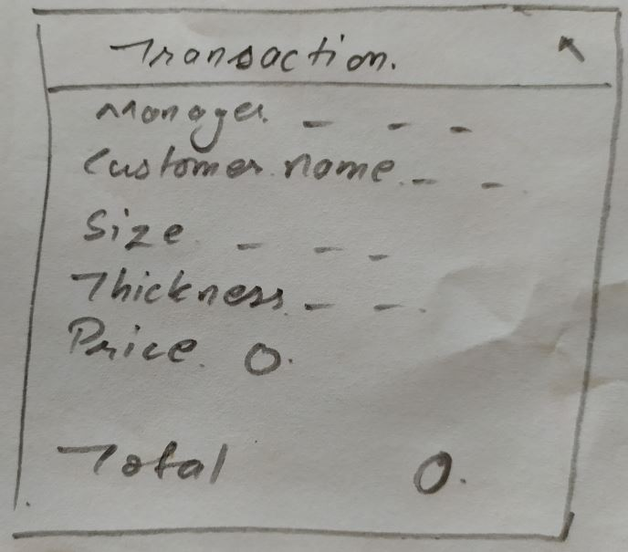

# **Implementation**

Here are the codes that have been implemented in this project in Visual Studio 2015 with C# programming language.

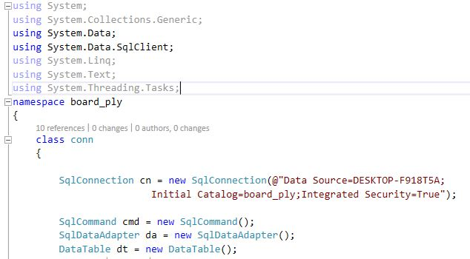

Fig: database connection 1

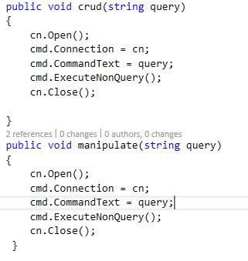

Fig: database connection 2

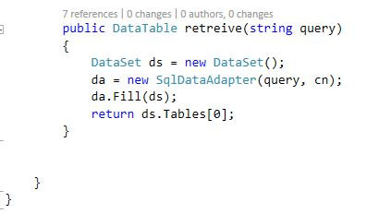

Fig: database connection 3

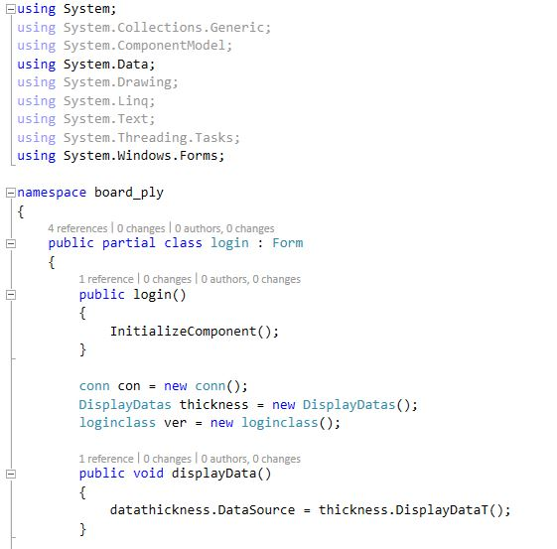

Fig: login 1

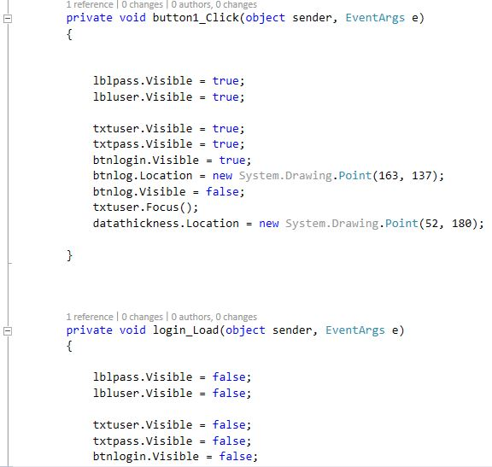

Fig: login 2

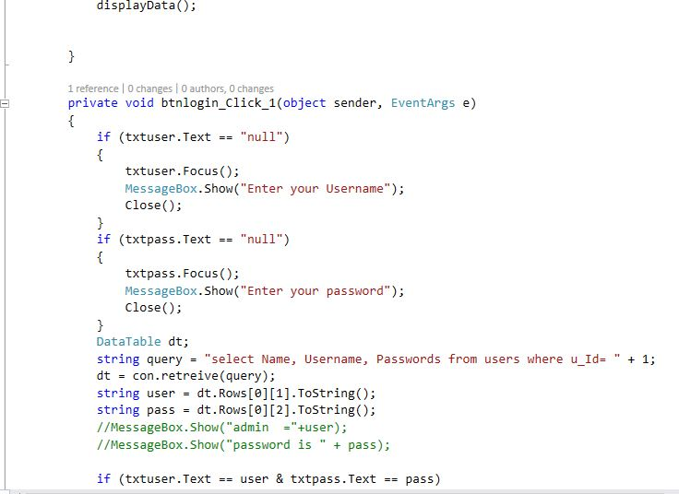

Fig: login 3

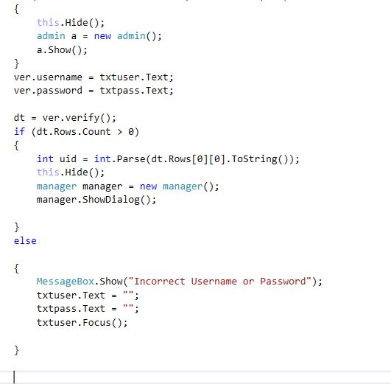

Fig: login 4

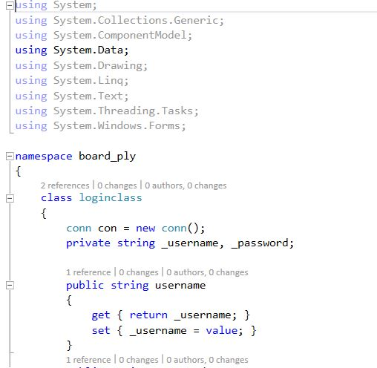

Fig: loginclass 1

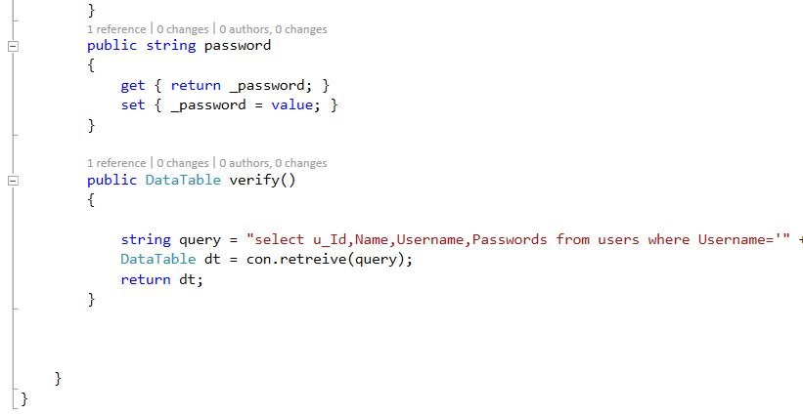

Fig: loginclass 2

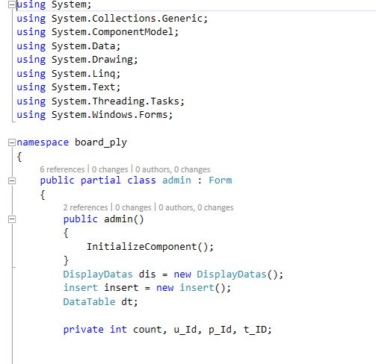

Fig: admin 1

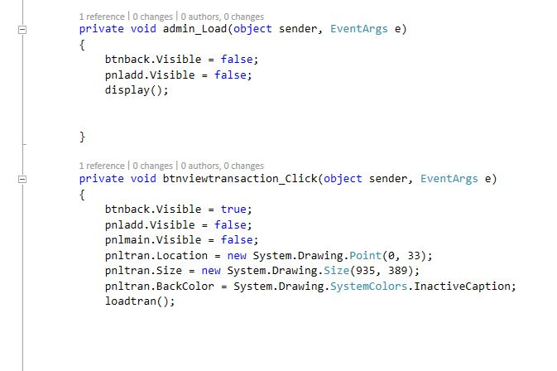

Fig: admin 2

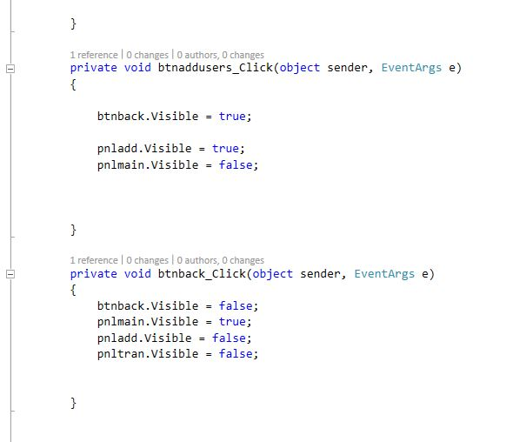

Fig: admin 3

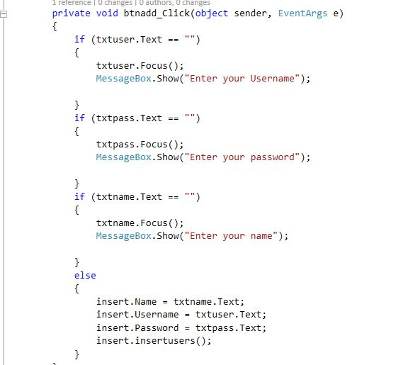

Fig: admin 4

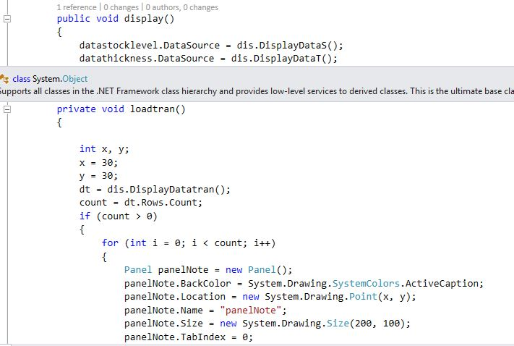

Fig: admin 5

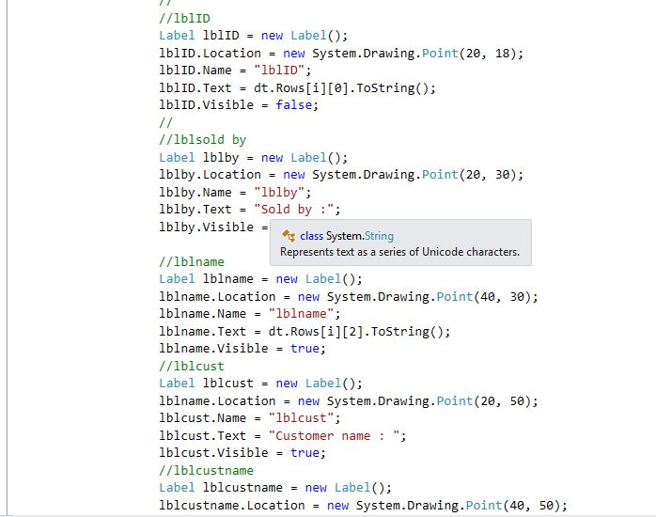

Fig: admin 6

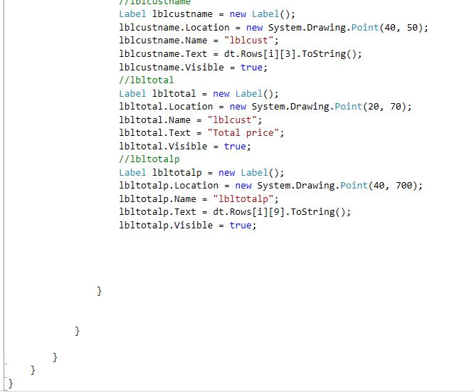

Fig: admin 7

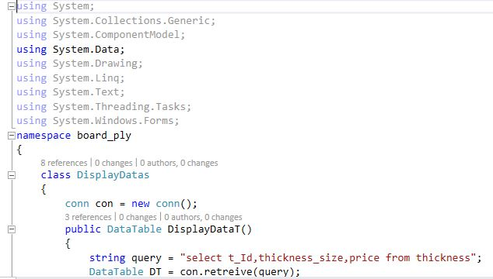

Fig: display 1

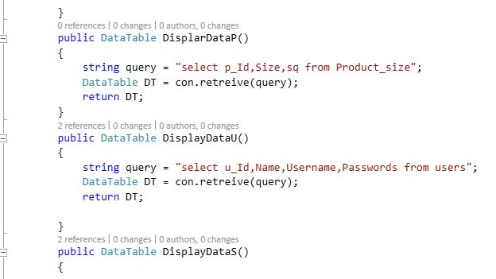

Fig: display 2

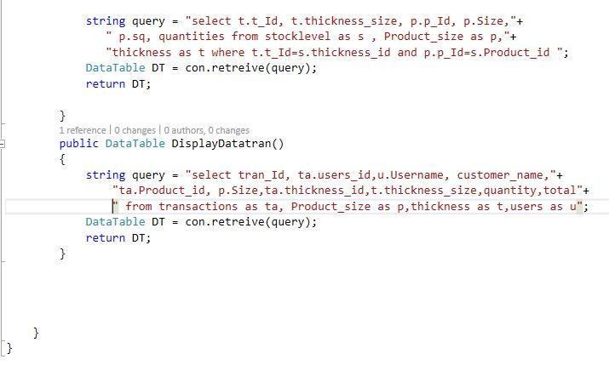

Fig: display 3

# **Testing**

White-box testing: In these types of testing, each and every step of the procedure can be checked.

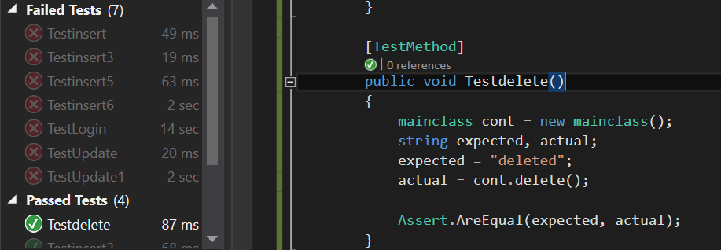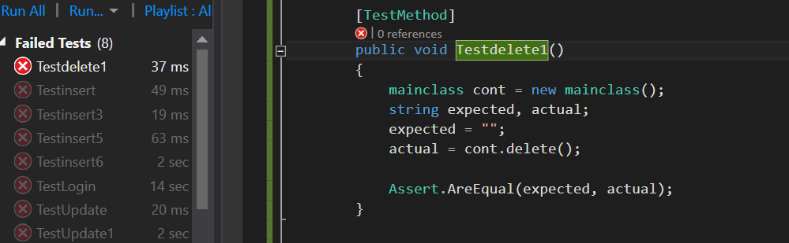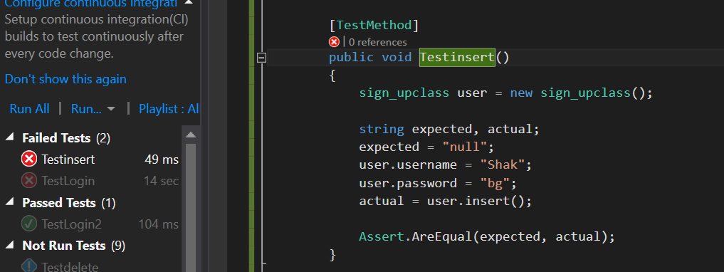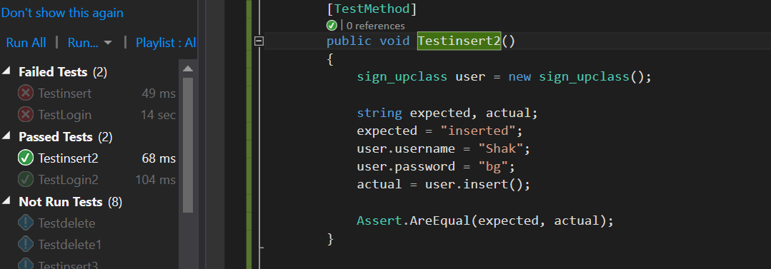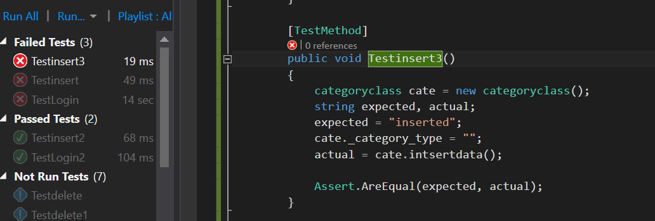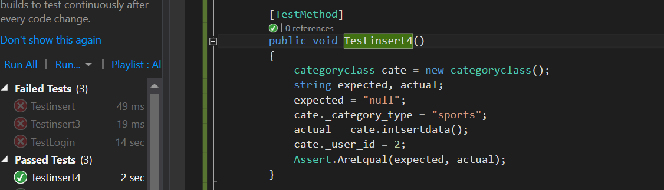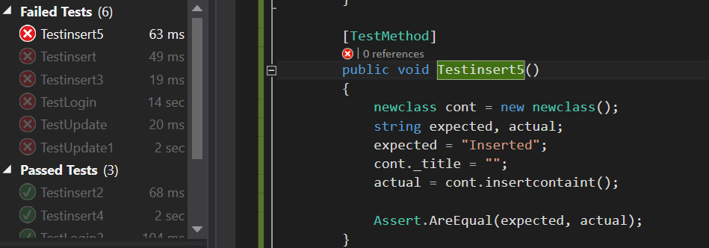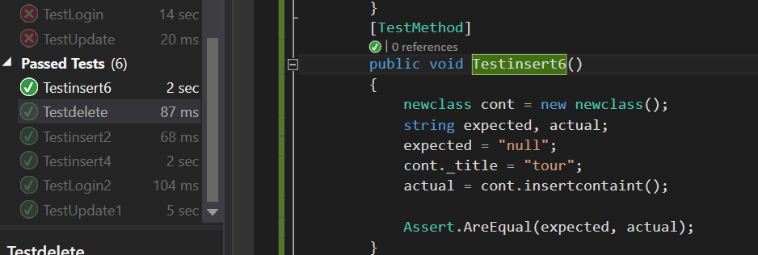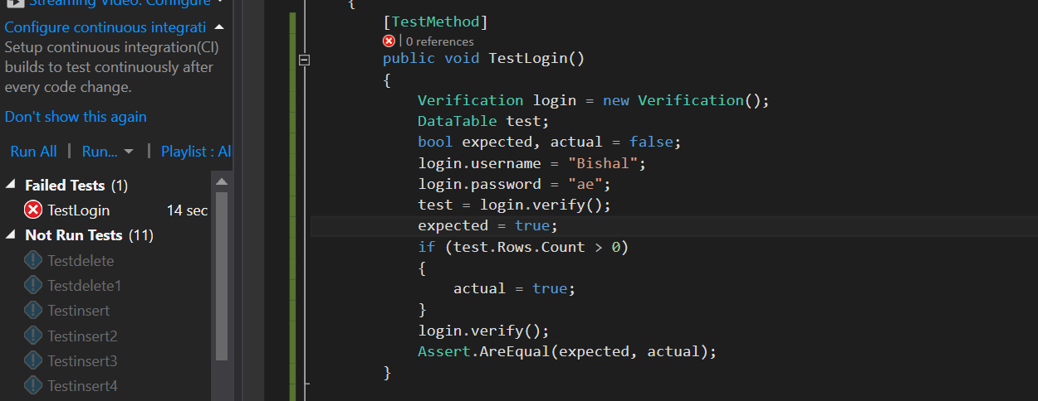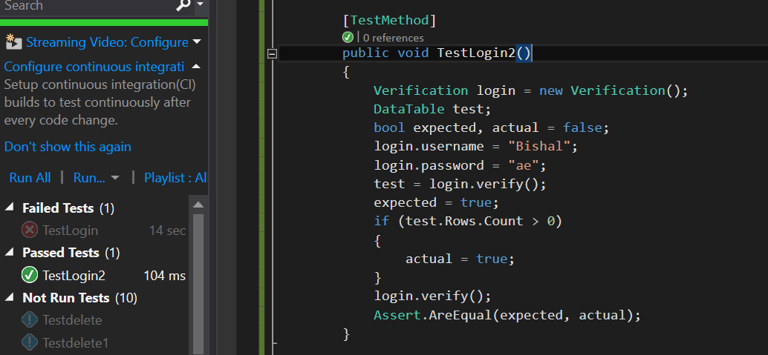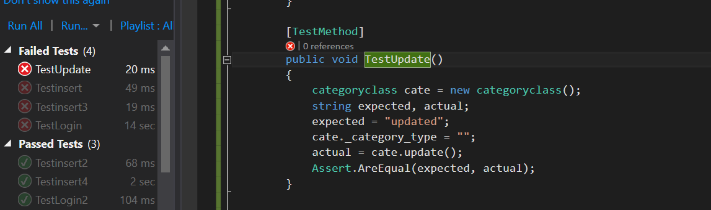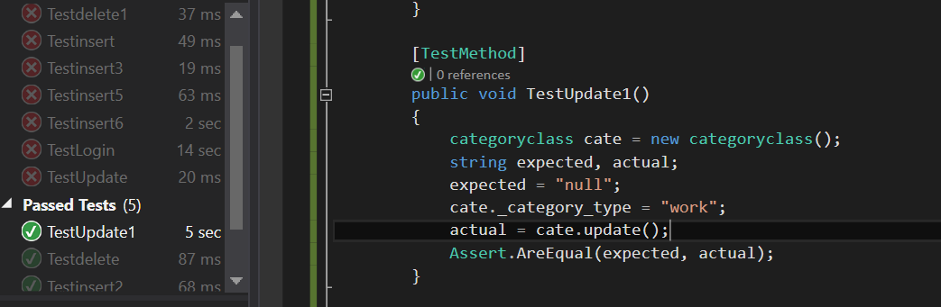

# **Other project issues**

## **Risk Management**

Risk management is the process of identifying, assessing and controlling threats to an organization's capital and earnings. These threats, or risks, could stem from a wide variety of sources, including financial uncertainty, legal liabilities, strategic management errors, accidents and natural disasters. IT security threats and data-related risks, and the risk management strategies to alleviate them, have become a top priority for [digitized](https://whatis.techtarget.com/definition/digitization) companies. As a result, a risk management plan increasingly includes companies' processes for identifying and controlling threats to its digital assets, including proprietary corporate data, a customer's personally identifiable information and intellectual property.

## **Configuration Management**

Configuration Management helps organizations to systematically manage, organize, and control the changes in the documents, codes, and other entities during the Software Development Life Cycle. It is abbreviated as the SCM process. It aims to control cost and work effort involved in making changes to the software system. The primary goal is to increase productivity with minimal mistakes.

# **Conclusion**

Hence, a application is built for the company to maintain and check their stock level. It helps to identify the required materials which are mostly to be used in the company. Most of the requirements that the client wanted was fulfilled.