**Board-Ply Management System**



**Computing Project**

**Level 5 Diploma in Computing**

**Softwarica College of IT & E-Commerce**

**Kathmandu, Nepal**

**9th April, 2019**

**Submitted to**

**Niman Maharjan**

**Bishal Maharjan**

**Id**: 00170250

**Batch**: 22B

Contents

**Chapter1: Introduction** 4

**Project introduction** 4

**Background** 4

**Problem statement** 5

**Description** 5

**Features of project** 5

**Overview of project** 5

**Chapter 2: Scope of the project** 6

**Scope** 6

**Limitation:** 6

**Aims:** 6

**Objectives** 6

**Overview of the scope** 6

**Chapter 3: Development Methodology** 7

**Development method** 7

*Fig: Waterfall model* 8

**Design pattern** 8

*Fig: MVC pattern* 8

**System Architecture** 9

*Fig: System Architecture* 9

**Chapter 4: Project plan** 10

**Work Breakdown Structure** 10

*Fig: Work breakdown structure* 10

**Time Estimate** 11

*Table: Time estimation* 11

**Milestones** 12

*Table: Milestone* 12

**Gant chart** 13

*Fig: Gant chart 1* 13

*Fig: Gant chart 2* 14

**Chapter 5** 15

**Risk Management** 15

**Risk identification** 15

**Risk analysis** 15

**Risk assessment  and evaluation** 15

**Risk mitigation** 15

**Risk monitoring** 16

**Likelihood table:** 16

*Table 1: Risk likelihood values* 16

**Risk consequences table:** 16

*Table 2: Risk consequence values* 16

**Risk management table:** 17

*Table: Risk management* 17

**Chapter 6** 18

**Configuration Management** 18

**Chapter 7** 19

**Conclusion** 19

**Chapter 8** 20

**References** 20

# **Chapter1: Introduction**

## **Project introduction**

The Board-ply management system was developed to check the stock level of the materials in the company, keeping day to day records. This application features technologies like:

Microsoft Visual studio (Programming Language, C#)

SQL Server (Database management system)

Microsoft Visual studio:

Microsoft Visual Studio is an [integrated development environment](https://en.m.wikipedia.org/wiki/Integrated_development_environment) (IDE) from [Microsoft](https://en.m.wikipedia.org/wiki/Microsoft). It is used to develop [computer programs](https://en.m.wikipedia.org/wiki/Computer_program) for [Microsoft Windows](https://en.m.wikipedia.org/wiki/Microsoft_Windows), as well as [web sites](https://en.m.wikipedia.org/wiki/Web_site), [web apps](https://en.m.wikipedia.org/wiki/Web_app), [web services](https://en.m.wikipedia.org/wiki/Web_service) and [mobile apps](https://en.m.wikipedia.org/wiki/Mobile_app). Visual Studio uses Microsoft software development platforms such as [Windows API](https://en.m.wikipedia.org/wiki/Windows_API), [Windows Forms](https://en.m.wikipedia.org/wiki/Windows_Forms), [Windows Presentation Foundation](https://en.m.wikipedia.org/wiki/Windows_Presentation_Foundation), [Windows Store](https://en.m.wikipedia.org/wiki/Windows_Store) and [Microsoft Silverlight](https://en.m.wikipedia.org/wiki/Microsoft_Silverlight). It can produce both [native code](https://en.m.wikipedia.org/wiki/Native_code) and [managed code](https://en.m.wikipedia.org/wiki/Managed_code).

SQL Server:

SQL Server is a Microsoft product used to manage and store information. Technically, SQL Server is a “relational database management system” (RDMS). Broken apart, this term means two things. First, that data stored inside SQL Server will be housed in a “relational database”, and second, that SQL Server is an entire “management system”, not just a database. SQL itself stands for Structured Query Language. This is the language used to manage and administer the database server.

## **Background**

There are basically 3 different thickness and furthermore, different sizes. All three different thickness has all the same sizes. These sizes are measured in feet or inch and all prices range are very much different as well. This project has been planned to reduce some repeating issues and missing stock the hampers the company.

## **Problem statement**

The company wants to maintain and record the ups and downs in the stock level. Due to different thickness the usage of different sizes also varies. This may help in determine which size is mostly used in the company.

## **Description**

The concept of this project is to help keep day to day record of usage of different thickness and sizes of the material. Thus, the manager (the client) wants an application the helps him/her to check the demand of different sizes and update the stock level in the company.

## **Features of project**

* Features that are provided in the project:
* Check stock level of different thickness and sizes.
* Record daily usage of material.
* Find the most useful thickness and size of the material.

## **Overview of project**

Board-ply management system is an application that could help in maintain and checking the stock level of the materials within the company. It is a paper less method that is eco-friendly as well as easier to search.

# **Chapter 2: Scope of the project**

## **Scope**

The main purpose of the application is to check the stock level of the company and order according to necessity. Records can be easily found for future use and help the company invest properly in most useful size and thickness.

## **Limitation:**

* Prices may change according to batch.
* Good quality product may be difficult find for time to time.

## **Aims:**

* The aims of this project are as follow:
* Help to maintain stock level.
* Help to determine the most used size.

## **Objectives**

* The objectives of that will be applied to achieve are as follow:
* To perform analysis and gather related data.
* To document profit or loss
* To create a working database design
* To produce information ready to be used based on the analysis
* To implement the code and maintain the system afterwards
* To record all the activities of the usage of the material.

## **Overview of the scope**

The aim is to create an application that allows to check stock level in the company. Which material is widely consumed/used.

# **Chapter 3: Development Methodology**

## **Development method**

I have chosen the waterfall model as a development method because we can move on with sequentially design process without iteration. These steps are followed logically. The flow goes steadily downward though the phase of conception, initiation, analysis, design, construction and testing etc. Phases on this model can be separated from other steps allowing the simple steps and planning. Exact extensions of the required efforts and cost is possible. Thus, waterfall model is preferred. (istqbexamcertification, n.d.)

The steps to be followed in waterfall model are as follows:

Requirement analysis

System design

Implementation

Testing

Deploying

Maintenance

Requirement Analysis

Design

Implementation

Integration

Deploying

Maintenance

### *Fig: Waterfall model*

## **Design pattern**

I will be using MVC pattern and object oriented approach using framework for my project for faster development process. MVC pattern is one o fthe design pattern which is important for handeling complex functionality.

The Model View Controller (MVC) design pattern specifies that an application consist of a data model, presentation information, and control information. The pattern requires that each of these be separated into different objects.

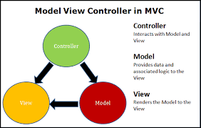

### *Fig: MVC pattern*

## **System Architecture**

System architecture serve as a model or blueprint for developing the application. Systems Architecture is a generic discipline to handle objects (existing or to be created) called "systems", in a way that supports reasoning about the structural properties of these objects.  
Systems Architecture is a response to the conceptual and practical difficulties of the description and the design of complex systems.

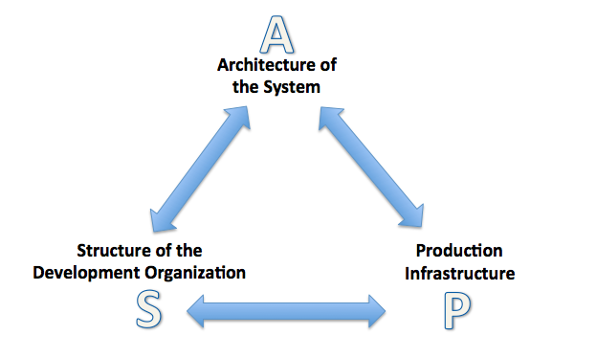

### *Fig: System Architecture*

# **Chapter 4: Project plan**

## **Work Breakdown Structure**

A work breakdown structure in systems engineering is breaking down the whole project into smaller chunks such that it organizes the team into manageable sections.  (Anon., n.d.)

Requirement analysis

Scoping

Planning

Monitoring

Requirement gathering

Use case diagram

Analysis specification

Class

Diagram

Unit

Testing

Integration

Testing

User

Manual

Final Report

Report

Submission

Sequence Diagram

User

Interface

Diagram

Design

Specification

Design

Specification

Proposal

Analysis

Design

Testing

Documentation

Board-ply management system

### *Fig: Work breakdown structure*

## **Time Estimate**

|  |  |  |
| --- | --- | --- |
| Task number | Task name | Tine estimation |
| **1** | **Proposal** | **18** |
| 2 | Analysis | 19 |
| 2.1 | Requirement Gathering | 8 |
| 2.2 | Requirement Analysis | 6 |
| 2.3 | Analysis Specification | 3 |
| 2.4 | Use Case Diagram | 2 |
| **3** | **Design** | **25** |
| 3.1 | Class Diagram | 10 |
| 3.2 | Sequence Diagram | 8 |
| 3.3 | User Interface Design | 6 |
| 3.4 | Design Specification | 1 |
| **4** | **Implementation (Coding)** | **20** |
| **5** | **Testing** | **8** |
| 5.1 | Unit Testing | 5 |
| 5.2 | Integration Testing | 3 |
| **6** | **Documentation** | **12** |
| 6.1 | User Manual | 5 |
| 6.2 | Final Report | 5 |
| 6.3 | Report Submission | 2 |
|  | **Total days** | **102** |

### *Table: Time estimation*

## **Milestones**

The estimated key dates on which completion of certain stages of my projects are as follows:

|  |  |  |  |
| --- | --- | --- | --- |
| **Milestone** | **Start date** | **End date** | **No. of days** |
| **Proposal** | 3/29/2019 | 4/15/2019 | 18 |
| **Analysis** | 4/16/2019 | 5/4/2019 | 19 |
| Requirement Gathering |  |  |  |
| Requirement Analysis |  |  |  |
| Analysis Specification |  |  |  |
| Use Case Diagram |  |  |  |
| **Design** | 5/5/2019 | 5/29/2019 | 25 |
| Class Diagram |  |  |  |
| Sequence Diagram |  |  |  |
| User Interface Design |  |  |  |
| Design Specification |  |  |  |
| **Implementation (Coding)** | 5/30/2019 | 6/18/2019 | 20 |
| **Testing** | 6/19/2019 | 6/26/2019 | 8 |
| Unit Testing |  |  |  |
| Integration Testing |  |  |  |
| **Documentation** | 6/27/2019 | 7/8/2019 | 12 |
| User Manual |  |  |  |
| Final Report |  |  |  |
| Report Submission |  |  |  |
| Final deadline | | | 7/15/2019 |

### *Table: Milestone*

## **Gant chart**

A Gantt chart, commonly used in project management, is one of the most popular and useful ways of showing activities (tasks or events) displayed against time. On the left of the chart is a list of the activities and along the top is a suitable time scale. Each activity is represented by a bar; the position and length of the bar reflects the start date, duration and end date of the activity. This allows you to see at a glance:

* What the various activities are
* How long each activity is scheduled to last
* Where activities overlap with other activities, and by how much
* The start and end date of the whole project

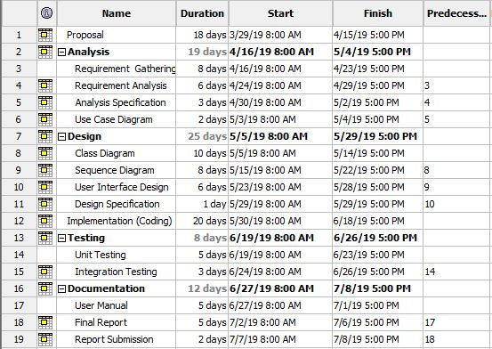

### *Fig: Gant chart 1*

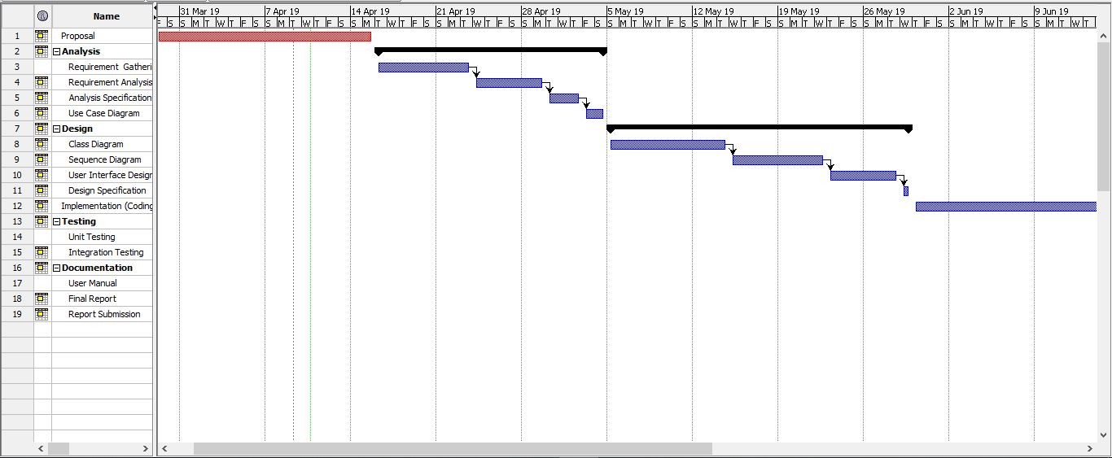

### *Fig: Gant chart 2*

# **Chapter 5**

## **Risk Management**

Risk management is the process of identifying, assessing and controlling threats to an organization's capital and earnings. These threats, or risks, could stem from a wide variety of sources, including financial uncertainty, legal liabilities, strategic management errors, accidents and natural disasters. IT security threats and data-related risks, and the risk management strategies to alleviate them, have become a top priority for [digitized](https://whatis.techtarget.com/definition/digitization) companies. As a result, a risk management plan increasingly includes companies' processes for identifying and controlling threats to its digital assets, including proprietary corporate data, a customer's personally identifiable information and intellectual property. There are some steps for risk management they are:

## **Risk identification**

Risk identification is the process of listing potential project risks and their characteristics.

The results of risk identification are normally documented in a risk register, which includes a list of identified risks along with their sources, potential risk responses, and risk categories.

## **Risk analysis**

Risk analysis is the process of identifying and analyzing potential issues that could negatively impact key business initiatives or critical projects in order to help organizations avoid or mitigate those risks.

## **Risk assessment and evaluation**

Here we identify and rank the risks by determining the risk magnitude, which is the combination of likelihood and consequences. We make decision about whether the risk is acceptable or whether it is serious enough to warrant the treatment.

## **Risk mitigation**

In this stage we assess our highest ranked risks and set out a plan to treat or modify these risks to achieve acceptable risk level.

## **Risk monitoring**

In this stage we monitor, track and review the risk that occurs during the time of project.

Risks should be managed in time before they become a problem. So here we are trying to identify and plan countermeasures to the risks.

## **Likelihood table:**

|  |  |
| --- | --- |
| **Likelihood** | **Value** |
| Low | 1 |
| Medium | 2 |
| High | 3 |

### *Table 1: Risk likelihood values*

## **Risk consequences table:**

|  |  |
| --- | --- |
| **Consequence** | **Value** |
| Very low | 1 |
| Low | 2 |
| Medium | 3 |
| High | 4 |
| Very high | 5 |

### *Table 2: Risk consequence values*

## **Risk management table:**

|  |  |  |  |  |
| --- | --- | --- | --- | --- |
| Risk | Likelihood | Consequence | Impact | Action |
| Computer system Crash | 2 | 4 | 8 | A reliable backup will be maintained. |
| Server failure | 2 | 3 | 6 | Backup will be maintained. |
| Budget imbalance | 3 | 3 | 9 | Budgeting will be reconsidered in case of low prediction |
| Low Time Estimation | 2 | 3 | 6 | Duration to complete the project will be extended for some time after discussion with client. |
| Theft of data | 3 | 3 | 9 | Install defensive mechanisms such as verification system |
| Natural Disasters | 1 | 5 | 5 | The application will be made re functioning in case of this issue as fast as possible. |

### *Table: Risk management*

# **Chapter 6**

## **Configuration Management**

Configuration Management helps organizations to systematically manage, organize, and control the changes in the documents, codes, and other entities during the Software Development Life Cycle. It is abbreviated as the SCM process. It aims to control cost and work effort involved in making changes to the software system. The primary goal is to increase productivity with minimal mistakes. A separate folder called backup will be created to store copy of all files. I will be using **GitHub** to store the data and for regular backup so that it will be easier for data recovery in case of failure. Here is the screenshot of configuration management on my hard drive.

The folder of Board-ply contains 5 subfolders. All the required materials are managed and stored in those directories.

# **Chapter 7**

## **Conclusion**

Hence, a application is built for the company to maintain and check their stock level. It helps to identify the required materials which are mostly to be used in the company. Most of the requirements that the client wanted was fulfilled.

# **Chapter 8**

## **References**

<http://www.assignmentpoint.com/business/banking/scope-limitation-e-banking-bangladesh.html>

<https://www.classle.net/projects/project-ideas/banking-system>

<https://searchsoftwarequality.techtarget.com/definition/3-tier-application>

<https://www.tutorialspoint.com/design_pattern/mvc_pattern.htm>

<https://www.workbreakdownstructure.com/>

<https://searchsoftwarequality.techtarget.com/definition/Gantt-chart>