Infosys Limited (NSE: INFY) — Financial Model Report
The base-case DCF values Infosys at ₹1,183 per share, 2.5% above the ₹1,153 close on 22 Oct 2026 — broadly fair value. The range runs from ₹952 (Bear, −17%) to ₹1,335 (Bull, +16%), so the stock prices in roughly the base case: low-single-digit CC growth in FY27, a recovery to 5–6% thereafter and EBIT margins held near 21%.

Model architecture
The workbook is a fully linked three-statement model with a DCF on top: one scenario switch (Assumptions!D4) drives every forecast cell, and all values are in ₹ crore on an Ind AS consolidated basis, fiscal years ending 31 March.
Tab | Role | Feeds
Cover | Live key outputs, model map, colour conventions, methodology and risks | —
Hist | Reported IS, BS and CF for FY2022A–FY2026A; Q1 FY27 results, FY27 guidance, post-balance-sheet items | IS, BS, CF, Assumptions
Assumptions | Scenario selector; Bear / Base / Bull driver blocks; common working-capital, lease, payout and share-count drivers | IS, BS, CF, WACC
IS | Income statement: revenue build (CC growth × FX), cost lines, EBIT, other income, tax, EPS | BS, CF, DCF
BS | Balance sheet: working capital, fixed assets, goodwill, leases, equity roll-forward; cash plugged from CF | CF, DCF
CF | Indirect cash flow; closing cash feeds the BS | BS, DCF
WACC | INR CAPM cost of equity, lease-based cost of debt, market-value weights | DCF
DCF | Unlevered FCF, terminal value, EV-to-equity bridge, roll-forward to valuation date, three 5×5 sensitivity tables | Cover
Checks | 15 integrity checks rolled up into a master flag | Cover
Sources | Document reference for every reported and market input | —
Formatting follows banking convention: blue font for hard-coded inputs, black for same-sheet formulas, green for cross-sheet links, grey fill for editable assumptions and teal fill for key outputs.

Historical performance (FY2022A–FY2026A)
Revenue compounded at 10.1% a year from ₹1,21,641 crore to ₹1,78,650 crore, but diluted EPS grew slower at 8.1% because EBIT margin slipped about 210 bps from its FY22 peak of 23.0% to 20.9%.
₹ crore unless stated | FY2022A | FY2023A | FY2024A | FY2025A | FY2026A
Revenue from operations | 1,21,641 | 1,46,767 | 1,53,670 | 1,62,990 | 1,78,650
Revenue growth (INR) | – | 20.7% | 4.7% | 6.1% | 9.6%
EBITDA margin | 25.9% | 23.9% | 23.7% | 24.1% | 23.7%
EBIT margin (pre-exceptional) | 23.0% | 21.1% | 20.7% | 21.1% | 20.9%
Effective tax rate | 26.4% | 27.7% | 27.1% | 28.9% | 26.3%
Net profit to owners | 22,110 | 24,095 | 26,233 | 26,713 | 29,440
Net margin | 18.2% | 16.4% | 17.1% | 16.4% | 16.5%
Diluted EPS (₹) | 52.41 | 57.54 | 63.29 | 64.34 | 71.46
ROE (on average owners' equity) | – | 32.0% | 32.1% | 29.1% | 31.2%
Cash from operations | 23,885 | 22,467 | 25,210 | 35,694 | 33,986
Free cash flow (CFO − capex) | 21,724 | 19,888 | 23,009 | 33,457 | 31,259
FCF / profit for the year | 98% | 82% | 88% | 125% | 106%
Receivable days (DSO) | 68 | 63 | 72 | 70 | 72
Cash + investments (year-end) | 37,796 | 31,651 | 39,409 | 47,996 | 44,081
Dividends paid | 12,731 | 13,653 | 14,731 | 20,289 | 18,656
Buybacks | 11,125 | 11,499 | 0 | 0 | 18,058
- Growth has normalised. FY23's 20.7% reflected the post-COVID deal surge; FY24–FY25 slowed to 5–6%, and FY26's 9.6% INR growth came largely from rupee depreciation, with constant-currency (CC) growth of only 3.1%.
- Margins sit in a narrow band. EBIT margin has held at 20.7–21.1% for four years, matching management's 20–22% guidance band. Employee costs are steady at 53–54% of revenue.
- Cash conversion is strong. FCF averaged ~100% of profit, capex runs at just 1.4–1.8% of revenue, and the company carries no borrowings — lease liabilities (₹9,176 crore) are its only debt-like item.
- Almost all cash is returned. Dividends and buybacks totalled ₹1,20,742 crore over five years, 93% of cumulative FCF, which keeps ROE near 30–32%.
- FY26 one-off. Reported FY26 PBT absorbs a ₹1,289 crore exceptional charge for the new Labour Codes; the model keeps it below EBIT, so the 20.9% margin is pre-exceptional.

Forecast assumptions
The base case sits inside FY27 guidance — 2.5% CC growth against a 1.5–3.0% range and a 21.0% EBIT margin against 20–22% — then assumes CC growth recovers to 5–6% from FY28 as discretionary tech spend returns.
Revenue is built as prior year × (1 + CC growth) × (1 + FX translation), so operating growth and rupee movement can be flexed separately. The FY27 FX effect is large (6–8%) because Q1 FY27 reported INR growth of 14.0% on just 2.4% CC growth.
Driver (FY2027E → FY2031E) | Bear | Base | Bull | FY2026A
CC revenue growth | 1.5% → 4.0% | 2.5% → 6.0% → 5.5% | 3.0% → 8.0% → 7.5% | 3.1%
FX translation effect | 6.0% → 1.0% | 7.0% → 2.5% | 8.0% → 3.0% | –
Implied INR growth, FY27E | 7.6% | 9.7% | 11.2% | 9.6%
EBIT margin | 20.0% → 19.5% | 21.0% → 21.3% | 21.5% → 22.0% | 20.9%
Employee cost % revenue | 53.5% → 54.0% | 53.0% → 52.5% | 52.5% → 51.5% | 53.2%
D&A % revenue | 2.9% | 2.8% | 2.7% | 2.7%
Capex % revenue | 1.8% | 1.6% | 1.5% | 1.5%
Receivable days | 76 | 72 | 70 | 72
Effective tax rate | 28.5% | 27.5% | 26.5% | 26.3%
Drivers common to all three cases, each anchored to the FY26 ratio:
- Stock compensation 0.55% of revenue (non-cash, inside employee cost); other current assets 17.5%, trade payables 2.7% and other current liabilities 21.7% of revenue.
- Lease liabilities 5.1% of revenue and lease principal repayment 1.6% of revenue; finance cost 5.0% of opening lease liabilities.
- Other income at a 6.7% yield on opening cash and investments (management's stated yield, below the 9.0% realised in FY26).
- Dividend payout 70% of net profit, no further buybacks, and ₹5,311 crore of committed acquisitions (Optimum Healthcare IT and Stratus Global) paid in FY27.
- Diluted shares fixed at 405.3 crore, implied from Q1 FY27 profit and EPS — already net of the FY26 buyback.

Forecast outputs (base case)
Revenue compounds at 8.5% a year to ₹2,69,190 crore by FY2031E, and diluted EPS at 9.1% to ₹110.24, as margins tick up only modestly from 21.0% to 21.3%.
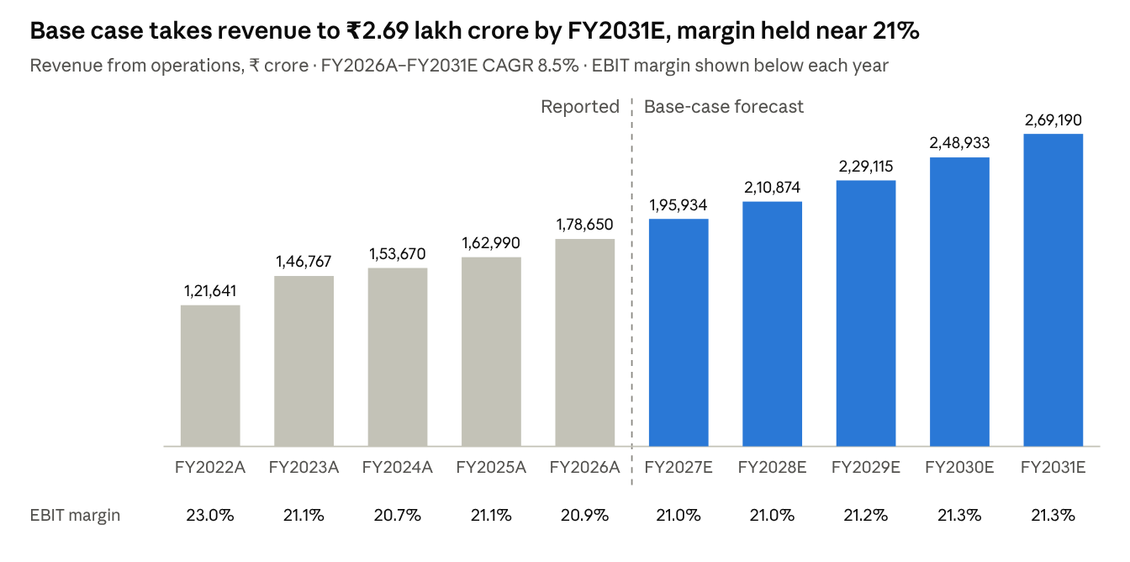
Infosys financial model (IS tab) · FY2022A–FY2026A reported, FY2027E–FY2031E base case
₹ crore unless stated | FY2027E | FY2028E | FY2029E | FY2030E | FY2031E
Net profit to owners | 31,602 | 33,958 | 37,455 | 41,094 | 44,678
Diluted EPS (₹) | 77.98 | 83.79 | 92.42 | 101.40 | 110.24
EPS growth | 9.1% | 7.5% | 10.3% | 9.7% | 8.7%
Free cash flow (CFO − capex) | 32,923 | 35,773 | 39,170 | 42,958 | 46,844
FCF / profit for the year | 104% | 105% | 104% | 104% | 105%
Dividends paid (70% payout) | 22,121 | 23,771 | 26,218 | 28,766 | 31,274
Cash + investments (year-end) | 46,437 | 55,065 | 64,351 | 74,560 | 85,823
FY27E EPS growth of 9.1% is helped by FX translation and the lower share count after the FY26 buyback, and held back by lower other income (a 6.7% yield on cash vs 9.0% in FY26).

Cost of capital
WACC is 12.33%, almost entirely the 12.5% cost of equity, because Infosys has no borrowings and leases are only 1.9% of total capital.
Component | Value | Basis
Risk-free rate | 7.40% | India 10-year G-sec, ~7.4–7.5% in October 2026
Equity beta | 0.85 | Analyst assumption vs Nifty 50
Equity risk premium | 6.00% | Analyst assumption, India INR
Cost of equity (CAPM) | 12.50% | 7.4% + 0.85 × 6.0%
Pre-tax cost of debt | 5.00% | Implied interest on lease liabilities
After-tax cost of debt | 3.63% | At the 27.5% FY27E tax rate
Market capitalisation | ₹4,67,417 cr | ₹1,153.35 × 405.3 crore diluted shares
Lease liabilities | ₹9,176 cr | 31 March 2026 balance sheet
Equity / debt weight | 98.1% / 1.9% | Market values
WACC | 12.33%
The rate is INR-denominated and consistent with a 5.0% INR terminal growth rate, which implies about 1% real growth above the RBI's 4% inflation target. Note that the WACC moves by a few basis points between scenarios because the after-tax cost of debt uses the live tax rate.

DCF valuation
Discounting five years of unlevered FCF plus a perpetuity-growth terminal value gives an enterprise value of ₹4,29,197 crore and ₹1,182.59 per share at the 23 October 2026 valuation date.
UFCF = EBIT × (1 − tax) + D&A − capex − new lease additions − increase in net working capital. Two choices make it conservative: stock compensation is treated as a real cost (not added back), and new right-of-use lease additions are deducted like capex because leases are treated as debt.
Base case, ₹ crore | FY2027E | FY2028E | FY2029E | FY2030E | FY2031E
Revenue | 1,95,934 | 2,10,874 | 2,29,115 | 2,48,933 | 2,69,190
EBIT | 41,146 | 44,284 | 48,572 | 53,023 | 57,338
Less: tax on EBIT (27.5%) | (11,315) | (12,178) | (13,357) | (14,581) | (15,768)
NOPAT | 29,831 | 32,106 | 35,215 | 38,442 | 41,570
Add: D&A | 5,486 | 5,904 | 6,415 | 6,970 | 7,537
Less: capex | (3,135) | (3,374) | (3,666) | (3,983) | (4,307)
Less: new lease additions | (3,952) | (4,136) | (4,596) | (4,994) | (5,340)
Less: increase in NWC | (2,146) | (1,916) | (2,340) | (2,542) | (2,598)
Unlevered FCF | 26,085 | 28,584 | 31,029 | 33,893 | 36,862
UFCF margin | 13.3% | 13.6% | 13.5% | 13.6% | 13.7%
Discount period (mid-year) | 0.5 | 1.5 | 2.5 | 3.5 | 4.5
PV at 12.33% | 24,612 | 24,010 | 23,202 | 22,563 | 21,845
The terminal value is ₹5,28,095 crore at FY2031 (FY31 UFCF × 1.05 ÷ (12.33% − 5.0%)), worth ₹3,12,966 crore today. That is 72.9% of EV and an implied exit multiple of only 8.1× FY31E EBITDA.
EV-to-equity bridge | ₹ crore
PV of FY27E–FY31E UFCF | 1,16,232
PV of terminal value | 3,12,966
Enterprise value | 4,29,197
Add: cash and cash equivalents | 22,201
Add: current investments | 12,950
Add: non-current investments | 8,930
Less: restricted cash | (422)
Less: lease liabilities | (9,176)
Less: non-controlling interests | (445)
Less: acquisitions committed after 31-Mar-26 | (5,311)
Equity value at 31-Mar-2026 | 4,57,924
Per share (405.3 crore diluted shares) | ₹1,129.93
Roll-forward to 23-Oct-2026 at 12.5% cost of equity (×1.0687) | ₹1,207.59
Less: FY26 final dividend paid June 2026 | (₹25.00)
Implied value per share | ₹1,182.59
Current price (NSE, 22-Oct-2026) | ₹1,153.35
Upside | +2.5%
At the implied value the stock would trade on 15.2× FY27E EPS of ₹77.98 and 9.2× FY27E EBITDA; at today's price it trades on 14.8× FY27E EPS with a 7.0% FY27E FCF yield.

Scenario outcomes
The three cases span ₹952 to ₹1,335 per share, a −17% to +16% range around today's price, so the risk-reward is roughly balanced.
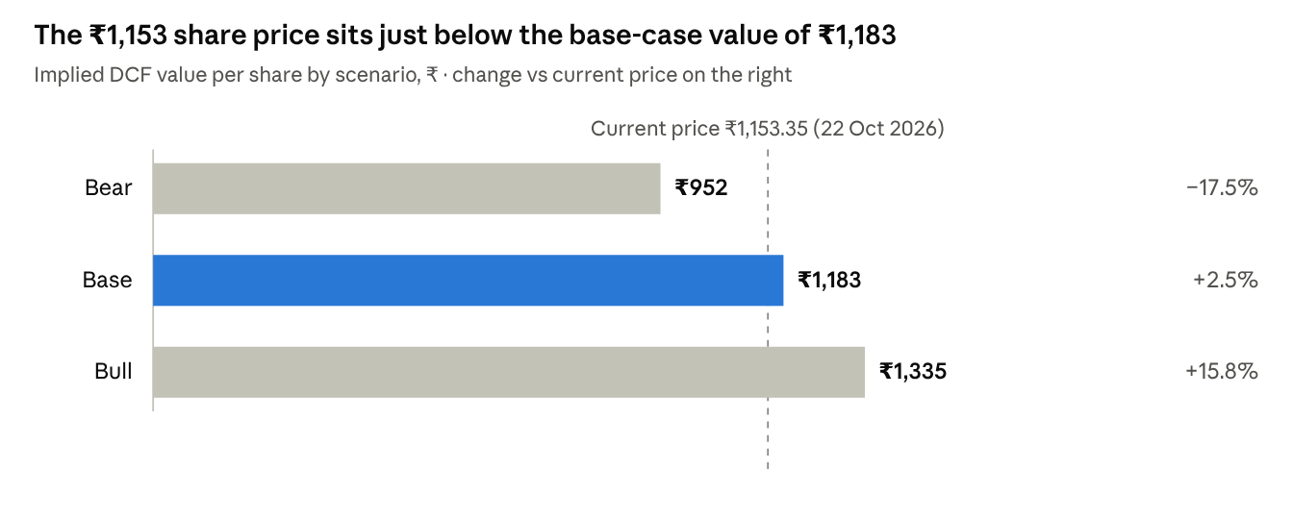
Infosys financial model (DCF tab), recalculated with Assumptions!D4 = 1, 2, 3 · price: Tickertape, NSE close 22 Oct 2026
Scenario output | Bear | Base | Bull
Enterprise value (₹ crore) | 3,41,704 | 4,29,197 | 4,87,133
FY2031E revenue (₹ crore) | 2,29,505 | 2,69,190 | 3,00,091
FY2027E diluted EPS (₹) | 72.14 | 77.98 | 81.92
FY2031E diluted EPS (₹) | 86.01 | 110.24 | 127.76
Implied P/E on FY2027E EPS | 13.2× | 15.2× | 16.3×
Terminal value % of EV | 71.5% | 72.9% | 73.7%
The Bear case is close to a no-recovery path: CC growth never exceeds 4%, margin drifts to 19.5% and DSO stretches to 76 days. The Bull case needs CC growth back at 7–8% — levels last seen in the FY22–FY23 upcycle — with margin at the top of the guided band.

Sensitivity analysis
The discount rate matters more than the operating case: ±1 pp on WACC moves value by roughly ₹130–180 per share, while ±1 pp on CC growth in every year moves it by only about ₹35. Values are implied ₹ per share; the base case is in bold.
1. WACC vs terminal growth
WACC \ g | 4.0% | 4.5% | 5.0% | 5.5% | 6.0%
11.33% | 1,215 | 1,282 | 1,359 | 1,450 | 1,557
11.83% | 1,141 | 1,199 | 1,264 | 1,340 | 1,429
12.33% | 1,077 | 1,126 | 1,183 | 1,247 | 1,322
12.83% | 1,019 | 1,062 | 1,111 | 1,167 | 1,230
13.33% | 968 | 1,006 | 1,049 | 1,097 | 1,151
2. CC revenue growth vs EBIT margin (shift applied to every forecast year)
Growth Δ \ Margin Δ | −2 pp | −1 pp | 0 | +1 pp | +2 pp
−2 pp | 1,004 | 1,059 | 1,115 | 1,170 | 1,225
−1 pp | 1,033 | 1,091 | 1,148 | 1,206 | 1,263
0 | 1,062 | 1,122 | 1,183 | 1,243 | 1,303
+1 pp | 1,093 | 1,155 | 1,218 | 1,281 | 1,343
+2 pp | 1,123 | 1,189 | 1,254 | 1,319 | 1,385
3. Beta vs risk-free rate
Beta \ Rf | 6.4% | 6.9% | 7.4% | 7.9% | 8.4%
0.65 | 1,630 | 1,498 | 1,388 | 1,293 | 1,212
0.75 | 1,475 | 1,368 | 1,276 | 1,197 | 1,128
0.85 | 1,348 | 1,259 | 1,183 | 1,115 | 1,056
0.95 | 1,243 | 1,168 | 1,103 | 1,045 | 994
1.05 | 1,155 | 1,091 | 1,034 | 984 | 939
- The current price of ₹1,153 sits inside the base row of every table: the market is pricing close to these assumptions.
- A 1 pp margin change is worth about ₹60 per share, close to twice the value of a 1 pp growth change, so margin defence is the bigger lever.
- If Indian bond yields eased back to ~6.9%, the same operating case would be worth about ₹1,259 (+9%); the cost-of-capital inputs carry as much weight as any business assumption.

Model integrity
All 15 checks pass in every scenario: with the workbook recalculated under Bear, Base and Bull, the master flag reads "✓ ALL CHECKS PASS" in each.
Check | Periods | Status
Balance sheet balances (assets − liabilities − equity = 0) | FY22A–FY31E | OK
Cash tie-out (CF closing cash = BS cash) | FY22A–FY31E | OK
Model PBT = reported PBT | FY22A–FY26A | OK
Model total assets = reported total assets | FY22A–FY26A | OK
Model total L&E = reported total L&E | FY22A–FY26A | OK
Rebuilt closing cash = reported closing cash | FY22A–FY26A | OK
Opening cash = prior-year closing cash (historical) | FY23A–FY26A | OK
CF profit = IS profit | FY27E–FY31E | OK
Equity roll-forward (opening + profit + SBC − dividends − buybacks = closing) | FY27E–FY31E | OK
Opening cash = prior-year closing cash (forecast) | FY27E–FY31E | OK
DCF revenue = IS revenue | FY27E–FY31E | OK
Terminal growth below WACC | – | OK
Sensitivity-table centres = implied value per share | – | OK
Forecast fixed assets and cash non-negative | FY27E–FY31E | OK
Scenario selector is 1, 2 or 3 | – | OK
Tolerance is ±₹0.5 crore. The historical reconciliations matter most: they confirm the grouped line items in the model add back exactly to the audited Ind AS statements.

Review notes
The model is sound and leans conservative; the items below are deliberate simplifications worth knowing before the output is quoted, with the refinement each would take.
# | Observation | Effect on value | Possible refinement
1 | The ₹5,311 crore for Optimum and Stratus is deducted in the bridge, but no revenue or EBIT from them is added explicitly | About −₹13 per share if the CC path excludes them | Add an inorganic revenue line, or state that CC growth includes the deals
2 | Terminal value implies only 8.1× FY31E EBITDA, well below where large Indian IT has typically traded | Conservative terminal | Cross-check with an exit-multiple terminal value
3 | WACC of 12.33% (beta 0.85, ERP 6.0%, Rf 7.4%) is at the higher end for a net-cash, large-cap IT company | Each −0.5 pp adds ~₹81 per share | Show a peer-beta range; Sensitivity 3 already covers it
4 | A 70% payout with no buybacks lets cash and investments climb from ₹44,081 crore to ₹85,823 crore by FY31, short of Infosys's policy of returning ~85% of FCF over five years | No effect on DCF; lifts forecast other income and EPS slightly | Tie distributions to the 85%-of-FCF policy
5 | UFCF margin of ~13.5% sits below the 17.5% FY26 FCF-to-revenue ratio | Conservative cash flows | Explained by stock comp treated as cost (0.55% of revenue) and lease additions deducted (~2% of revenue); keep, but disclose
6 | Other income is set at a 6.7% yield vs 9.0% realised in FY26 | Lower EPS, no DCF effect | None needed; matches management commentary
7 | Goodwill absorbs the full acquisition consideration; tax assets, other non-current items and investments are held flat | Balance-sheet presentation only | Acceptable at this level of detail
8 | Share price is from an unofficial aggregator (Tickertape, corroborated by Trendlyne) | Upside % and WACC weights | Refresh from NSE before publishing
9 | All three sensitivity grids use LET formulas | Grids show errors in older Excel or LibreOffice before 24.8 | Note the requirement: Excel 2021 or Microsoft 365
What the model does well: revenue split into CC growth and FX, leases treated consistently as debt (in WACC, UFCF and the bridge), stock compensation charged as a real cost, mid-year discounting, and a clean roll-forward from the balance-sheet date to the valuation date net of the June dividend.

Key risks to the valuation
- AI-led deflation. Automation could compress pricing and volumes in application services; this hits both growth and margin (Sensitivity 2).
- Weak discretionary spend. Softness in Financial Services, Manufacturing and Retail already pushed FY27 CC guidance down to 1.5–3.0%.
- Currency. Translation drives much of reported INR growth (Q1 FY27: 14.0% INR vs 2.4% CC); a rupee rebound would cut INR revenue even with steady demand.
- Cost pressure. Wage inflation, Labour Code costs and utilisation could push the margin out of the 20–22% band.
- Discount rate. G-sec yields are near multi-year highs; value is highly sensitive to WACC and terminal growth (Sensitivities 1 and 3).
- Terminal reliance and execution. Terminal value is 73% of EV; integration of recent acquisitions and client concentration add execution risk.

Sources
As cited in the model's Sources tab:
- Infosys Form 6-K Ex. 99.3 — results for the year ended 31 March 2026 (FY2025A–FY2026A statements; Optimum and Stratus acquisitions; FY26 final dividend)
- Infosys Form 6-K Ex. 99.3 — results for the year ended 31 March 2024 (FY2023A–FY2024A)
- Infosys Form 6-K Ex. 99.3 — results for the year ended 31 March 2023 (FY2022A comparative)
- Infosys IFRS-INR press release, 23 July 2026 (Q1 FY27 results and FY27 guidance)
- Infosys Q4 FY26 earnings call transcript (FY26 CC growth, yield on cash)
- Tickertape — Infosys share price (₹1,153.35 NSE close, 22 Oct 2026; unofficial)
- Trading Economics — India 10-year bond yield (risk-free rate; unofficial)
Beta, equity risk premium, terminal growth and all forecast drivers are analyst assumptions, not sourced data. This report is independent analysis for learning purposes and is not investment advice.

