Marico Limited — Financial Model & DCF Valuation Report

Executive summary
The base-case DCF values Marico at ₹320 per share, 59% below the ₹775 market price (NSE close, 22-Oct-2026). Even the bull case (₹458) sits 41% below the market. The gap is about the discount rate and long-run growth, not about the forecasts themselves.
Scenario | Value per share (₹) | Upside / (downside) | Enterprise value (₹ cr) | FY27E EBITDA margin | Terminal growth
Bear | 180 | (77%) | 23,792 | 15.1% | 5.0%
Base | 320 | (59%) | 41,947 | 18.1% | 6.0%
Bull | 458 | (41%) | 59,884 | 19.9% | 6.5%
- Operating story: revenue grows from ₹13,611 cr (FY26A) to ₹22,505 cr (FY31E), a 10.6% CAGR. EBITDA margin recovers from 17.1% to 19.6% as copra costs ease, and EPS compounds at 12.5% to ₹24.5.
- Valuation: WACC is 11.47% (CAPM, near-zero debt). Terminal value makes up 80.7% of enterprise value. The implied EV/EBITDA is 15.2x FY27E, against 36.7x implied by the market price.
- What the price implies: to justify ₹775 at the model's cash flows, WACC would need to fall to about 8.3% (at 6% terminal growth), or terminal growth would need to rise to about 9.4% (at 11.47% WACC).
- Model quality: the three statements are fully linked, and all 17 integrity checks pass. The one warning flag is the high terminal-value share.

Model architecture
The workbook is a seven-sheet, integrated three-statement model with a DCF. One input, the scenario selector in Assumptions!C3, drives every output. Figures are in ₹ crore on a consolidated basis, and the fiscal year ends 31 March. It covers five years of actuals (FY22A–FY26A, with FY22 partial) and five years of forecasts (FY27E–FY31E).
Sheet | Role | What it contains
Cover | Summary | Valuation outputs, workbook map, colour conventions, sources, limitations
Assumptions | Inputs | Scenario selector; Bear, Base and Bull drivers for 21 line items; historical ratios beside them; base-case rationale
Historicals | Reported data | Consolidated P&L, balance sheet, cash flow and segment revenue for FY23–FY26, each row source-noted
Model | Engine | Two-segment revenue build, integrated income statement, condensed balance sheet, indirect cash flow, ratios
WACC | Discount rate | CAPM cost of equity, after-tax cost of debt, market-value weights
DCF | Valuation | Unlevered FCF, mid-year discounting with an FY27 stub, Gordon-growth terminal value, EV-to-equity bridge, two 5×5 sensitivity grids
Checks | Control | 17 zero-difference checks, two warning flags, a master status cell
How the model flows: Historicals feed Model's actual columns. The selected case in Assumptions (via CHOOSE) drives Model's forecast columns. Model's EBIT, D&A, capex and working capital feed the DCF, and WACC supplies the discount rate and diluted share count.
Design choices that keep it auditable:
- No circularity. Other income is earned on opening cash and treasury balances, and finance cost is charged on opening debt and leases.
- Treasury income is kept out of EBIT and UFCF. Cash and investments are added in the equity bridge instead, so they are not counted twice.
- Revenue is built bottom-up. India revenue is volume × price/mix, and International revenue is constant-currency growth × FX translation.
- Colours follow banking convention. Blue is a hardcoded input, black is a formula and green is a cross-sheet link.

Historical performance, FY22–FY26
In FY26, revenue grew 25.7% to ₹13,611 cr, mostly through pricing: India grew 27.6% on just 8% volume. Copra inflation cut gross margin by 5.8 percentage points, so EBITDA grew only 8.8%.
₹ crore | FY22A | FY23A | FY24A | FY25A | FY26A
Revenue from operations | 9,512 | 9,764 | 9,653 | 10,831 | 13,611
Revenue growth | — | 2.6% | (1.1%) | 12.2% | 25.7%
Gross margin | — | 45.2% | 50.8% | 50.3% | 44.5%
EBITDA | 1,681 | 1,810 | 2,026 | 2,139 | 2,328
EBITDA margin | 17.7% | 18.5% | 21.0% | 19.7% | 17.1%
PAT to owners | — | 1,302 | 1,481 | 1,629 | 1,762
Diluted EPS (₹) | — | 10.05 | 11.43 | 12.56 | 13.59
Cash from operations | — | 1,419 | 1,436 | 1,442 | 2,085
Free cash flow (CFO – capex) | — | 1,237 | 1,283 | 1,281 | 1,766
Return on avg. owners' equity | — | — | 38.8% | 41.7% | 43.1%
FY22 shows only revenue and EBITDA. The model did not estimate the missing FY22 lines because no official source for them could be found.
What the history says:
- Input costs drive margins. Material cost swung from 54.8% of revenue (FY23) to 49.2% (FY24) and back to 55.5% (FY26) as copra and vegetable-oil prices moved. EBITDA margin followed, peaking at 21.0% in FY24.
- Advertising and promotion (A&P) spend has stepped up. It rose from 8.6% of revenue in FY23 to 10.4% in FY25. That supports the premium personal-care and Foods portfolio.
- International is the steadier engine. It grew 19.9% in FY26 (20% constant currency), reaching ₹3,263 cr, or 24% of revenue.
- Cash conversion is high. Free cash flow was about 100% of owners' PAT in FY26 (₹1,766 cr vs ₹1,762 cr). Part of that came from a ₹253 cr working-capital release, helped by ₹405 cr of supplier-finance acceptances.
- The balance sheet is net cash, but there is a growing put liability. Net cash, excluding the NCI obligation, was ₹2,019 cr at FY26. Separately, the obligation to buy out minority holders in acquired brands rose from ₹266 cr (FY23) to ₹2,055 cr (FY26); ₹1,108 cr of it is current.

Forecast assumptions and scenarios
The base case assumes India volumes of 8% and modest 3% pricing in FY27E, International growth of 15% in constant currency, and a 2-percentage-point gross-margin recovery as copra deflates. The three cases differ mainly in volume, margin and terminal growth.
Driver | FY26A | Bear FY27E | Base FY27E | Bull FY27E | Base FY31E
India underlying volume growth | 8.0% | 5.0% | 8.0% | 10.0% | 6.0%
India price / mix | 18.1% | 1.0% | 3.0% | 4.0% | 3.5%
International constant-currency growth | 20.0% | 10.0% | 15.0% | 18.0% | 10.0%
International FX translation | (0.1%) | (3.0%) | (1.0%) | 0.0% | (1.0%)
Material cost, % revenue | 55.5% | 55.5% | 53.5% | 52.5% | 52.0%
A&P, % revenue | 9.6% | 10.8% | 10.3% | 10.0% | 10.3%
Employee cost, % revenue | 6.7% | 7.0% | 6.8% | 6.6% | 6.8%
Other expenses, % revenue | 11.1% | 11.6% | 11.3% | 11.0% | 11.3%
Capex (incl. ROU), % revenue | 2.3% | 2.5% | 2.2% | 2.0% | 2.2%
Receivable / inventory / payable days | 35 / 78 / 79 | 40 / 85 / 75 | 37 / 80 / 80 | 35 / 75 / 85 | 37 / 80 / 80
Effective tax rate | 20.4% | 24.0% | 23.0% | 22.5% | 23.0%
Terminal growth | — | 5.0% | 6.0% | 6.5% | —
Receivable days are measured on revenue; inventory and payable days are measured on material cost. D&A is held at 1.55% of revenue, dividend payout at 80% of owners' PAT and net borrowing at zero in all three cases.
Base-case rationale (as set out in the model):
- India volume of 8%. Management has guided to high-single-digit volume growth for FY27, and Q1 FY27 (Apr–Jun 2026) reportedly delivered 11%.
- India pricing of only 3%, down from 18%. Copra has corrected from its peak, and Parachute has taken selective price cuts. Premiumisation in Foods and premium personal care partly offsets this.
- International growth of 15% in constant currency, tapering to 10% by FY31. This follows mid-teens guidance. The model applies a 1% annual FX drag for the Bangladeshi taka, Vietnamese dong, Egyptian pound and South African rand.
- Material cost of 53.5% of revenue. It sits between FY26's 55.5% and the 49–50% of FY24–FY25, because vegetable-oil and crude-linked packaging costs offset copra deflation.
- A&P of 10.3%. Brand investment has stepped up; Q1 FY27 A&P was reportedly up 25% year on year.
- Terminal growth of 6.0% nominal. This is below both India's nominal GDP growth and the 7.47% 10-year G-sec yield.
The Q1 FY27 figures come from press reports of company commentary. The model flags them to be checked against Marico's own Q1 FY27 information update.

Forecast outputs, FY27E–FY31E
In the base case, EPS grows from ₹13.59 to ₹24.50 (12.5% CAGR), ahead of revenue (10.6% CAGR), because EBITDA margin recovers 2.5 percentage points. By FY31E, EPS reaches ₹16.54 in the bear case and ₹31.48 in the bull case.
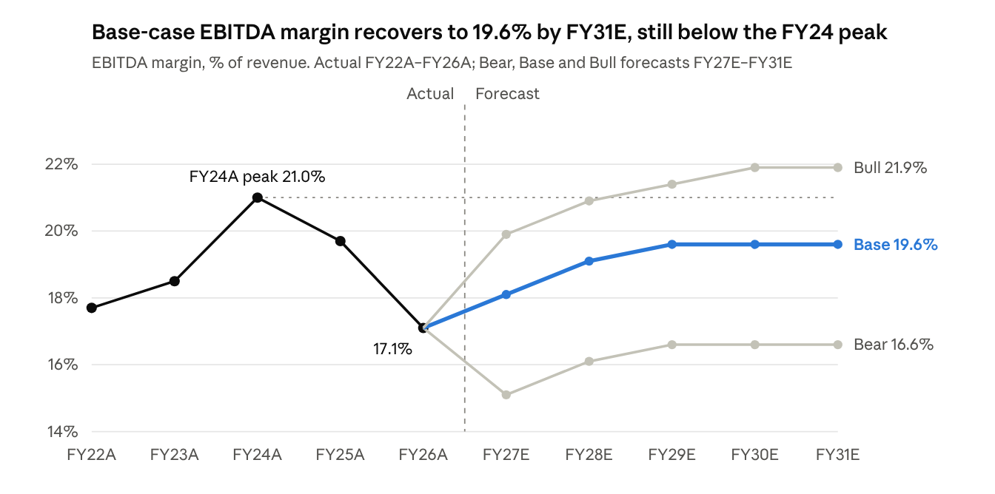
Marico model, Model sheet row 24 (EBITDA margin), recalculated for each scenario
Base case, ₹ crore
₹ crore | FY26A | FY27E | FY28E | FY29E | FY30E | FY31E
India revenue | 10,348 | 11,511 | 12,686 | 14,050 | 15,486 | 16,990
International revenue | 3,263 | 3,715 | 4,156 | 4,608 | 5,064 | 5,514
Revenue from operations | 13,611 | 15,226 | 16,842 | 18,658 | 20,550 | 22,505
Revenue growth | 25.7% | 11.9% | 10.6% | 10.8% | 10.1% | 9.5%
EBITDA | 2,328 | 2,756 | 3,217 | 3,657 | 4,028 | 4,411
PAT to owners | 1,762 | 1,990 | 2,315 | 2,636 | 2,906 | 3,187
Diluted EPS (₹) | 13.59 | 15.29 | 17.79 | 20.26 | 22.34 | 24.50
Unlevered FCF | — | 1,504 | 2,040 | 2,330 | 2,574 | 2,828
Return on avg. owners' equity | 43.1% | 45.1% | 47.8% | 49.4% | 49.4% | 49.0%
Net cash (excl. NCI obligation) | 2,019 | 1,981 | 2,208 | 2,471 | 2,771 | 3,108
- FY27E free cash flow dips. Unlevered FCF is only ₹1,504 cr because working capital absorbs ₹337 cr. Receivable days normalise from 35 to 37, and other current liabilities fall from 6.8% to 6.0% of revenue as the FY26 supplier-finance benefit unwinds.
- ROE rises towards 49%. With an 80% payout, equity grows slowly while profit compounds.
- Net cash keeps building. It grows by about ₹300 cr a year from FY28E, even after dividends of ₹1,850–2,550 cr a year.

WACC and DCF valuation
At an 11.47% WACC and 6.0% terminal growth, the enterprise value is ₹41,947 cr. After the bridge items, equity value is ₹41,627 cr, or ₹320 per diluted share.
WACC component | Value | Basis
Risk-free rate | 7.47% | India 10-year G-sec, 23-Oct-2026 (Trading Economics; unofficial)
Raw beta → adjusted beta | 0.51 → 0.67 | Blume adjustment: 0.67 × raw + 0.33
Equity risk premium | 6.0% | Analyst assumption; India range 5.5–7.5%
Cost of equity | 11.50% | CAPM
Pre-tax / after-tax cost of debt | 8.0% / 5.99% | AAA issuer about 50 bp over G-sec; 25.17% marginal tax
Equity / debt weight | 99.45% / 0.55% | Market cap ₹100,825 cr; debt and leases ₹557 cr
WACC | 11.47%
DCF mechanics:
- Free cash flow. Unlevered FCF is NOPAT plus D&A, less capex (including right-of-use additions) and the increase in working capital. NOPAT is EBIT taxed at the 23% effective rate.
- Discounting. Cash flows are discounted at mid-year from the 23-Oct-2026 valuation date. FY27E counts only the 43.6% stub of the year left from that date to 31-Mar-2027.
- Terminal value. The Gordon-growth terminal value is ₹54,810 cr at end-FY31E, which is 12.4x FY31E EBITDA. Its present value is ₹33,860 cr.
- Equity bridge. It uses audited 31-Mar-2026 balances. It deducts the ₹2,055 cr obligation to buy minority stakes as debt-like, and book NCI of ₹284 cr.
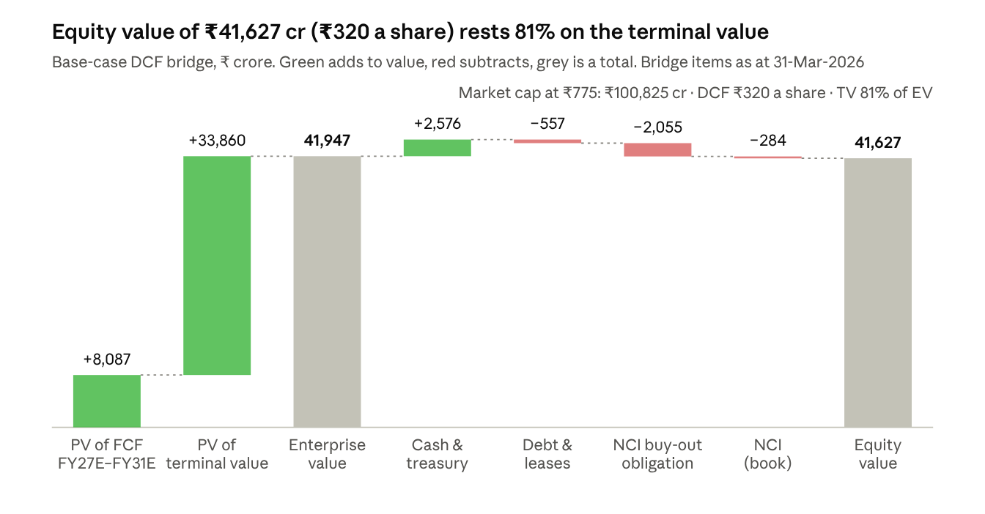
Marico model, DCF sheet rows 42–56, base case
The implied multiples are 15.2x FY27E EV/EBITDA and 20.9x FY27E P/E. At ₹775, the market is paying 36.7x FY27E EV/EBITDA, about 2.4 times the model's value.

Sensitivities and reverse DCF
Across the model's own grids, value per share ranges from ₹240 to ₹492. No combination within ±1 percentage point of WACC and terminal growth comes within 35% of the ₹775 market price.
Value per share (₹): WACC (rows) vs terminal growth (columns)
WACC \ g | 5.0% | 5.5% | 6.0% | 6.5% | 7.0%
10.47% | 329 | 358 | 392 | 436 | 492
10.97% | 301 | 325 | 353 | 387 | 430
11.47% | 278 | 297 | 320 | 348 | 381
11.97% | 257 | 274 | 293 | 315 | 343
12.47% | 240 | 254 | 270 | 289 | 311
Value per share (₹): WACC (rows) vs change in EBITDA margin, all forecast years (columns)
WACC \ Δ margin | −2.0 pp | −1.0 pp | 0 | +1.0 pp | +2.0 pp
10.47% | 344 | 368 | 392 | 417 | 441
10.97% | 309 | 331 | 353 | 374 | 396
11.47% | 280 | 300 | 320 | 340 | 360
11.97% | 256 | 275 | 293 | 311 | 329
12.47% | 236 | 253 | 270 | 287 | 304
Reverse DCF (base-case cash flows, recomputed for this report):
To reach ₹775 per share | Required value | Model value
WACC, holding terminal growth at 6.0% | 8.3% | 11.47%
Terminal growth, holding WACC at 11.47% | 9.4% | 6.0%
Free cash flow in every year, at model WACC and growth | 2.4x the base case | 1.0x
What this means:
- The DCF is most sensitive to the discount rate. A 1-percentage-point move in WACC changes value by ₹50–70 per share. A 1-point move in EBITDA margin changes it by only about ₹20.
- The risk-free rate matters a lot. It is the single largest input to WACC. At a 6.5% G-sec yield, WACC falls to 10.5% and value rises to about ₹389. Trading Economics put the 10-year yield at about 7.18% on 28-Sep-2026, so the 7.47% input should be checked against RBI/CCIL data.
- The market is pricing Marico as a long-duration compounder. The price fits only with a cost of capital near 8%, or with growth persisting well beyond FY31. Both are common for Indian staples leaders, but the model does not assume either. The fair reading is that Marico looks expensive on CAPM-based fundamentals, not that the forecasts are too low.

Model integrity and review observations
The model passes all 17 integrity checks in every scenario. I recalculated the Bear, Base and Bull cases independently in LibreOffice, and the base case reproduces the stored ₹319.97 exactly. Observations 1–5 below each move value by less than ₹15 per share. Only the market inputs (observation 6) move it materially, and even a full 1-point drop in WACC leaves value near ₹390.
What the Checks sheet tests:
- Historicals (5 checks). The balance sheet balances, and computed totals match reported totals. Cash-flow cash ties to the balance sheet, P&L PBT ties to cash-flow PBT, and segment revenue sums to total revenue.
- Model (7 checks). The balance sheet balances and cash ties in all 9 years. Cash-flow net income equals P&L net income, owners' equity rolls forward correctly, historical PBT and EBITDA tie to reported figures, and forecast revenue equals the segment build.
- DCF (5 checks). Both sensitivity centre cells equal the headline value. Terminal growth sits below both WACC and the risk-free rate. Share counts agree across sheets.
- Warning flags. Terminal value is 80.7% of EV, above the 75% threshold, so the sheet flags it for review. Forecast net cash stays positive in every year.
Review observations:
# | Observation | Direction | Approx. impact
1 | NOPAT is taxed at the 23% effective rate, not the 25.17% marginal rate used for the cost of debt | Value overstated | About −₹10 / share at the marginal rate
2 | The FY27E stub drops Apr–Oct 2026 cash flow, but the bridge still uses 31-Mar-2026 balances. Dividends paid in that window are also not deducted, which partly offsets this | Value understated (net) | Up to +₹7 / share before the dividend offset
3 | The bridge deducts both the ₹2,055 cr NCI buy-out obligation and ₹284 cr of book NCI. Some of that book NCI may relate to the same put-covered stakes. Meanwhile, Marico Bangladesh's listed minority is carried at book, not market value | Two-way | About ±₹2 / share from the overlap
4 | The 80% dividend payout is well above the FY23–FY26 average of about 52% | Cash and other income only | No DCF effect
5 | No future M&A or NCI buy-out cash flows are modelled, although Marico has been acquiring digital-first brands | Depends on deal returns | Not quantified
6 | Share price, beta and the G-sec yield come from unofficial aggregators | Two-way | ₹50–70 / share per 1 pp of WACC
One check holds up well: the 6% terminal growth is consistent with FY31E reinvestment. FY31E reinvestment (capex less D&A, plus working-capital build) is ₹299 cr, or 9.6% of NOPAT. That implies a return on new capital of about 63%, which fits an asset-light FMCG business earning 45–50% ROE.

Limitations, next steps and sources
The model is a sound base for an independent valuation. Before it is published, it needs three things: verified market inputs, a relative-valuation cross-check and a Q2 FY27 refresh.
Limitations (as disclosed in the model):
- FY22 is partial. It shows revenue and EBITDA only; no missing figures were estimated.
- The forecast balance sheet is condensed. Treasury investments, goodwill, leases, the NCI put obligation and other non-current items are held flat, and surplus cash builds up as cash.
- Leases are simplified. Right-of-use additions are treated as capex, so lease cash costs fall inside UFCF.
- Q2 FY27 (Jul–Sep 2026) is not yet reflected. The board meeting is on 2-Nov-2026.
Suggested next steps:
- Replace the share price, beta and G-sec yield with NSE, Bloomberg and RBI/CCIL figures, and re-run WACC.
- Add a comparables sheet (Hindustan Unilever, Dabur, Godrej Consumer, Emami, Colgate-Palmolive India) with EV/EBITDA and P/E. Use it to cross-check the DCF against how the sector is priced.
- Add an exit-multiple terminal value beside the Gordon-growth method to test the 80.7% terminal-value weight.
- Update FY27E drivers after Q2 FY27 results, especially India volume, copra-led gross margin and A&P intensity.
- Tax NOPAT at the marginal rate, and roll the bridge to 30-Sep-2026 balances once the half-year balance sheet is out.
Sources
The sources below are those cited in the workbook. Only the Trading Economics page was opened while preparing this report.
- Marico Integrated Annual Report FY2025-26: FY25–FY26 statements, Notes 12(a), 13(b) and 36, and FY22 highlights
- Marico Board Meeting Update, 6-May-2024: audited FY23–FY24 consolidated results
- Marico Q4 FY26 media release: FY26 India volume growth and International constant-currency growth
- Trading Economics, India 10-year yield, 28-Sep-2026: yield at about 7.18%, a near-two-year high
This report is an independent academic exercise. It is not investment advice.

