EQUITY RESEARCH | EARNINGS UPDATE

Shopify Inc
Q2 2026: Thirty-plus growth with leverage; the price has caught up
Results reported 5 August 2026 | US$ unless stated

Q2 2026: a clean beat on every line, and the stock has re-rated to match. Revenue of $3,583 mn (+34% YoY) was about 4% above consensus, adjusted EPS of $0.42 beat by 5-14% depending on the consensus source, and GMV rose 32% to $115.6 bn. Operating income grew 68% to $488 mn (13.6% margin) and the free cash flow margin was 18%. Every metric beat the company's own May guidance. The shares rose roughly 18-25% on the day and are now about 39% above the pre-results close.  - Growth is broad. International GMV +37%, B2B +76%, offline +32%, Shop Pay +53%. Payments penetration reached 68% of GMV.  - Operating leverage. Opex fell to 34% of revenue from 38%, more than offsetting a gross margin that slipped to 47.7% as payments grew faster than subscriptions.  - Q3 guide is strong. Low-thirties revenue growth, opex at 33-34% of revenue and an FCF margin in the high teens to low twenties. Consensus Q3 revenue is $3.74 bn.  - Estimates. FY26E revenue $15.2 bn (+32%), FCF $2.8 bn; FY27E revenue $19.0 bn, FCF $3.8 bn.  - Illustrative HOLD, scenario value $163. At 57x FY27E free cash flow, the price already reflects most of our base case; the range runs from $106 to $213. | Key data  Rating and value are an illustrative academic view, not investment advice. Estimates are ours.
  Illustrative rating | HOLD
  Scenario value | $163
  Price (22 Oct 2026) | $170.8
  Implied return | -5%
  Market cap | ~$220 bn
  52-week range | $94 - 182
  Ticker | SHOP (Nasdaq, TSX)
  EV / FY27E FCF | 57x
  FY26E revenue | $15.2 bn
  FY26E FCF | $2.8 bn
  Next results | 3 Nov 2026
Table 1: Q2 2026 results summary (US$ mn unless stated)
Metric | Q2 2026 | Q2 2025 | YoY | Consensus | vs cons. | May guide
GMV ($ bn) | 115.6 | 87.8 | +32%
Revenue | 3,583 | 2,680 | +34% | ~3,440-3,460 | +4% | high-20s %
Subscription solutions | 802 | 656 | +22%
Merchant solutions | 2,781 | 2,024 | +37%
Gross profit | 1,708 | 1,302 | +31% |  |  | mid-20s %
Gross margin | 47.7% | 48.6% | -90bp
Opex % of revenue | 34.0% | 37.7% | -370bp |  |  | 35-36%
Operating income | 488 | 291 | +68%
Free cash flow margin | 18% | 16% | +2pp |  |  | mid-teens
Adjusted EPS ($) | 0.42 | n.a. |  | 0.37-0.40 | +5-14%
GAAP diluted EPS ($) | 1.16 | n.a.
Source: Shopify Q2 2026 press release, Form 8-K exhibit 99.1 (5 Aug 2026); Shopify Q1 2026 press release, Form 8-K (5 May 2026); Benzinga, SHOP earnings history and Q3 estimates (accessed 22 Oct 2026); StockStory, Q2 2026 vs expectations (5 Aug 2026); Investing.com, Q2 2026 earnings call transcript (5 Aug 2026). Consensus differs by provider: revenue $3.44 bn (Benzinga), $3.45 bn (Investing.com), $3.46 bn (StockStory); adjusted EPS $0.37 (Benzinga) and $0.40 (Investing.com). GAAP EPS includes $1.25 bn of gains on equity investments

1. The quarter: beats against the street and against guidance
Shopify reported Q2 2026 on 5 August 2026. This note comes about eleven weeks later and a little under two weeks before Q3 results on 3 November, so it also looks at what the Q2 print implies for Q3. Revenue grew 34% (33% in constant currency) to $3,583 mn, against consensus of roughly $3.44-3.46 bn. In May, management had guided to high-twenties revenue growth, mid-twenties gross profit growth, opex at 35-36% of revenue and a mid-teens FCF margin. The quarter beat all four.
The shares had closed at $123.30 before results and traded about 18% higher pre-market and up to about 25% during the session. They have kept climbing and were $170.82 on 22 October, close to the 52-week high of $182.19.

Figure 1: GMV of $115.6 bn, up 32%
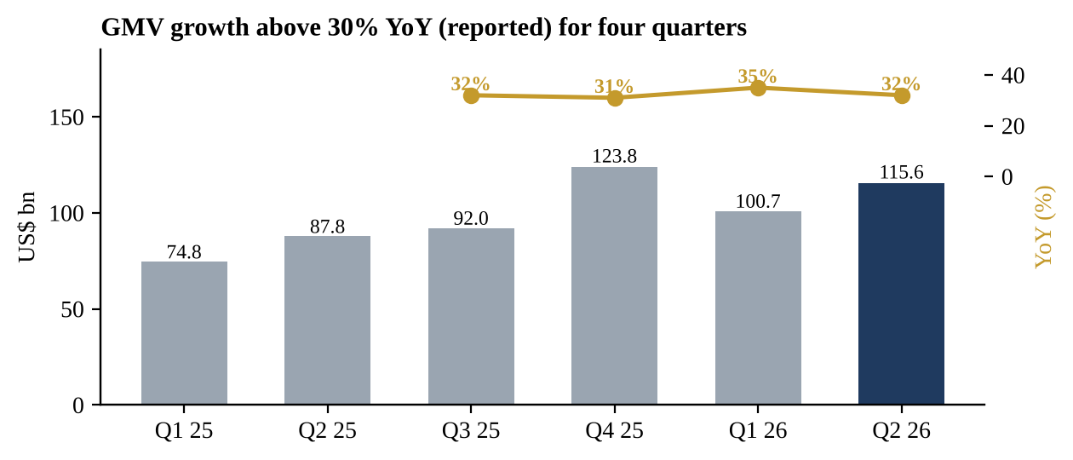

Source: Shopify Q2 2026 press release, Form 8-K exhibit 99.1 (5 Aug 2026); Shopify Q1 2026 press release, Form 8-K (5 May 2026); Shopify Q4 2025 press release, Form 8-K (11 Feb 2026); BetaKit, Q3 2025 results (4 Nov 2025). Q3 2025 derived from full-year 2025 less the other three quarters; YoY shown where the prior-year quarter is in the series or reported

Figure 2: Revenue growth has accelerated to 34%
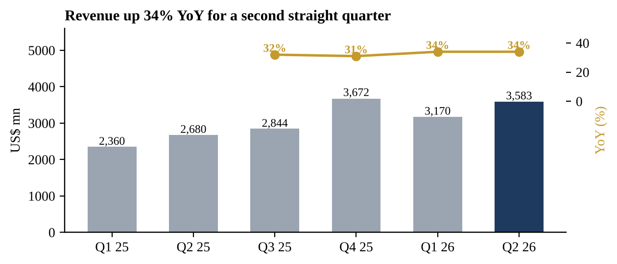

Source: Shopify Q2 2026 press release, Form 8-K exhibit 99.1 (5 Aug 2026); Shopify Q1 2026 press release, Form 8-K (5 May 2026); Shopify Q4 2025 press release, Form 8-K (11 Feb 2026); BetaKit, Q3 2025 results (4 Nov 2025)
Figure 3: Q2 beat every line of May's guidance
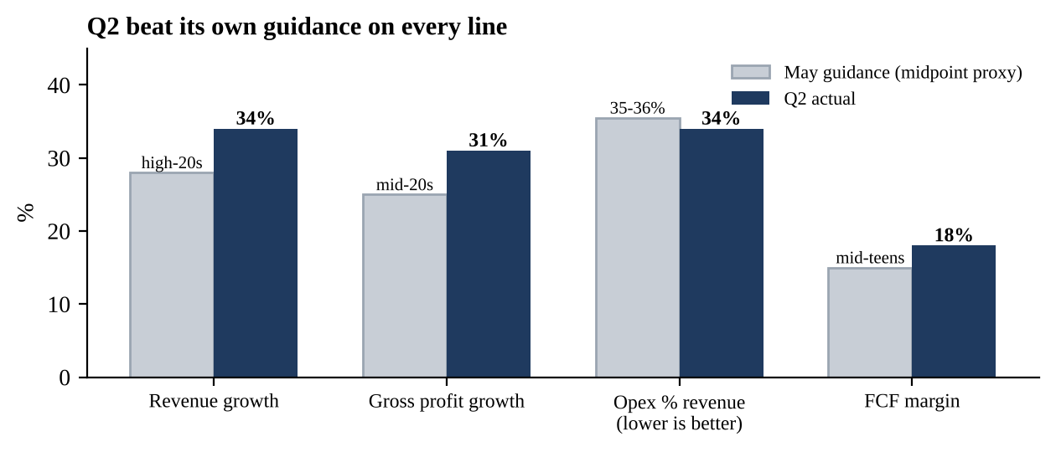

Source: Shopify Q2 2026 press release, Form 8-K exhibit 99.1 (5 Aug 2026); Shopify Q1 2026 press release, Form 8-K (5 May 2026). Guidance ranges shown at an approximate midpoint for illustration

Figure 4: Revenue and EPS beats in each of the last four quarters
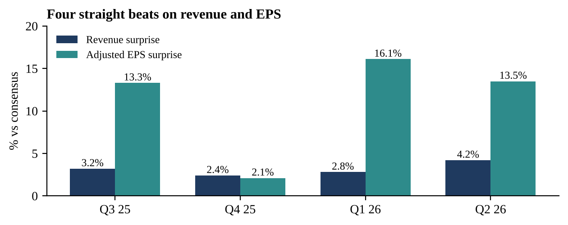

Source: Benzinga, SHOP earnings history and Q3 estimates (accessed 22 Oct 2026). Benzinga consensus; adjusted EPS

2. What drove it

Growth: broad-based, with payments in front
Merchant solutions revenue, which is mostly payments, grew 37% to $2,781 mn and is now 78% of revenue. Shopify Payments processed 68% of GMV, up 3 points, and merchant solutions revenue rose to 2.41% of GMV from 2.30%. Subscription solutions grew 22% to $802 mn, with monthly recurring revenue up about 19% to $221 mn.
By channel and region, B2B GMV grew 76%, the Shop app over 70%, Shop Pay 53%, offline point-of-sale 32% and international 37%, against 28% in North America. Europe grew 34% in constant currency. Enterprise wins cited on the call included Balmain, Guess, Avon, e.l.f. Cosmetics, Claire's, Burton and Suitsupply.
Figure 5: B2B, the Shop app and Shop Pay grew fastest
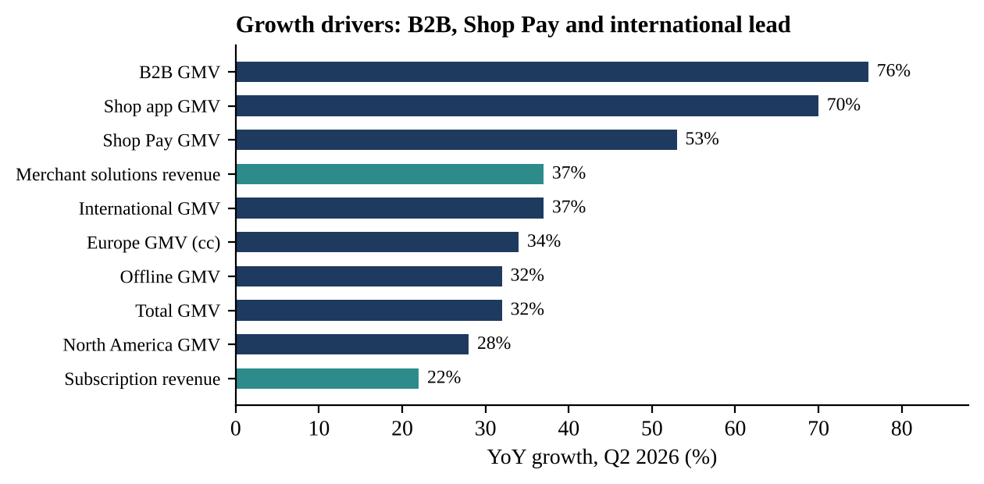

Source: Investing.com, Q2 2026 earnings call transcript (5 Aug 2026); Platform Aeronaut, Q2 2026 call summary; Shopify Q2 2026 press release, Form 8-K exhibit 99.1 (5 Aug 2026)

AI: early, but growing fast
Management said AI-driven traffic and orders to Shopify stores both tripled year on year, though they are still small relative to GMV. AI searches using Shopify's product Catalog converted at twice the rate of those using scraped data, and about 75% of AI-attributed orders came from outside the top 100 product categories. Usage of Sidekick, the merchant AI assistant, roughly tripled. Importantly for the model, management said agentic transactions carry the same economics as a normal online store sale: there is no new fee, but also no loss of take rate.

Margins: lower gross margin, much lower opex
Gross margin fell to 47.7% from 48.6%, because merchant solutions (38.4% gross margin) grew faster than subscriptions (79.7%), and AI-related cloud costs rose. This is the trade-off investors accept: payments dilute the margin percentage but add gross profit dollars. Operating expenses grew only 21% and fell to 34.0% of revenue from 37.7%, so operating income rose 68% to $488 mn. Free cash flow was $654 mn (18% margin); management said that, excluding an accounting change that moved $37 mn of merchant cash advance flows to investing activities, the margin was about 150 bp better than a year earlier.

Figure 6: Operating margin up 2.7pp YoY to 13.6%
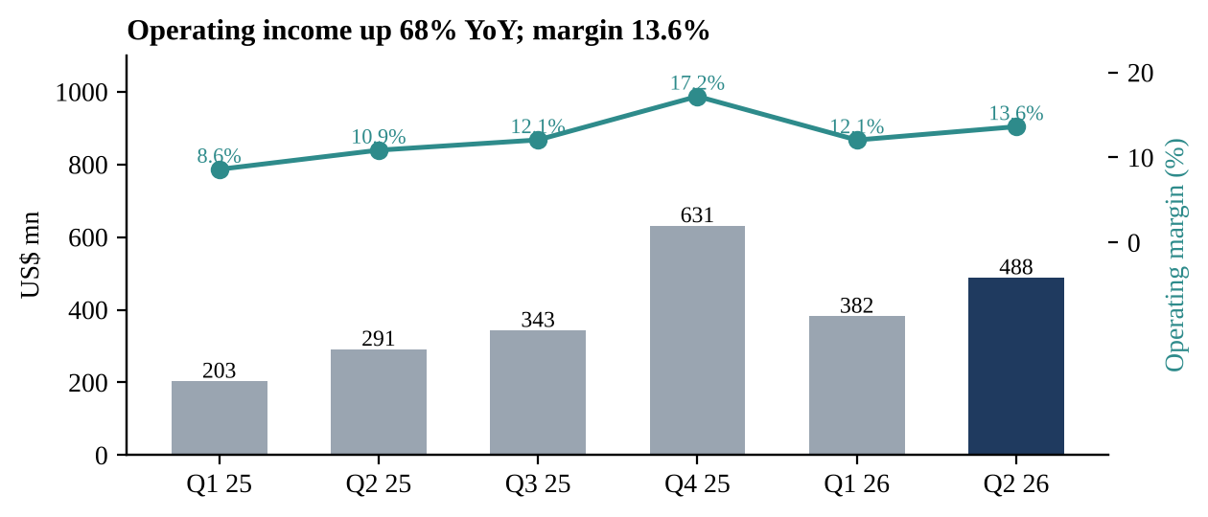

Source: Shopify Q2 2026 press release, Form 8-K exhibit 99.1 (5 Aug 2026); Shopify Q1 2026 press release, Form 8-K (5 May 2026); Shopify Q4 2025 press release, Form 8-K (11 Feb 2026); BetaKit, Q3 2025 results (4 Nov 2025). Q3 2025 operating income derived from full-year 2025 less the other three quarters
Figure 7: FCF margin back to 18%
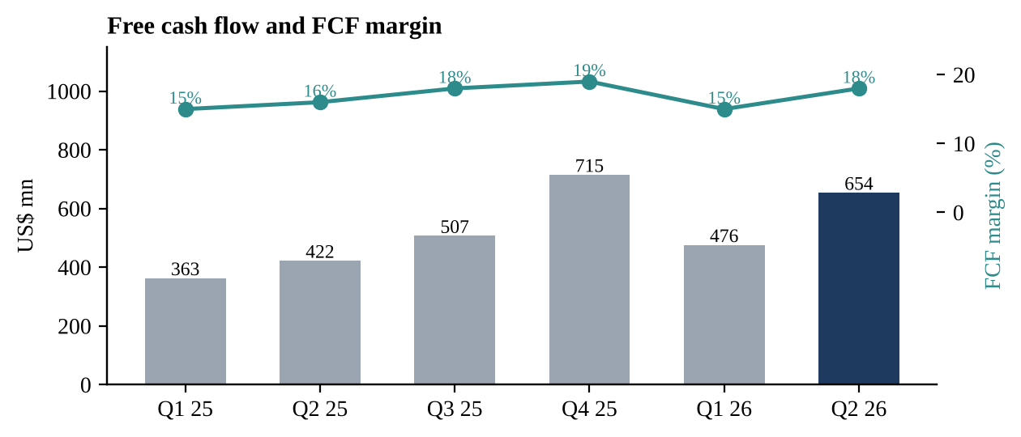

Source: Shopify Q2 2026 press release, Form 8-K exhibit 99.1 (5 Aug 2026); Shopify Q1 2026 press release, Form 8-K (5 May 2026); Shopify Q4 2025 press release, Form 8-K (11 Feb 2026); BetaKit, Q3 2025 results (4 Nov 2025)

Figure 8: Gross margin edging down as payments mix rises
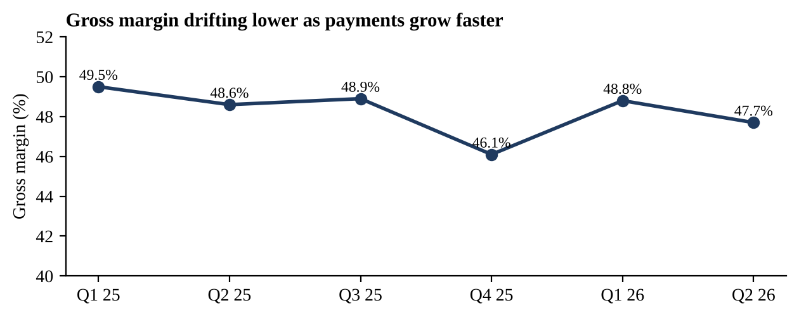

Source: Shopify Q2 2026 press release, Form 8-K exhibit 99.1 (5 Aug 2026); Shopify Q1 2026 press release, Form 8-K (5 May 2026); Shopify Q4 2025 press release, Form 8-K (11 Feb 2026). Gross profit / revenue; Q3 2025 derived

Capital return
Shopify bought back $1,420 mn of shares in Q2 and enlarged its programme to $5 bn, with $3,067 mn remaining. Cash and marketable securities were $4.95 bn at the end of June, down from $5.78 bn at the end of 2025 after the buybacks. GAAP net income of $1,502 mn was flattered by $1.25 bn of gains on equity investments; excluding those, net income was $439 mn (+30%).

3. Q3 outlook and what to watch on 3 November
For Q3, management guided to revenue growth at a low-thirties rate, gross profit growth in the mid-to-high twenties, opex of 33-34% of revenue (37% a year ago), stock-based compensation of $150 mn and a free cash flow margin in the high teens to low twenties, including less than a point from the accounting change. On the Q3 2025 base of $2,844 mn, low-thirties growth implies roughly $3.70-3.79 bn of revenue; Benzinga consensus is $3.74 bn and adjusted EPS $0.44. Our estimate is $3.75 bn.
- GMV and revenue growth: whether both stay above 30% for another quarter. Shopify beat its own revenue guidance in Q2 and beat consensus revenue in each of the last four quarters.
- Gross profit growth vs revenue growth: the guide implies a widening gap; a narrower gap would be a positive surprise.
- FCF margin: management declined to call ~20% a new normal. A print near the top of the range would support a higher multiple.
- Q4 guidance and holiday commentary: the stock now prices sustained 30% growth, so the tone for Q4 matters.

4. Thesis update
The fundamental story strengthened in Q2: growth has re-accelerated to the mid-thirties, payments and international are compounding, enterprise and B2B are adding new GMV pools, and opex discipline is turning growth into operating income and cash. Management estimates Shopify has captured less than 1% of global retail sales. The open questions are mostly about price: the stock has risen more than 80% from its 52-week low and now trades at about 76x our FY26E free cash flow.
- What would push it higher: sustained 30%+ growth into 2027; FCF margin settling at 20% or above; measurable GMV from AI and agentic channels.
- What would hurt: consumer spending slowing; gross margin falling faster as payments and partnerships grow; competition from Amazon, TikTok Shop and marketplace models; any slip from beats to in-line prints at this valuation.

5. Estimates and valuation
This is our first note on Shopify, so we compare with FY25 actuals and with consensus where available. For Q3 we assume 32% revenue growth ($3.75 bn), 27% gross profit growth and opex at 33.5% of revenue; for Q4, 28% revenue growth on a tougher base and opex at 31%. That gives FY26E revenue of $15.2 bn (+32%), operating income of $2.0 bn (13.4% margin) and free cash flow of $2.8 bn (18.6%). For FY27E we assume 25% revenue growth, a 15.5% operating margin and a 20% FCF margin.
Table 2: Estimates (US$ mn)
 | FY25A | FY26E | Growth | FY27E | Growth
GMV ($ bn) | 378.4 | ~495 | +31% | ~620 | +25%
Revenue | 11,556 | 15,207 | +32% | 19,009 | +25%
Operating income | 1,468 | 2,038 | +39% | 2,946 | +45%
Operating margin | 12.7% | 13.4% |  | 15.5%
Free cash flow | 2,007 | 2,830 | +41% | 3,802 | +34%
FCF margin | 17% | 18.6% |  | 20.0%
EV / FCF at $170.8 | 107x | 76x |  | 57x
Source: Shopify Q4 2025 press release, Form 8-K (11 Feb 2026); Shopify Q2 2026 press release, Form 8-K exhibit 99.1 (5 Aug 2026); StockAnalysis, SHOP quote and targets (22 Oct 2026). Our estimates. GMV estimates assume a stable revenue-to-GMV ratio. EV is market cap of about $220 bn less $4.95 bn of cash and marketable securities; equity investments excluded
Figure 9: Our revenue and FCF estimates
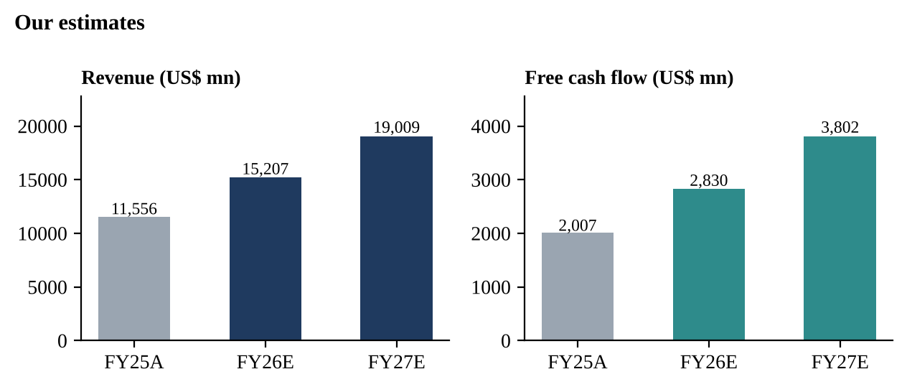

Source: Shopify Q4 2025 press release, Form 8-K (11 Feb 2026). Our estimates
Table 3: Valuation scenarios (FY27E free cash flow basis)
 | Bear (25%) | Base (50%) | Bull (25%)
Story | Growth slows to ~20%; margin stalls; multiple compresses | ~25% growth; FCF margin reaches 20% | ~30% growth holds; FCF margin 21%; AI adds GMV
FY27E revenue growth | +20% | +25% | +30%
FY27E FCF margin | 18% | 20% | 21%
FY27E FCF ($ mn) | 3,285 | 3,802 | 4,152
EV / FCF multiple | 40x | 55x | 65x
Value per share ($) | 106 | 166 | 213
vs price $170.8 | -38% | -3% | +25%
Source: StockAnalysis, SHOP quote and targets (22 Oct 2026); Shopify Q2 2026 press release, Form 8-K exhibit 99.1 (5 Aug 2026). Our scenario assumptions; value = (FCF x multiple + $4.95 bn cash) / 1.29 bn shares
Probability-weighted value: $163, about 5% below the current price. A 55x free cash flow multiple for a business growing revenue at 25% and FCF faster is demanding but not unusual for high-quality software platforms. Each 5x on the base multiple moves the base value by about $15. The street is slightly more optimistic: the average 12-month target is about $176 across 54 analysts, with recent targets of $175 (Jefferies), $190 (Baird), $200 (JPMorgan) and $210 (Stifel).

Figure 10: Our weighted value sits just below the price and street targets
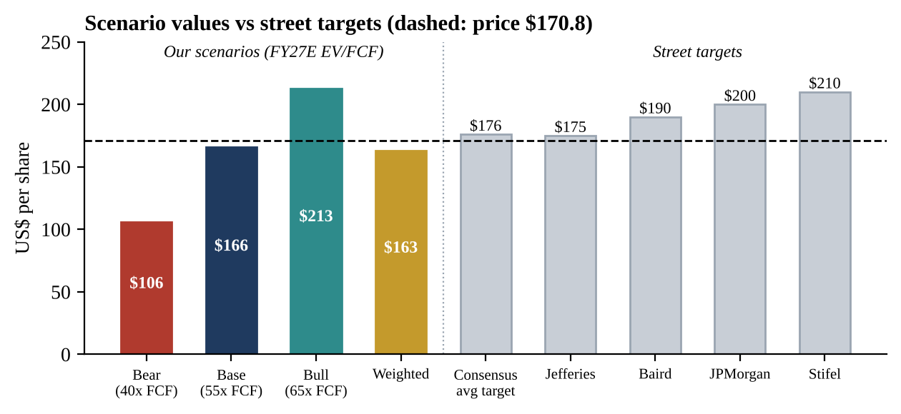

Source: StockAnalysis, SHOP quote and targets (22 Oct 2026); ad-hoc-news, Jefferies $175 target; ad-hoc-news, Baird target to $190; ad-hoc-news, JPMorgan target to $200; ad-hoc-news, Stifel target to $210. Street targets as reported in October 2026
Illustrative rating: HOLD. Q2 was as good a quarter as Shopify has produced, and the business deserves a premium. But the share price has risen about 39% since the print and now sits slightly above our weighted value, so the near-term case rests on Q3 and Q4 beating again. A pullback toward $140-150, or evidence that FCF margins are moving sustainably above 20%, would make the risk-reward more attractive.

Catalysts and risks
- 3 November 2026, Q3 results: revenue against $3.74 bn consensus; FCF margin; Q4 guidance.
- Holiday season (Black Friday / Cyber Monday): GMV data points in late November.
- Upside risks: faster enterprise and international growth; AI channels scaling; higher payments take rate.
- Downside risks: weaker consumer spending; gross margin dilution; volatility in equity-investment gains driving GAAP earnings swings; valuation de-rating.

Sources and references
Company filings (SEC)
- Shopify Q2 2026 press release, Form 8-K exhibit 99.1 (5 Aug 2026)
- Shopify Q1 2026 press release, Form 8-K (5 May 2026)
- Shopify Q4 2025 press release, Form 8-K (11 Feb 2026)
Q2 2026 call and analysis
- Investing.com, Q2 2026 earnings call transcript (5 Aug 2026)
- Platform Aeronaut, Q2 2026 call summary
- Beancount, Q2 2026 earnings analysis (24 Aug 2026)
Consensus, price and targets
- Benzinga, SHOP earnings history and Q3 estimates (accessed 22 Oct 2026)
- StockStory, Q2 2026 vs expectations (5 Aug 2026)
- StockAnalysis, SHOP quote and targets (22 Oct 2026)
- ad-hoc-news, Jefferies $175 target
- ad-hoc-news, Baird target to $190
- ad-hoc-news, JPMorgan target to $200
- ad-hoc-news, Stifel target to $210
Other
- BetaKit, Q3 2025 results (4 Nov 2025)
- Quiver Quant, Q3 2026 results date announcement
Disclaimer: This report was prepared as an academic exercise. The rating, scenario values and estimates are illustrative, rely on public sources, and are not investment advice or a recommendation to buy or sell any security.

