Name Trishna Roy

Father’s Name Bijon Bihari Roy

Mother’s Name Seema Roy

Date of Birth Marital Status Religion Nationality
Blood Group NID
Current Address

Education
14 -08-1999

Single Hinduism
Bangladeshi

A+(VE) 5556104312

Josher Abda , Habiganj-3300 , Sylhet , Bangladesh .

2016

2018
Degree Name : Secondary School Certificate
Institution : B.K.G.C Govt. Girls High School, Habiganj .
Group : Science CGPA : 4.94

Degree Name : Higher Secondary Certificate
Institution : Brindaban Govt. College, Habiganj
Group : Science CGPA : 4.25

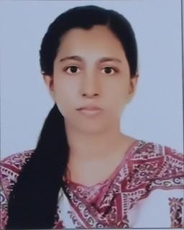



TRISHNA ROY
568676
Josher Abda , Habiganj-3300 ,
Sylhet , Bangladesh .
2022 Degree Name : Bachelor of Science in botany
Subject:Botany
Institution : Brindaban Govt. College, Habiganj
CGPA : 3.37 out of 4 (First class )

Fahim Bokth

- IELTS Instructor Adelac coaching centre, Habiganj

Email : Phone:
fahimbokth131@gmail.com

+880 1315-329802


IELTS SCORE
English
Computer literacy
Skills & Expertise
Good command of English (CEFR Level B2–C1)
Confident public speaker

and communicator
knowledge

Patience and student-friendly attitude
Basic knowledge of IELTS

exam format and strategies -->
writing and speaking practice
Overall Band Score: 6.5 Listening: 7.0
Reading: 7.0
Writing: 6.5
Speaking: 6.0

Exam Date: [5 July 2025]

Declaration

I, the undersigned certify that this curriculum vitae correctly describes my qualifications and myself.

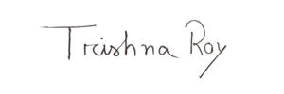

Trishna Roy

