Bishesh Tuladhar

Matthew Bell

7th January 2020

Homework 1: Exercise 3

1. CIL Code

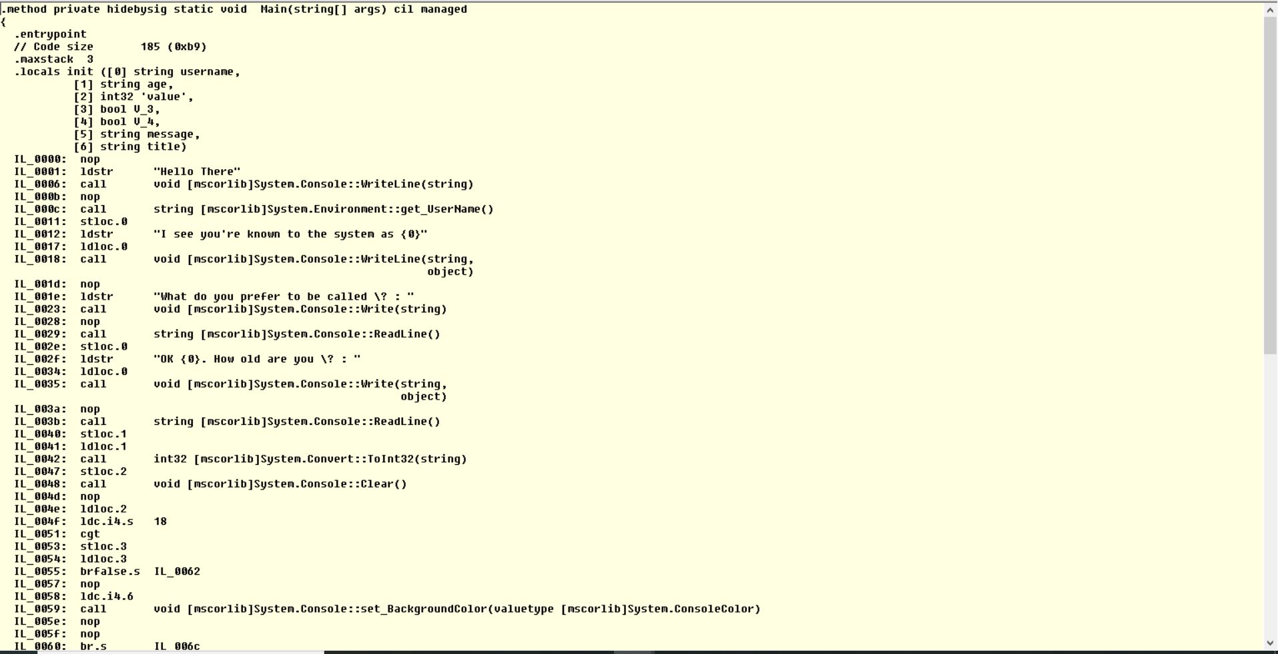

Each .NET-aware compiler produces nearly identical CIL instructions. Therefore, all languages are able to interact within a well-defined binary arena. One of the biggest advantages of CIL code is that it is a language integration.

1. Manifest

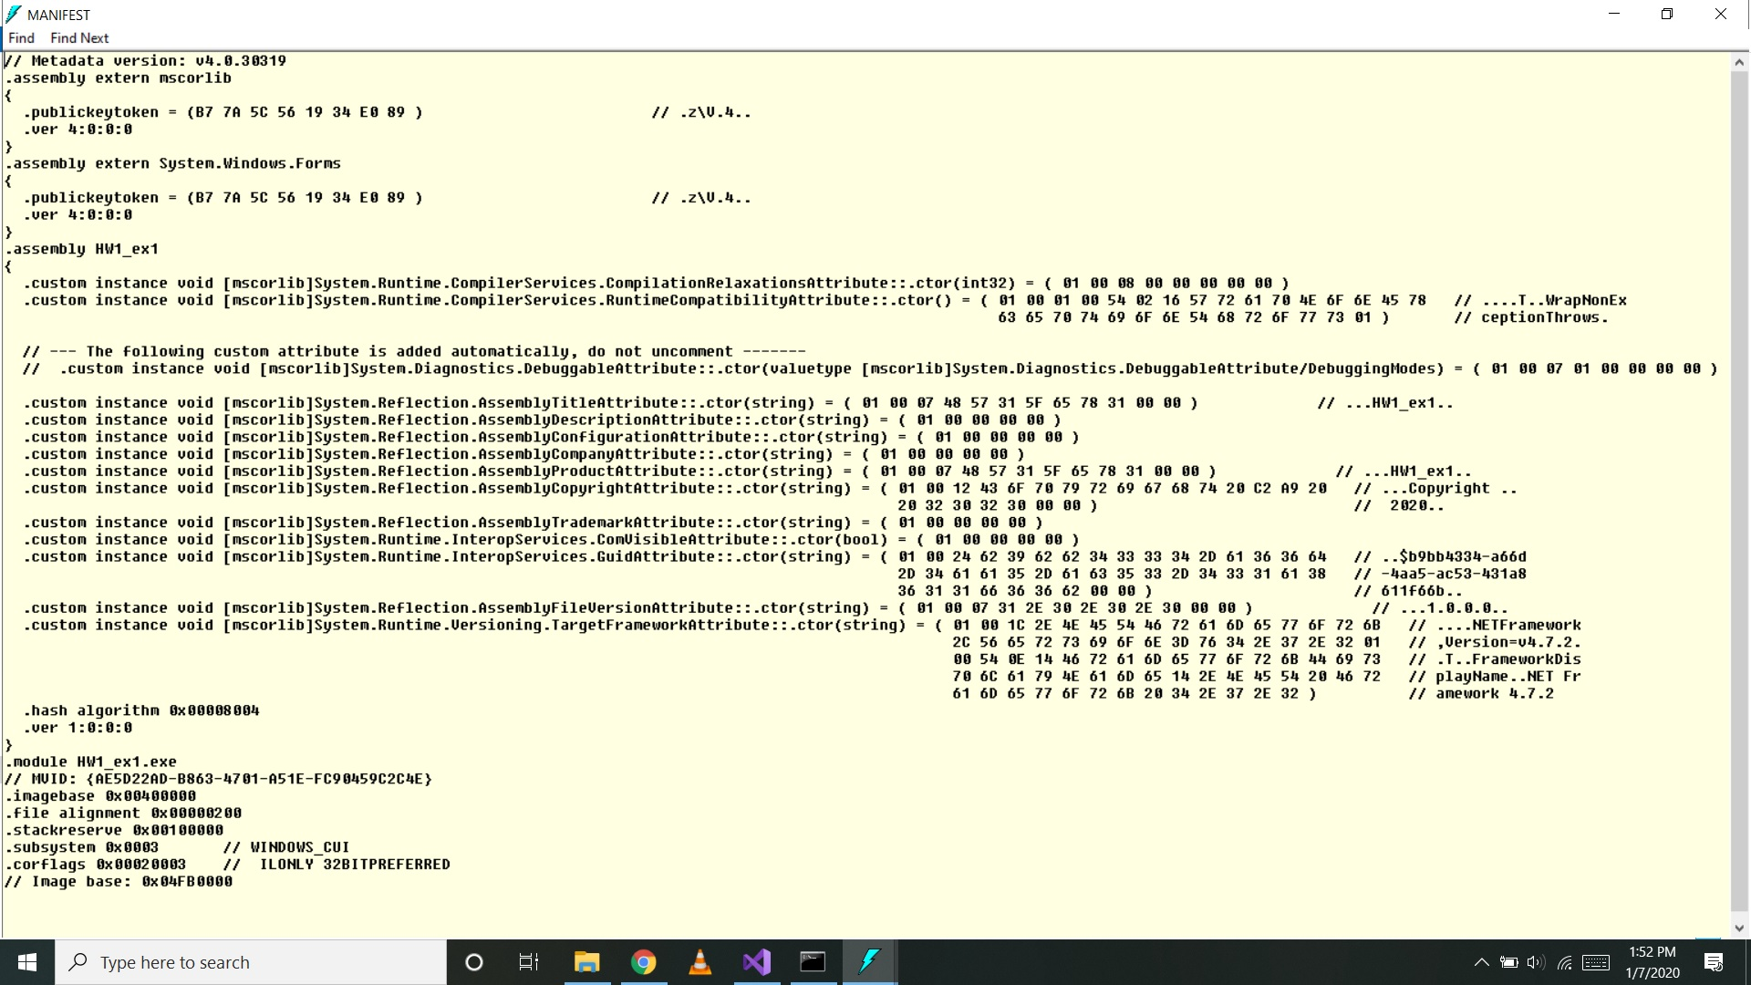

Manifest documents all external assemblies required by the current assembly to function correctly, the assembly’s version number, copyright information, and so forth. It is always the job of the compiler to generate the assembly’s manifest.

1. Metadata

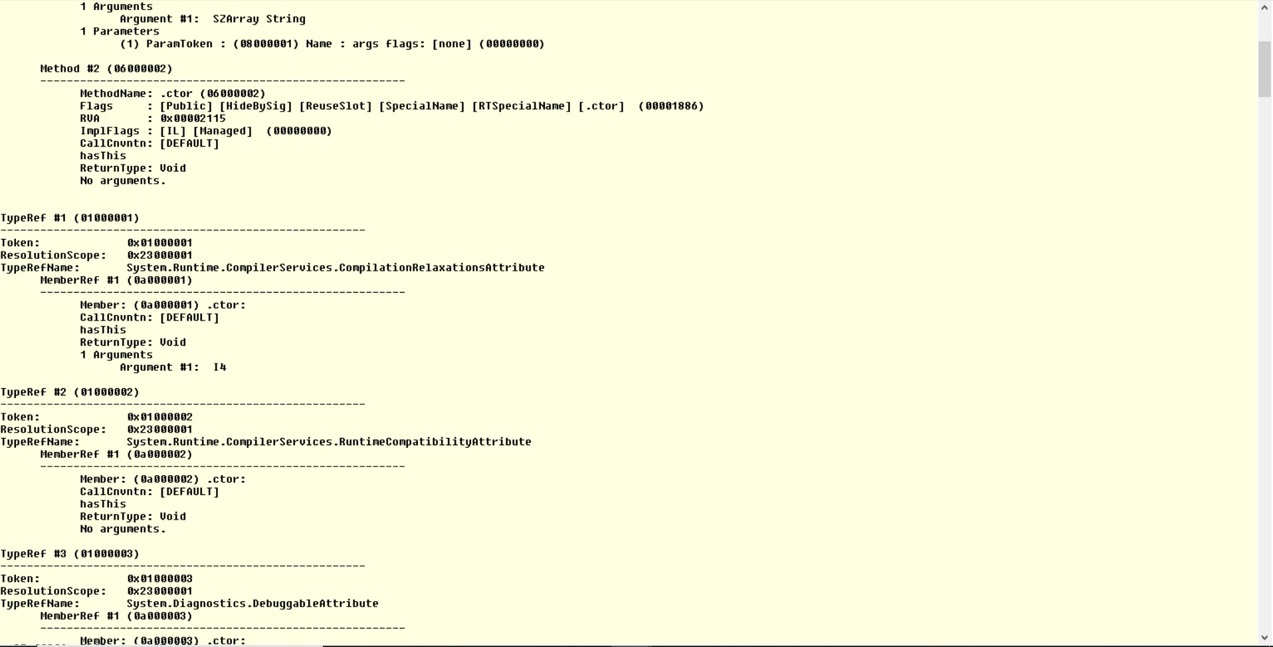

A .NET assembly contains full, complete, and accurate metadata, which describes every type. It is always the job of the compiler to emit the latest and greatest type metadata. Because .NET metadata is so wickedly meticulous, assemblies are completely self-describing entities.