**Bishesh Tuladhar**

CS – 371-1

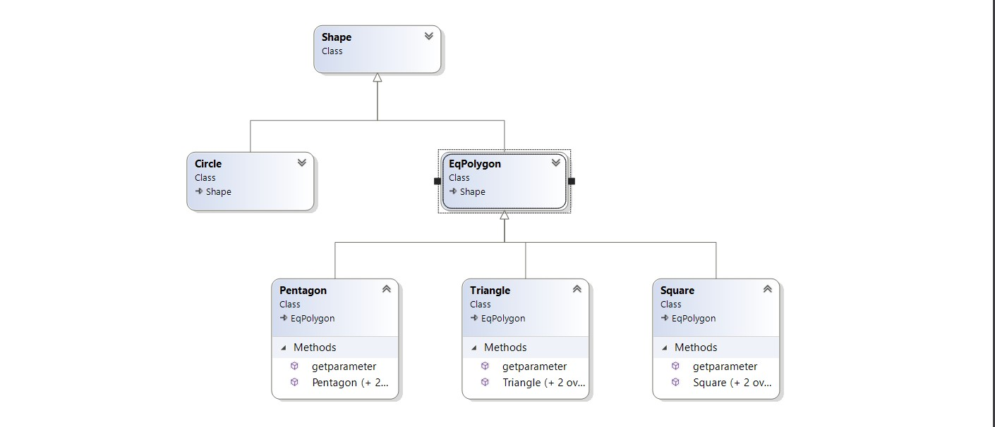Homework 2: Ex 2

Shape is the parent class and Circle and EqPolygon are the child class of Shape class. Methods and properties are inherited from Shape class to Circle and EqPolygon class. Further down in the hierarchy Triangle, Square and Pentagon class are the child of EqPolygon class. Pentagon, Triangle and Square Class inherit properties and method not only from EqPolygon but also from Shape class.