Project Proposal

On

Wallpaper Application Promoting Local Photographers

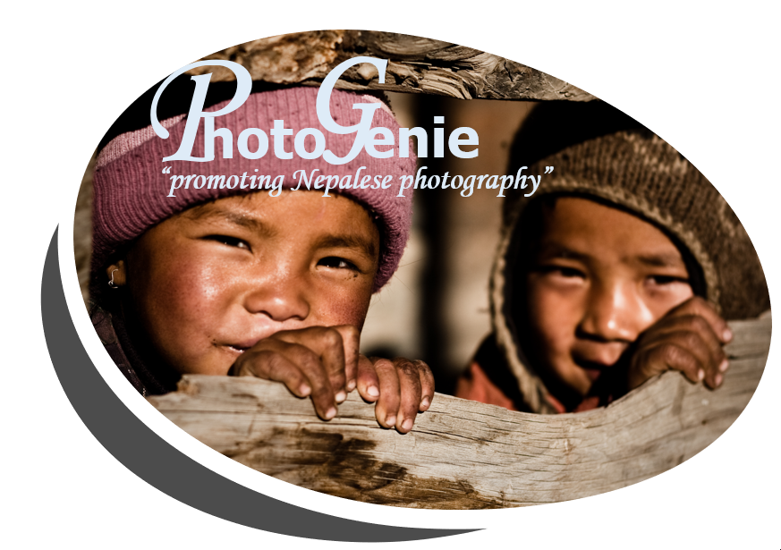

Module: STW300CEM Android Application Development

Softwarica college of IT and E-Commerce

Mahakavi Marg, Kathmandu 44600, NEPAL

Submitted By: Submitted to:

Mr. Bishes Upadhyaya Mr. Aayush Mainali

160304 Module leader:

19D Mr. Kiran Rana

Contents

1. Introduction 1

a) Project introduction 1

b) Justification of project 2

i. Background of the project 2

ii. Problem statement 2

c) Description of the project 2

i. Features of the project 2

2. Aims and Objective of the project 3

3. Development Methodology 4

a) Description of the methodology 4

b) Design pattern 6

c) System Architecture 7

i. Three tier architecture 7

4. Configuration Management (GitHub Screenshot) 8

5. Prototyping 9

6. References 13

Table of Figures

Figure 1: Waterfall Methodology 4

Figure 2: MVC pattern 6

Figure 3:Three Tier Architecture 7

Figure 4: GitHub Link 8

Figure 5: prototyping of the application 9

Figure 6: prototype for registration. 10

Figure 7: prototype for user profile 11

Figure 8: prototype for login form 12

# Introduction

## Project introduction

In simple words photography is the practice and art of capturing and processing moments and objects it has many uses in different fields and sector related to science, business, fashion, tourism, adverting etc. It is a powerful means that acts as a link between reality and fantasy. Photography is everywhere. We see numerous photographic pictures every day, many of which advertise products, services, lifestyles and ideologies. In the modern era photographs can be considered as a visual literacy and photographers are the ones who capture these entities.

The application that I am proposing to be developed is named as Photo Genie. This is an android application that is made in conjunction with a website of the same functionality from where I aim to import different APIs to make the user experience more optimized. The main goal of the application is to promote the local photography scene of the country. The users will be able to make profile in which they will be able to upload photos with detailed description, location and category. The starting page of the app will have a collage of different photographs from different users and a search bar will also be available from where people can search for the user or the category of the photos that they want to see furthermore the uploaded phots can be downloaded and even rated. There will also be a donation button from where the users can donate money to the photographers.

This project aims to be the go to application for Nepalese photography whose aim is to promote the local photography scene of the country and encourage people to make photography as a part of their career and provide the users exposure to national as well as the international market

## Justification of project

### Background of the project

The project is an attempt to build a mobile application in conjunction with a web application that aims to promote the local photographers of the country. The scene in Nepal is that there are a lot of talented photographers, but they don’t have a dedicated place to share their work, yes there are photographers who share their photos in the social sites like Facebook, Instagram and twitter but it has its limits. The social sites don’t provide exposure to the artist as a dedicated application would furthermore promoting and advertising your work in these sites are quite costly and have very small returns. Therefore, the project aims to create an app that can be the central hub for all the local photographers of the country.

### Problem statement

According to 2019 US industry statistics and market research – commercial photography 2018 had recorded the maximum profit with the total revenue reaching more than a billion dollars therefore this proves that photography can be a good source of earning money and can be taken as a career but in a developing country like Nepal majority of people take photography as a part time or a side hustle because people don’t see this line of work as a way to earn money long term. We can take example of people like Sagar Giri who works as the wildlife photographer for national geography and is earning good income at the same time advertising his talents in the foreign market but Since there are no dedicated apps like **Pexels,** **Resplash**, **Canva** etc. in the country that promotes the photographers and encourages them to make photography as a career my projects aims to be the go to application for all the Nepalese commercial photography and provide the photographers exposure to a large array of audience.

## Description of the project

### Features of the project

* **The photographers can make their own profile:** this android application will have the feature where the photographers can make their personal profile where they will be able to upload their pictures.
* **Data filtering for best result:** the application will contain a search bar where there will be the option for searching photos based on the profile or the categories.
* **Photos and profile can be rated:** this app will also have the feature where the photos and user’s profile can be rated, this will be done to encourage the users and increase their popularity at the same time.
* **Detailed information of the photographs with its location:** the user must provide a brief information about the details of the pictures that has been uploaded with the location details too.
* **Photos can be downloaded:** the photos can be downloaded for advertising and marketing purpose.
* **Donation can be made to users:** Donation feature is available so that the users have a way to earn income from this application.

# Aims and Objective of the project

**Aim of the project**

* Build an android application that promotes the local photography scene of the country

**Objectives to fulfill the aim**

* Make a user-friendly mobile application,
* To show the photography potential of the local photographers of Nepal to national and international audience,
* Admin dashboard for controlling the functionality of the application,
* To be able to rate, review and download the uploaded photographs,
* To Import different APIs from the website of the app,

# Development Methodology

## Description of the methodology

The development methodology that I will be using for this particular project will be that of the Waterfall Methodology

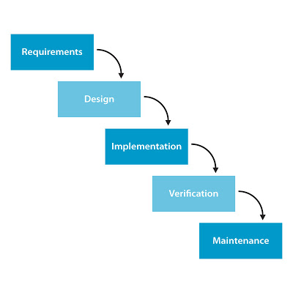

Figure 1: Waterfall Methodology

Waterfall methodology is a project development methodology best suited for small project where the project’s requirements are clearly understood. According to the waterfall approach each stage of the project must be finished prior to moving to the next stage and at the conclusion of each stage a review will be conducted to ensure that the assignment is on the right track.

My reason behind choosing this methodology for this particular project is because this methodology is easily understood and since each stage will have specific time for completion thus the waterfall methodology will ensure that each and every stage is fully finished before going to the next part.

Advantages of following this approach:

* This approach is straight forward so it is easily understandable.
* Every stage will have a specific goal to complete
* No overlapping of the phases, this will ensure timely completion of each stage

Disadvantage of following this approach:

* a prototype will only be made in the final stages of the application lifecycle.
* Less revision compared to agile.

## Design pattern

The design pattern that I will be following will be the MVC pattern. The Model View Controller pattern will classify the project into three linked groups known as Model, View and Controller.

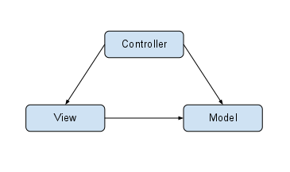

Figure 2: MVC pattern

**Model:** this group is responsible will define the logical structure of the data and information for this project also defining the high-level class that will relate to it.

**View:** it is the user interface part of the project. There will be multiple views in a single project with different functionality.

**Controller:** controller is the part that will be responsible for making interactions between the model and the view part without any dependencies. Creation of objects falls under controller.

The reason behind choosing this patternis because the development process will be much faster with less code redundancy, plus the modification of codes will not affect the entire model because the models are independent of each other

## System Architecture

### Three tier architecture

Three tier architecture is a client server architecture where the functional logic, data storage and the user interface are established and kept as an independent element on separate platforms.

the three layers involved in this architecture are as follows:

**Presentation layer:** this layer is the user interface layer that provides the content to the user in a digital form.

**Application layer:** this layer uses the application server and processes the program logic for the application.

**Data layer:** this layer is responsible for the database management system that provides access to the application data.

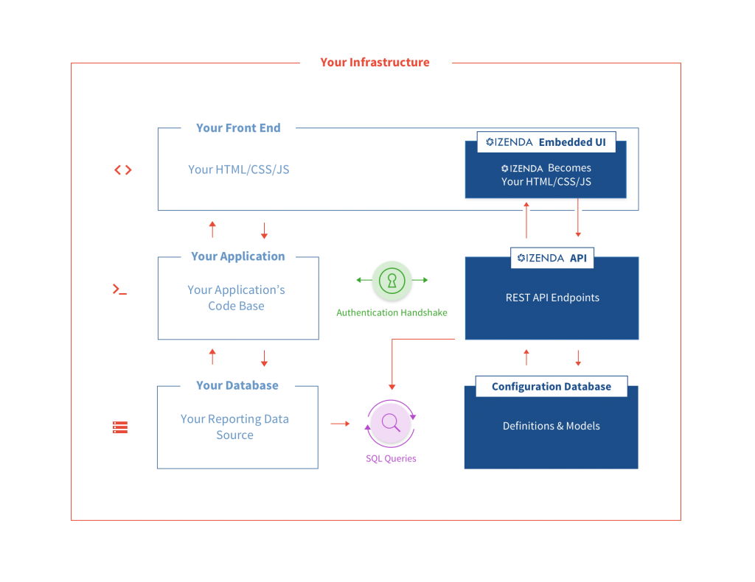

Figure 3:Three Tier Architecture

# Configuration Management (GitHub Screenshot)

Configuration management is a way of systematically managing changes to the space of work in a way that it sustains integrity over time. It helps the project to accomplish an improved consistency by ordering the files in a systematized order so they can be accessed straightforwardly. Further these files will frequently be backed up on the Git Hub repository for data recovery.

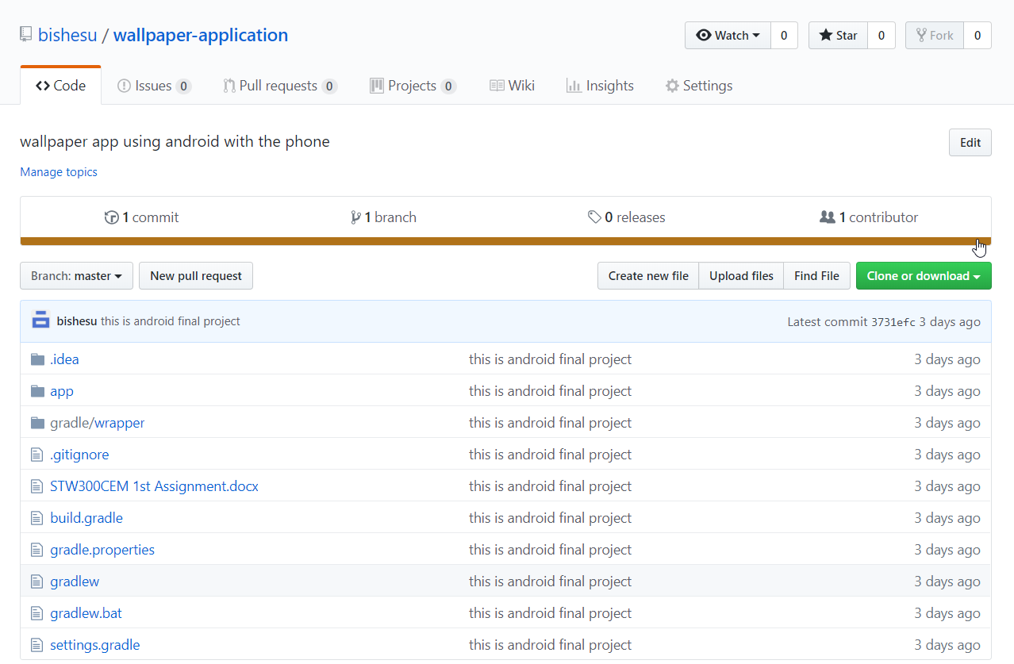

Figure 4: GitHub Link

# Prototyping

Prototyping is a research methodology that helps to visualize and test ideas and concepts in the early stages of the project development with a minimum investment in time and cost.

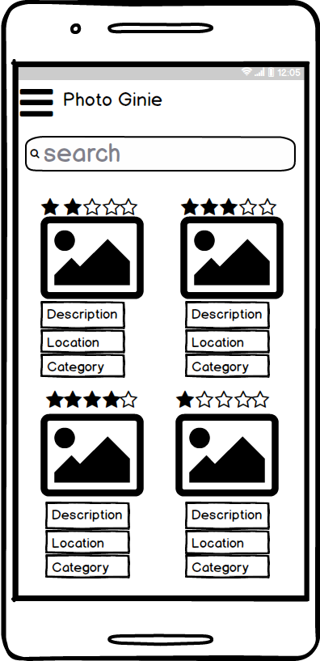

Figure 5: prototyping of the application

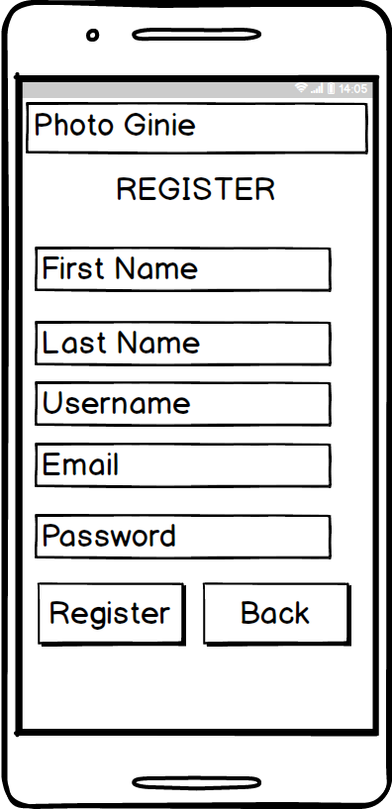

Figure : prototype for registration.

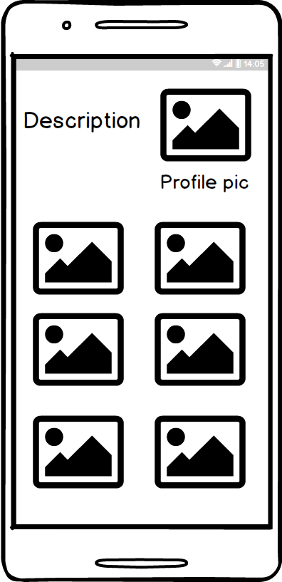

Figure : prototype for user profile

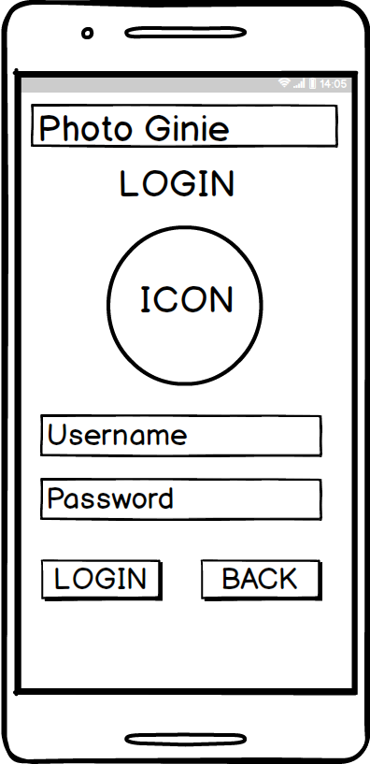

Figure : prototype for login form

# References

Izenda. (2019). *5 Benefits of a 3-Tier Architecture - Izenda*. [online] Available at: <https://www.izenda.com/5-benefits-3-tier-architecture/>

[Accessed 12 Apr. 2019].

Medium. (2019). *A guide to paper prototyping & testing for web interfaces*. [online] Available at: <https://medium.com/digital-experience-design/a-guide-to-paper-prototyping-testing-for-web-interfaces-49e542ba765f>

[Accessed 12 Apr. 2019].

Techspirited. (2019). *Advantages and Disadvantages of the Waterfall Model You Ought to Know*. [online] Available at:

<https://techspirited.com/waterfall-model-advantages-disadvantages>

[Accessed 12 Apr. 2019].