Initiated By Third Party
- Payoff request can be created against a customer from the Contact form as below.
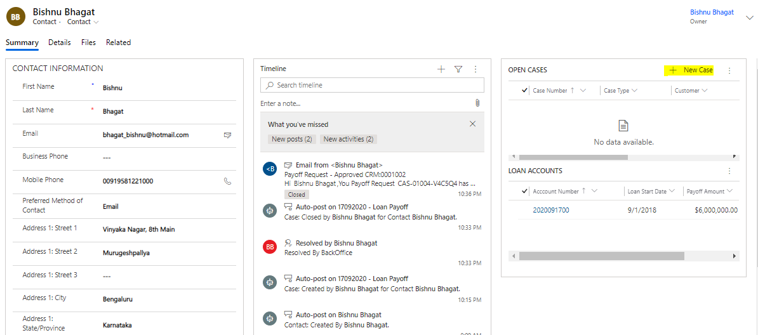
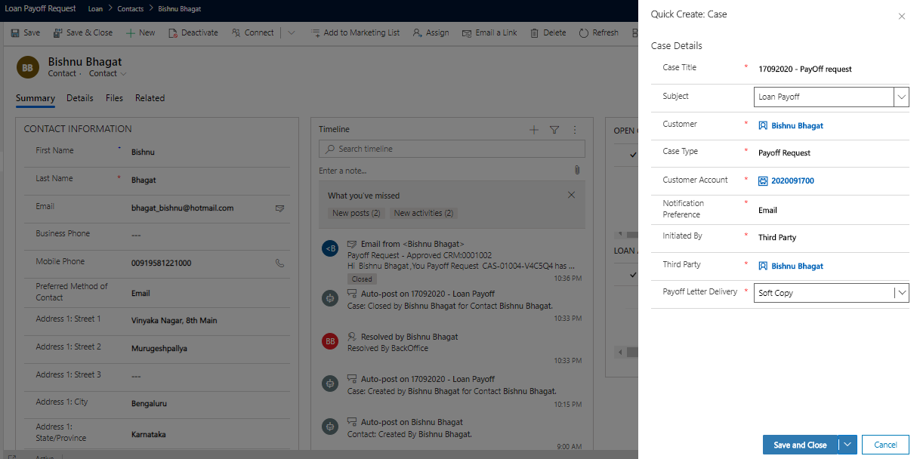

- If Initiated by Third Party, Case gets first Added to Owner’s Queue.
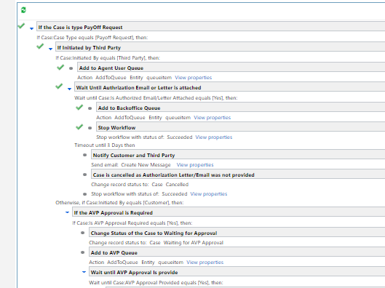
- Worflow Keeps waiting until Required Documents(Authorization Letter/Email) is attached.
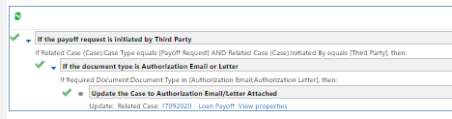
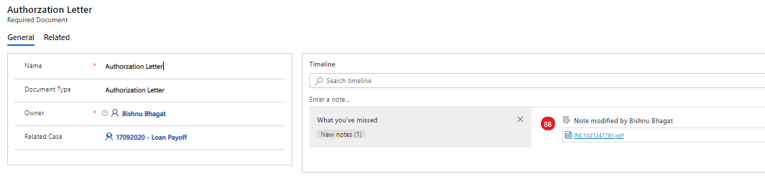
- If the Document Type Attached is Authorization Letter or Email, Case is updated as AuthorizationEmailAttached = true
- After the Authorization Email is Attached, Case gets Added to <BackOffice> Queue.
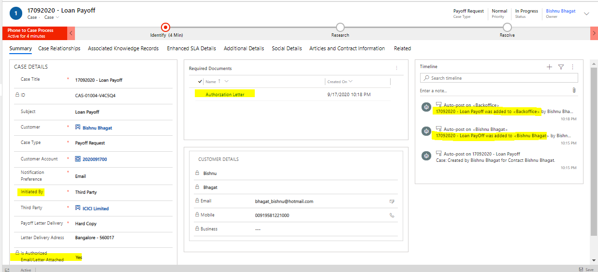
- Attached is the POT with Activities, showing the Cases were added to multiple Queue During the process.
- After the BackOffice resolves the case, attaching the supporting documents, notification is sent to the customer based on the notification Preference.
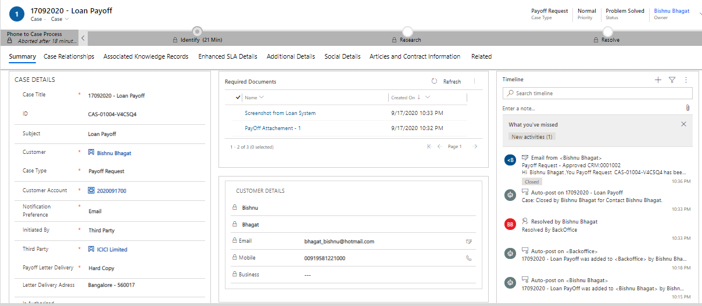
- During resolution, Payoff attachment is attached and screenshot from the Loan Processing System as shown in the above POT.

- In case if the payoff request was initiated by Third party, workflow does Parallel wait until 3 days and then send notification to both Customer and Third Party.
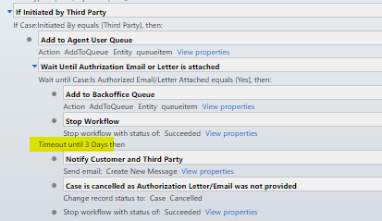

Initiated By Customer
- If the payoff request is initiated by customer, request should be validated against any AVP approval.
Each Loan Account has Loan Start Date and Payoff Amount (can be a calculated field or may be fetched real-time via Loan System)
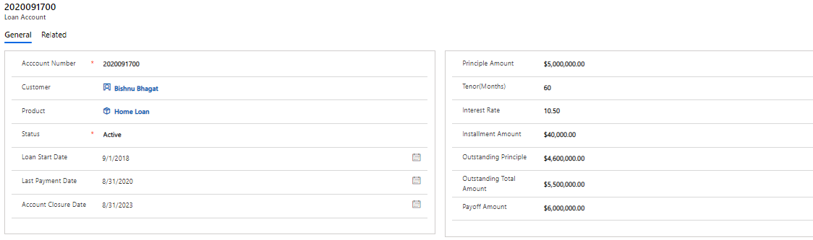
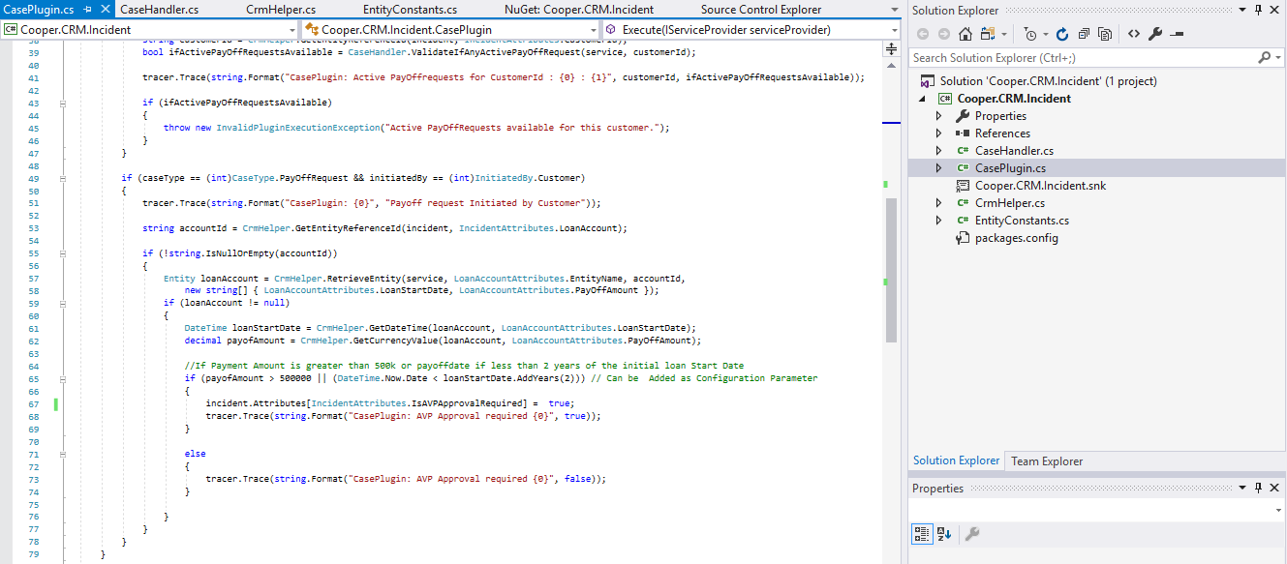
- Case gets added to AVP Queue, if approval is required. Approve Button will be available to approve the request.
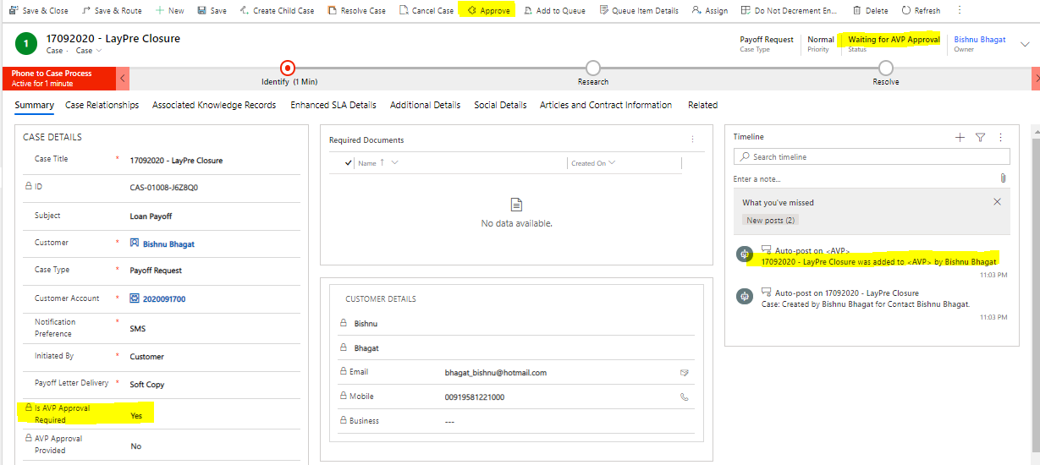
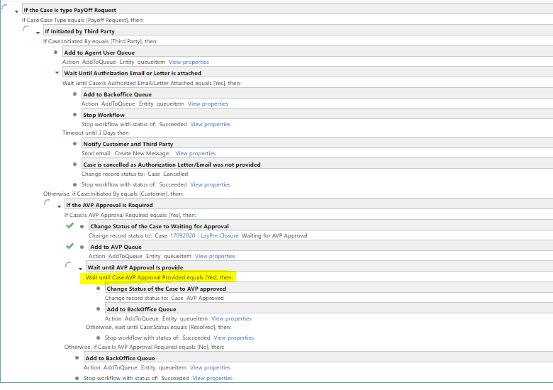
- Once the Approval is provided by clicking Approve Button, the case is then added into BackOffice Queue.
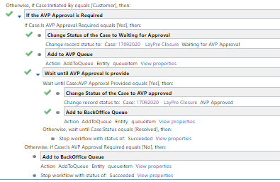
- After the back Office resolves the case adding the supporting documents, notifications are sent based on the preference. In the below case, SMS was generated.
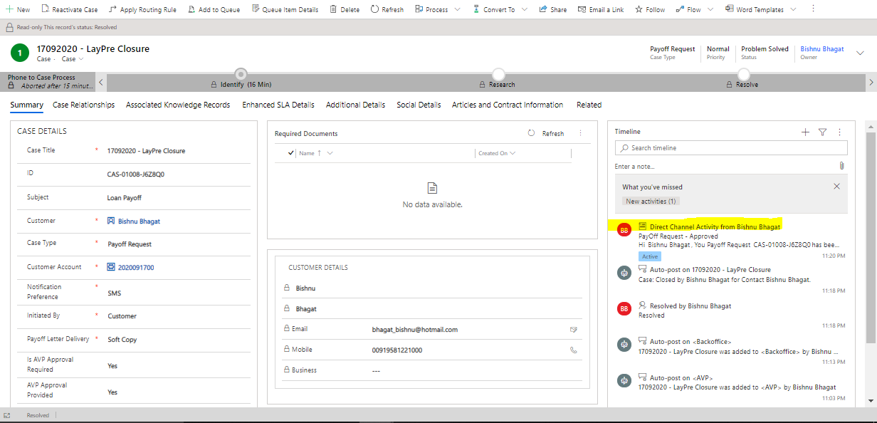

Adding Loan PayOff Request
- In Case there is an Active Payoff request, agent would not be allowed to register a new request.
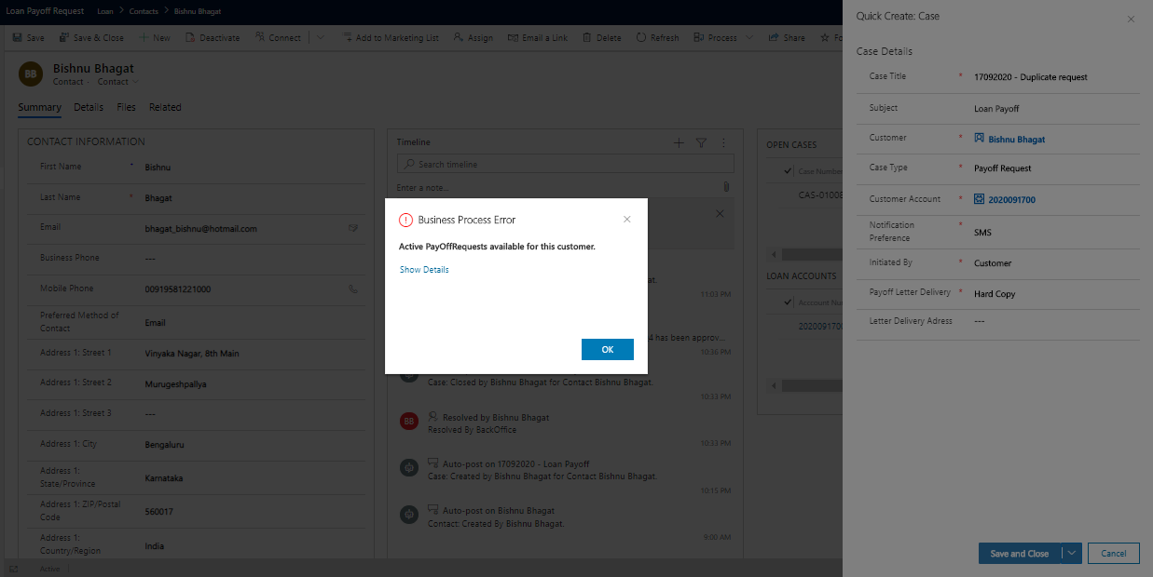

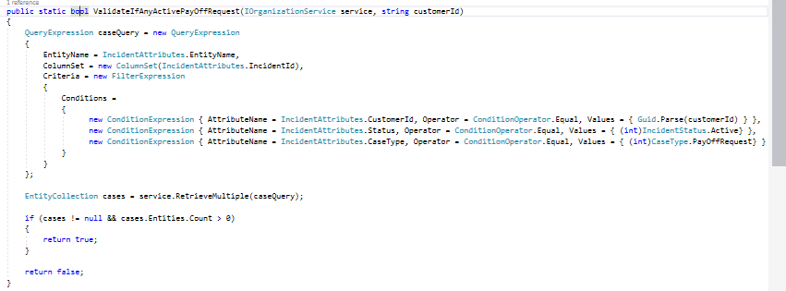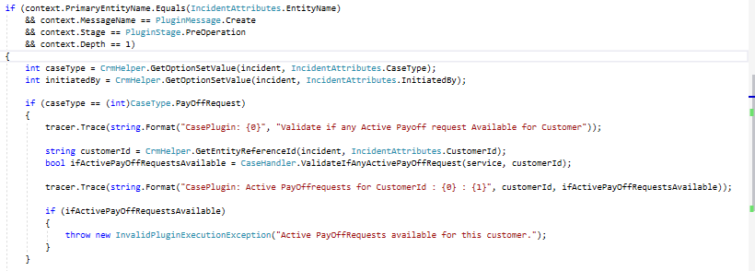

- If no Active Payoff request is present against an account, case can be successfully registered.
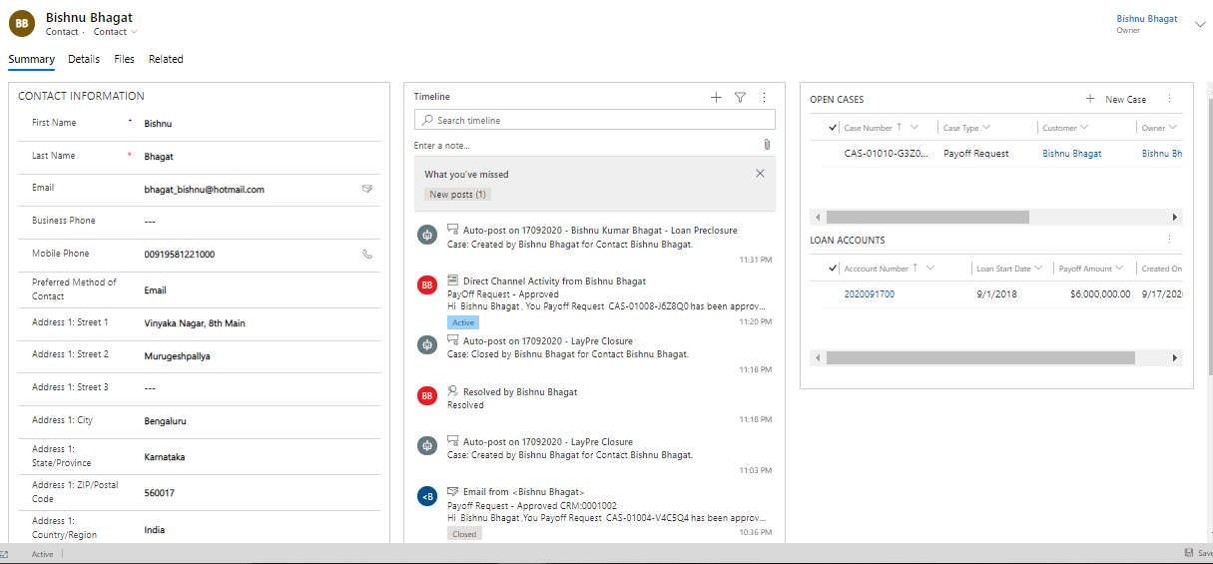

Solution Components

Entities
- Contact
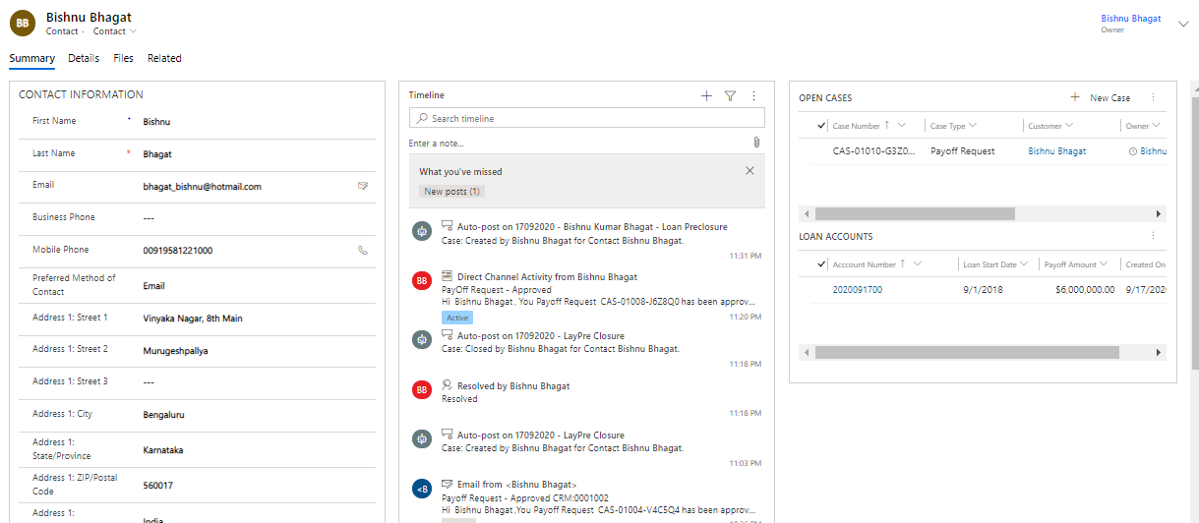

- Case
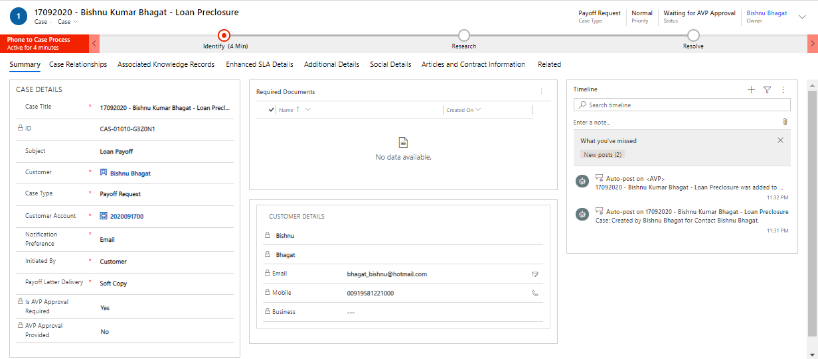
- Loan Account
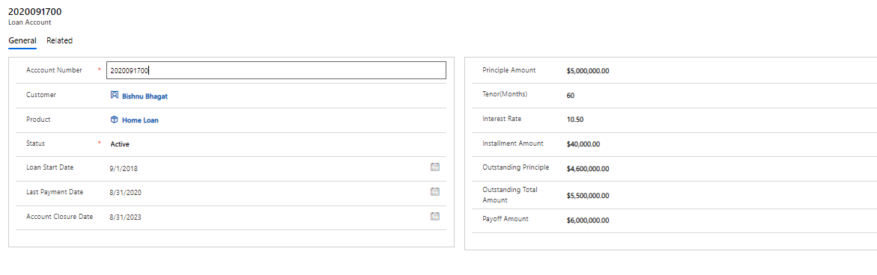
- Required Document
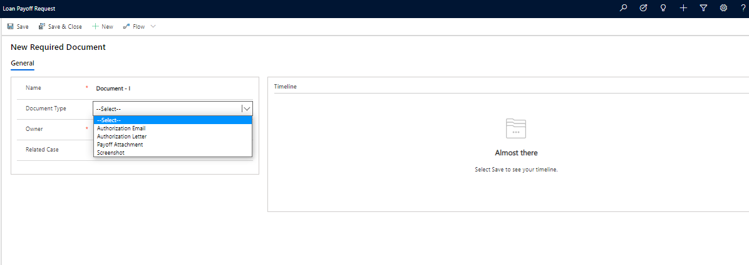

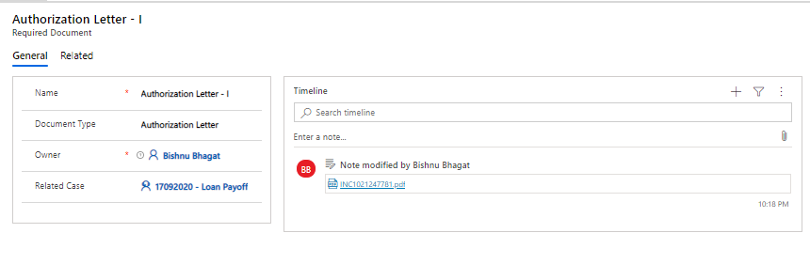

- Direct Channel Activity
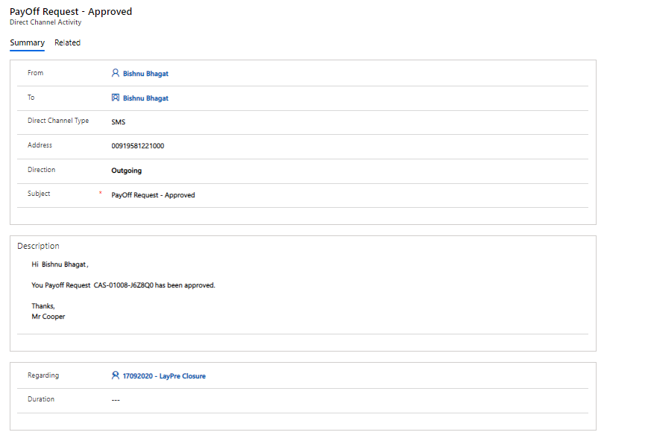

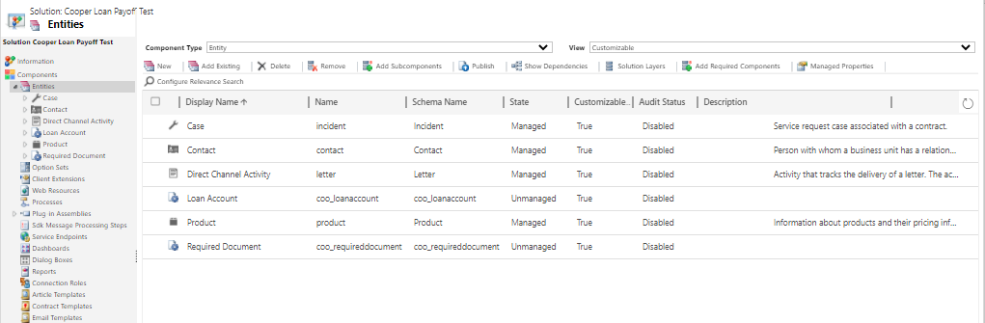

Plugin
- Pre - operation Plugin is registered on Case Creation.
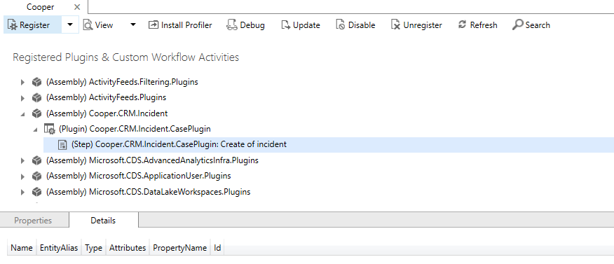

Workflow
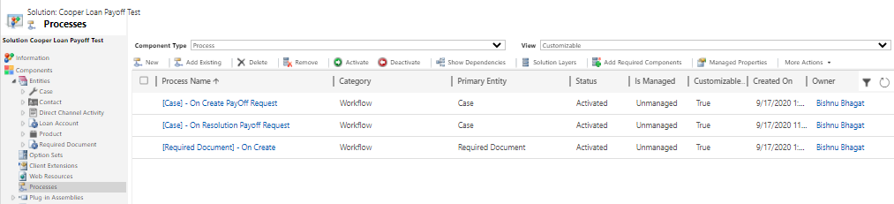
- On Create of Payoff Request
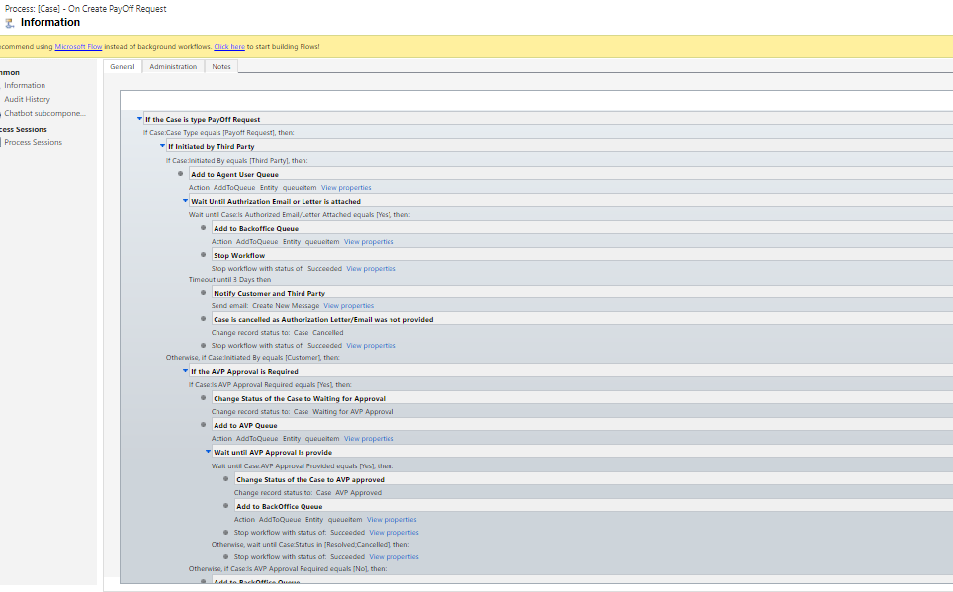
- On Case Resolution
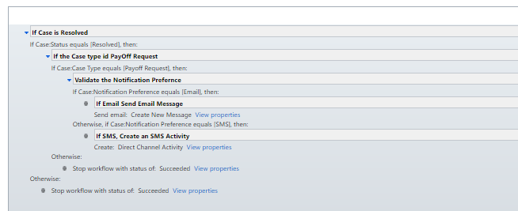
- On Required Document Creation
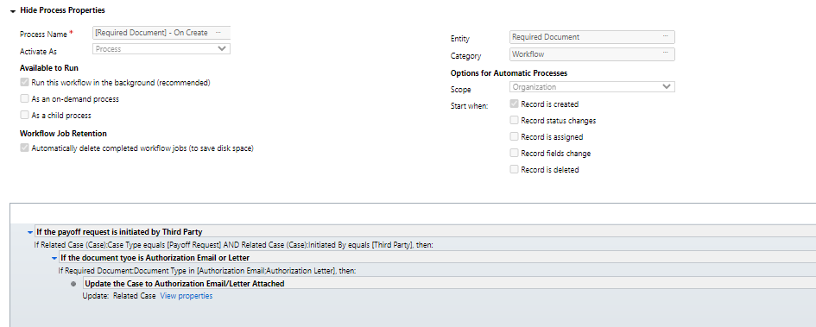

Javascript
- AVP approval is required for Customer Initiated Cases which meet the condition. On click of Approve Button, Approval Provided is set to true.
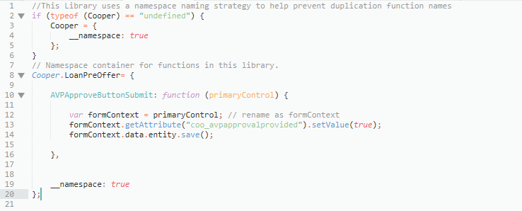

Business Rules
Couple of Business rules are used to perform client side validations
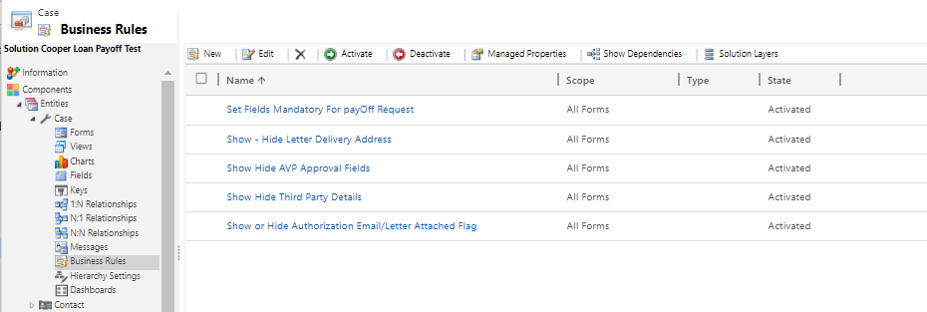

Teams and Queues
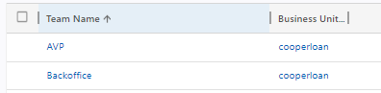

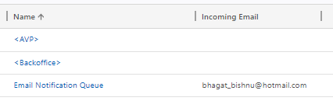

SLA
Enhanced SLA is created for Resolve By KPI
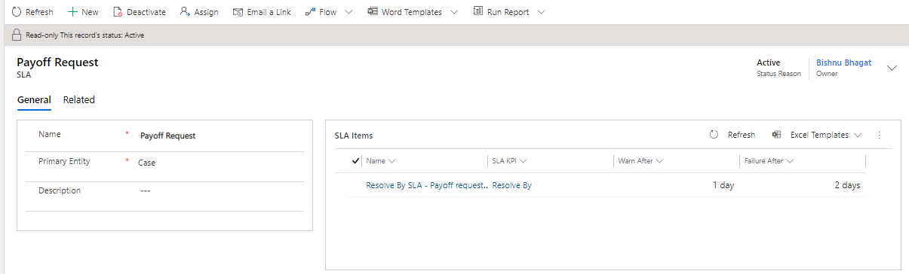

Known Areas
- Solution Selected above is to demonstrate all the areas like Plugins, workflows, JavaScript.
- Workflow were preferred over Routing rules to add to Queues.
- Pre – operation Plugin was used instead on JavaScript form on Save
- Workflows were used to create Email and SMS Activities instead on Flow with real-time integrations.
- Required Document Entity was created to store various types of documents as it can support better document categorization. Documents can directly be uploaded to the other storage system, if we provide the iframes to upload or download the documents.

