**Chapter 19Instructions and Procedures**

“Clear, accurate instructions and procedures are essential to the work we do in aerospace engineering. We need to ensure that the mechanics, ground control personnel, and pilots have the information they need to perform tasks and conduct safety and operations checks. these instructional documents can’t have too much detail or be too wordy, and they need a clear list of steps. Hazard and warning material needs to show up easily, usually through the use of a visual. At our company, teams of engineers and technical writers work together to design, write, and evaluate all of our instructions, which we then print on quick-reference cards and make available on our Web site.”

—Farid Akina, Aerospace Engineer at an international aerospace design firm

Chapter Outline

1. [19.1 Considering Audience and Purpose](https://revel-ise.pearson.com/eps/sanvan/api/item/2dcdbc14-7038-4c7a-bb35-030be7da7fd0/1/file/lannon_gurak-tc-15e-revel_v4_RR1/OPS/xhtml/ch19_pg0002.xhtml#P70010155170000000000000000045CB)
2. [19.2 Formats for Instructional Documents](https://revel-ise.pearson.com/eps/sanvan/api/item/2dcdbc14-7038-4c7a-bb35-030be7da7fd0/1/file/lannon_gurak-tc-15e-revel_v4_RR1/OPS/xhtml/ch19_pg0003.xhtml#P70010155170000000000000000045EC)
3. [19.3 Faulty Instructions and Legal Liability](https://revel-ise.pearson.com/eps/sanvan/api/item/2dcdbc14-7038-4c7a-bb35-030be7da7fd0/1/file/lannon_gurak-tc-15e-revel_v4_RR1/OPS/xhtml/ch19_pg0004.xhtml#P700101551700000000000000000464D)
4. [19.4 Elements of Effective Instructions](https://revel-ise.pearson.com/eps/sanvan/api/item/2dcdbc14-7038-4c7a-bb35-030be7da7fd0/1/file/lannon_gurak-tc-15e-revel_v4_RR1/OPS/xhtml/ch19_pg0005.xhtml#P7001015517000000000000000004672)
   1. [Guidelines for Providing Appropriate Detail in Instructions](https://revel-ise.pearson.com/eps/sanvan/api/item/2dcdbc14-7038-4c7a-bb35-030be7da7fd0/1/file/lannon_gurak-tc-15e-revel_v4_RR1/OPS/xhtml/ch19_pg0010.xhtml#P70010155170000000000000000046F0)
   2. [Guidelines for Designing Instructions](https://revel-ise.pearson.com/eps/sanvan/api/item/2dcdbc14-7038-4c7a-bb35-030be7da7fd0/1/file/lannon_gurak-tc-15e-revel_v4_RR1/OPS/xhtml/ch19_pg0015.xhtml#P70010155170000000000000000047D5)
5. [19.5 Online and Social Media Instructions](https://revel-ise.pearson.com/eps/sanvan/api/item/2dcdbc14-7038-4c7a-bb35-030be7da7fd0/1/file/lannon_gurak-tc-15e-revel_v4_RR1/OPS/xhtml/ch19_pg0017.xhtml#P7001015517000000000000000004872)
6. [19.6 Procedures](https://revel-ise.pearson.com/eps/sanvan/api/item/2dcdbc14-7038-4c7a-bb35-030be7da7fd0/1/file/lannon_gurak-tc-15e-revel_v4_RR1/OPS/xhtml/ch19_pg0020.xhtml#P7001015517000000000000000004895)
7. [19.7 Evaluating the Usability of Instructions and Procedures](https://revel-ise.pearson.com/eps/sanvan/api/item/2dcdbc14-7038-4c7a-bb35-030be7da7fd0/1/file/lannon_gurak-tc-15e-revel_v4_RR1/OPS/xhtml/ch19_pg0021.xhtml#P70010155170000000000000000048C0)
   1. [Checklist: Instructions and Procedures](https://revel-ise.pearson.com/eps/sanvan/api/item/2dcdbc14-7038-4c7a-bb35-030be7da7fd0/1/file/lannon_gurak-tc-15e-revel_v4_RR1/OPS/xhtml/ch19_pg0024.xhtml#P70010155170000000000000000048F6)
   2. [Projects](https://revel-ise.pearson.com/eps/sanvan/api/item/2dcdbc14-7038-4c7a-bb35-030be7da7fd0/1/file/lannon_gurak-tc-15e-revel_v4_RR1/OPS/xhtml/ch19_pg0025.xhtml#P7001015517000000000000000004943)

Learning Objectives

1. [19.1Describe the audience and purpose of instructions in the workplace](https://revel-ise.pearson.com/eps/sanvan/api/item/2dcdbc14-7038-4c7a-bb35-030be7da7fd0/1/file/lannon_gurak-tc-15e-revel_v4_RR1/OPS/xhtml/ch19_pg0002.xhtml#P70010155170000000000000000045CB)
2. [19.2Recognize the various formats for instructions](https://revel-ise.pearson.com/eps/sanvan/api/item/2dcdbc14-7038-4c7a-bb35-030be7da7fd0/1/file/lannon_gurak-tc-15e-revel_v4_RR1/OPS/xhtml/ch19_pg0003.xhtml#P70010155170000000000000000045EC)
3. [19.3Appreciate how instructions have serious legal implications](https://revel-ise.pearson.com/eps/sanvan/api/item/2dcdbc14-7038-4c7a-bb35-030be7da7fd0/1/file/lannon_gurak-tc-15e-revel_v4_RR1/OPS/xhtml/ch19_pg0004.xhtml#P700101551700000000000000000464D)
4. [19.4Identify the main components of instructions and write a full set of instructions](https://revel-ise.pearson.com/eps/sanvan/api/item/2dcdbc14-7038-4c7a-bb35-030be7da7fd0/1/file/lannon_gurak-tc-15e-revel_v4_RR1/OPS/xhtml/ch19_pg0005.xhtml#P7001015517000000000000000004672)
5. [19.5Explain the benefits of online and social media instructions](https://revel-ise.pearson.com/eps/sanvan/api/item/2dcdbc14-7038-4c7a-bb35-030be7da7fd0/1/file/lannon_gurak-tc-15e-revel_v4_RR1/OPS/xhtml/ch19_pg0017.xhtml#P7001015517000000000000000004872)
6. [19.6Write procedures to help groups of people coordinate their activities](https://revel-ise.pearson.com/eps/sanvan/api/item/2dcdbc14-7038-4c7a-bb35-030be7da7fd0/1/file/lannon_gurak-tc-15e-revel_v4_RR1/OPS/xhtml/ch19_pg0020.xhtml#P7001015517000000000000000004895)
7. [19.7Evaluate the usability of instructional documents](https://revel-ise.pearson.com/eps/sanvan/api/item/2dcdbc14-7038-4c7a-bb35-030be7da7fd0/1/file/lannon_gurak-tc-15e-revel_v4_RR1/OPS/xhtml/ch19_pg0021.xhtml#P70010155170000000000000000048C0)

*Instructions* spell out the steps required for completing a task or a series of tasks (say, installing printer software on your computer or operating an electron microscope). the audience for a set of instructions might be someone who doesn’t know how to perform the task or someone who wants to perform it more effectively. In either case, effective instructions enable people to complete a job safely and efficiently.

*Procedures*, a special type of instructions, serve also as official guidelines. Procedures ensure that all members of a group (such as employees at the same company) follow the same steps to perform a particular task. For example, many companies have procedures in place that must be followed for evacuating a building or responding to emergencies.

Almost anyone with a responsible job writes and reads instructions. For example, you might instruct new employees on how to activate their voicemail system or advise a customer about shipping radioactive waste. An employee going on vacation typically writes instructions for the person filling in. When people buy a new computer, tablet, or any other electronic device, they turn to the instruction manual or quick reference card to get started.

# 19.1 Considering Audience and Purpose

1. Describe the audience and purpose of instructions in the workplace

Before preparing instructions, find out how much your audience already knows about the task(s) involved. For example, technicians who have done this procedure often (say, fixing a jammed photocopier) will need only basic guidelines rather than detailed explanations. But a more general audience (say, consumers trying to set up and use a new smart speaker or home security system) will need step-by-step guidance. A mixed audience (some experienced people and some novices) may require a layered approach; for instance, some initial basic information with a longer section later that has more details.

The general purpose of instructions is to help people perform a task. the task may be simple (inserting a new toner cartridge in a printer) or complex (using an electron microscope). Whatever the task, people will have some basic questions:

* Why am I doing this?
* How do I do it?
* What materials and equipment will I need?
* Where do I begin?
* What do I do next?
* What could go wrong?

Because they focus squarely on the person who will “read” and then “do,” instructions must meet the highest standards of excellence.

# 19.2 Formats for Instructional Documents

1. Recognize the various formats for instructions

Instructional documents take various formats. Here are some of the most common ones:

* ****Manuals****([Figure 19.1](https://revel-ise.pearson.com/eps/sanvan/api/item/2dcdbc14-7038-4c7a-bb35-030be7da7fd0/1/file/lannon_gurak-tc-15e-revel_v4_RR1/OPS/xhtml/ch19_pg0003.xhtml#P70010155170000000000000000045F9)) are the most comprehensive form of instructions, often containing instructions for using the product along with descriptions, specifications, warnings, and troubleshooting advice. For a complex product (such as a 3D printer) or procedures (such as cleaning a hazardous waste site), manuals can be quite long (like a book).
* ****Quick reference materials****([Figures 19.2](https://revel-ise.pearson.com/eps/sanvan/api/item/2dcdbc14-7038-4c7a-bb35-030be7da7fd0/1/file/lannon_gurak-tc-15e-revel_v4_RR1/OPS/xhtml/ch19_pg0003.xhtml#P70010155170000000000000000045FF) and [19.6](https://revel-ise.pearson.com/eps/sanvan/api/item/2dcdbc14-7038-4c7a-bb35-030be7da7fd0/1/file/lannon_gurak-tc-15e-revel_v4_RR1/OPS/xhtml/ch19_pg0009.xhtml#P700101551700000000000000000461C)) typically fit on a single page or a small card. the instructions focus on basic steps for people who only need enough information to get started and perform the task.
* ****Assembly guides****([Figure 19.4](https://revel-ise.pearson.com/eps/sanvan/api/item/2dcdbc14-7038-4c7a-bb35-030be7da7fd0/1/file/lannon_gurak-tc-15e-revel_v4_RR1/OPS/xhtml/ch19_pg0008.xhtml#P700101551700000000000000000460D)) are a common form of instructions found with consumer products (such as furniture, home repair items, and appliances) that describe how to assemble parts into a final product. these guides can be one page or several pages long and usually rely heavily on visuals ([Figure 19.5](https://revel-ise.pearson.com/eps/sanvan/api/item/2dcdbc14-7038-4c7a-bb35-030be7da7fd0/1/file/lannon_gurak-tc-15e-revel_v4_RR1/OPS/xhtml/ch19_pg0008.xhtml#P7001015517000000000000000004614)).
* ****Web-based instructions****([Figure 19.3](https://revel-ise.pearson.com/eps/sanvan/api/item/2dcdbc14-7038-4c7a-bb35-030be7da7fd0/1/file/lannon_gurak-tc-15e-revel_v4_RR1/OPS/xhtml/ch19_pg0003.xhtml#P7001015517000000000000000004606)) allow readers to click on links to explore more information beyond the basic instructions on the main page.
* ****Online help****([Figure 19.8](https://revel-ise.pearson.com/eps/sanvan/api/item/2dcdbc14-7038-4c7a-bb35-030be7da7fd0/1/file/lannon_gurak-tc-15e-revel_v4_RR1/OPS/xhtml/ch19_pg0018.xhtml#P700101551700000000000000000462D)) is part of most software packages. these instructions are “context sensitive”—that is, the help system recognizes what you are trying to accomplish (how to create a table in Microsoft Word, for example), provides a brief explanation if needed, and then guides you to that function.

# Figure 19.1

# Figure 19.2

A Brief Reference Card

# 

# Figure 19.3

Web-based Instructions



**Source:**U.S. Environmental Protection Agency.

Except for Web-based and online instructions, most other instructional documents are available in both print and PDF. Since consumers tend to lose the original manual that came with the product, PDF versions are usually available on the company Web site. (See “[Online and Social Media Instructions](https://revel-ise.pearson.com/eps/sanvan/api/item/2dcdbc14-7038-4c7a-bb35-030be7da7fd0/1/file/lannon_gurak-tc-15e-revel_v4_RR1/OPS/xhtml/ch19_pg0017.xhtml#P7001015517000000000000000004872)” later in this chapter for more information on PDF and instructional documents.) Regardless of its format, any set of instructions must meet the strict legal and usability requirements discussed on the following pages.

# 19.3 Faulty Instructions and Legal Liability

1. Appreciate how instructions have serious legal implications

If you write, design, or are in any other way involved in researching and creating instructional documents, you need to remember that instructions have serious ethical and legal implications and that you, as part of the team, are responsible for making the material accurate and safe. Numerous workers are injured on the job each year, often due to faulty, unusable, or incomplete instructions. Countless injuries also result from misuse of consumer products such as power tools, car jacks, or household cleaners—types of misuse that are often caused by defective instructions.

Any person injured because of unclear, inaccurate, or incomplete instructions can sue the writer as well as the manufacturer. Courts have ruled that a writing defect in product support literature carries the same type of liability as a design or manufacturing defect in the product itself (Girill, “Technical Communication and Law” 37).

Those who prepare instructions are potentially liable for damage or injury resulting from information omissions such as the following (Caher 5–7; Manning 13; Nordenberg 7):

* ****Failure to instruct and caution readers in the proper use of a product:****for example, a medication’s proper dosage or possible interaction with other drugs or possible side effects.
* ****Failure to warn against hazards from proper use of a product:****for example, the risk of repetitive stress injury resulting from extended use of a keyboard.
* ****Failure to warn against the possible misuses of a product:****for example, the danger of child suffocation posed by plastic bags or the danger of toxic fumes from spray-on oven cleaners.
* ****Failure to explain a product’s benefits and risks in language that average consumers can understand.****
* ****Failure to convey the extent of risk with forceful language.****
* ****Failure to display warnings prominently.****

Some legal experts argue that defects in the instructions carry even greater liability than defects in the product because such deficits are more easily demonstrated to a nontechnical jury (Bedford and Stearns 128).

**Note:**  Among all technical documents, instructions have the strictest requirements for giving readers precisely what they need precisely when they need it.

# 19.4 Elements of Effective Instructions

1. Identify the main components of instructions and write a full set of instructions

Effective instructions typically contain several key elements including a title, accurate content, and appropriate visuals. these elements should be combined in ways that are most useful to your audience and the tasks they need to perform.

# 19.4.1 Clear and Limiting Title

Provide a clear and exact preview of the task. For example, the title “Instructions for Cleaning the DVD Drive of Your Laptop Computer” tells people what to expect: instructions for a specific procedure involving one selected part. But the title “Laptop Computer” gives no such forecast; a document so titled might contain a history of the laptop, a description of each part, or a wide range of related information.

# 19.4.2 Informed and Accurate Content

Make sure you know exactly what you are talking about. Ignorance, inexperience, or misinformation on your part makes you no less liable for faulty or inaccurate instructions:

If the author of [a car repair] manual had no experience with cars, yet provided faulty instructions on the repair of the car’s brakes, the home mechanic who was injured when the brakes failed may recover [damages] from the author. (Walter and Marsteller 165)

Only write instructions when you completely understand the task and have performed the task often enough to understand all important details.

# 19.4.3 Visuals

Instructions often include a persuasive dimension: to promote interest, commitment, or action. In addition to showing what to do, visuals attract the reader’s attention and help keep words to a minimum.

Types of visuals especially suited to instructions include icons, representational and schematic diagrams, flowcharts, photographs, and prose tables.

Visuals to accompany instructions can be created using a variety of software packages. other sources for instructional graphics include clip art, scanning, and downloading from the Internet. (See [Chapter 12](https://revel-ise.pearson.com/eps/sanvan/api/item/2dcdbc14-7038-4c7a-bb35-030be7da7fd0/1/file/lannon_gurak-tc-15e-revel_v4_RR1/OPS/xhtml/ch12_pg0001.xhtml#P7001015517000000000000000002A22), ”[Guidelines for Obtaining and Citing Visual Material](https://revel-ise.pearson.com/eps/sanvan/api/item/2dcdbc14-7038-4c7a-bb35-030be7da7fd0/1/file/lannon_gurak-tc-15e-revel_v4_RR1/OPS/xhtml/ch12_pg0041.xhtml#P7001015517000000000000000002FB2),” for information about using visuals you find online.)

To use visuals effectively, consider these suggestions:

* Illustrate any step that might be hard for readers to visualize. the less specialized your readers, the more visuals they are likely to need.
* Parallel the reader’s angle of vision in performing the activity or operating the equipment. Name the angle (side view, top view) if you think people will have trouble figuring it out for themselves.
* Avoid illustrating any action simple enough for readers to visualize on their own, such as “PRESS ENTER” for anyone familiar with a keyboard.

Visuals can be used without words, too, especially for international audiences. Often called *wordless instructions*, these diagrams use clear, simple line drawings, arrows, and call-outs to let people see how to do something. [Figure 19.4](https://revel-ise.pearson.com/eps/sanvan/api/item/2dcdbc14-7038-4c7a-bb35-030be7da7fd0/1/file/lannon_gurak-tc-15e-revel_v4_RR1/OPS/xhtml/ch19_pg0008.xhtml#P700101551700000000000000000460D) shows one page from a set of wordless instructions for assembling a TV stand.

# Figure 19.4

Wordless Instructions

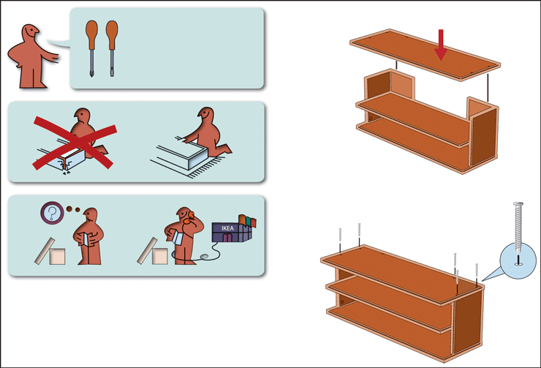

**Source:**Used with the permission of Inter IKEA Systems B.V.

[Figure 19.5](https://revel-ise.pearson.com/eps/sanvan/api/item/2dcdbc14-7038-4c7a-bb35-030be7da7fd0/1/file/lannon_gurak-tc-15e-revel_v4_RR1/OPS/xhtml/ch19_pg0008.xhtml#P7001015517000000000000000004614) presents an array of visuals and their specific instructional functions. You may also require visuals for tasks such as how to repair something or how to understand key measures such as temperature or other measurements. Visuals like these are easily constructed, and some could be further enhanced, depending on your production budget and graphics capability.

# Figure 19.5

Common Types of Instructional Visuals and their Functions

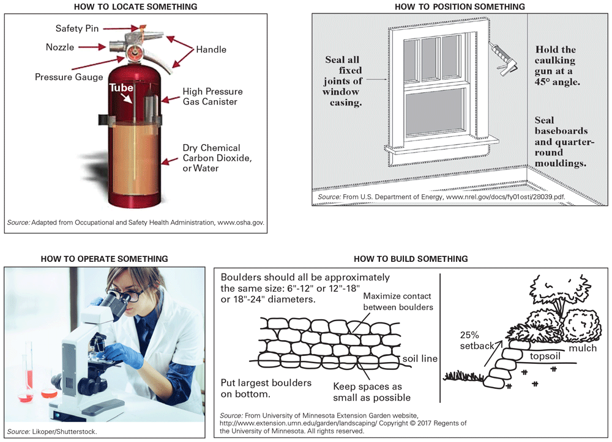

In addition to these examples, use visuals to show other tasks, such as how to perform a procedure (see [Figure 19.6](https://revel-ise.pearson.com/eps/sanvan/api/item/2dcdbc14-7038-4c7a-bb35-030be7da7fd0/1/file/lannon_gurak-tc-15e-revel_v4_RR1/OPS/xhtml/ch19_pg0009.xhtml#P700101551700000000000000000461C)), how to assemble something, how to download something, how to repair something, and many more. Visuals can also provide important safety information (see “[Notes and Hazard Notices](https://revel-ise.pearson.com/eps/sanvan/api/item/2dcdbc14-7038-4c7a-bb35-030be7da7fd0/1/file/lannon_gurak-tc-15e-revel_v4_RR1/OPS/xhtml/ch19_pg0012.xhtml#P7001015517000000000000000004720)” later in this chapter).

Likoper/Shutterstock. From University of Minnesota Extension Garden website, http://www.extension.umn.edu/garden/landscaping/ Copyright © 2017 Regents of the University of Minnesota. All rights reserved.

# 19.4.4 Appropriate Level of Detail and Technicality

 Listen to the Audio

Unless you know your readers have the relevant background and skills, write for a general audience, and do three things:

1. Give readers enough background to understand why they need to follow these instructions.
2. Give enough detail to show *what* to do.
3. Give enough examples so each step can be visualized clearly.

These three procedures are explained and illustrated on the following pages.

# Provide Background

Begin by explaining the purpose of the task.

 Listen to the Audio

You might easily lose information stored on a flash drive if

* The drive is damaged by repeated use, moisture, or extreme temperature;
* The drive is erased by a power surge, a computer malfunction, or a user error; or
* The stored information is scrambled by a nearby magnet (telephone, computer terminal, or the like).

Always use another back-up device, such as a Firewire hard drive, for important material.

Also, state your assumptions about your reader’s level of technical understanding.

 Listen to the Audio

To follow these instructions, you should be able to identify these parts of your iMac: computer, keyboard (wireless or USB), mouse, and external DVD drive.

Define any specialized terms that appear in your instructions.

 Listen to the Audio

*Initialize:*Before you can store or retrieve information on a new CD, you must initialize the disk. Initializing creates a format that computers and CD players can understand—a directory of specific memory spaces on the disk where you can store information and retrieve it as needed.

When the reader understands *what* and *why,* you are ready to explain *how* he or she can complete the task.

# Provide Adequate Detail

Include enough detail for people to understand and perform the task successfully. Omit general information that readers probably know, but if you are uncertain about their knowledge or experience level, do not overestimate the audience’s background, as in the following example of inadequate detail:

 Listen to the Audio

**First Aid for Electrical Shock**

1. Check vital signs.
2. Establish an airway.
3. Administer CPR as needed.
4. Treat for shock.

These steps might be suitable for experts (such as paramedics or nurses), but terms such as “vital signs” and “CPR” are too technical for laypersons. Such instructions posted for workers in a high-voltage area would be useless. Illustrations and explanations are needed, as in the instructions in [Figure 19.6](https://revel-ise.pearson.com/eps/sanvan/api/item/2dcdbc14-7038-4c7a-bb35-030be7da7fd0/1/file/lannon_gurak-tc-15e-revel_v4_RR1/OPS/xhtml/ch19_pg0009.xhtml#P700101551700000000000000000461C) for item 3 above, administering CPR.

# Figure 19.6

Adequate Detail for Laypersons

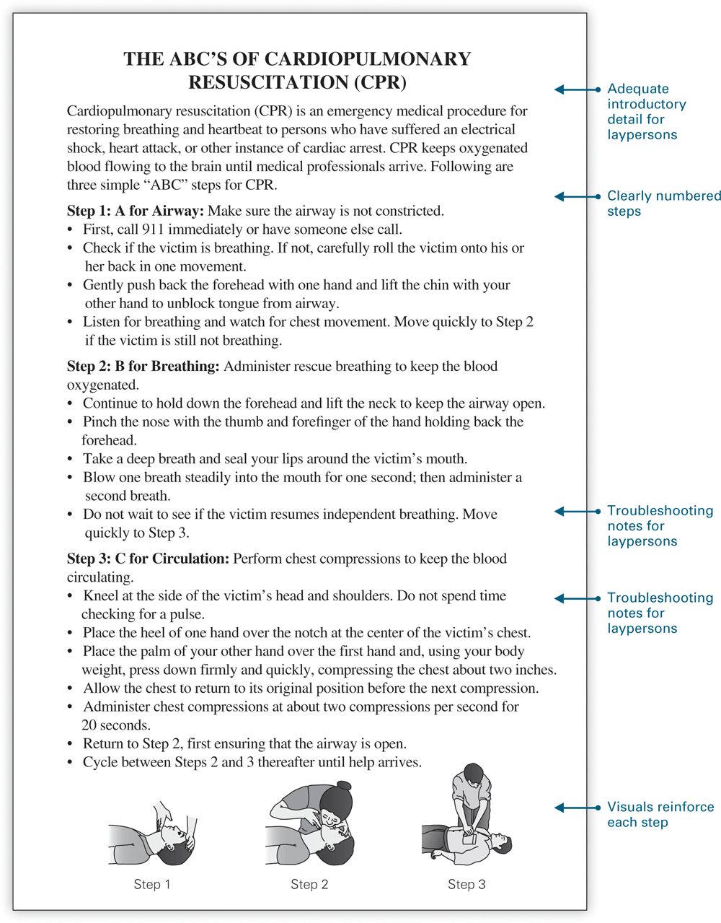

[Figure 19.6 Full Alternative Text Description](https://revel-ise.pearson.com/eps/sanvan/api/item/2dcdbc14-7038-4c7a-bb35-030be7da7fd0/1/file/lannon_gurak-tc-15e-revel_v4_RR1/OPS/longalt/la-fg_19_006.xhtml#longdescid)

Don’t assume that people know more than they really do, especially when you can perform the task almost automatically. (Think about when a relative or friend taught you to drive a car—or perhaps you tried to teach someone else.) When writing for a more general audience, always assume that your readers know less than you. A colleague will know at least a little less; a layperson will know a good deal less—maybe nothing—about this procedure.

Exactly how much information is enough? See “[Guidelines for Providing Appropriate Detail in Instructions](https://revel-ise.pearson.com/eps/sanvan/api/item/2dcdbc14-7038-4c7a-bb35-030be7da7fd0/1/file/lannon_gurak-tc-15e-revel_v4_RR1/OPS/xhtml/ch19_pg0010.xhtml#P70010155170000000000000000046F0)” following this section.

# Offer Examples

Instructions require specific examples (how to load a program, how to order a part) to help people follow the steps correctly:

 Listen to the Audio

To load your program, type this command:  
  
Load “Style Editor”  
  
Then press RETURN.

Like visuals, examples *show* readers what to do. Examples, in fact, often appear as visuals.

# Include Troubleshooting Advice

Anticipate things that commonly go wrong when this task is performed—the paper jams in the printer, the tray of the DVD drive won’t open, or some other malfunction. Explain the probable cause(s) and offer solutions, as in the following example:

 Listen to the Audio

NOTE:  IF X doesn’t work, first check Y and then do Z.

# 19.4.5 Guidelines for Providing Appropriate Detail in Instructions

# Guidelines for Providing Appropriate Detail in Instructions

* ****Provide *all* the necessary information.****The instructions must be able to stand alone.
* ****Don’t provide unnecessary information.****Give only what readers need. Don’t tell them how to build a computer when they only need to know how to copy a file.
* ****Instead of focusing on the *product*, focus on the *task*.****“How does it work?” “How do I use it?” or “How do I do it?” (Grice 132).
* ****Omit steps that are obvious.****“Seat yourself at the computer,” for example.
* ****Divide the task into simple steps and substeps.****Allow people to focus on one step at a time.
* ****Adjust the *information rate*.****this is “the amount of information presented in a given page” (Meyer 17), adjusted to the reader’s background and the difficulty of the task. For complex or sensitive steps, slow the information rate. Don’t make people do too much too fast.
* ****Reinforce the prose with visuals.****Don’t be afraid to repeat information if it saves readers from going back to look something up.
* ****Keep it simple.****When writing instructions for consumer products, assume that your readers are not overly technical and that they have little to no experience with the product.
* ****Recognize the persuasive dimension of the instructions.****Readers may need persuading that this procedure is necessary or beneficial, or that they can complete this procedure with relative ease and competence.

# 19.4.6 Logically Ordered Steps

 Listen to the Audio

Instructions are almost always arranged in chronological order, with warnings and precautions inserted for specific steps.

 Listen to the Audio

You can’t splice two wires to make an electrical connection until you have removed the insulation. To remove the insulation, you will need. …

# 9.4.7 Notes and Hazard Notices

 Listen to the Audio

Following are the only items that normally should interrupt the steps in a set of instructions (Van Pelt 3):

* A *note* clarifies a point, emphasizes vital information, or describes options or alternatives.

 Listen to the Audio

NOTE: If you don’t name a newly initialized hard drive, the computer automatically names it “Untitled.”

While a note is designed to enhance performance and prevent error, the following hazard notices—ranked in order of severity—are designed to prevent damage, injury, or death.

* A *caution*, the least forceful notice, prevents possible mistakes that could result in injury or equipment damage:

 Listen to the Audio

CAUTION: A momentary electrical surge or power failure may erase or damage the contents of an internal hard drive. To avoid losing your work, save your files to a backup disk on a regular basis.

* A *warning*, a moderately forceful notice, alerts readers to potential hazards to life or limb:

 Listen to the Audio

WARNING: To prevent electrical shock, always disconnect your printer from its power source before cleaning internal parts.

* A *danger* notice, the most forceful notice, identifies an immediate hazard to life or limb:

 Listen to the Audio

DANGER: The red canister contains DEADLY radioactive material. **Do not break the safety seal** under any circumstances.

Inadequate notices of warning, caution, or danger are a common cause of lawsuits (see "[Faulty Instructions and Legal Liability](https://revel-ise.pearson.com/eps/sanvan/api/item/2dcdbc14-7038-4c7a-bb35-030be7da7fd0/1/file/lannon_gurak-tc-15e-revel_v4_RR1/OPS/xhtml/ch19_pg0004.xhtml#P700101551700000000000000000464D)" in this chapter). Each hazard notice is legally required to (1) describe the specific hazard, (2) spell out the consequences of ignoring the hazard, and (3) offer instruction for avoiding the hazard (Manning 15).

Even the most emphatic verbal notice might be overlooked by an impatient or inattentive reader. Direct attention with symbols, or icons, as a visual signal (Bedford and Stearns 128), as in the following sampling of hazard symbols:

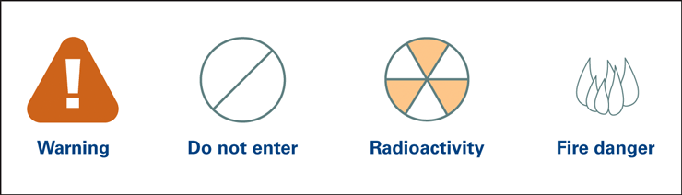

Keep the hazard notices prominent: Preview the hazards in your introduction and place each notice, *clearly highlighted* (by a ruled box, a distinct typeface, larger type size, or color), immediately before the respective step.

**Note:**  Use hazard notices only when needed; overuse will dull their effect, and readers may overlook their importance.

19.4.8 Readability

Listen to the Audio

Instructions must be understood on the first reading because people want to take immediate action. Like descriptions (Chapter 18), instructions name parts, use location and position words, and state exact measurements, weights, and dimensions. Instructions additionally require your strict attention to phrasing, sentence structure, and paragraph structure.

Use Direct Address, Active Voice, and Imperative Mood

Write instructions in the second person, as direct address, in order to emphasize the role of the reader.

In general, begin all steps and substeps with action verbs, using the active voice and imperative mood (“Insert the disk” instead of “The disk should be inserted” or “You should insert the disk”). In the following example, the steps are indirect and confusing:

Listen to the Audio

The user keys in his or her access code.

You should key in your access code.

It is important to key in the access code.

The access code is keyed in.

In this next clear and direct version, the opening verb announces the specific action required:

Listen to the Audio

Key in your access code.

In certain cases, you may want to provide a clarifying word or phrase that precedes the verb (Read Me 130), as in the following example:

Listen to the Audio

[To log on,] key in your access code.

[If your screen displays an error message,] restart the computer.

[Slowly] scan the seal for gamma ray leakage.

[In the Edit menu,] click on Paste.

Note: Certain cultures consider the direct imperative bossy and offensive. For cross-cultural audiences, you might rephrase an instruction as a declarative statement: from “Key in your access code” to “The access code should be keyed in.” Or you might use an indirect imperative such as “Be sure to key in your access code” (Coe, “Writing” 18).

Use Short and Logically Shaped Sentences

Use shorter sentences than usual, but never “telegraph” your message by omitting articles (a, an, the). Use one sentence for each step, so that people can perform one step at a time.

If a single step covers two related actions, describe these actions in their required sequence. The following sentence is out of sequence and confusing:

Listen to the Audio

Before switching on the computer, insert the DVD in the drive.

This corrected version follows a logical sequence:

Listen to the Audio

Insert the DVD in the drive; then switch on the computer.

Simplify explanations by using a familiar-to-unfamiliar sequence. The following sentence is hard to follow, due to its unfamiliar-to-familiar sequence:

Listen to the Audio

You must initialize a blank CD before you can store information on it.

This corrected version follows an easier familiar-to-unfamiliar sequence:

Listen to the Audio

Before you can store information on a blank CD, you must initialize the CD.

Use Parallel Phrasing

Parallelism is important in all writing but especially so in instructions, because repeating grammatical forms emphasizes the step-by-step organization. Parallelism also increases readability and lends continuity to the instructions. The following example is difficult to follow because the phrasing of the steps is not parallel:

Listen to the Audio

To connect to the server, follow these steps:

Switch the terminal to “on.”

The CONTROL key and C key are pressed simultaneously.

Typing LOGON, and pressing the ESCAPE key.

Type your user number, and then press the ESCAPE key.

All steps should be in identical grammatical form, as in the following easier-to-follow parallel example:

Listen to the Audio

To connect to the server, follow these steps:

Switch the device to “on.”

Press the CONTROL key and C key simultaneously.

Type LOGON, and then press the ESCAPE key.

Type your user number, and then press the ESCAPE key.

Phrase Instructions Affirmatively

Research shows that people respond more quickly and efficiently to instructions phrased affirmatively rather than negatively (Spyridakis and Wenger 205). The following sentence is phrased negatively, slowing readers down:

Listen to the Audio

Verify that your camera lens is not contaminated with dust.

This corrected version with affirmative phrasing is easier to grasp on a first reading:

Listen to the Audio

Examine your camera lens for dust.

Use Transitions to Mark Time and Sequence

Transitional expressions (see Appendix B, “Transitions”) provide a bridge between related ideas. Some transitions (“first,” “next,” “meanwhile,” “finally,” “ten minutes later,” “the next day,” “immediately afterward”) mark time and sequence. They help readers understand the step-by-step process, as in the next example. (Bold face is used to illustrate the transitions.)

Listen to the Audio

Preparing the Ground for a Tent

Begin by clearing and smoothing the area that will be under the tent. This step will prevent damage to the tent floor and eliminate the discomfort of sleeping on uneven ground. First, remove all large stones, branches, or other debris within a level area roughly 10 × 10 feet. Use your camping shovel to remove half-buried rocks that cannot easily be moved by hand. Next, fill in any large holes with soil or leaves. Finally, make several light surface passes with the shovel or a large, leafy branch to smooth the area.

19.4.9 Effective Design

Instructions rarely get undivided attention. The reader, in fact, is doing two things more or less at once: interpreting the instructions and performing the task. An effective instructional design conveys the sense that the task is within a qualified person’s range of abilities. The more accessible and inviting the design, the more likely your readers will follow the instructions.

19.4.10 Guidelines for Designing Instructions

Guidelines for Designing Instructions

* **Use informative headings.**Tell readers what to expect; emphasize what is most important; provide cues for navigation. A heading such as “How to Initialize Your Compact Disk” is more informative than “Compact Disk Initializing.”
* **Arrange all steps in a numbered list.**Unless the procedure consists of simple steps (as in “Preparing the Ground for a Tent,” above), list and number each step. Numbered steps not only announce the sequence of steps, but also help readers remember where they left off. (For more on using lists, see [Appendix B](https://revel-ise.pearson.com/eps/sanvan/api/item/2dcdbc14-7038-4c7a-bb35-030be7da7fd0/1/file/lannon_gurak-tc-15e-revel_v4_RR1/OPS/xhtml/bm02_pg0001.xhtml#P70010155170000000000000000061D5), “[Lists](https://revel-ise.pearson.com/eps/sanvan/api/item/2dcdbc14-7038-4c7a-bb35-030be7da7fd0/1/file/lannon_gurak-tc-15e-revel_v4_RR1/OPS/xhtml/bm02_pg0037.xhtml#P7001015517000000000000000006556).”)
* **Separate each step visually.**Single-space within steps and double-space between.
* **Double-space to signal a new paragraph, instead of indenting.**
* **Make warning, caution, and danger notices highly visible.**Use ruled boxes or highlighting, and plenty of white space.
* **Make visual and verbal information redundant.**Let the visual repeat, restate, or reinforce the prose.
* **Keep the visual and the step close together.**If room allows, place the visual right beside the step; if not, right after the step. Set off the visual with plenty of white space.
* **Consider a multicolumn design.**If steps are brief and straightforward and require back-and-forth reference from prose to visuals, consider multiple columns.
* **Keep it simple.**Readers can be overwhelmed by a page with excessive or inconsistent designs.
* **For lengthy instructions, consider a layered approach.**In a complex manual, for instance, you might add a “Quick Start Guide” for getting started, with cross-references to pages containing more detailed and technical information. PDF documents can provide a layered approach by using links.
* **For online instructions, use the appropriate software to format the information.**See ”[Online and Social Media Instructions](https://revel-ise.pearson.com/eps/sanvan/api/item/2dcdbc14-7038-4c7a-bb35-030be7da7fd0/1/file/lannon_gurak-tc-15e-revel_v4_RR1/OPS/xhtml/ch19_pg0017.xhtml#P7001015517000000000000000004872)” in this chapter.

For additional design considerations, see [Chapter 13](https://revel-ise.pearson.com/eps/sanvan/api/item/2dcdbc14-7038-4c7a-bb35-030be7da7fd0/1/file/lannon_gurak-tc-15e-revel_v4_RR1/OPS/xhtml/ch13_pg0001.xhtml#P7001015517000000000000000003081).

19.5 Online and Social Media Instructions

1. Explain the benefits of online and social media instructions

Because of the costs involved in printing and updating instructions, especially lengthy user manuals, companies have shifted toward a combination of print and digital or have moved to digital entirely. Most products now come with a “Getting Started” quick reference guide and then direct readers to a Web site where they can access the longer, complete instruction manual. Companies also realize that people usually lose or misplace their original instructions or manual. By putting these documents on a Web site, these organizations save countless hours of time (answering phone calls or emails) and expense. Customers are also happy when they can find the manual they’ve been looking for and download it right when they need it.

The most common online format for instructional material is PDF, which retains the proper formatting no matter what computer or device is being used. For more information on PDF, see [Chapter 13](https://revel-ise.pearson.com/eps/sanvan/api/item/2dcdbc14-7038-4c7a-bb35-030be7da7fd0/1/file/lannon_gurak-tc-15e-revel_v4_RR1/OPS/xhtml/ch13_pg0001.xhtml#P7001015517000000000000000003081) “[Adobe Acrobat and PDF files.](https://revel-ise.pearson.com/eps/sanvan/api/item/2dcdbc14-7038-4c7a-bb35-030be7da7fd0/1/file/lannon_gurak-tc-15e-revel_v4_RR1/OPS/xhtml/ch13_pg0018.xhtml#P70010155170000000000000000032DE)” [Figure 19.7](https://revel-ise.pearson.com/eps/sanvan/api/item/2dcdbc14-7038-4c7a-bb35-030be7da7fd0/1/file/lannon_gurak-tc-15e-revel_v4_RR1/OPS/xhtml/ch19_pg0016.xhtml#P7001015517000000000000000004626), the instructions for replacing a worn faucet washer, would be easy to convert to PDF using Microsoft Word or Apple Pages (just “Save as PDF”).

19.5.1 Online Help

Unlike online user manuals and guides, online help is part of the product or software and provides quick answers, directs people to tasks they want to perform, and offers links to additional information. [Figure 19.8](https://revel-ise.pearson.com/eps/sanvan/api/item/2dcdbc14-7038-4c7a-bb35-030be7da7fd0/1/file/lannon_gurak-tc-15e-revel_v4_RR1/OPS/xhtml/ch19_pg0018.xhtml#P700101551700000000000000000462D) shows a typical online help screen for Microsoft Word. In this example, a person is trying to create a table; after entering “table” in the help search bar, the software guided her to the appropriate menu. More detailed help information on creating a table is also available by clicking on a link in the right-hand column of the screen.

Figure 19.8

Online Help Screen

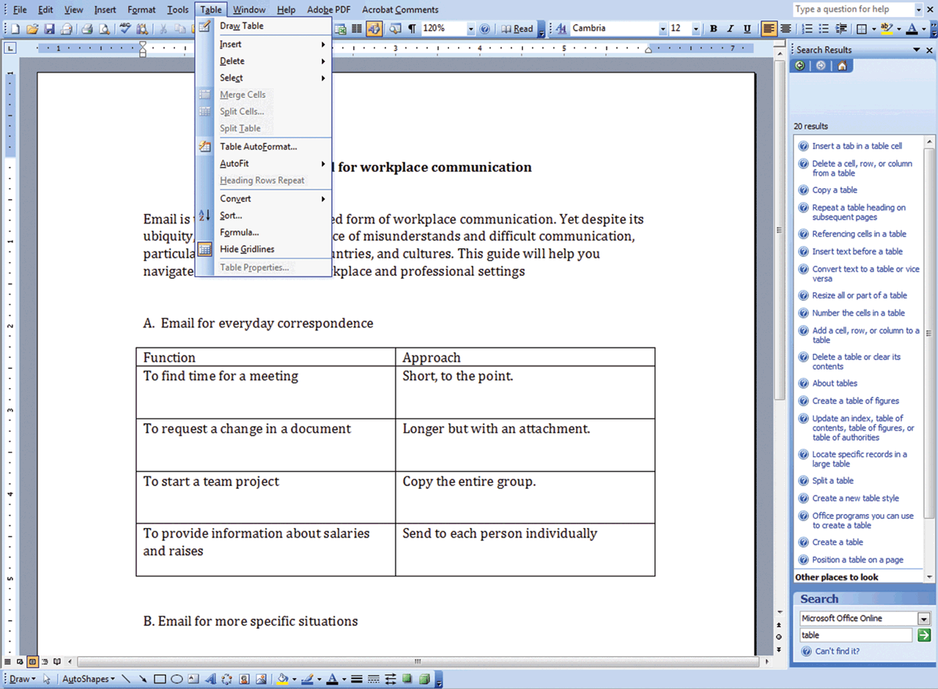

**Source:**Microsoft Word 2003.

As with Web pages ([Chapter 24](https://revel-ise.pearson.com/eps/sanvan/api/item/2dcdbc14-7038-4c7a-bb35-030be7da7fd0/1/file/lannon_gurak-tc-15e-revel_v4_RR1/OPS/xhtml/ch24_pg0001.xhtml#P7001015517000000000000000005914)), online help should be written in short chunks. Experienced technical writers use special software, such as Adobe RoboHelp, to convert content into the appropriate format for online help. Online help can be coded to be *context sensitive*; that is, when people get stuck, the system recognizes what task they are trying to perform and offers help for that situation. You can also search using the help menu to locate information on specific tasks. Online help can be found in all kinds of apps and in many new consumer products such as cars, refrigerators, DVRs, and more. People appreciate being able to get help when they need it, rather than having to search around for the original user manual.

19.5.2 Social Media Instructions

Many people turn to social media for instructions, typically starting with a search on YouTube. Almost anyone with a cell phone can make an instructional video, and there can be dozens if not hundreds of videos posted on the same topic, each of differing qualities. For example, if you search on topics such as “how to do my own oil change,” “how to change the strings on a classical guitar,” or “how to program the remote to my garage door opener,” you will find more videos than you can possibly imagine, some of which are easy to follow, accurate, and thorough, but others that are almost unusable. Sorting through these videos and determining which ones are credible (and have been tested) and which ones are not can be incredibly time-consuming. Many of the people who make and upload instructional videos receive commercial compensation via ads, which is not necessarily bad but adds to the items that audiences must consider when choosing a credible, usable video for instructions.

If you work for an organization that creates instructional videos, you may wish to put videos on your company’s main Web site and Facebook page. The video can be run right from your server or from a YouTube link. Having these videos available on your official company page or social media feed provides customers with the confidence to know that these instructions are direct from the source and have been tested and authorized by the engineers, technicians, and others at your organization.

A big advantage of video instructions is the ability for customers to comment and rate the video (thumbs up or down). Customers are usually more than happy to point out places where the video is inaccurate or could use more detail. Remember that as with all forms of instructions, instructional videos need to take safety into account at all times. In a video, you may need to repeat the safety and caution information and include text frames that restate and summarize important safety considerations.

[Chapter 25](https://revel-ise.pearson.com/eps/sanvan/api/item/2dcdbc14-7038-4c7a-bb35-030be7da7fd0/1/file/lannon_gurak-tc-15e-revel_v4_RR1/OPS/xhtml/ch25_pg0001.xhtml#P7001015517000000000000000005B93) discusses using social media for technical communication, including a complete section on creating video instructions and using sites such as YouTube, Vimeo, and others to post the video and interact with customers. As you work on the documents for this chapter, consider how these

19.6 Procedures

1. Write procedures to help groups of people coordinate their activities

*Instructions* show an uninitiated person how to perform a task. *Procedures,* on the other hand, provide rules and guidance for people who usually know how to perform the task but who are required to follow accepted practice. To ensure that everyone does something in exactly the same way, procedures typically are aimed at groups of people who need to coordinate their activities so that everyone’s performance meets a certain standard. Consider, for example, police procedures for properly gathering evidence from a crime scene: Strict rules stipulate how evidence should be collected and labeled and how it should be preserved, transported, and stored. Evidence shown to have been improperly handled is routinely discredited in a courtroom.

Organizations need to follow strict safety procedures as defined by the U.S. Occupational Safety and Health Administration (OSHA) and other federal, state, and local government agencies. As laws and policies change, such procedures are often updated. The written procedures must be posted for employees to read. [Figure 19.9](https://revel-ise.pearson.com/eps/sanvan/api/item/2dcdbc14-7038-4c7a-bb35-030be7da7fd0/1/file/lannon_gurak-tc-15e-revel_v4_RR1/OPS/xhtml/ch19_pg0020.xhtml#P70010155170000000000000000048A0) shows one page outlining OSHA regulations for evacuating high-rise buildings. This document is available in PDF on the OSHA Web site; it can be printed as well as shared with employees via email.

Figure 19.9

Safety Procedures

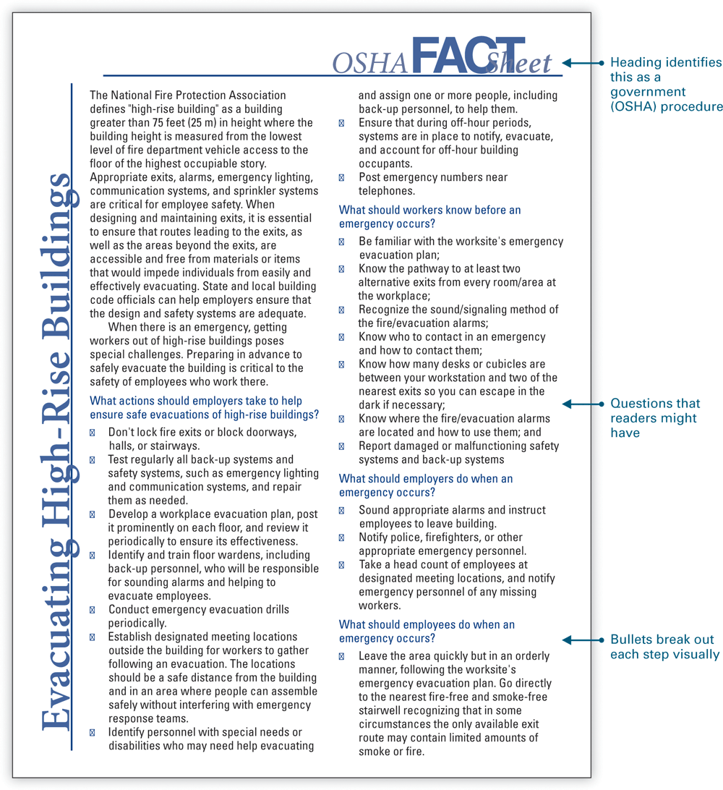

This page defines general safety and evacuation procedures to be followed by employers and employees. Each building in turn is required to have its own specific procedures, based on such variables as location, design, and state law.

**Source:**U.S. Occupational Safety and Health Administration, 2007, www.osha.gov.

Procedures are also useful in situations in which certain tasks need to be standardized. For example, if different people in your organization perform the same task at different times (say, monitoring groundwater pollution) with different equipment, or under different circumstances, this procedure may need to be standardized to ensure that all work is done with the same accuracy and precision. A document known as a *Standard Operating Procedure (SOP)* becomes the official guideline for that task. SOPs for complicated procedures may be many pages long, while those written for simpler procedures might only be a few pages in length. In many situations, such as manufacturing facilities, SOPs must be kept updated (usually by a team of engineers and technical writers) and be available for review during government safety inspections. See [Figure 19.10](https://revel-ise.pearson.com/eps/sanvan/api/item/2dcdbc14-7038-4c7a-bb35-030be7da7fd0/1/file/lannon_gurak-tc-15e-revel_v4_RR1/OPS/xhtml/ch19_pg0020.xhtml#P70010155170000000000000000048AB) for an example of a Standard Operating Procedure.

Figure 19.10

Standard Operating Procedure

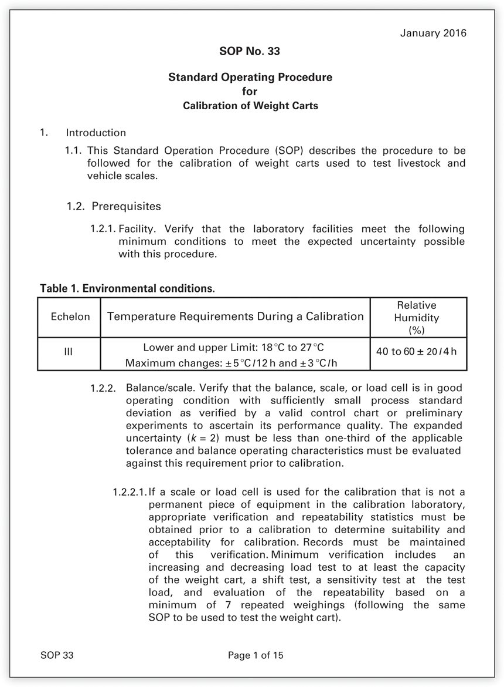

Page one of a fifteen page SOP from the National Institutes of Standards and Technology describing the official procedure for calibrating weight carts (a device used to test large scales, such as those used for weighing livestock). This SOP uses an outline-style numbering system to list the required steps, starting with steps for balancing the scale. The format is simple and easy to read.

**Source: https://www.nist.gov/pml/weights-and-measures/standard-operating-procedures.**

[Figure 19.10 Full Alternative Text Description](https://revel-ise.pearson.com/eps/sanvan/api/item/2dcdbc14-7038-4c7a-bb35-030be7da7fd0/1/file/lannon_gurak-tc-15e-revel_v4_RR1/OPS/longalt/la-fg_19_010.xhtml#longdescid)

The steps in a procedure may or may not need to be numbered. This choice will depend on whether or not steps must be performed in strict sequence. Compare, for example, [Figure 19.9](https://revel-ise.pearson.com/eps/sanvan/api/item/2dcdbc14-7038-4c7a-bb35-030be7da7fd0/1/file/lannon_gurak-tc-15e-revel_v4_RR1/OPS/xhtml/ch19_pg0020.xhtml#P70010155170000000000000000048A0) versus [Figure 19.10](https://revel-ise.pearson.com/eps/sanvan/api/item/2dcdbc14-7038-4c7a-bb35-030be7da7fd0/1/file/lannon_gurak-tc-15e-revel_v4_RR1/OPS/xhtml/ch19_pg0020.xhtml#P70010155170000000000000000048AB).

# 19.7 Evaluating the Usability of Instructions and Procedures

1. Evaluate the usability of instructional documents

A usable document enables readers to easily locate the information they need, understand this information immediately, and use it safely and effectively (Coe, Human Factors 193; Spencer 74). When you write and design any type of workplace or technical document, the end goal is for people to be able to *use* the document successfully. Although usability is an important feature of all documents, it is critical with instructions and procedures because of safety and liability concerns (see “[Faulty Instructions and Legal Liability](https://revel-ise.pearson.com/eps/sanvan/api/item/2dcdbc14-7038-4c7a-bb35-030be7da7fd0/1/file/lannon_gurak-tc-15e-revel_v4_RR1/OPS/xhtml/ch19_pg0004.xhtml#P700101551700000000000000000464D)” earlier in this chapter).

Once you have created a first draft, you can conduct some basic usability evaluations to see how people use your document and to determine whether you need to revise the instructional material. Obtaining this feedback in the early stages enables you to correct errors or problems before the instructions are finalized.

19.7.1 Usability and the User Experience

Companies are increasingly interested in the overall “user experience” (UX). In many organizations, teams of technical writers, designers, engineers, and marketing specialists work together to ensure that customers have an outstanding experience with the product *and* its documentation. Instructions are key to the user experience: if instructional documents are too hard to understand, don’t provide accurate information, contain poorly rendered drawings, or cause frustration, people will often return the entire product and purchase a different brand.

One way to evaluate the user experience is to conduct some basic usability testing. You can do this by observing how people read, respond to, and work with your document. Begin by identifying the performance objectives—the precise tasks or goals readers must accomplish successfully, or the precise knowledge they must acquire (Carliner, “Physical” 564; Zibell 13). For example, the tasks involved in [Figure 19.7](https://revel-ise.pearson.com/eps/sanvan/api/item/2dcdbc14-7038-4c7a-bb35-030be7da7fd0/1/file/lannon_gurak-tc-15e-revel_v4_RR1/OPS/xhtml/ch19_pg0016.xhtml#P7001015517000000000000000004626) (instructions for replacing a worn faucet washer) are evident by the numbered steps. Readers must successfully complete each of these main steps as well as the tasks within each step. For instance, Step 2, “Disassemble the faucet,” contains substeps (open the faucet; remove the screw; remove the handle; remove the packing nut). Your document is considered usable if readers are able to successfully complete these tasks, from start to finish.

Usability testing on documents that involve regulation (medical devices, for example, which are regulated by the Food and Drug Administration) or in other high-stakes settings is usually conducted by experts with training and experience in this area. Yet all instructional and procedural documents can benefit from basic usability testing. Conducting such testing and revising your document before publication can save your organization time, money, and potential legal challenges.

**Note:**  In some companies, technical writing and usability jobs are often combined into positions called “UX engineers” or the like. If your college offers a class in usability, see if you can take it. Otherwise, look online for the Usability Professionals Association (UPA) and see if your campus has a student chapter.

19.7.2 Approaches for Evaluating a Document’s Usability

Using the Audience and Use Profile ([Chapter 2](https://revel-ise.pearson.com/eps/sanvan/api/item/2dcdbc14-7038-4c7a-bb35-030be7da7fd0/1/file/lannon_gurak-tc-15e-revel_v4_RR1/OPS/xhtml/ch02_pg0001.xhtml#P7001015517000000000000000000335), ”[Develop an Audience and Use Profile](https://revel-ise.pearson.com/eps/sanvan/api/item/2dcdbc14-7038-4c7a-bb35-030be7da7fd0/1/file/lannon_gurak-tc-15e-revel_v4_RR1/OPS/xhtml/ch02_pg0021.xhtml)”), expand on the “Intended use of document” and “Information needs” items. What are the precise tasks readers need to accomplish using this document? How much time will readers typically have—a few minutes, or several hours? What other factors are key to your understanding of what will make your instructions or procedures usable?

Once you have answered these questions, check your document using the ”[Checklist: Analyzing Audience and Purpose](https://revel-ise.pearson.com/eps/sanvan/api/item/2dcdbc14-7038-4c7a-bb35-030be7da7fd0/1/file/lannon_gurak-tc-15e-revel_v4_RR1/OPS/xhtml/ch02_pg0022.xhtml)” in [Chapter 2](https://revel-ise.pearson.com/eps/sanvan/api/item/2dcdbc14-7038-4c7a-bb35-030be7da7fd0/1/file/lannon_gurak-tc-15e-revel_v4_RR1/OPS/xhtml/ch02_pg0001.xhtml#P7001015517000000000000000000335), along with the specific Checklist for the given document (for example, “[Checklist: Instructions and Procedures](https://revel-ise.pearson.com/eps/sanvan/api/item/2dcdbc14-7038-4c7a-bb35-030be7da7fd0/1/file/lannon_gurak-tc-15e-revel_v4_RR1/OPS/xhtml/ch19_pg0024.xhtml)” in this chapter). Revise if necessary. Then, you can use two approaches to test the document’s usability. Be sure to run your tests on people who represent the typical audience for the situation. For instance, if your audience for [Figure 19.7](https://revel-ise.pearson.com/eps/sanvan/api/item/2dcdbc14-7038-4c7a-bb35-030be7da7fd0/1/file/lannon_gurak-tc-15e-revel_v4_RR1/OPS/xhtml/ch19_pg0016.xhtml#P7001015517000000000000000004626) is homeowners who have experience using basic tools and doing simple home repairs, do not test your documents with people who have never used a pair of pliers.

Revise your document based on what you learn from the usability evaluations. If time permits, see if you can set up a second usability test on the revised version, but don’t run it on the same people from the first test.

Think-Aloud Evaluation

In this approach, you will need three to five people but should test them one at a time. Each person is provided with your instructions and a way he or she can actually test the document. For instance, if your instructions explain how to connect a digital camera to a computer, provide a camera, cable, and laptop. Ask subjects to “think out loud” (talk about what they are doing) as they try to follow your instructions. Note those places where people are successful and where they get stuck. Don’t coach them but do remind them to describe their thinking (sometimes when people are concentrating, they will stop talking, and you need to ask them “what are you thinking now?” or something along those lines). After the test is concluded, follow up with questions about places where your document seemed unclear or where people seemed to have particular problems. Take good notes and, at the end of your tests, compare findings to look for common themes.

Focus Groups

In this approach, eight to ten people are provided with the instructions and are asked to complete the task. Based on a targeted list of questions about the document’s content, organization, style, and design (Basic Usability Survey, [Figure 19.11](https://revel-ise.pearson.com/eps/sanvan/api/item/2dcdbc14-7038-4c7a-bb35-030be7da7fd0/1/file/lannon_gurak-tc-15e-revel_v4_RR1/OPS/xhtml/ch19_pg0023.xhtml#P70010155170000000000000000048E2)), focus group members are asked to complete the survey and then describe (out loud) what information they think is missing or excessive, what they like or dislike, and what they find easy or hard to understand. They may also suggest revisions for graphics, format, word choice, platform (is the print copy easier to use than the online version? How about the phone app?), or level of technicality.

Figure 19.11

A Basic Usability Survey

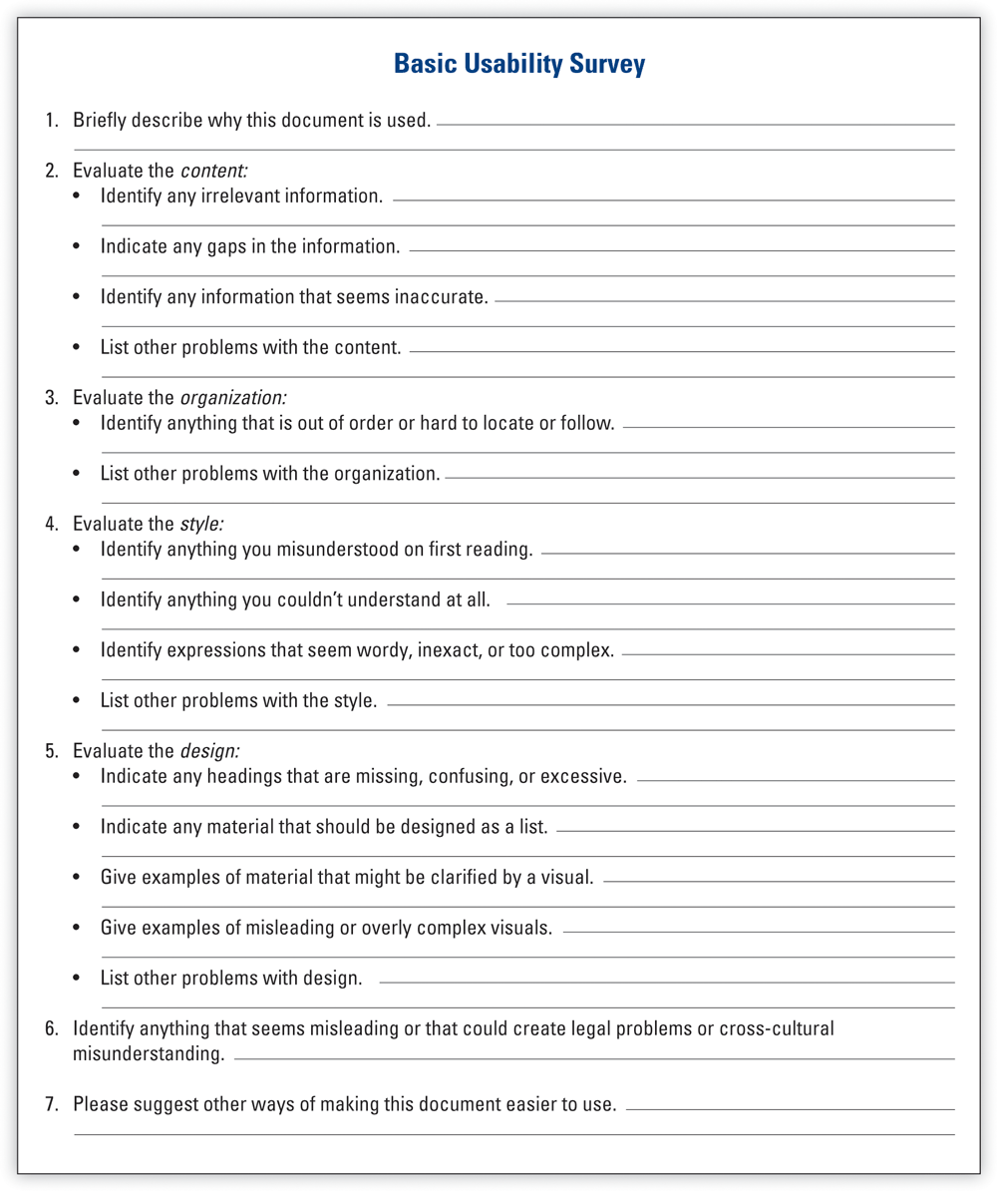

Versions of these questions can serve as a basis for testing your document.

**Source:**Based on Carliner, “Demonstrating Effectiveness” 258.

Projects: Instructions and Procedures

Projects

For all projects, check with your instructor about whether to present your findings in class, bring drafts to class for discussion, upload your project to the class learning management system (LMS), and/or use the LMS forum or discussion boards to collaborate and review each activity below.

General

1. Improve readability by revising the style and design of these instructions.

**What to Do Before Jacking Up Your Car**

Whenever the misfortune of a flat tire occurs, some basic procedures should be followed before the car is jacked up. If possible, your car should be positioned on as firm and level a surface as is available. The engine has to be turned off; the parking brake should be set; and the automatic transmission shift lever must be placed in “park” or the manual transmission lever in “reverse.” The wheel diagonally opposite the one to be removed should have a piece of wood placed beneath it to prevent the wheel from rolling. The spare wheel, jack, and lug wrench should be removed from the luggage compartment.

1. Select part of a technical manual in your field or instructions for a general audience and make a copy of the material. Using ”[Checklist: Instructions and Procedures](https://revel-ise.pearson.com/eps/sanvan/api/item/2dcdbc14-7038-4c7a-bb35-030be7da7fd0/1/file/lannon_gurak-tc-15e-revel_v4_RR1/OPS/xhtml/ch19_pg0024.xhtml)” in this chapter, evaluate the sample’s usability. In a memo to your instructor, discuss the strong and weak points of the instructions. Or explain your evaluation in class.
2. Assume that colleagues or classmates will be serving six months as volunteers in agriculture, education, or a similar capacity in a developing country. Do the research and create a set of procedures that will prepare individuals for avoiding diseases and dealing with medical issues in that specific country. Topics might include safe food and water, insect protection, vaccinations, medical emergencies, and the like. Be sure to provide background on the specific health risks that travelers will face. Design your instructions as a two-sided brief reference card, as a chapter to be included in a longer manual, a PDF page, or in some other format suggested by your instructor.
3. Select any one of the instructional visuals in [Figure 19.4](https://revel-ise.pearson.com/eps/sanvan/api/item/2dcdbc14-7038-4c7a-bb35-030be7da7fd0/1/file/lannon_gurak-tc-15e-revel_v4_RR1/OPS/xhtml/ch19_pg0008.xhtml#P700101551700000000000000000460D) and write a prose version of those instructions—without using visual illustrations or special page design. Bring your version to class and be prepared to discuss the conclusions you’ve derived from this exercise.
4. Find a set of instructions or some other technical document that is easy to use. Assume that you are Associate Director of Communications for the company that produced this document and you are doing a final review before the document is released. With “[Checklist: Instructions and Procedures](https://revel-ise.pearson.com/eps/sanvan/api/item/2dcdbc14-7038-4c7a-bb35-030be7da7fd0/1/file/lannon_gurak-tc-15e-revel_v4_RR1/OPS/xhtml/ch19_pg0024.xhtml)" as a guide, identify those features that make the document usable and prepare a memo to your boss that justifies your decision to release the document.

Following the identical scenario, find a document that is hard to use, and identify the features that need improving. Prepare a memo to your boss that spells out the needed improvements. Submit both memos and the examples to your instructor.

Team

1. Draw a map of the route from your classroom to your dorm, apartment, or home—whichever is closest. Be sure to include identifying landmarks. When your map is completed, write instructions for a classmate who will try to duplicate your map from the information given in your written instructions. Be sure your classmate does not see your map, and don’t let either person use GPS. Exchange your instructions and try to duplicate your classmate’s map. Compare your results with the original map. Discuss your conclusions about the usability of these instructions.
2. Divide into small groups and locate fairly brief instructions that could use revision for improved content, organization, style, or format. (Hint: look at the instructions that came with your most recent purchase.) Choose instructions for a procedure you are able to perform. Make a copy of the instructions, test them for usability, and revise as needed. Submit all materials to your instructor, along with a memo explaining the improvements. Or be prepared to discuss your revision in class.
3. Test the usability of a document prepared for this chapter or [Chapter 18](https://revel-ise.pearson.com/eps/sanvan/api/item/2dcdbc14-7038-4c7a-bb35-030be7da7fd0/1/file/lannon_gurak-tc-15e-revel_v4_RR1/OPS/xhtml/ch18_pg0001.xhtml#P7001015517000000000000000004277) by using the think-aloud evaluation (see “[Approaches for Evaluating a Document’s Usability](https://revel-ise.pearson.com/eps/sanvan/api/item/2dcdbc14-7038-4c7a-bb35-030be7da7fd0/1/file/lannon_gurak-tc-15e-revel_v4_RR1/OPS/xhtml/ch19_pg0023.xhtml#P70010155170000000000000000048D7)” in this chapter). Begin by adapting the Audience and Use Profile Sheet ([Chapter 2](https://revel-ise.pearson.com/eps/sanvan/api/item/2dcdbc14-7038-4c7a-bb35-030be7da7fd0/1/file/lannon_gurak-tc-15e-revel_v4_RR1/OPS/xhtml/ch02_pg0001.xhtml#P7001015517000000000000000000335), “Develop an Audience and Use Profile”) to include more questions about the intended use of the document. To become familiar with the technique, first practice the think-aloud evaluation on something simple (such as a one page set of instructions on how to get from your classroom to the nearest pizza shop). Then, run the test on your actual document. Take plenty of notes, and when the test is completed, use the Basic Usability Survey ([Figure 19.11](https://revel-ise.pearson.com/eps/sanvan/api/item/2dcdbc14-7038-4c7a-bb35-030be7da7fd0/1/file/lannon_gurak-tc-15e-revel_v4_RR1/OPS/xhtml/ch19_pg0023.xhtml#P70010155170000000000000000048E2)) to ask follow-up questions. Revise the document based on your observations.

Digital and Social Media

Think of a product you have at home, such as your coffee maker, dishwasher, Wi-Fi router, or DVD player. Imagine that the product is not working and you can’t find the original instruction manual. Search online for the user manual for that specific product and model number. Did your search send you to the company’s Web site, or did you find the manual on another site? How easy or difficult was it to locate? Is the manual in PDF and easy to download? Can you find the manual for all models or just newer ones? Write a one-page set of instructions to help others locate similar manuals online.

Global

In many cultures, the use of imperative mood is considered impolite or too direct. For instance, instructions that state “Place the disk into the disk drive” may sound bossy and inconsiderate. Find a set of instructions that use imperative mood (for example, [Figure 19.7](https://revel-ise.pearson.com/eps/sanvan/api/item/2dcdbc14-7038-4c7a-bb35-030be7da7fd0/1/file/lannon_gurak-tc-15e-revel_v4_RR1/OPS/xhtml/ch19_pg0016.xhtml#P7001015517000000000000000004626) in this chapter) and rewrite these for a cross-cultural audience where the imperative mood would be offensive. For instance, you might use an indirect imperative (“Be sure to insert the disk into the drive”).