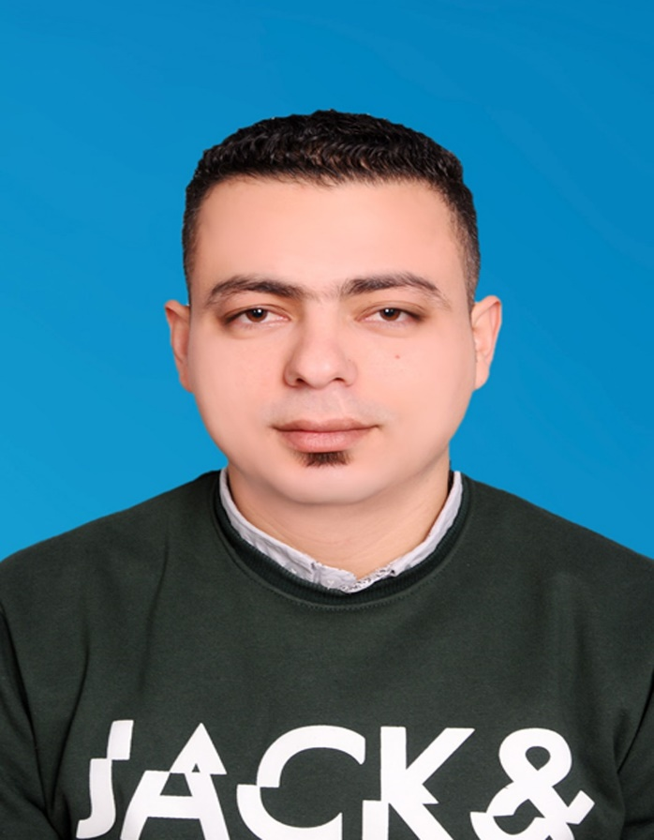

Bachelor of Sports Education

Beni suef University

Mahmoud Mohamed amin Mohamed

El Mahboula-block 2-212 street-Builing

96078001

mahmoudamin904@gmail.com

**Work in Samsung Egypt**

Experience

Work in Samsung Egypt (2013 – 2015)

Education

Lorem ipsum dolor sit amet, consectetur adipisicing elit, sed do eiusmod tempor incididunt ut labore et dolore magna aliqua. Ut enim ad minim veniam, quis nostrud exercitation ullamco laboris nisi ut aliquip ex ea commodo consequat. Duis aute irure dolor in reprehenderit in voluptate velit esse cillum dolore eu fugiat nulla pariatur. Lorem ipsum dolor sit amet, consectetur.

ABOUT ME

Skills

Lorem Ipsum:

Web Develop:

Graphic Design:

Consectetur elit:

Dolor sit amet: