COMPUTER SCIENCE PROJECT

ATM DATABASE

Name: Bishop Sarkar

Roll No.-

Date :

Roll No. :

Signature of Internal Signature of External
Examiner Examiner

__________________ __________________

ACKNOWLEDGEMENT

I thank my Computer Science teacher Mrs. Sushma Mukherjee for her guidance and support. I also thank my Principal ___Miss mukta nain__. Finally I would like to thank CBSE for giving me this opportunity to undertake this project.

CONTENTS

- Synopsis
- System Analysis
- Fundamental requirement
- Code Testing
- Source code
6. SOFTWARE OUTPUT
7. User manual
8. Future Enhancement
9. Conclusion
10. Bibliography

SYNOPSIS

OBJECTIVES OF THE PROJECT

h

The various reasons which led to the conversion of the manual system of the bank to the computerized system are as follows:-
- Entry of information in various registers was a very hectic job for the customer.
- The entry of information causing error in entering details of customer.
- Even the redundancy of the record was also found through they had taken certain precautions like entering the information with the pencil, leaving the space for making the entry in future, if not possibly confirmed about the details.
- The error prone details causing the making in the other related registers, which might some problem while producing reports.
- Even a lot of times begin spent on the entering of details after crosschecking details from various registers.
- Then the security of these registers being a major problem. Even a single page should not be teased. Then it should not get into the hand of some unauthorized person.
- And last but not least, because it is vary calculation oriented and computerized system can be used for given current result always.
The proposed ATM system will make current manual system easy to monitor, efficient and almost error free.

HARDWARE & SOFTWARE REQUIREMENT

- HARDWARE REQUIREMENT-
An Intel based central processing unit capable of running any sort of windows operating system such as Pentium based workstation.

- Minimum 64 MB RAM (128 MB Desirable) at server.
- Minimum 60 MB of free disk space for files.
- A CD Rom drive
- Minimum 48 MB of RAM at workstation.
- VGA 15” color monitor for workstation.

- SOFTWARE REQUIREMENT-
The software requirements are as follows.

- Windows 98 or Above
- C++ editor
- Microsoft word

INTRODUCTION

ATM system involves maintaining of account related information. This requires greater accuracy and speed. The computerization system does the job monitoring the record in easy and effective manner as stated below:

- Efficiently handles customer, account related data.
- Monitor transaction and makes related information.
- Keeps records of customer account detail and other information.
- Generates reports.

Account system involved maintaining data related different customer and his transaction. This required greater accuracy, speed that is why the proposed system is the computerization of the existing system. The computerized system does the job of the monitoring the information easy and effective manner.

.

DESCRIPTION OF EXISTING SYSTEM

In the ongoing process, the records are maintained manually and the paper work is more.

Entering Record-
Entry of each record is done manually each time the record is changed, Manually. The record is maintained on paper and it maximizes the maintenance of additional files.

Searching the record-
Due to absence of unique identification of person the searching of record takes too much time.
Deleting the Record-
In the current system there is no concept of deleting record.

Modification of Records-
If any modification is required it is done directly on the documents being preserved in correspondence to account information.

PROBLEMS

- As the work is carried out manually so the requirement of the maintenance of record.
- The system is handled manually so it requires a lot of time to maintain the records.
- The current system is not reliable as manually recording often leads to mistakes and no accurate result are found.
- No feasibility
- As huge data is to be maintaining, so it’s not easy to maintain the huge data without any error, which in turn makes the less efficient.

SKETCH OF PLANNED SYSTEM

To avoid the limitation of current system it’s necessary to design and develop a new system which have the following benefit and the existing system.

(a)Everything is automated which reduce the risk factor.

(b)Flexibility in generating of information.

(c)Quick retrieved and maintenance of data.

(d)Highly accurate.

(e)User satisfaction.

FEASIBILITY STUDY
Feasibility study is a report directed management. It evaluates the impact of the proposed changes in the area(s) in question. The report is a formal document for management, brief enough and sufficiently, non technical to be understandable, yet detailed enough to provide the basis for system design.

Technical feasibility
Technical feasibility centers around the existing system (hardware, software, etc) into what it can sort the proposed addition.

Present system Vs. Candidate System

CRITERIA | PRESENT SYSTEM | CANDIDATE SYSTEM
System accuracy | 75% | 90%
Growth potential | Average | Good
Response time | Average | Good
User friendly | No | Yes

Economical Feasibility

Economical analysis in the most frequently used method for evaluation the effectiveness of a candidate system. This procedure is to determine the benefits and saving that are expected from a candidate system and compare it with cost.
Present system Vs. Candidate System

CRITERIA | PRESENT SYSTEM | CANDIDATE SYSTEM
System Performance | Only one task can be performed at a time | One computer system perform more then one task
User training | 15 days or more | In a minimum time
System Operation | Fair | Very Good

Operational Feasibility

Employees of any organization are inherently resistant to changes because they believe that it will be very difficult to adapt in the new system. Computers have been to facilitate changes. It is well known that computerization has something to do with transfers, retraining and changes in employee job status.
Present system Vs. Candidate System
CRITERIA | PRESENT SYSTEM | CANDIDATE SYSTEM
Operation time | The present system takes more time for displaying procedures | It takes less time in comparison to present system.
Reliability | It is less reliable | It is more reliable.
Accuracy | 75% | 95%
Retrieval | It takes few minutes | It takes few seconds

SYSTEM ANALYSIS

Feasibility Study

A study was undertaken to compare the existing manual system with the new proposed system to be developed.

Economic Feasibility

The ATM will considerably reduce the man-power and the time necessary to manage the process and generate the report for the following imperative action to be taken place on the basis of the reports. The proposed system will require only the Person to manage the Contacts. The new system will generate the reports automatically optimizing the efforts and time required.
Thus proposed system is economically feasible because it is being developed with out having to incur the heavy development costs and it will considerably reduce time and effort required managing the present system.

Technical Feasibility

The proposed system, which is to be developed, will be installed at Personal Computer. Since we have to also install the computer systems with the configuration given below:-
System Configuration
- One PC with any version above Windows98
- Turbo C++ editor
- Switches to connect the computer’s Together
So we have necessary Hardware and Software supporting the implementation of the proposed system. There is however a need of the one technical person to effectively manage the resource in the computer. Since there are no technical constraints the project is technically feasible.

Behavioral Feasibility

Since the new system is going to solve the difficulties that come in the manual system of the procurement and allow customer to withdraw/deposit money anytime. So proposed system is completely feasible in terms of the behavior.

Project Plan
The Objective of the software project planning is to provide a framework that enables an owner to make reasonable estimate of the resources, cost and schedule. The project leader is responsible for designing the system precisely according the requirement specified by the customer. He is also responsible for maintenance of the system for certain period of time. Since cost of maintenance is much higher than cost of developing system. Thus to reduce developing and maintenance cost, to provide the system in predefine time proper planning of system is necessary.
For this project, we used the Waterfall Model. The methodology has the following phases:
- Initial Investigation
The most crucial phase of managing system projects is planning to launch a system investigation, we need a master plan detailing the steps to be taken, the people to be questioned, and outcome expected. The initial investigation has the objective of determining whether the user’s request has potential merits the major steps are defining user requirements, studying the present system and defining the performance expected by the candidate system to meet user requirements. The first step in the system development life cycle is the identification of need. There may be a user request to change, improve or enhance an existing system. The initial investigation is one way of handling these needs. The objective is to determine whether the request is valid and feasible before a recommendation is reached to do nothing, improve or modify the existing system, are to build a new one.
Thus for an effective maintenance, paper follow-up and handling of the data resulting from different information in records, it felt necessary to develop a ATM software so that monitoring and maintenance of record data could be done.

INFORMATION GATHERING

A key parts of the system analysis is gathering information about the present system. The developer must know that information to gather, where to find it, how to collect it, and what to make of it.
The proper use of tools for gathering information is the key to successful analysis. The tools are

- The Traditional Interview
- Questionnaires
- On-site Observation

The major objective of on-site observation is to get as close as possible to the real system. In the interest to get more potential information we personally approached the senior officials of the concerned department.
Required data are collected as forms.

- Analysis phase

It includes the study of the problem and creation of the System Requirement Specification (SRS) Document. The most crucial phase of the managing system projects is analysis. It requires the people to be questioned, study of manual system if it exits, and on the site observations. Analysis is necessary to understand the problem, the software system is to solve
The analysis model is concise, precise abstraction of what the desired system must do, not how it will done. Thus, main emphasis in analysis phase is on identifying what is needed from system. The objective is to determine whether the request is valid and feasible before a recommendation is reach to do nothing , improve or modify the existing system, or to building a new one. Thus ATM is automation of the existing manual system.
An SRS establishes the basis for agreement between the client and the developer on what the software will do. An SRS provides references for validation of the final product. A high quality SRS is prerequisite to high quality software, which reduces overall development cost of system.

- Design Phase

It begins when the analysis phase and thus requirements documents, for the software to be developed has been prepared. The objective of the design process is to be to produce a model or representation of the system, which is used to build the system. The design of the system is essentially a blueprint or plan for solution for system.
Design process for software system has two levels:
- System Design
- Object Design

The System Design is the high-level strategy for solving the problem and building a solution. System design includes decisions about the organization of the system into subsystem, the allocation of the subsystem to hardware and software component and major conceptual and policy decisions that for the detailed design.
The Object Design phase determines the full definitions of the classes and the association used in the implementations as well as interfaces and algorithms of the methods used to implement operations.

- Implementation of the project required the design of the system developed in the design phase of the project to be coded and implemented. The modules defines in the design phase are coded in ‘C’ language. Integration phase requires the integration of the various modules developed in the project implementation phases. In implementation, it is important to follow good software engineering practice so that tracing to the design is straightforward and so that the implemented system remains flexible and extensible, thus it reduce cost of maintenance and enhancement of the system.

- Testing Phase includes the conformation of the acceptance criteria set down in the system requirements specification document. The development of the software system involved a series of activities where opportunities for injection of human fallibilities are enormous. Error may begin occur at every stage of the system development where the objectives may be erroneously or imperfectly specified as well as later design and development stage. Software testing is critical element of software quality assurance and represents the review of specification, design and coding. Testing can’t show the absences of defects, it can only show that software defects are present.

Packaging and Deployment phase comes after completion of the software. Application packaging is the act of creating a package that can install our application onto user’s computer. A package consists of the files that contain compressed project files and any other necessary files the user needs to install and run the application. These files may include setup programs secondary files, or other needed files. The additional files vary based on the type of packaging. One can create two kind of packaging – standard package or internet packages. If we plan to distribute on disk, floppy or via a network share, we should create a standard package for our application. If we plan to distribute via an internet or internet site, we should create an Internet package

Code TESTING

TESTING TECHNIQUES

The development of software systems involves a series of production activities where opportunities for injection of human fallibilities are enormous. Errors may begin to occur at every inception of the process where the objectives may be erroneously or imperfectly specified as well as later design and development stages. Because of human inability to perform and communicate with perfection, software development is accompanied by quality assurance activity.
Software testing is a critical element of software quality assurance and represents the ultimate review of specification, design and coding.
The increasing visibility of software as a system element and attendant “costs” associated with a software failure is motivating forces for well planned, through testing.

Software Testing Fundamentals
During earlier definition and development phases, the engineer attempts to build software from a concept to tangible implementations. Now comes the testing. The engineer creates a series of test cases that are intended to demolish the software has been built. In fact testing is the one step in the software engineering process that could be viewed as destructive rather than constructive.
Testing required that the developer discard preconceived notion of the “correctness “of the software just developed and overcome a conflict of the interest that occurs when error are uncovered.

TESTING OBJECTIVES

A numbers of rules that can serve well as testing objectives:

- Testing is a process of executing a program with the intent of finding an error.
- A good test case is one that has high probabilities of finding an as yet undiscovered error.
- A successful test is one that uncovers an as yet undiscovered error.

Our objective is to design test systematically uncover different classes of errors and do so with minimum amount of time and effort. Data collected as testing is conducted provide a good indication of software reliability and some indication of software quality as a whole. But there is one thing that testing can not do.
Testing can not show the absence of defects, it can only show that software defects are present.

Test information flow

Information flow for testing follows the pattern described in the figure:
Two classes of input are provided:
- A software configuration that includes a software requirement specification, a design specification, and Source code
- A test configuration that include a Test Plane and Procedure, any testing tools that are to be used, and test cases and there expected results.

Reliability
Corrections
Errors
Error Data Rate
Expected Results
Test Configuration
Test Results

Testing

Evolution

Debug

Reliability
Software
Configuration
Model
Predicted

Source code

#include<iostream.h>
#include<stdio.h>
#include<fstream.h>
#include<conio.h>
#include<time.h>
#include<stdlib.h>
class ATM
{
long acno; //account number
int pin; //account pin
char name[30];
float bal;
public:
void balenq()
{
cout<<"\nName\t\t: "<<name;
cout<<"\nAccount ID\t: "<<acno;
cout<<"\nAccount Balance\t: "<<bal;
}
void cashdep();
void cashwth();
void pinch();
long gacno()
{
return acno;
}
int gpin()
{
return pin;
}
void pacno(long a)
{
acno=a;
}
void ppin(int p)
{
pin=p;
}
void pname()
{
gets(name);
}
void pbal(float b)
{
bal=b;
}

}n2;
void ATM::cashdep()
{
float amt;
cout<<"\nEnter amount to be deposited : Rs.";
cin>>amt;
if(amt>0)
{
bal+=amt;
}
}
void ATM::cashwth()
{
float amt;
cout<<"\nEnter amount to be withdrawn : Rs.";
cin>>amt;
if((bal-amt)>40000)
{
bal-=amt;
}
else
{
cout<<"Balance insufficient for transaction!";
getch();
}
}
void ATM::pinch()
{
int num;
cout<<"\nEnter new 3-digit pin : ";
cin>>num;
if((num>=100)&&(num<=999))
{
pin=num;
return;
}
}
void modify(ATM);
void openac();
void closac(ATM);
int login();
void main()
{
int c1=1,c2=1;
while(c1)
{
clrscr();
c1=0;
cout<<"\n---CITIBANK SERVICES---";
cout<<"\n\nPlease choose from below :";
cout<<"\n1. Log in";
cout<<"\n2. Create new account";
cout<<"\nEnter choice (any other key to exit): ";
cin>>c1;
if(c1==1)
{
while(c2)
{
if(login()==0)
break;
c2=0;
clrscr();
cout<<"\nLogged in\n";
n2.balenq();
cout<<"\n\nPlease select from the following:";
cout<<"\n1. Balance enquiry";
cout<<"\n2. Cash deposit";
cout<<"\n3. Cash Withdrawal";
cout<<"\n4. Pin Change";
cout<<"\n5. Delete account";
cout<<"\nEnter choice (any other key to exit): ";
cin>>c2;
switch(c2)
{
case 1: n2.balenq();
break;
case 2: {
n2.cashdep();
modify(n2);
n2.balenq();
}
break;
case 3: {
n2.cashwth();
modify(n2);
n2.balenq();
}
break;
case 4: {
n2.pinch();
modify(n2);
n2.balenq();
}
break;
case 5: closac(n2);
default:{
cout<<"\nReturning to previous menu";
c2=0;
}
}
}
}
else if(c1==2)
{
clrscr();
openac();
}
}
cout<<"\nTHANK YOU FOR USING CITIBANK!!!";
getch();
}
void modify(ATM n)
{
fstream fio("List.txt", ios::in|ios::out);
ATM n1;
long pos;
while(fio)
{
pos=fio.tellg();
fio.read((char*)&n1, sizeof(n1));
if(n1.gacno()==n.gacno())
{
fio.seekg(pos);
fio.write((char*)&n, sizeof(n));
break;
}
}
fio.close();
}
void openac()
{
ATM n;
float amt;
ofstream fout("List.txt", ios::app);
cout<<"Enter name: ";
n.pname();
while(1)
{
cout<<"Enter amout to deposit (must be in excess of Rs.40000) : Rs.";
cin>>amt;
if(amt>=40000)
{
n.pbal(amt);
break;
}
else
cout<<"Wrong input! Please reenter amount!\n";
}
randomize();
n.pacno(random(90000000)+10000000);
n.ppin(random(900)+100);
cout<<"\nYour new acount ID : "<<n.gacno();
cout<<"\nYour new 3-digit PIN : "<<n.gpin();
getch();
fout.write((char*)&n,sizeof(n));
fout.close();
return;
}
void closac(ATM n)
{
ifstream fin("List.txt",ios::in);
ofstream fout("Temp.txt",ios::out);
ATM n1;
while(fin)
{
fin.read((char*)&n1, sizeof(n1));
if(n1.gacno()==n.gacno())
{
cout<<"\nThe following account is being deleted :";
n1.balenq();
getch();
}
else
fout.write((char*)&n1,sizeof(n1));
}
fin.close();
fout.close();
remove("List.txt");
rename("Temp.txt","List.txt");
}
int login()
{
long id;
char flag='n';
cout<<"\nEnter account ID : ";
cin>>id;
ifstream fin("List.txt", ios::in);
fin.seekg(0);
while(fin)
{
fin.read((char*)&n2, sizeof(n2));
if(n2.gacno()==id)
{
flag='y';
break;
}
}
if(flag=='n')
{
cout<<"\nAccount ID not found!";
getch();
fin.close();
return 0;
}
int pcode, tries=0;
while(tries<3)
{
cout<<"\nEnter 3-digit pin : ";
cin>>pcode;
if(n2.gpin()==pcode)
break;
else
{
cout<<"\nWrong input! Please try again.";
tries++;
}
}
fin.close();
if(tries==3)
{
cout<<"\nNo more retries! Quitting!!!";
getch();
return 0;
}
return 1;
}

SOFTWARE OUTPUT

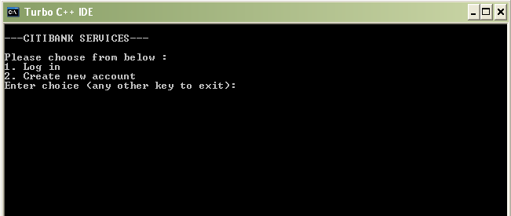

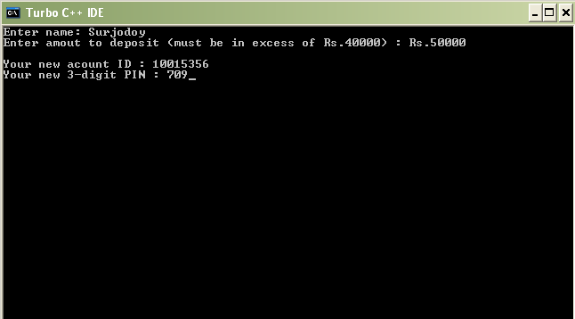

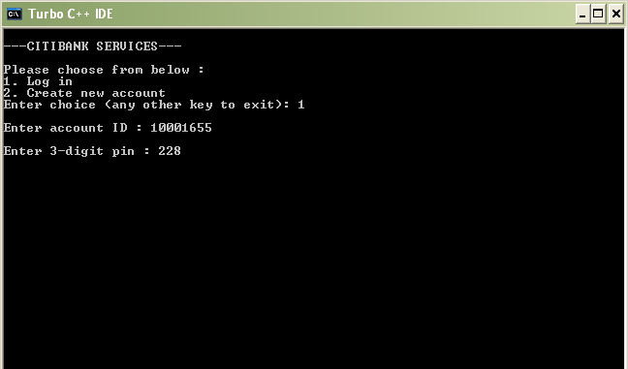

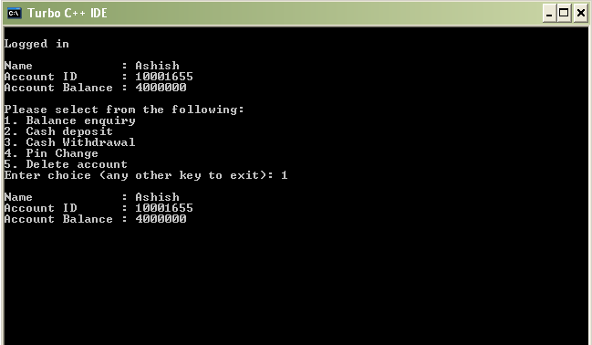

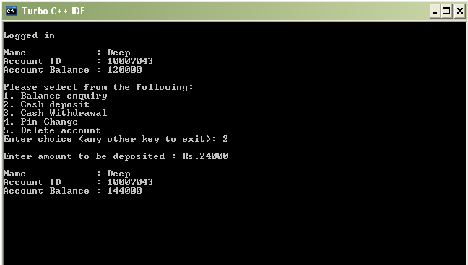

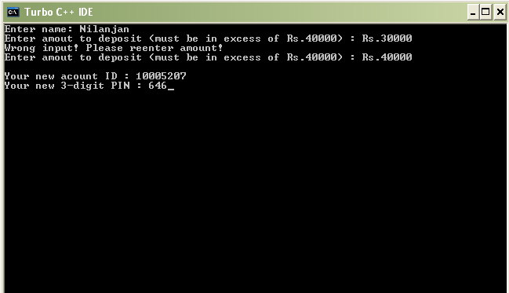

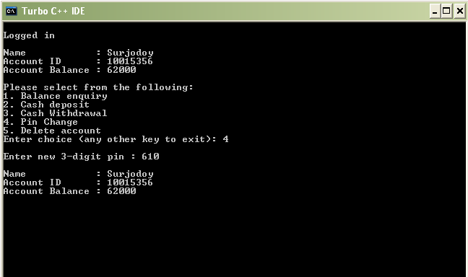
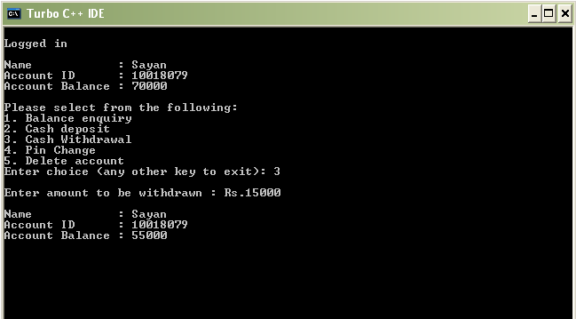
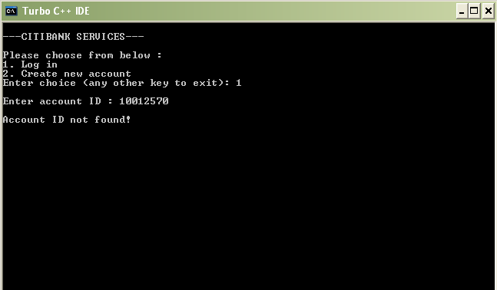
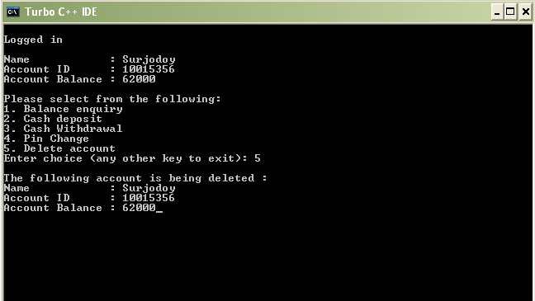
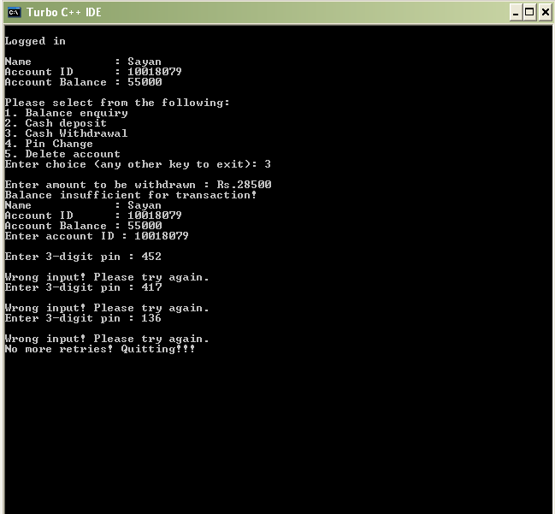
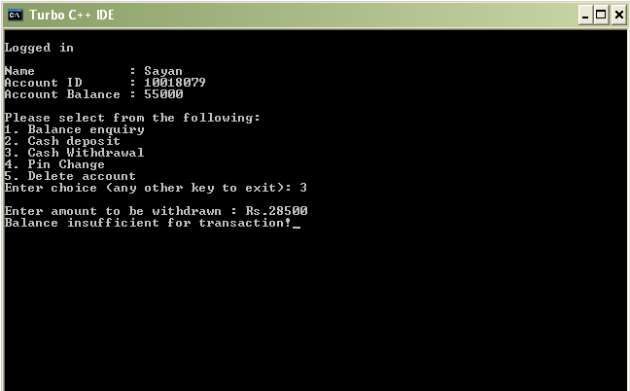
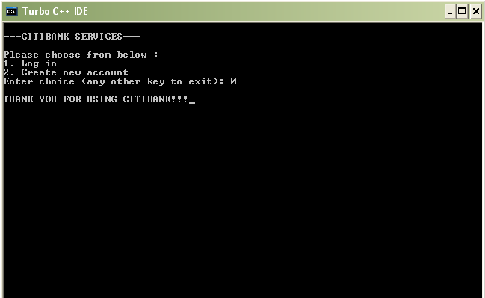

USER MANUAL

There is no use of mouse to handle the software .The keyboard is meant for providing any sort of inputs. There is only vertical menu with key access.

Vertical menu includes the following under their respective headings.

- LOG IN: the personal directory file.
- CRETATE NEW ACCOUNT: Create Customer Account details.

SCOPE OF FUTURE ENHANCEMENT

The application certainly has same striking advantage over manual system. There will be no paper work as possible and the information will be updated as it changes.
- Allows customer to use money, anywhere and every where
- With this system one can generate the report of the account without visiting a bank.
- It secures the database of ATM system from the unauthorized person.
- The operator does not require any previous training because of its user friendliness the operator is free from any technicality of the backend processing, that is how database is maintained.
- If the process of the working changes in future then the alteration in the system will be done easily and will not cause in the mismanaging of data.
- Furthermore with its implementation very large amount of data will be secure and editing and addition or deletion of data is done very easily.
- In future according to the user’s requirement it can be updated so that to reach the user specification.

CONCLUSION

The application certainly has some striking feature over manual system. User queries have become quite accurate and efficient. Future modification and enhancements have become quite easier now in comparison to the previous manual system.
Last but one of the most important advantages of the ATM is that, through this system the whole procedure will take too less time in comparison of the manual system.
No doubt ATM will be helpful for institutes in all procedure, which will be monitoring through Account. The main advantage of ATM is that, it will become a powerful tool in establishment of better system in comparison of the existing system. It helps to protect the system from the corruption. After installation of the ATM, there is a greater possibility of stabilization of a clear and fair system, which will be accurate, update and fast.
There is no doubt that there always remains some scope of improvement. The important thing is that the system developed should be flexible to accommodate any future enhancements. This system can be used to provide some enhancement without rewriting of existing code.

BIBLIOGRAPHY

- OBJECT ORIENTED PROGRAMMING IN C++ BY ROBERT LAFORE
- SYSTEM ANALYSIS AND DESIGN BY ELIAS AWAD
- INTERNET COLLECTION

