# Part 0 - ERD

## Manufacturer

A manufacturing company produces products. The following product information is stored: product name, product ID and quantity on hand. These products are made up of many components. Each component can be supplied by one or more suppliers. The following component information is kept: component ID, name, description, suppliers who supply them, and products in which they are used.

Create an ERD to show how you would track this information.

Show entity names, primary keys, attributes for each entity, relationships between the entities and cardinality.

## Assumptions

* A supplier can exist without providing components.
* A component does not have to be associated with a supplier.
* A component does not have to be associated with a product. Not all components are used in products.
* A product cannot exist without components.

# Part 1 – DDL

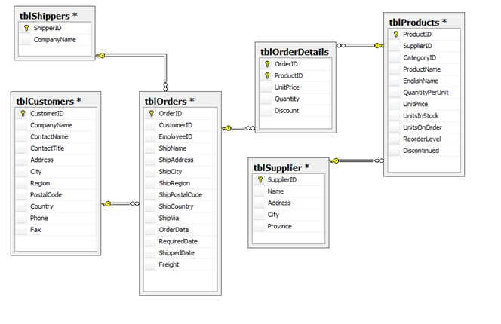

1. Use the above ERD and the following tables on my schema (BLANKENSHISE) as a reference
   * Customer
   * Shipper
   * Supplier
   * Product
   * Orders
   * OrderDetail
2. Recreate the structure of these tables in SQL DDL language
   * Add all primary and foreign key constraints
3. Add the following additional constraints:
   * Customer: Country – default to Canada
   * OrderDetail: Quantity default to 0
   * Shipper: CompanyName must be unique

# Part 2 – Create the Following SQL Statements

* Execute the SQL DDL language you created in Part 1
* SELECT the table values from my schema to yours, populating your tables with the same data as mine

1. Show a list of customers and the orders they generated during 2014. Display customer ID, order ID, order data and date ordered.
2. Using the ALTER TABLE statement, add a new field (Active) in Customer. Default it to True.
3. Show all orders purchased before September 1, 2012. Display company name, date ordered and total amount of order (include freight).
4. Show all orders that have been shipped via Federal Shipping. Display OrderID, ShipName, ShipAddress and CustomerID.
5. Show all customers who have not made purchases in 2011.
6. Show all products that have never been ordered.
7. Show OrderIDs for customers who reside in London. Use a subquery. Display CustomerID, CustomerName and OrderID.
8. Show products supplied by Supplier A and Supplier B. Display product name and supplier name.
9. Show all products that come in boxes. Display product name and QuantityPerUnit.

# Part 3 – Insert, Update, Delete, Indexes

1. Create an Employee table. The primary key should be EmployeeID (autonumber). Add the following fields: LastName, FirstName, Address, City, Province, Postalcode, Phone, Salary. Show the CREATE TABLE statement and the INSERT statements for the five employees. Join the employee table to the Orders. Show the script for creating the table, setting constraints and adding employees.
2. Add a field to tblOrders called TotalSales. Show DDL – ALTER TABLE statement.
3. Using the UPDATE statement, add the total sale for each order based on the order details table.