**VIDEO: PLO > Low Stakes > 3-betting Small in Position**

**Video Thesis:**

* 3-betting in position seems to beneficial
* Problems with 3-betting all the time (or three-betting the pot all of the time):
  + If you get 4-bet, your opponent can get 1/3 of his stack in the pot
    - At this point, it is correct to jam the flop with any AAxx hand
  + So, you want to find a way to avoid getting bet-jammed by AAxx and KKxx
* Some of the benefits of 3-betting small
  + It allows one to 3-bet a wider range
  + It keeps the SPR (marginally) lower
  + It forces opponents to play bloated pots OOP

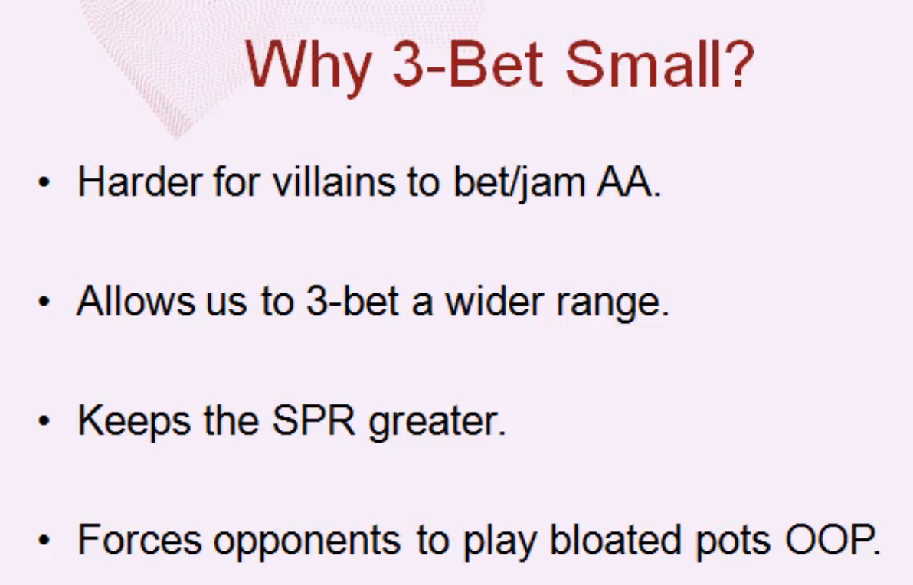

**A comparison of 3-bettting the pot versus 3-betting small(er):**

If we pot:

* Villain opens to $3.50
* We 3-bet to $12.00
* Allows Villain to 4-bet to $37.50
* Flop pot is $76.50, required equity 31%

If we 4-bet small

* Villain opens to $3.50
* We 3-bet to $9.00
* Allows Villain to 4-bet to $28.50
* Flop pot is $58.50, required equity is 35.5%

Example hand (JdTc9d7c):

* Flop pot $76.60
* Required equity = call/pot = $62.50/$201.50 = 31%
  + Amount you’d have to call-off divided by the total pot
* This happens 68% of the time (other 32% we fold flop)
  + Based on the minimum equity vs. %flops graphs

EV calculation

* EV = ($Calling * %Call) + ($Folding * Fold%)
* $Calling = (Average Equity * Pot) – Call
  + Call = Amount called when you call the 4-bet call and flop-jam
* $Folding = losing $25.50 when you fold to 4-bet
* Average Equity = 60%

If we three-bet small

* Increases the EV
* Moves-up the average equity slightly b/c we’re not calling as often

If we pot:, SPR = 3.45

If we 3-bet small, SPR = 4.67

When go back to the pot button.

* When getting stacks in is hard
  + Even when we 3-bet small, we can get ~150-160BB in on the river

