PLO > Low Stakes > Calling 4-bets

**Working assumptions:**

* Opponents only 4-bet AAxx
* Opponents will bet/get-it-in on every flop
* Every pot is heads-up
* 100BB

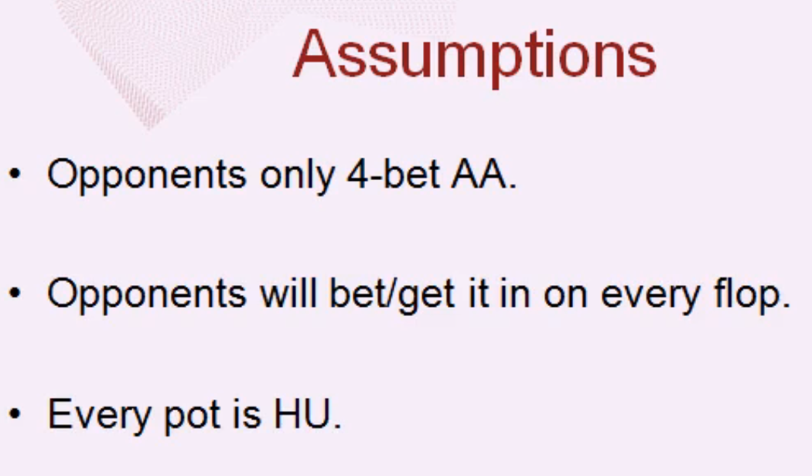

**Formula to be used in the estimates:**

EV = ($Calling * Call%) + ($Folding * Fold%)

$Calling = (Average Equity * Pot) - $Call

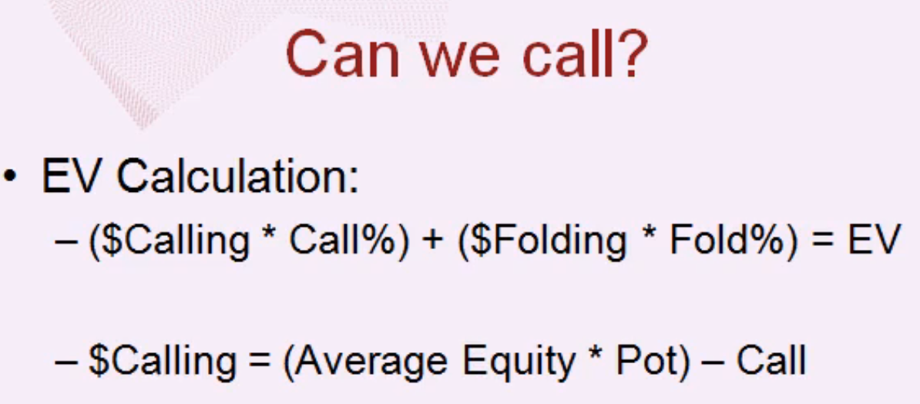

**Example Hand:**

{Kh Qd Jh Td}

**Action leading to the decision:**

* Opponent raises 3.5BB (pot)
* You 3-bet to 9BB
* Opponent 4-bets to 28.5BB (pot)

**Decision: Do you call the $19.50?**

**Step 1: Estimate the minimum required equity to call on the flop.**

Flop pot = $58.50

Money behind = $71.50 (each)

Total pot = $201.50 (in the event all the money goes in)

Minimum Required Equity = Money behind / Total Pot

= $71.50 / $201.50

= 35.5%

**Step 2: Estimate the fraction of the time the hand has the required equity on the flop against the suspected range of the opponent**

Use Pro Poker Tools to compute the frequency of the flops that the tested hand has at least 35% equity on the flop. This is **Call%** in the above equation.

*## One way to compute the minimum equity on the flop*

select count(minHVREquity(PLAYER_1,flop,0.35)) as COUNT4

from game='omahahi', syntax='Generic',

PLAYER_1='KhQdJhTd',

PLAYER_2='AA'

Result = 58.5% (+/- 1.5%)

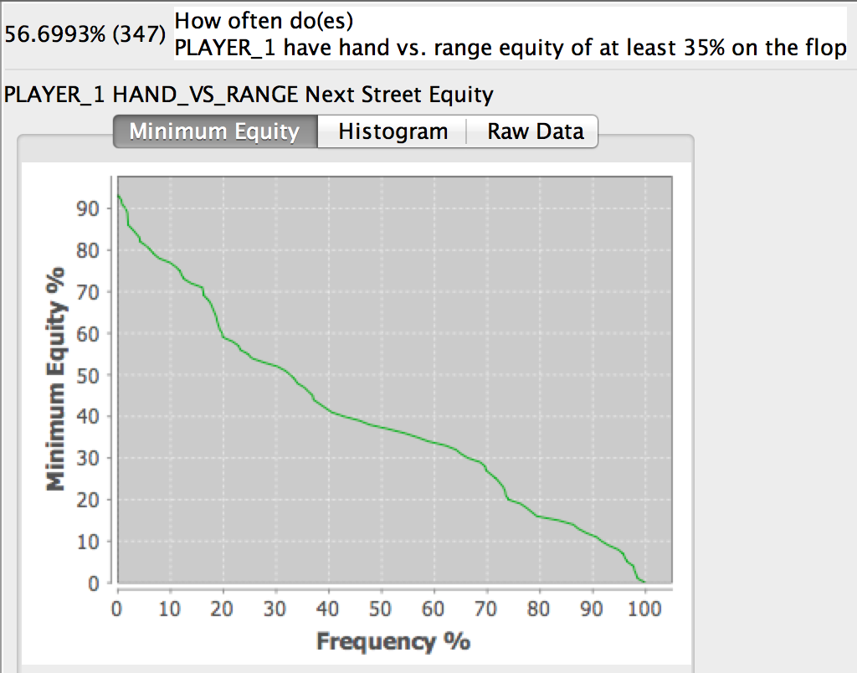

Alternatively, this might be an appropriate query

*## How often a player flops more than 35% equity*

select count(equity(PLAYER_1, flop) > 0.35) as test

from game='omahahi', syntax='Generic',

PLAYER_1='KhQdJhTd',

PLAYER_2='AA'

Result ~ 57.8% (Tom estimates 57%)

**Call% ~ 57.8%**

**Step 3: Estimate the average equity in for the fraction of the cases where the flop equity is greater than 0.35.**

Tom does this via a rough interpolation scheme. Basically, he is computing the average minimum equity (i.e., y-axis) given that the equity exceeds 35%. It is, in effect, a weighted average of the minimum equity for all cases where the equity is greater than 35%.

Using this method, Tom estimates a value of ~60.3%. But it can be done more accurately via a query in Odds Oracle.

*## Query to compute an average equity for a hand on*

*## the flop, for those cases where the flop equity*

*## exceeded 35%*

select avg(equity(PLAYER_1, flop)) as flopEquity

from

game='omahahi',

syntax='Generic',

PLAYER_1 ='KhQdJhTd',

PLAYER_2 ='AA'

where (equity(PLAYER_1, flop) >= 0.35)

Result ~ 59% (Tom gets 60.3%)

**Average Equity ~ 59%**

**Step 4: Use these results to return to the 4-bet calling question.**

Call Percentage = 57% (Tom’s estimate)

Average Equity = **60.34%** (Tom’s estimate)

How much money we make when we call?

(Average Equity * Pot) – Call = (**0.6034** * $201.50) - ($19.50 - $71.5)

= $30.50

= $Calling

Now we can compute the EV of the 4-bet call:

EV = ($Calling * Call%) + ($Folding * Fold%)

= ($30.50 * 57%) + (-$19.50 * 47%)

= **$9.00**

**Comparison: Now, let’s explore how a variety of hands do against AAxx hands.**

* Rundowns
  + Small card run-downs tend to do better (b/c the aces do not block as many of your straights)
  + Double suited > Single suited >> Rainbow
    - Rainbow hands have much less value than the suited permutations
* Connectivity
  + Not a lot of difference in the various gap permutations
    - There’s a lot of noise in the simulations, though.
  + How connected the rundowns are doesn’t matter as much as the rank and suited-ness of the cards
* Paired hands
  + Higher paired hands less value than the smaller double-paired hands and/or the middle paired-rundown.
  + The high-card hands are being blocked by the AAxx

