Know your enemy Low Stakes Zoom

Video Purpose

* Look to see how statistics change across different stakes in the Zoom player pool (ca. June 2014)

Summary Statistics:

Trends:

* Slight convergence in VPIP/PFR as you increase the stakes
* Difference b/w 25PLO and 50PLO is larger than the gaps seen in 10PLO and 25PLO
* 3-bet ranges widen as you go-up (7% 3-bet is sensible)
  + 4-bet stat is roughly constant (mainly AAxx, KKxx, AKQJds/ss)
* Increase in c-betting as you move to 50PLO (tighter, more aggressive)
* Fold to c-bet stat is roughly constant across the games

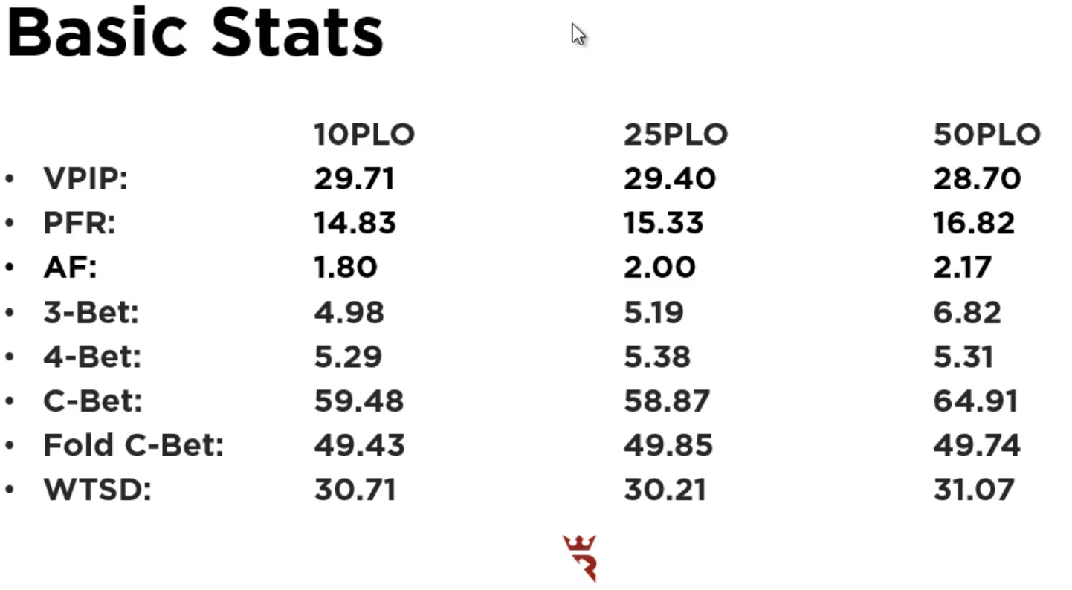

Positional Stats

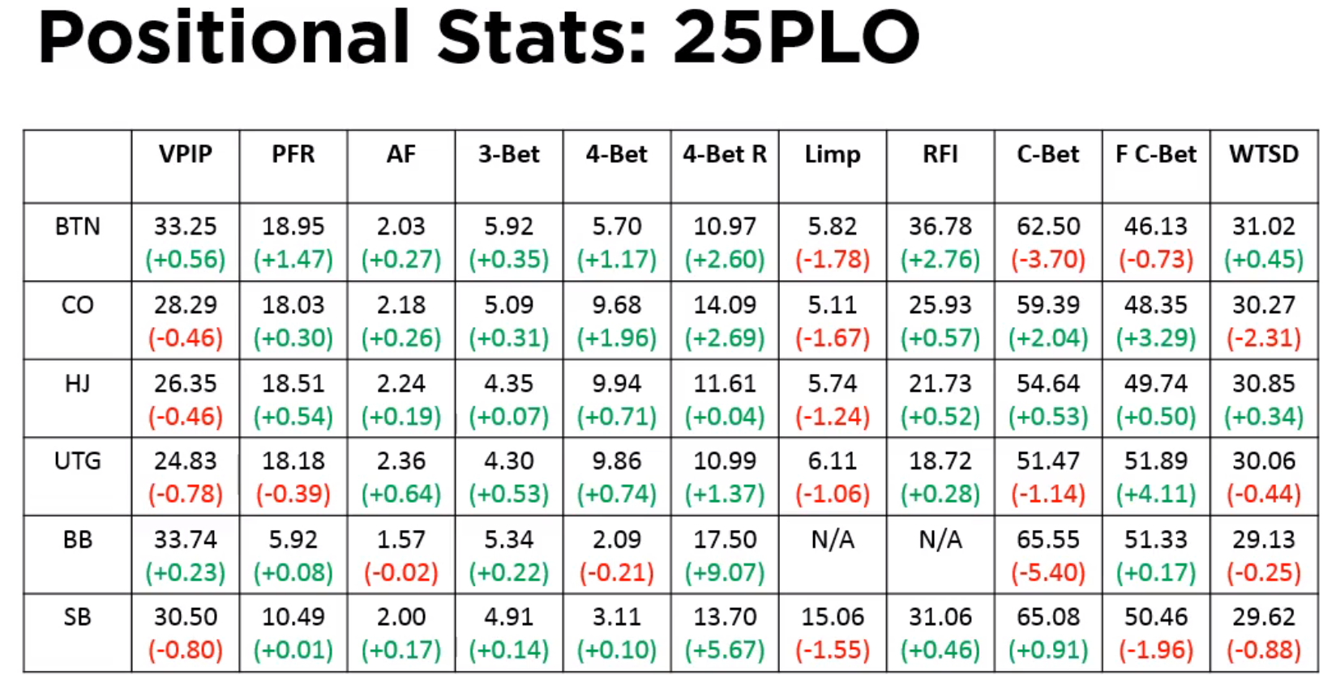

VPIP

* Increase from BTN/BB; decrease from everywhere else
* Increased positional awareness

PFR

* Big jump in PFR from BTN (some for the Raised-First-In)

3-betting

* Increased numbers from all seats

4-bet

* Large jump in the 4-betting
* If you’re opening a tighter range, then you’ll have a increased 4-bet frequency

Liming

* Decreases across the board
* Non-zero, so perhaps this reflects over-limps (e.g., with some speculative hands)

Fold to c-bet

* Still folding to 50% of c-bets
* But decreases on BTN (perhaps more floating?)

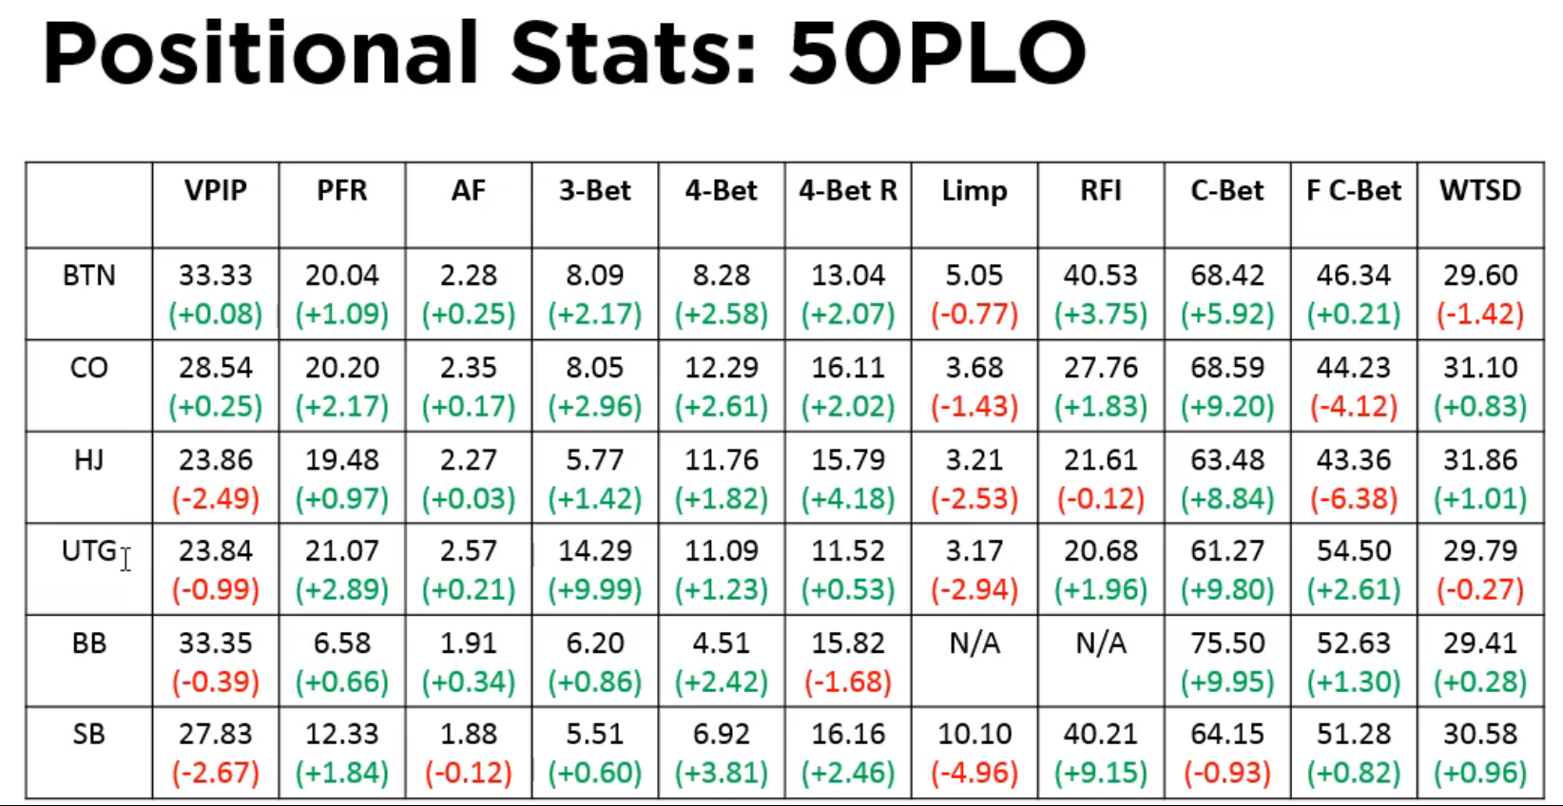

**VPIP**

* Decreases from HJ/UTG/SB
* Now starting to see distinct differences between the early two seats (HJ/UTG) and the late position seats (CO/BTN)

**PFR**

* Above 20% in the later seats (more aggression)

**3-bet**

* Numbers are much higher
* Mainly coming from the BTN and the CO (higher level of aggression and positional awareness)
* The UTG increase is odd; suggests a big-pair (AAxx; KKxx) limp-raise

**4-bet/4-bet R**

* Some divergence across position; seeing larger proportion in earlier seats
* More attacking going-on with some of the higher hands beyond AAxx (high rundowns); Attacking of positional 3-bets

**RFI**

* Statistics are “very good”
* Good positional gradient
  + Small blind being opened far more often to try to steal the BB

**C-bet**

* Jumped across the board (aggression)
* Will enable check-raise opportunities

**Fold to C-bet**

* Don’t decrease all that often when compared with PLO10
* Still letting us attack them often

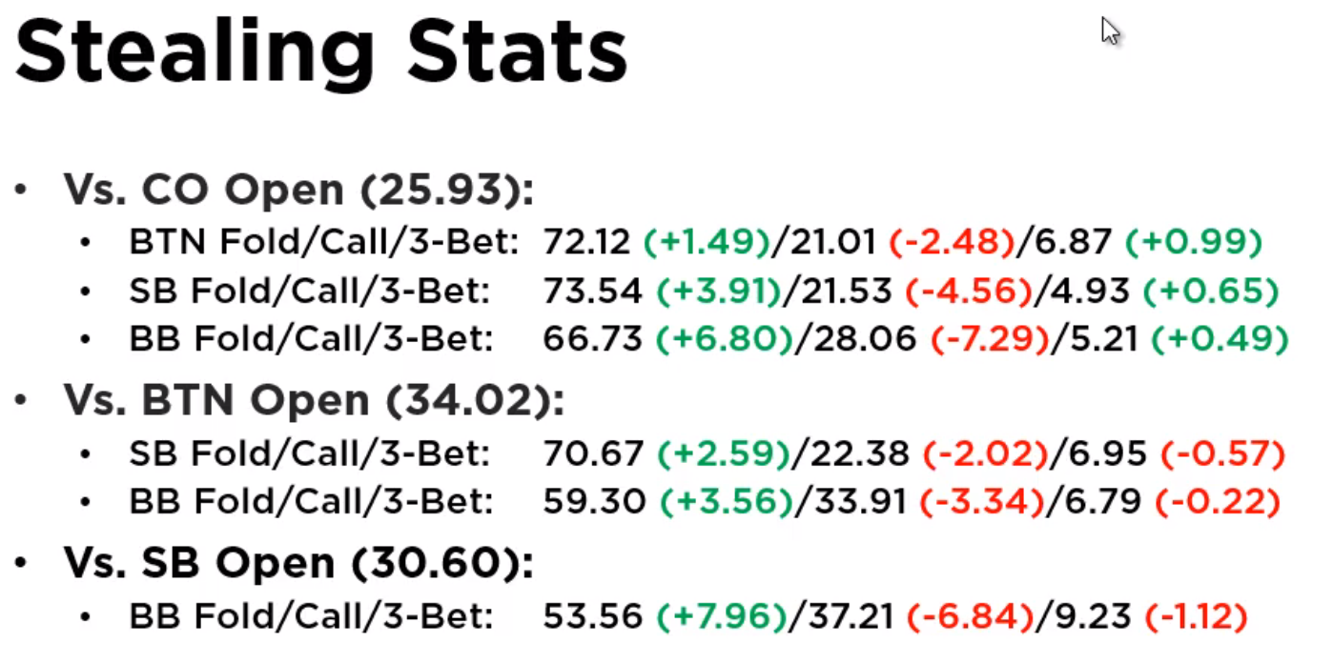

General trends (PLO25)

* Increased fold percentage across the board
  + Steals are MORE PROFITABLE than in PLO10
  + Need to try to steal often
* Decreased defense of the blinds
* Decreased 3-bets from SB/BB

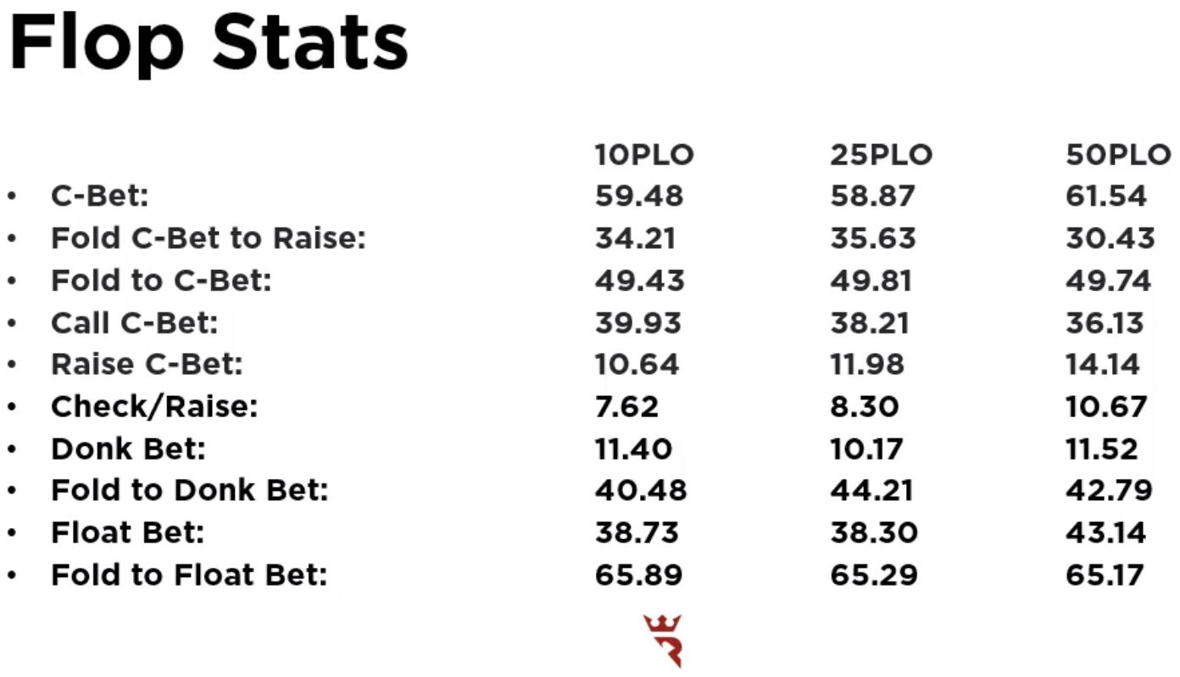

Fold to C-bet to Raise

* Sticky, still. Will fold only 35% of the time

Raise C-bet

* Increasing with stakes

Check/Raise

* Increasing with stakes
* Therefore, should c-bet less and less with hands that you’d rather not fold (b/c they have the potential to turn equity) … e.g., middle-pair and a nut-flush draw

Float betting

* Jump with stakes
* Again, more aggression – attacking checks wide to take down the pot

Fold to Float Bet

* Still many people are indicating that they’re giving-up when they check
* Take advantage of this by floating in position

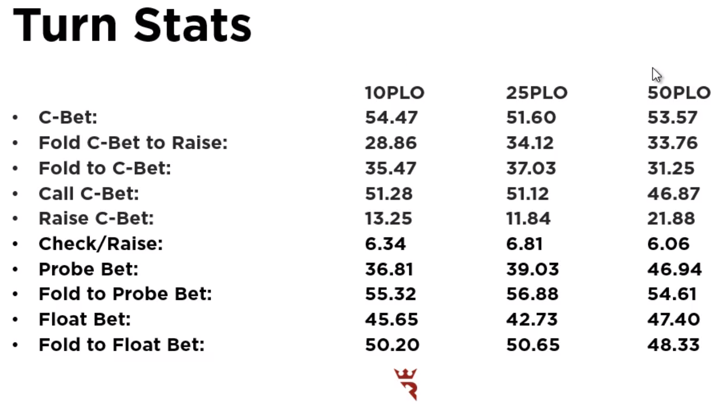

Fold c-bet to Raise

* Evidence of disciplined folds at 50PLO

Fold to c-bet

* Shouldn’t be c-betting with junk; random double barrels will not be hugely profitable
* Most of the time you are not getting this through
* Evidence that people are sticky

Raise c-bet

* Much larger increase of raises of c-bets in 50PLO
* Probably people raising when they hit (playing nut hands more aggressively)
* Perhaps also more semi-bluffing & slightly wider stack-off ranges

Probe bet

* Increased % of bets in 50PLO – attacking weakness

Fold to Float Bet

