Purpose of the video:

* To construct a profile of a “random” player in the PokerStarts 10PLO Zoom player pool

**Overall Player Summary (based on global stats)**

* Playing a bit passively (30/15); so either cold-calling or limping often
* Nothing that jumps-out other than a general feeling of passivivty

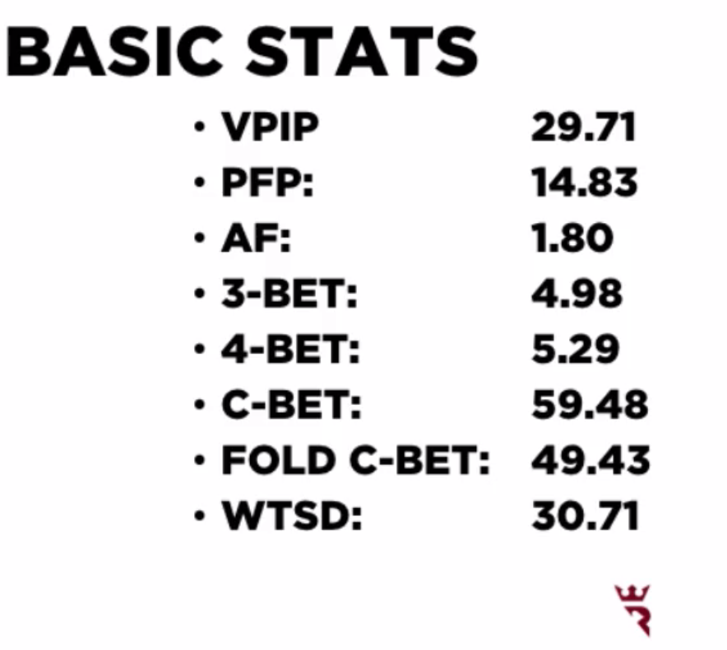

**Player Stats By Position**

Note some of the additional statistics added to the table:

* 4-bet R = Frequency of 4-betting having opened the pot (i.e., % of opening range that is 4-bet)
* RFI = Raised First In

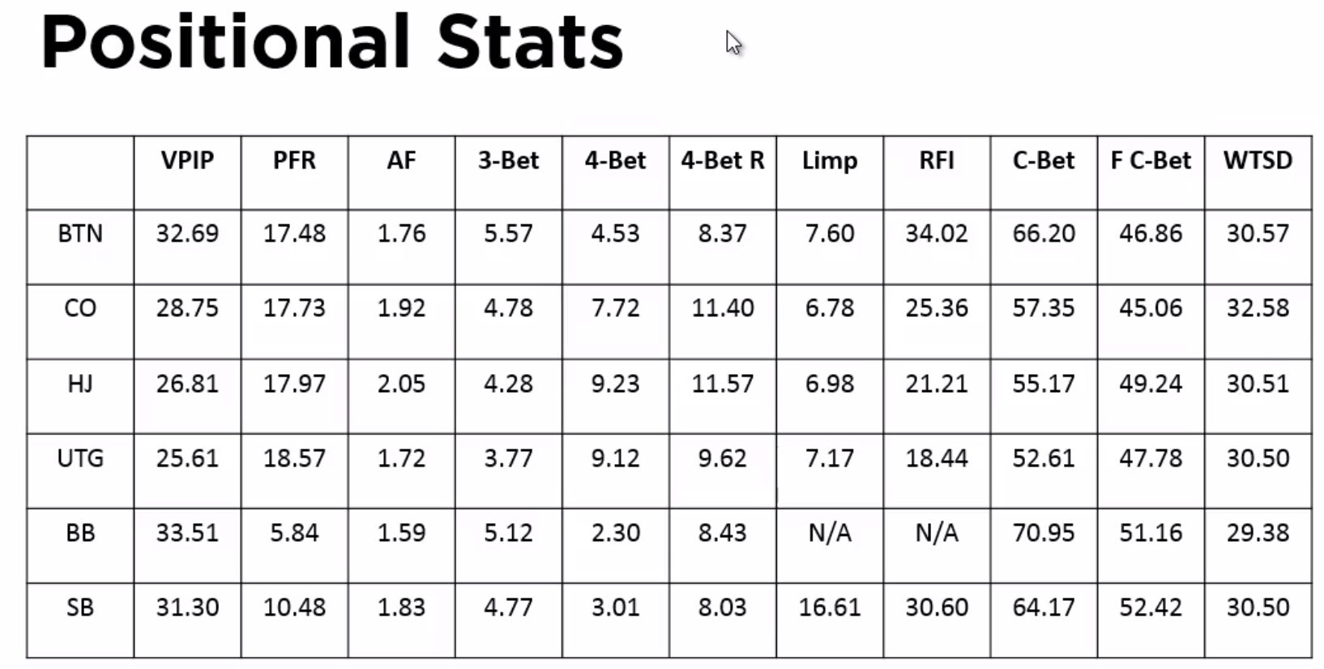

VPIP

* Little evidence of positional awareness (7% variation across positions; therefore limited positional awareness)
  + By contrast Tom’s BTN ~ 60%

PFR

* Strange PFR numbers; UTG > BTN
* Also, it is very constant across positions
  + UTG range similar to BTN range?
  + But, see the RFI numbers that may contradict these trends
  + Maybe speaks more about raises after limps

4-bet

* 4-bet ranges = AAxx (nearly always)
* Therefore, be careful with calling-off their 4-bets with weaker hands

Limp

* Limping not infrequent and same from all seat
* Expect a good play NOT to limp UTG (except with some speculative hands; e.g.,weak Kings/weak Queens)
* However, pretty constant across seats (7% for all positions)

RFI

* CO/BTN numbers are insanely low; too tight
* 34% BTN open is so-bad; not stealing enough

C-bet

* Differs by position
* More c-bets with position (suggests that they’re betting their weakest ranges)

F C-bet

* Folding roughly 50% of the time; which suggests you can c-bet / stab because opponents will fold very often

**Player Stealing Stats (vs. late position raises)**

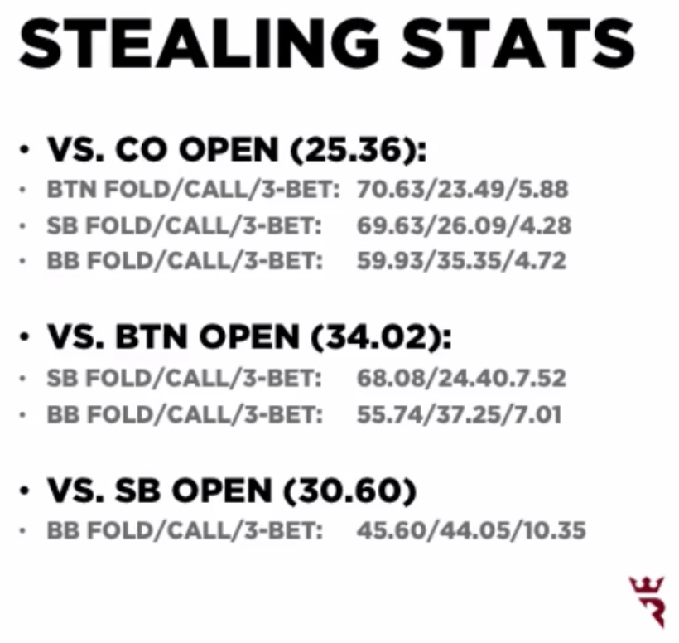

Some level of positional awareness

* Defending BB
* BUT BTN folds vs. CO open are too high (insanely tight)
* BUT given the fold statistics of the blinds; makes sense to min-raise 100% of hands from the BTN when folded to

Main take-away

* Not defending against steals enough
* Don’t give-up with a quick-fold
* Open 100% of hands (risk 2 to win 1.5)
  + E.g., raise hands like Q863ss
* Also need to play lot of half-decent hands from the CO

**Player Flop Stats**

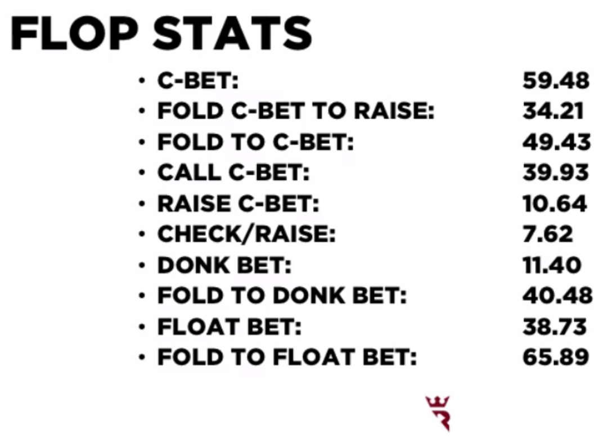

* Fold to C-bet ~ 50%
* With a tight c-betting range; they are not folding to flop raises
  + Fold c-bet to raise = 34.21%
  + Once made the c-bet, more often than not, they will stick around
  + Not wise to randomly bluff
  + They will cling-on
* Also, we don’t need to be concerned with your c-bets
  + Rarely play back at you (c/r % = 7.62%)
  + Don’t need to be concerned about a c/r
    - So don’t check-back b/c you “want to avoid being check-raised”
  + Cb-
* Donk Bet
  + A lead into the pre-flop raiser
  + Donk betting more than raising c-bets
    - Not leading that often (11.4%), so it is not something that they do all the time
    - But donk betting is a personal strategy
    - Often with weak top-pair
* Float Bet
  + If you don’t c-bet, how often are they betting
  + Frequency that they bet when we check is low; therefore, we can often check to pot control
    - However, it means that if you want to check-raise; well over half the time they will check-back
    - Need to realize you equity by betting
  + But the fold to float bet is 65.89%
    - So, if they check instead of c-bet, you must bet at them because they are giving-up

**Player Turn Stats:**

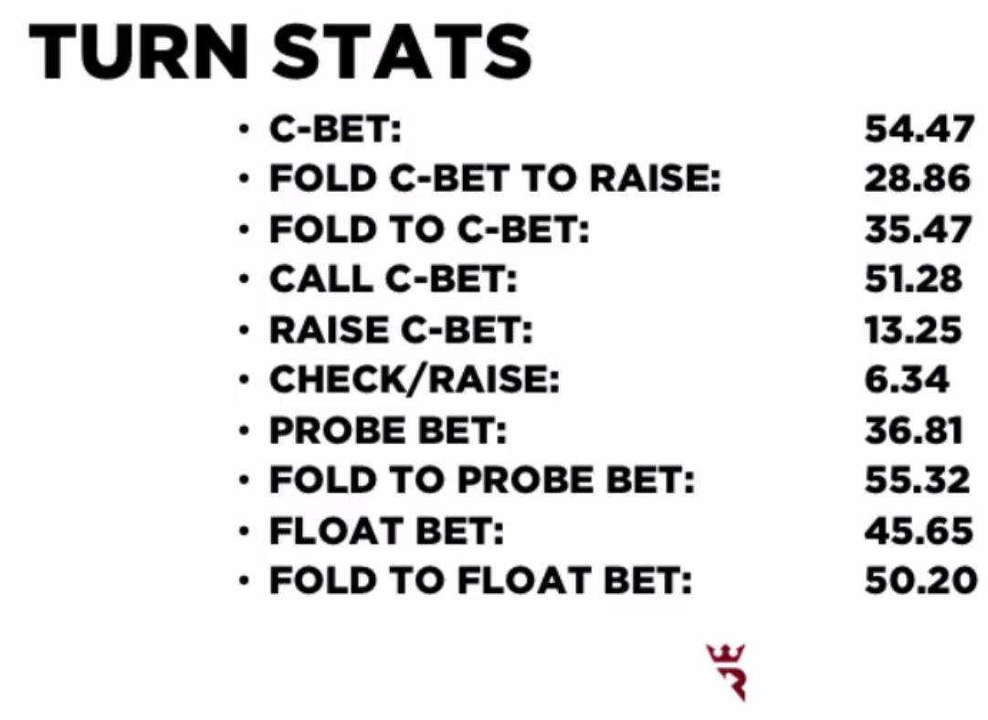

General theme

* Once they’ve bet, they’re not likely to fold to a raise – so random bluff are not going to be hugely profitable
* Fold to c-bet
  + Stabbing turns is not as good (folding only 35.47%)
  + Defending against 2nd barrels more often
* Check/raise is still small
  + Can two-barrel [1] semi-bluffs and [2] weak value hands b/c they simply won’t check-raise you off those hands
  + You won’t have to sacrifice your equity”
* Float bet is still low
  + You can’t expect them to bet (if you wanted to check-raise)
  + Can still
* Probe bet
  + When Villain is out-of-position (probe-bet; they check to you on flop; you check behind; how often they lead turn)
  + Only leading 36.81%, so you can pot-control flops if you want
    - But why bother b/c you can get folds with a c-bet so often
* Fold to probe bet
  + Above 50% (55.32%), so you can again bet into them when it is checked to you

**Conclusions:**

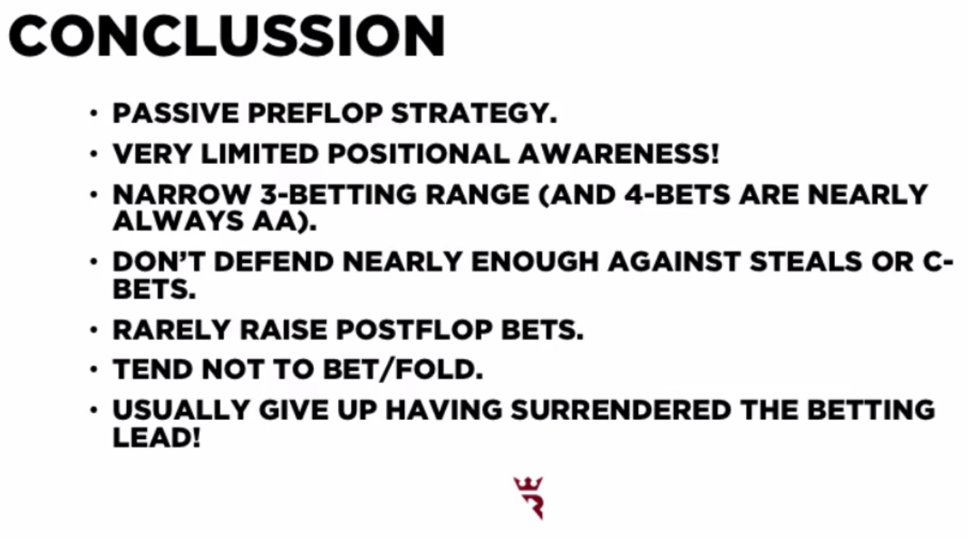

**General Themes**

* Passive play
  + Raising ranges are quite narrow, even in late position
  + Little variation in ranges with position
  + Conclusion:
    - This means we can attack both UTG and BTN ranges similarly
    - Don’t have to consider that UTG ranges are stronger
* Very narrow 3-bet and 4-bet ranges
  + Conclusion:
    - Need to be very careful when you see action
* Not defending against steals
  + Conclusion:
    - Take the pots away
      * Steal
      * Bet when it is checked to you
* Be very cautious if they raise post-flop
  + Conclusion:
    - Tom treated raises in the same was as PLO50, which meant he overvalued some of his hands
    - Their aggression means a strong hand; a lot of the time people are only raising the nuts
    - Once you get action, have a good think before you put money in
* Opponents are not able to fold
  + Conclusions:
    - Bet for value (don’t rely on them to take the lead if you want to get a check-rasie)
    - Don’t bluff randomly
* If they haven’t put money in the pot, then they’ll give up
* If they’ve invested some money, then they’re less likely to give-up
* BUT, they’ll usually give-up if they’ve surrendered the betting lead