**Playing Aces multi-way on flops that don’t hit your range**

**Example:**

* Your hand is AA72 (we’ll test various permutations)
* Flop comes Tc4d3d

**Case #1: Rainbow Aces vs. several (capped) calling ranges**

* A naked overpair is an underdog against the field
* Clearly the capped ranges include cards that connect with this low, 2-flush board

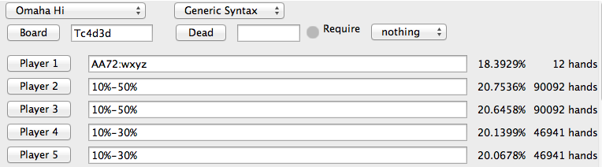

.

**Case #2: All permutations of double-suited Aces**

* Now the Aces become a favorite, but this presumably only because of those Ace combos that connect with the suits of the flop
* Nevertheless, in a range vs. range calculation, the equity of the Aces improves significantly

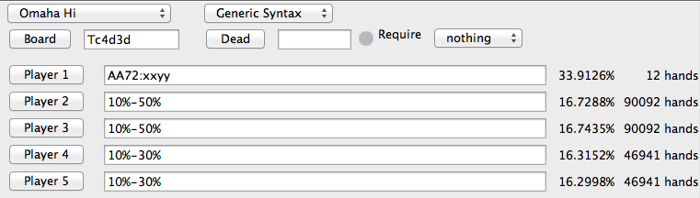

**Case #3: Include a specific permutation that hits the flop**

* In this instance, the equity of the hand increases dramatically, to over 50% against 4 opponents
* The naked overpair is helped by the two different flush draws

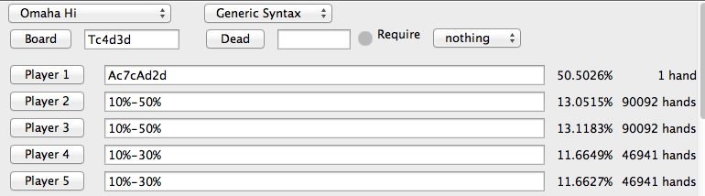

**Case #4: Back to a rainbow AA72 hand, but now removing the caps on the ranges**

* Again we are an underdog to all villains

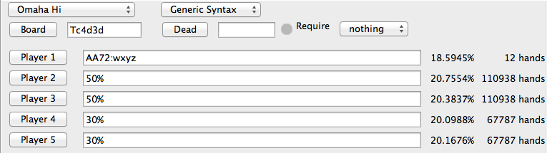

**Case #5: All double-suited combinations vs. uncapped ranges**

* Again, there is improvement versus the ranges … presumably because the combos that connect with the flop are helping those combos that did not connect with the suits of the flop

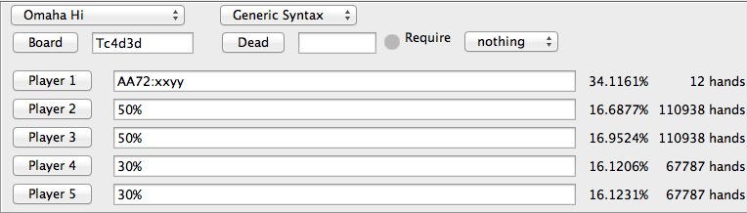

**Case #6: The double-suited combo that did not connect with the flop vs. uncapped ranges**

* Here we see that, in fact, the combo that does not connect with the flop is an underdog to the field

