Bishappcore DVD Rental Loyalty Program Synopsis

Within this synopsis you will find the makings of a report server in which the data in the report
Could be used to create a customer loyalty program by displaying both how much customers spend
and the frequency in which they rent.

The specific tables that will be queried are rental, inventory, customer and film since they have relationships both identifying and non-identifying amongst them.

Identify the specific fields that will be included in the detailed and the summary sections of the report.

Detailed Section:
customer.last_name
customer.first_name
address.district
payment.amount
payment.payment_date
rental.rental_id
rental.rental_date

Summary Section:
customer.last_name
address.district
payment.amount
rental.rental_id

The payment.amount filed will be transformed by summing up the amounts and rental.rental_id fields will be counted.

Summary Section:
This section will be used as high level information for executives to plan and implement a rewards program for loyal customers.
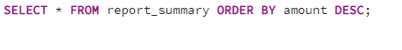
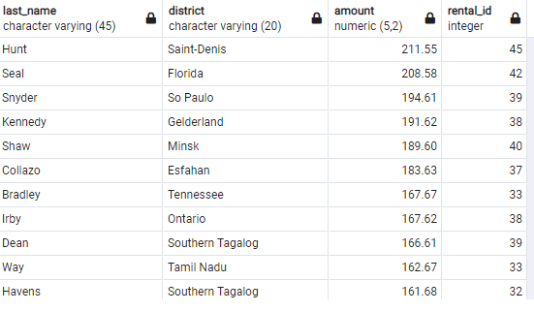

Detailed Section:
The data in this section will be used by analyst to generate the necessary reports as requested by the executive branch to assist in making decisions of how the loyalty program will be implemented.
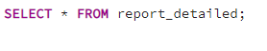

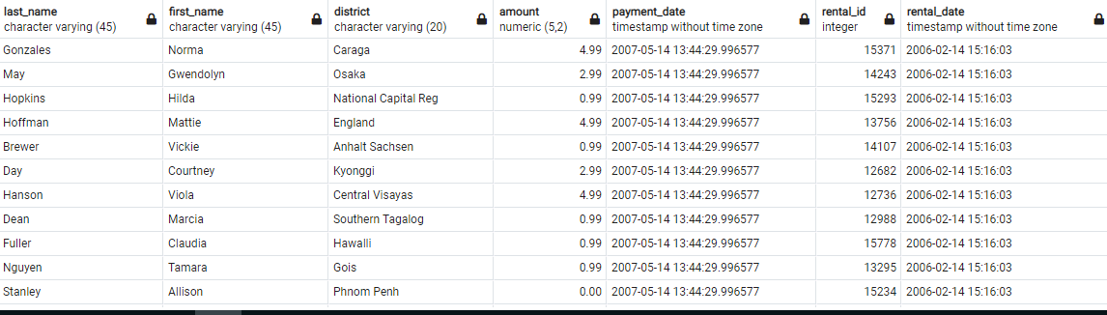

The report could be ran quarterly at first to track progress of the loyalty program and provide timely updates of other casualties that could be emerging with because of the program such as increased customer participation because of the rewards which also increase sales.

Code to create the report_summary and report_detailed tables to work with the provided data.
Summary Section:
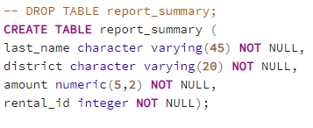

Detailed Section:
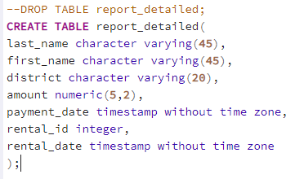

Extraction Query to pull data from the desired tables and insert them into the report_detailed table.
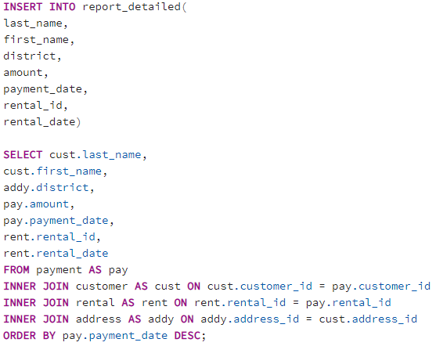
Result:
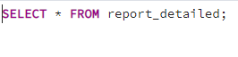
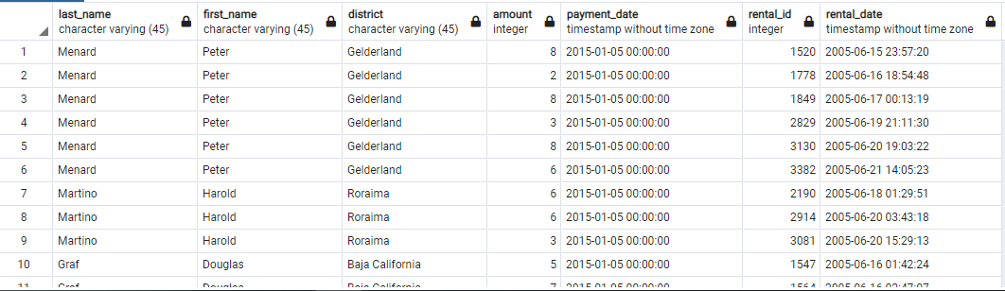

Transformation code to update customers spending amount and frequency.

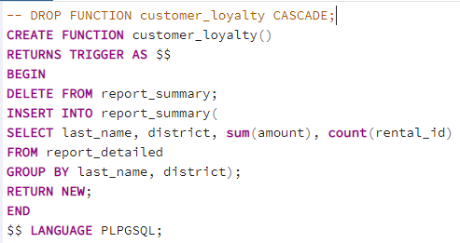

Continuous update to report_summary once report_detailed is updated.

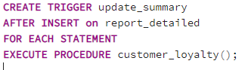
ETL Procedure to refresh both detailed and summary tables:

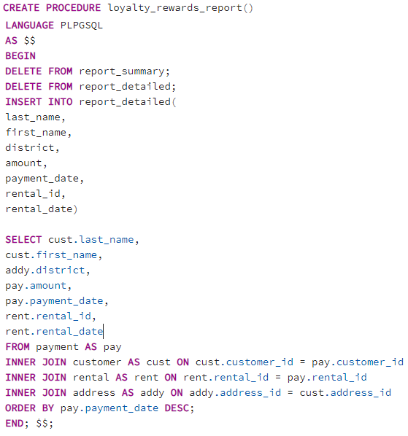
In this scenario we are focused on being able to run this procedure on a windows machine that at the time this article was written used the software known as PGAdmin 4. Currently there is a Service
Installation both as a pre-built for those using the Enterprise purchase option or as a command line install (PGAdmin Organization, 2021). According to the step-by-step guide the pgAgent will be able to run as windows service using command lines such as "C:\Program Files\pgAgent\bin\pgAgent" INSTALL pgAgent -u postgres -p secret hostaddr=127.0.0.1 dbname=postgres user=postgres” (PGAdmin Organization, 2021). However, it is important to note that this is just a guideline and there may be several adjustments needed in order to make this work properly depending on one’s needs.

REFERENCES

PGAdmin Organization. (n.d.) Installing pgAgent - pgAdmin 4 6.0 documentation.
Retrieved October 19, 2021, from https://www.pgadmin.org/docs/pgadmin4/development/pgagent_install.html.

