**FFT Generation**

1. Tools🡪IP Catalog
2. Write FFT in search box and press Enter
3. Double click on FFT to open IP Parameter Editor

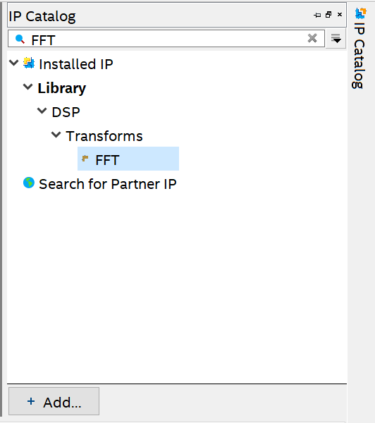

1. Enter the name of your entity as FFT and enter the path

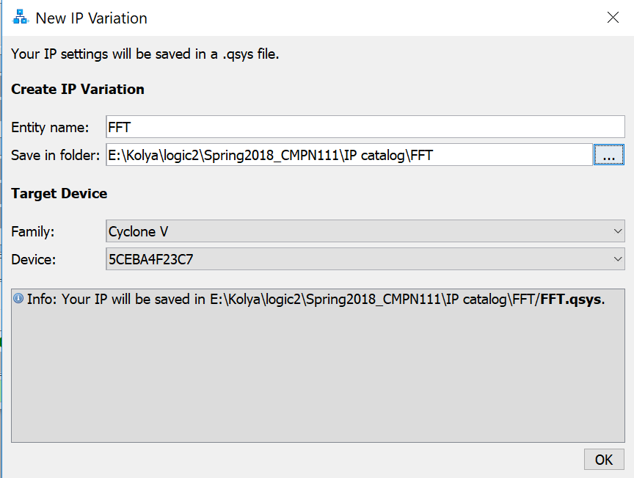

1. Enter the parameter as the following figure to configure the fft to work as 128 point and 16 bit data. (this parameter definition can be found at table 8 in ug_fft.pdf page 37)

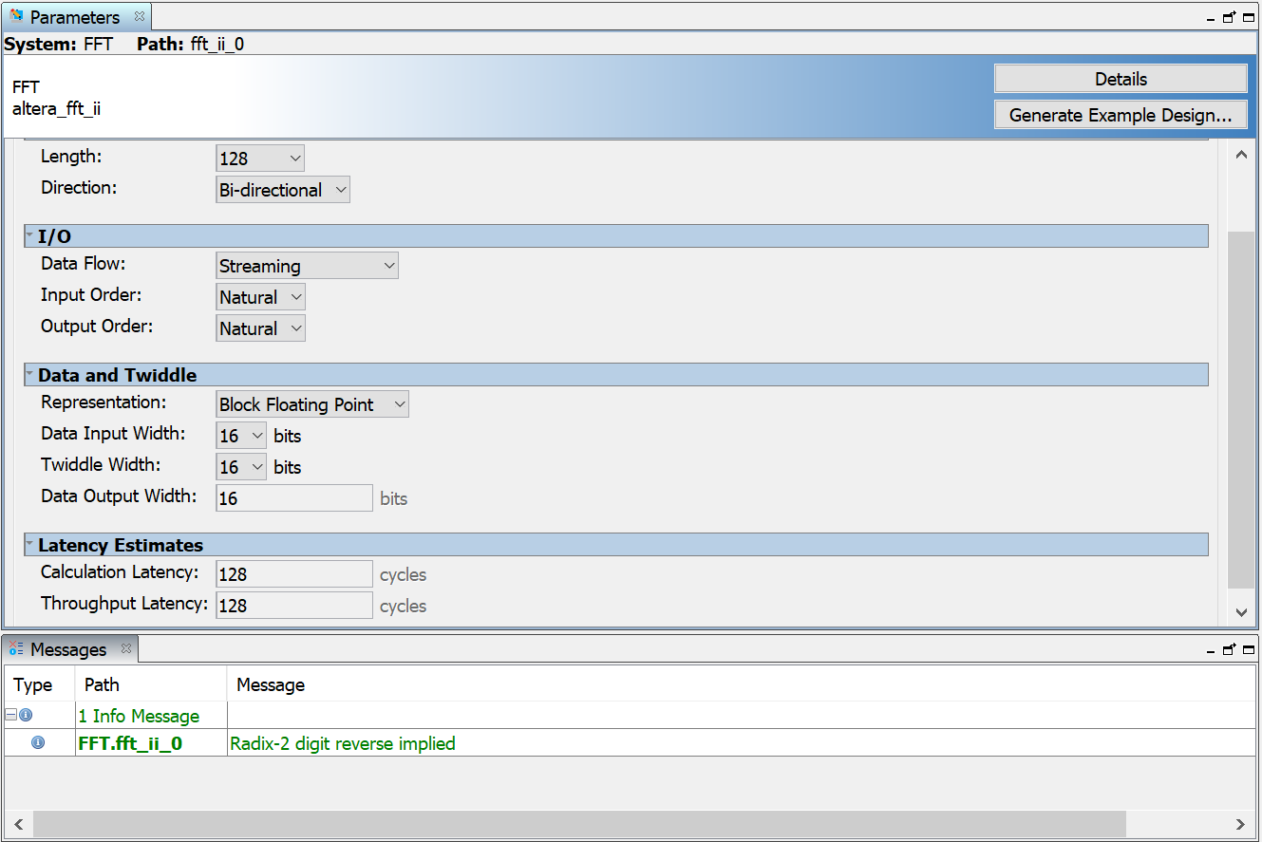

1. Click Generate HDL and enter the option as in the following figure Then click Generate

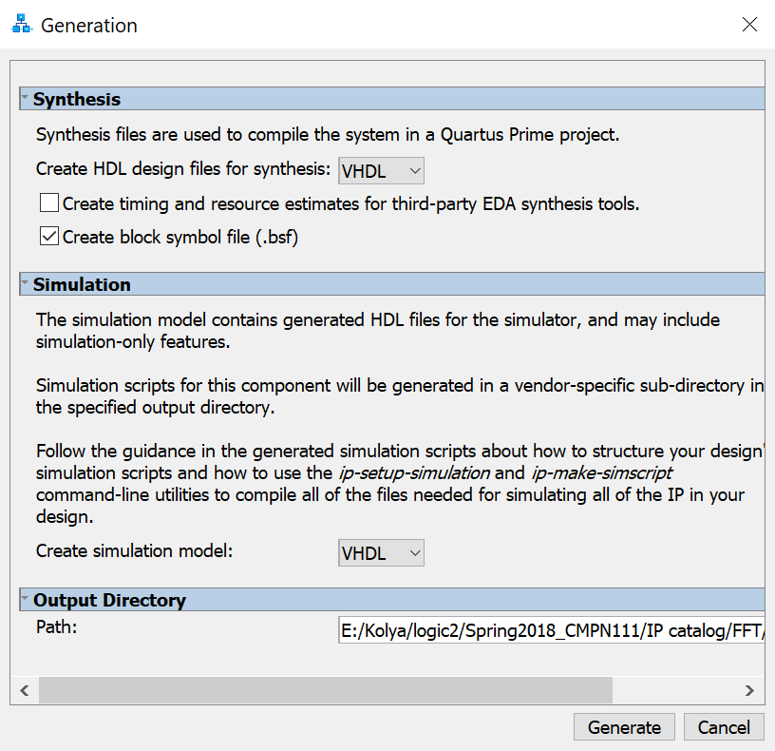

1. Add FFT.sip and FFT.qip to your project to add FFT IP to it.
2. The inputs and outputs port definition is found at table 10 in ug_fft.pdf page 39)
3. You must write your testbench to simulate the FFT, Your testbench must generate the waveforms of FFT Streaming Data Flow which shown in figures 11, 12, 13 in ug_fft.pdf page 30
4. To simulate the FFT you must simulate it from Quartus prime as following:
   1. Select Tools🡪Options🡪EDA Tool Options
   2. Enter in ModelSim-Altera the following path C:\intelFPGA_lite\17.0\modelsim_ase\win32aloem then press OK
   3. Select Assignments🡪Settings🡪Simulation
   4. Select Tool name: ModelSim-Altera
   5. Choose Compile test bench
   6. Press Test Benches button and add your test bench file (if you TB file is FFT128_TB)
   7. Click New then enter FFT128_TB in Test bench name and add your file by click the browsing button and click the add button
5. You TB file must wait first for sink_ready to be “1” then assert sink_valid
6. Put sink_error = ‘00’
7. The inverse input determin the direction of transform. it make FFT if it equal to 0 otherwise it make IFFT
8. After that you will load the 128 real and imaginary input points.
9. The start of input transfer is noted by sink_sop and the end of transfer is validated by sink_eop
10. You must assert source_ready to wait for output
11. The FFT will calculate the FFT and when it finished it will assert source_valid
12. The 128 output (source_real and source_img) will generated between source_sop and source_eop

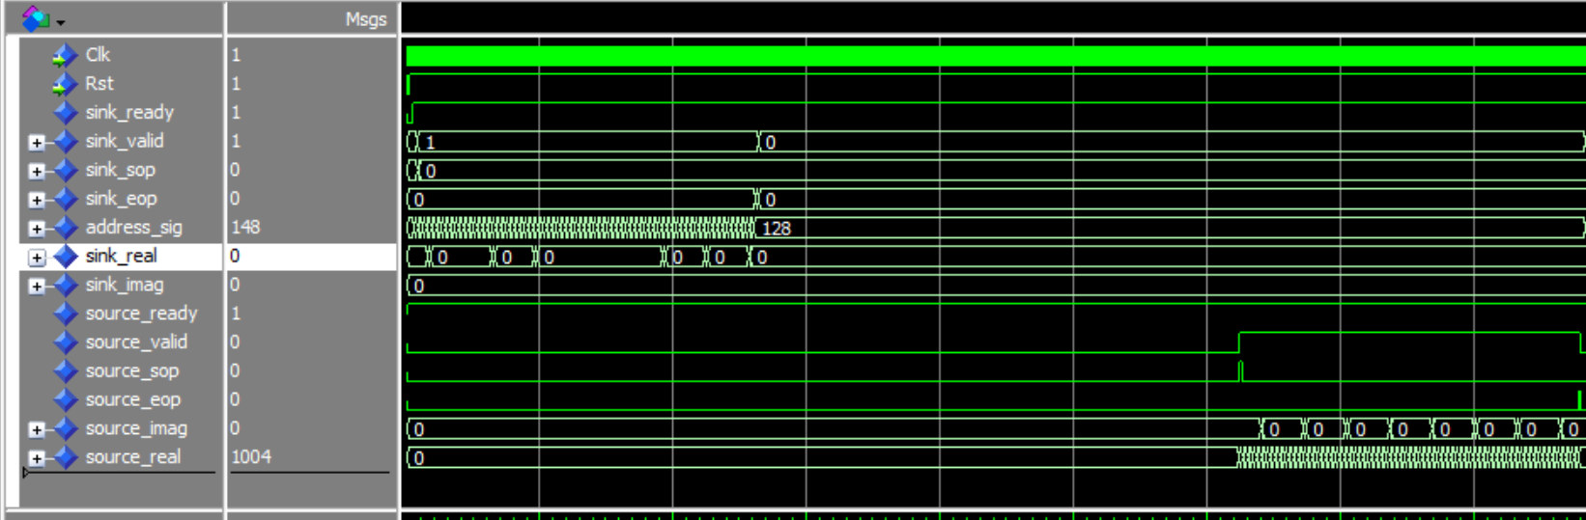

1. To run your TB chose RTL Simulation from Tasks panel then click RTL Simulation.