Natural Language Interface

Create an IoT app in Bluemix

The Internet of Things Platform Starter boilerplate contains a Node-RED engine that you will use later to process IoT messages. For now, you will create an Internet of Things service to send and receive MQTTmessages to and from the IBM IoT server on the cloud.

The NLI Android app uses Watson Android SDK to connect to watson STT and TTS services. MQTT-Client-Framework is used to communicate with Node Red application which in turn is configured to communicate with conversation service.

Adding Devices:

We need to register device to able to send and receive events/commands to/from IOTF. Following are the steps to register a device and obtain credentials.

1. Go to the Overview page of Bluemix App which has been configured with cognitive-iotf-service

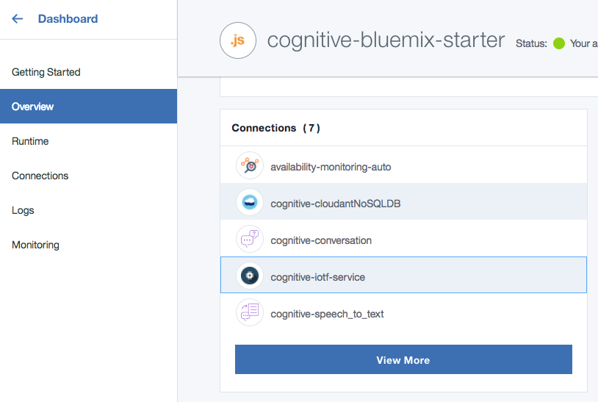

2. Select cognitive-iotf-service

3. Click on Launch dashboard under “Connect your devices” tab

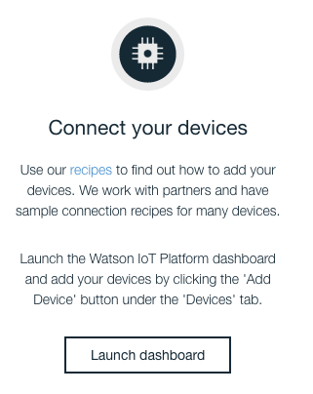

4.Select Devices from left side menu

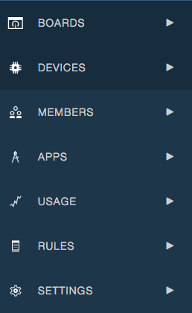

5. Click on “Add Device” in the top right corner of Devices page.

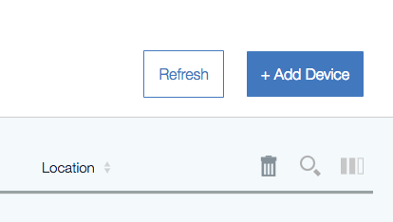

6. Click on create device type

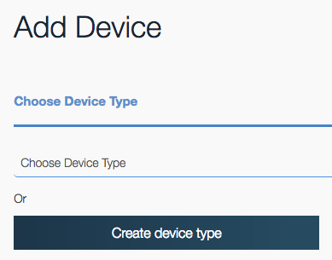

* Enter name and description.
* Click Next, until you get a create button.
* Click on create.
* Once Device Type is created. We need to create Device Id.
* Choose Device type you created from drop down and click next.
* Enter a Device Id and click next

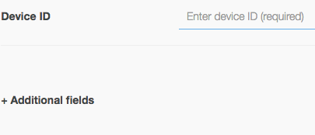

7. Provide a token. This is optional. If you don’t give a token value of your choice, a token would be automatically generated.

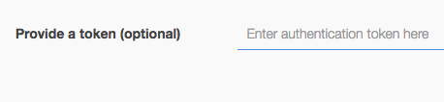

* Click next until you get an Add button.
* Click on Add.
* Device credentials will be displayed. Copy the credentials as the auto generated tokens are non-recoverable. If you misplace this token, you will need to re-register the device to generate a new authentication token.

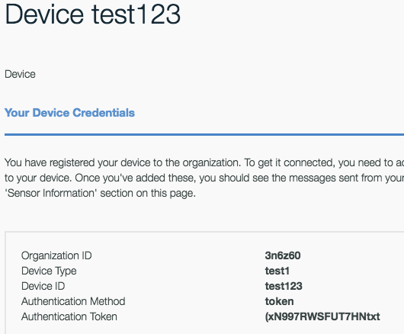

8. Configure Credentials in Settings:

* Select Natural Language Interface App
* Set the credentials which we obtained after registering device under MQTT Configuration.
* Similarly set the credentials for Watson STT, TTS.

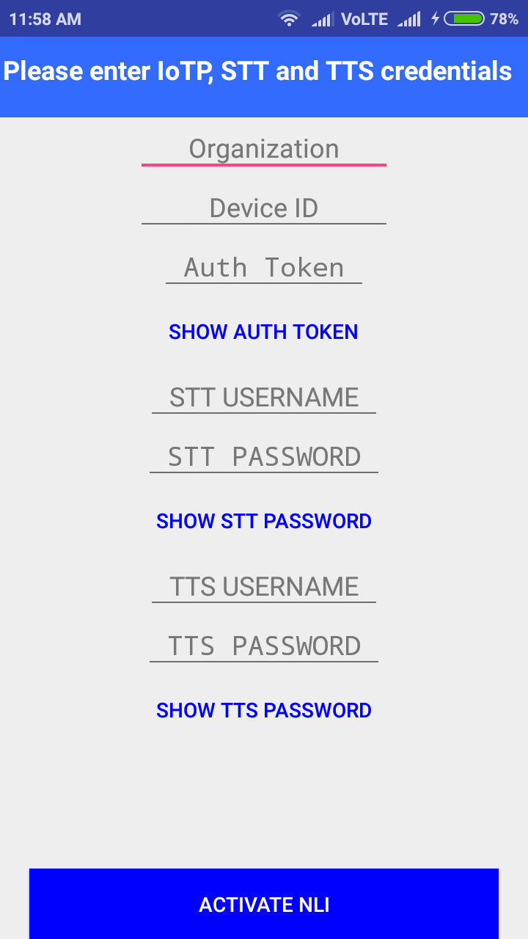

9. Steps to build Android Natural Language Interface Application

Step1: Install the android Studio in windows or mac.

Step2: open the Android studio and import the existing project into android studio

Step3: Do the sync project with Gardle.

Step4: once successful sync run the project.