Impact of Climate Variability on Agricultural

Productivity and Food Security in Banke, Nepal: Insights from 1990–2020

Rasila Gautam1, Bishwa Prakash Puri1, Madan Sigdel*2,3, and Hari Dahal1

1College of Applied Sciences-Nepal, Tribhuvan University,

Kathmandu, Nepal

2CAS-TU, Central Department of Hydrology and Meteorology, Tribhuvan University

3Kathmandu Centre for Research and Education (KCRE)

*Correspondence Author: madan.sigdel@cdhm.tu.edu.np

# ABSTRACT

Nepal’s diverse climate, spanning from subtropical lowlands to arctic high mountains, poses significant challenges for its predominantly agriculture-dependent population. There is a gap regarding the impact of climate change on yield. This study seeks to address the knowledge gaps and examines the impact of climate variability on agricultural productivity and food security in Banke, Nepal, over the period 1990–2020. Analysis of long-term climatic data revealed a minor but steady increase in average temperature (0.0946°C per year), a significant upward trend in sunshine hours (15.15 hours per year, *R*2 = 0*.*3125), and a modest annual rise in accumulated rainfall (approximately 1.94mm per year). Correlation analysis indicates that sunshine hours have a significant positive effect on crop yield (*r* = 0*.*417, *p* = 0*.*017), whereas rainfall and temperature exhibit weaker, statistically non-significant relationships. A linear regression model incorporating these variables explained 24.2% of the variation in crop yield. Additionally, the region’s agricultural profile is characterized by a high reliance on monoculture, limited crop diversification, and minimal institutional support despite generally sufficient food production. Shifts in cropping calendars and irrigation practices—most notably, the higher yields achieved under year-round irrigation compared to rainfed systems—further underscore farmers’ adaptive responses to climate uncertainties. These findings highlight the dominant role of solar radiation in driving crop productivity and underscore the need for integrated, climate-resilient strategies to ensure long-term agricultural sustainability and food security. There is a pressing need for integrated, climate-resilient approaches that encompass better irrigation systems, diverse cropping patterns, and stronger institutional support.

**Keywords:** Climate variability, Agricultural productivity, Food security, Irrigation and Crop yield, Climate change adaptation

# INTRODUCTION

Nepal’s climatic diversity, spanning from subtropical to arctic zones in its high mountains, is a unique geographical feature. Given that the majority of the population relies on agriculture for their livelihood, understanding the factors that influence agricultural output is crucial. Nepal’s long-term agricultural development is increasingly at risk due to climate change events, such as erratic rainfall, droughts, and floods, which significantly affect crop production, food security, and livelihoods. Additionally, the agriculture sector is vulnerable to pests and diseases, which are further exacerbated by climate change [1].

Malla highlights the multifaceted impacts of climate change on Nepalese agriculture, emphasizing the sensitivity of various crops to alterations in temperature, rainfall, and humidity, which influence pest and disease dynamics and potentially harm crop yields, with maize, for instance, showing a differential response to temperature increases, yielding more favorably in the mountainous regions than in the Terai and hills [2].

Climate change significantly impacts agriculture by altering key climatic factors such as temperature, carbon dioxide (CO2) levels, and precipitation patterns. While moderate increases in temperature and CO2 may enhance crop productivity in certain regions, extreme climate variations—such as more frequent droughts and floods—pose serious challenges to farmers. These climatic disruptions exacerbate existing stressors, including population growth and resource scarcity, amplifying their adverse effects on agricultural productivity and food security [3]. The effect of climate change on agriculture, which manifests in various forms, including changes in average temperature, rainfall, and climate extremes, and analyzes crop yield responses to these climatic changes [4].

Food security is ensured when everyone has consistent access to sufficient food for an active and healthy life [5]. According to Kang et al. food security depends on four key factors: food availability, stability, access, and utilization. Increased climate variability, along with more frequent and intense weather events, puts significant pressure on food stability [6]. Additionally, climate change impacts food quality by raising temperatures and shortening crop growth periods. Food security is impacted by climate change, especially in areas and populations where rain-fed agriculture is the primary source of food. Plants and crops have thresholds that when exceeded impair yield and growth [5]. Climate change is expected to intensify the frequency and severity of extreme weather events, leading to increased climate variability and uncertainty. Farmers in low-income countries are particularly vulnerable to these changes due to their high exposure to climate risks and limited adaptive capacity. As climate extremes become more frequent, the ability of farmers in these regions to sustain agricultural productivity and food security will be increasingly challenged [7].

One of the most significant issues in the 21st century is to supply enough food for the growing population while maintaining the already strained ecosystem, which is endangered by climate change [6]. With the global population steadily increasing, the need to enhance production to meet the growing demand for food has become crucial. However, this imperative has prompted a quest for sustainable agricultural approaches that not only boost productivity but also prioritize the preservation of resources for the benefit of future generation [8].

The effects of climate change on agricultural output frequently interact with those on water availability productivity and soil water balance. Climate change affects temperature and precipitation, which immediately affect the state of soil moisture and groundwater levels. Crop types, planting locations, soil degradation, the growing environment, and the availability of water throughout the crop growth period all have an impact on crop production [9].

Nepal’s geographical diversity, ranging from the Terai plains to the Himalayan peaks, makes it highly vulnerable to climate change. Agriculture is a critical sector in Nepal, forming the backbone of the economy and providing livelihoods for nearly two-thirds of the population. However, it faces numerous challenges, including poverty, limited access to resources, and climate change. Climate change significantly impacts agriculture by altering temperature and precipitation patterns, leading to shifts in soil moisture and groundwater levels [1].

In particular, the Western Terai region, known as the breadbasket of Nepal, has experienced observable shifts in climate patterns, including an annual temperature rise of approximately 0.040°C. Erratic weather events and climate variability significantly threaten agriculture, which forms the backbone of the region’s economy [10]. In order to improve agricultural resilience, production, food security, and sustainability, adaptive research should concentrate on creating crop varieties that can withstand drought, heat, and floods, including locally grown, indigenous, disease- and pest–resistant cultivars. It should also invest in resource centers, adjust sowing timing based on rainfall, encourage early maturing cultivars, ensure high-quality seeds and planting materials, and implement food production and self-reliance initiatives in rural, food-deficient areas [11].

In the Banke district, challenges such as limited irrigation infrastructure and agricultural constraints have exacerbated food deficits. For instance, in 2015-16, Banke faced a food deficit of -1767 MT, highlighting the growing issue of food insecurity [1]. Janaki Rural Municipality, situated in Banke, exemplifies the urgent need to understand the interplay between climate change impacts, agricultural resilience, and food security dynamics.

This study seeks to address the knowledge gap regarding the impact of climate change on agriculture in Banke. By examining the relationship between climatic variables (temperature, precipitation, and sunshine hours) and crop yields over the past three decades, the research aims to provide a comprehensive understanding of the region’s vulnerabilities. Additionally, the study explores farmers’ perceptions of climate change, food security scenarios, and the current state of irrigation. It also investigates how these factors collectively influence agricultural resilience and food production.

The findings from this study can inform strategic planning and policy-making to enhance agricultural resilience and food security in Banke. By identifying the key challenges and opportunities, the research aims to support local and provincial governments in developing targeted interventions, such as promoting drought resistant crops, improving irrigation systems, and providing training on adaptive farming practices. These measures are essential to ensuring sustainable agricultural development and improving the livelihoods of farmers in Janaki Rural Municipality, Banke.

# STUDY AREA, AND METHODOLOGY

## Study Area

The study area for this research is Janaki Rural Municipality, located in Nepalgunj, Banke District, Nepal (Figure1). Situated at an elevation of 165m above sea level, it is bordered by Nepalgunj Sub-Metropolitan City to the east, Kohalpur Municipality to the north, Khajura Rural Municipality to the west, and the international boundary with India to the south (Janaki Rural Municipality). The region features a temperate climate and flat terrain. Meteorological records indicate an average annual rainfall of 1445.58 mm, with temperatures ranging from a minimum of 4.5°C to a maximum of 46°C (Janaki Rural Municipality).

Figure 1: Study Area: Janaki Rural Municipality, Banke, Nepal



Agriculture is the primary livelihood for most households in Janaki Rural Municipality. Of the 5,063ha of cultivable land, only 2,532ha are utilized, comprising 1,798ha of farmland and 774ha of upland. Land ownership varies widely: 1,294 households possess less than 0.167ha, 1,222 hold 0.2–0.33ha, 2,338 own 0.37– 0.67ha, 1,512 control 0.7–1ha, and 973 own more than 20ha, while 52 households are landless (Janaki Rural Municipality, 2075). Irrigation remains limited, with only 321ha irrigated year-round and 1,871 ha lacking consistent water access. The municipality contains 50 ponds, some of which support irrigation. Despite abundant arable land, inadequate irrigation and limited technological resources hinder commercial agriculture, resulting in dependence on food imports from India (Janaki Rural Municipality, 2075).

Janaki Rural Municipality is divided into six wards, of which three were randomly selected for this study (Table 1).

Table 1: Study Area with elevation and coordinates

|  |  |  |  |
| --- | --- | --- | --- |
| **S.N.** | **Study Location** | **Elevation (m)** | **Coordinates** |
| 1 | Janaki Rural Municipality – 01, Saigaun | 164 | 28°02’42”N 81°34’05”E |
| 2 | Janaki Rural Municipality – 03, Indrapur | 172 | 28°05’02”N 81°36’20”E |
| 3 | Janaki Rural Municipality – 04, Khajura Khurda | 163 | 28°06’26”N 81°36’00”E |

Source: (Janaki Rural Municipality, 2075)

### Methods of Data Collection

**Primary Data Sources** : A comprehensive household survey and intensive field research were conducted across wards 1, 3, and 4 of Janaki Rural Municipality, encompassing 47 villages. Structured interviews and direct observations were employed to gather data on agricultural practices, irrigation access, food security, and perceptions of climate change. Village sample sizes were determined based on household ratios derived from municipal records, followed by systematic sampling of households within each village to ensure representativeness.

**Secondary Data Sources** : Secondary data were sourced from a literature review pertinent to the research objectives. Desk-based research, primarily utilizing online resources, provided the majority of the data. Additional information was obtained from reference books, recently published national newspapers, peer-reviewed international journals, government reports, historical records, and relevant websites.

### Sampling Frame

: The study employed stratified random sampling to select wards 1, 3, and 4 from the six wards of Janaki Rural Municipality, using a lottery method for ward selection. These wards were chosen to represent the municipality’s diversity, with ward 1 comprising 5 villages and wards 3 and 4 each containing 21 villages, as documented in an internal survey from 2075 B.S. Villages within each ward were sampled proportionally using stratified random sampling to enhance diversity and reduce sampling bias. Households within selected villages were then systematically chosen based on household data provided by the municipality. Field observations complemented the survey by providing additional insights into household conditions and local agricultural practices.

Details of the household distribution across the sampled wards are presented in Table 2. The table summarizes the number of households from wards 1, 3, and 4 of Janaki Rural Municipality, providing a foundation for the study’s analysis of agricultural and environmental conditions.

## Sample Size Determination

The total household population was derived from an internal survey conducted by Janaki Rural Municipality in 2075 B.S. (Janaki Rural Municipality). The sample Table 2: Household Distribution by Ward in Janaki Rural Municipality

|  |  |
| --- | --- |
| **Ward** | **Household** |
| 1 | 1242 |
| 3 | 1929 |
| 4 | 1050 |
| **Total** | 7391 |

size for the questionnaire survey was calculated at a 95% confidence level using the following formula (Dahal 2021):

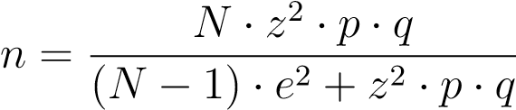

where:

* *n* = sample size,
* *N* = total number of households in selected wards (4,221),
* *z* = z-score for 95% confidence level (1.96),
* *p* = expected prevalence (0.9),
* *q* = 1 − *p* (0.1), • *e* = margin of error (0.05).

Substituting the values:



The sample size for each ward (*nh*) was determined proportionally using the formula (Dahal 2021)

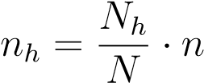

where:

* *nh* = sample size per ward,
* *Nh* = number of households in the ward,
* *N* = total household population (4,221),
* *n* = total sample size (134).

## Sample Size of Selected Wards

The proportional sample sizes for wards 1, 3, and 4 are presented in Table 3.

Table 3: Sample Size of Selected Wards in Janaki Rural Municipality

|  |  |  |  |
| --- | --- | --- | --- |
| **Ward** | *Nh* | *Nh/N* | *Nh/N* · *n* |
| 1 | 1242 | 0.29 | 39 |
| 3 | 1929 | 0.457 | 61 |
| 4 | 1050 | 0.249 | 33 |
| **Total** | 4221 |  | 134 |

### Data Collection and Calculation

This study aimed to examine production trends, climatic scenarios, and their interrelationships within the research area. Data collection involved integrating primary, secondary, and ancillary sources to ensure a robust and comprehensive analysis. Primary data were gathered through household surveys and field observations in Janaki Rural Municipality, as detailed in earlier sections. Secondary data were sourced from government reports, academic literature, books, and reputable organizations, including the Department of Hydrology and Meteorology (DHM) and the Ministry of Agriculture and Livestock Development (MOALD). Ancillary data from credible websites enhanced the dataset’s timeliness and depth. This multifaceted approach ensured the reliability, richness, and contextual relevance of the data. Statistical analyses were performed using IBM SPSS Statistics (version 27) and Microsoft Excel.

**Pearson Correlation Coefficient** The Pearson correlation coefficient (*r*) was calculated to assess the linear relationship between crop yield (dependent variable) and climatic factors—sunshine hours, accumulated rainfall, and average temperature (independent variables)—prior to regression analysis. This coefficient, ranging from -1 to 1, quantifies the strength and direction of linear associations. A value of *r* = 1 indicates a perfect positive correlation, *r* = −1 a perfect negative correlation, and *r* = 0 no linear correlation. The formula is:

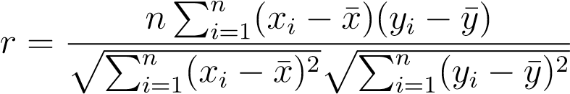

where *xi* and *yi* are individual data points, ¯*x* and ¯*y* are the means of variables *X* and *Y* , and *n* is the number of observations.

**Simple Linear Regression Analysis** Simple linear regression was employed to model the relationship between crop yield (*Yi*, dependent variable) and individual climatic variables (*Xi*, independent variables). This method estimates the linear effect of an independent variable on the dependent variable. The regression equation is:

*Yi* = *β*0 + *β*1*Xi* + *ϵ*

where *β*0 is the intercept, *β*1 is the slope, and *ϵ* is the error term capturing

unexplained variation.

**T-test** A two-sample t-test was conducted to compare average crop yields (kg/ha) between plots with year-round irrigation and those reliant on rainfed irrigation during the monsoon season. Year-round irrigation refers to plots with consistent water supply, while rainfed irrigation depends solely on seasonal rainfall. The null hypothesis (*H*0) posits no difference in yields between groups, against the alternative (*H*1) of a significant difference. The significance level was set at *α* = 0*.*05, and analysis was performed in SPSS. The t-test statistic is:

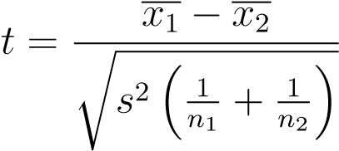

where *x*1 and *x*2 are group means, *s*2 is the pooled variance, and *n*1 and *n*2 are

sample sizes.

**Index Model** An index model was developed to assign index values to unit areas, facilitating the creation of a ranking map. Similar to binary models, it employs overlay operations and multicriteria assessment but generates continuous index scores rather than binary outcomes. The process involved two stages: (1) assigning weights to variables based on relative importance,

(2) scoring observed values.

**Climate Change and Production Trend Analysis** : Simple linear regression, implemented in IBM SPSS Statistics (version 27), was used to model the relationship between crop yield (dependent variable) and climatic variables—accumulated precipitation, average temperature, and sunshine radiation (independent variables). Pearson correlation coefficients were first calculated to assess linear associations, followed by regression analysis to quantify trends over time. This dual approach provided insights into both the strength and direction of relationships between yield and climate factors.

**Climate Change Trends** : Three climatic variables—accumulated rainfall, average temperature, and sunshine hours—were analyzed over a 30-year period (1990–2021) in the study area. Data were sourced from the Department of Hydrology and Meteorology (DHM). Linear trends were visualized using Microsoft Excel, with graphs illustrating changes in each variable over time.

**Climate Change Perception** : An index model evaluated farmers’ perceptions of climate change and its impact on agricultural production, recognizing that such perceptions shape adaptation strategies. A survey of 134 respondents assessed opinions on climate change using a three-point scale: +1 for agreement/approval, -1 for disagreement/disapproval, and 0 for “don’t know/absent.” For binary variables, the perception index was calculated using the formula by [12]:

INDEX =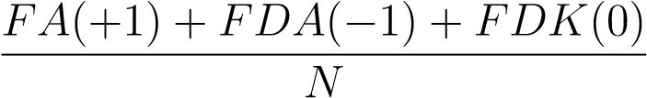

where:

* *FA* = frequency of agreement/approval,
* *FDA* = frequency of disagreement/disapproval,
* *FDK* = frequency of “don’t know/absent,”
* *N* = total respondents (134).

For variables with multiple categories, a normalized index was computed based on [13]:



where *X* is the observed value of a specific category, and Max/Min values define the range of responses.

# RESULTS AND DISCUSSION

## Climate and Production

### Climate Change Trend

Figure 2: Average Temperature since 1990 to 2021

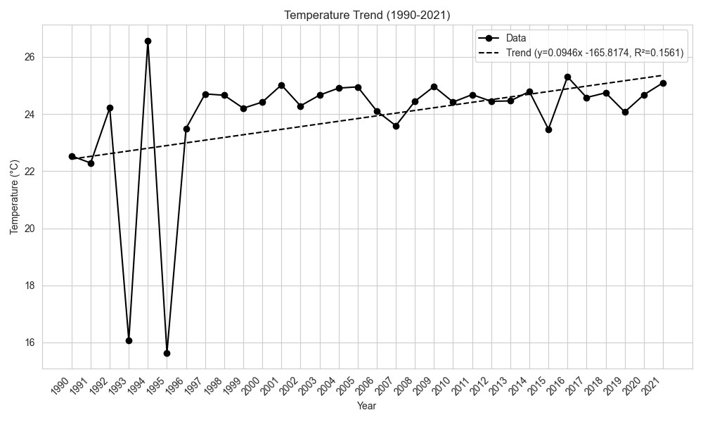

As shown in Figure 2, the results indicate that between 1990 and 2020, the average temperature showed a minor positive trend, averaging 0.0946 °C per year, with 15.61% of the variability explained by the linear trend *y* = 0*.*0946*x* − 165*.*8. Aligning with findings from Regmi et al. where The average maximum temperature ranges from 26 to 31 with standard deviation of less than one and average minimum temperature ranges from 15 to 20 degrees Celsius again with standard deviation of less than one showing almost no change on its trend value [4]. In contrast Puri et al. reported seasonal variability in temperature trends over a 60-year period in the Koshi Basin, detecting an overall slightly insignificant cooling trend [14]. Similarly, Risal et al. observed a linear but modest increasing trend in temperature for the Banke region using the *NOAA RegCM*4 model. However, the analysis revealed less variability in the linear trend, with a decrease in average and maximum temperatures, while minimum temperatures showed an increasing trend [9]. Dawadi et al. reported that while the annual maximum temperature exhibited an increasing trend (0.01°C per year), the overall annual temperature showed a decreasing trend (0.04°C per year) [15]. The positive trend observed in our study may be attributed to global warming, which could have profound impacts on crop production. Rising temperatures influence crop growth, development, and yield, while also altering pest and disease distribution, potentially affecting agricultural productivity.

Figure 3: Average Sunshine Hour since 1990 to 2021

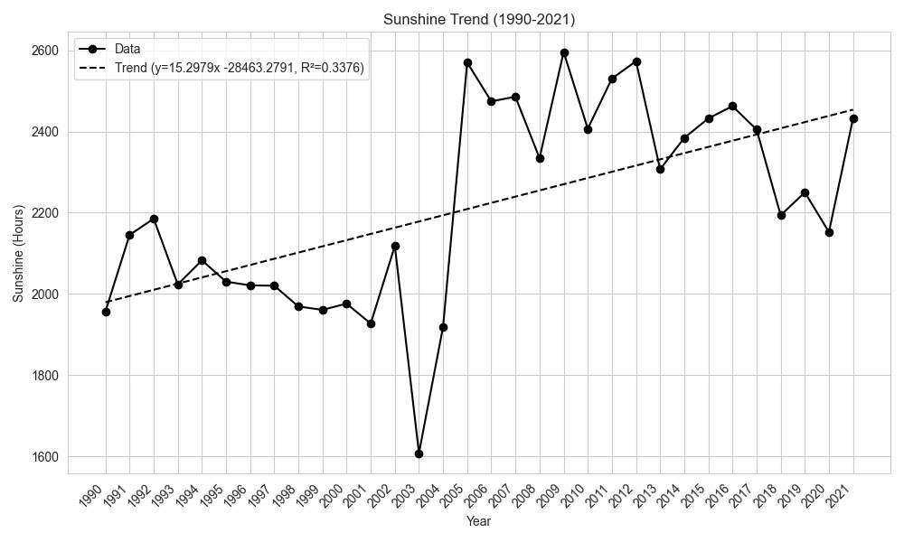

The average sunlight hours from 1990 to 2020 exhibited a positive trend, increasing by 15.15 hours per year, as shown in the linear trend analysis. The R-squared value (0.3376) indicates that the trend explains 33.76% of the variability (Figure 3). This increase in sunlight hours in Banke may be influenced by weather variations, land-use changes, and climate variability, potentially driven by local and global climate change.

Figure 4: Accumulated Rainfall since 1990 to 2021

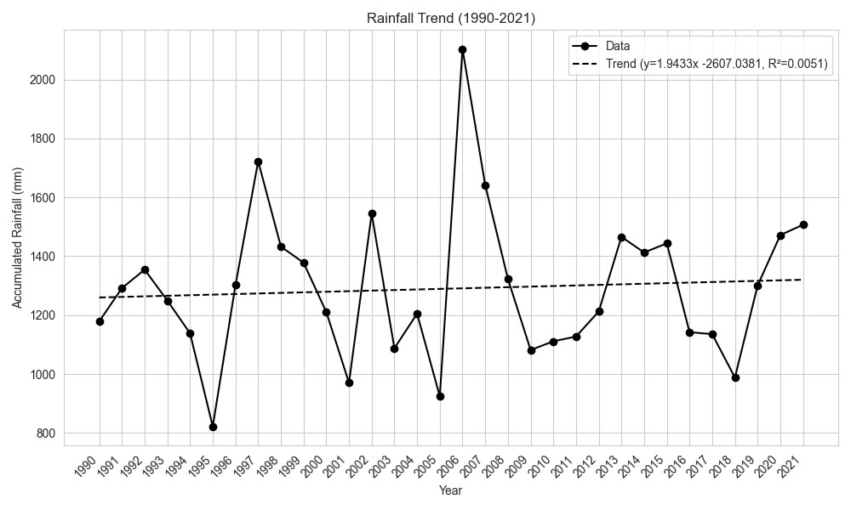

Figure 4 shows a slight positive trend in accumulated rainfall, represented by the equation *y* = 1*.*9433*x* − 2607*.*0381, indicating an annual increase of approximately 1.94 mm per year. This rise in rainfall in Banke, Nepal, may be influenced by local weather patterns, air circulation, land-use changes, and the broader effects of climate change. Similar to study by Poudel and Shaw in Lamjung District a mountainous region in Nepal, revealing heterogeneous precipitation trends, with two stations showing increasing precipitation and one showing a decreasing trend, likely influenced by the complex interplay of monsoon and westerly wind systems across the varied topography, while temperature analysis indicated a consistent warming trend, with an average increase of 0.07 degrees Celsius [16]. According to Regmi et al. the average annual precipitation in Banke over the past 37 years is approximately 1395 mm, with values ranging from 868 mm to 2173 mm per year. The high standard deviation (over 338 mm) suggests significant variability in annual rainfall patterns [4]. Rainfall patterns fluctuate annually, showing a lower degree of predictability. While there is an increasing trend in summer rainfall, winter rainfall is on the decline [17]. Manandhar et al. observed a diminishing trend in precipitation at the meteorological station at Bhairahawa Airport, along with highly irregular rainfall patterns in the region. Furthermore, although an analysis of temperature data indicates a marginal increase, the t-test results do not show any statistically significant trend [18].

## Yield and Climate Variables

In this study to find the relationship between crop yield and climate variables, a correlation analysis was conducted between crop yield and key climate variables, including sunshine hours, accumulated rainfall, and average temperature, followed by a linear regression analysis.

Table 4: Correlation Table between Yield and Climate Variables

|  |  |  |  |
| --- | --- | --- | --- |
|  | **Sunshine Hours** | **Accumulated Rainfall (mm)** | **Average Temperature (**°**C)** |
| **Yield (mt/ha)** | 0.417* | -0.074 | 0.287 |
| **(p-value)** | 0.017 | 0.686 | 0.112 |

Table 5: Linear Regression Model Summary for Yield and Climate Data

**Dep. Variable** Yield

### Adjusted R-squared 0.161

### Significance (p-value) 0.048

**F-statistic** 2.981

**R-squared** 0.242

Table 6: Regression Coefficients for Yield and Climate Data

**Std. Error**

**Model**

**Unstandardized Coefficients**

**Standardized**

**t**

**Sig**

**B**

**Beta**

|  |  |  |  |  |  |
| --- | --- | --- | --- | --- | --- |
| **(Constant)** | -99.061 | 903.331 | - | -0.110 | 0.913 |
| **Sunshine** | 0.670 | 0.291 | 0.391 | 2.306 | 0.029 |
| **Accumulated Rainfall** | -0.279 | 0.279 | -0.168 | -0.999 | 0.326 |
| **Average Temperature** | 43.825 | 32.148 | 0.232 | 1.363 | 0.184 |

The analysis of long-term climatic data revealed a slight but steady increase in average temperature (0.0946 °C per year), a significant upward trend in sunshine hours (15.15 hours per year, *R*2 = 0*.*3125), and a modest annual rise in accumulated rainfall (approximately 1.94 mm per year). Correlation analysis indicated that sunshine hours had a significant positive effect on crop yield (*r* = 0*.*417, *p* = 0*.*017), while rainfall and temperature exhibited weaker, statistically nonsignificant relationships.

Table 6 presents the correlation between crop yield and key climate variables: sunshine hours, accumulated rainfall, and average temperature. The results indicate that sunshine hours have a significant positive correlation with crop yield (*r* = 0*.*417*, p* = 0*.*017), suggesting that increased solar exposure enhances crop productivity. In contrast, accumulated rainfall exhibits a weak negative correlation (*r* = −0*.*074*, p* = 0*.*686), implying that rainfall variability does not have a statistically significant effect on crop yield. Average temperature shows a moderate positive correlation with yield (*r* = 0*.*287*, p* = 0*.*112); however, this relationship is not statistically significant. These findings suggest that sunshine hours play a more critical role in influencing crop yield than rainfall or temperature variations.

The linear regression model (Table 5), which includes sunshine hours, accumulated rainfall, and average temperature as predictor variables, explains 24.2% of the variation in crop yield (*R*2 = 0*.*242). After adjusting for the number of predictors, the adjusted (*R*2) value is 0.161, indicating moderate explanatory power. However, Maharjan and Joshi found that multivariate regression analysis indicate that the model can explain variations in the yields of food crops, ranging from 40% for paddy to only 2% for barley. Despite this, the regression findings in the current study show few significant relationships between crop yield and climate variables [17].

The model suggests that while climate variables contribute to variations in crop yield, additional factors may also play a role. The regression equation derived from the analysis is as follows:

Crop Yield = *β*0+*β*1(Sunshine Hours) +*β*2(Accumulated Rainfall)

+*β*3(Average Temperature) + *ε*

Crop Yield = −99*.*061 + 0*.*670 × Sunshine

− 0*.*279 × Accumulated Rainfall (1)

+ 43*.*825 × Average Temperature

The regression analysis presented in Table 6 highlights the differential influence of climate variables on crop yield. Sunshine hours exhibit a statistically significant positive effect on yield (*β* = 0*.*391*, p* = 0*.*029), confirming that increased solar exposure enhances photosynthesis and improves crop productivity. In contrast, accumulated rainfall shows a negative but non-significant effect (*β* = −0*.*168*,p* = 0*.*326), indicating that total precipitation levels alone do not significantly contribute to yield variations, in contrast Parajuli and Devkota observed positive correlation between precipitation and wheat yield [19]. Average temperature demonstrates a positive but non-significant relationship (*β* = 0*.*232*, p* = 0*.*184), suggesting that while temperature fluctuations influence crop growth, their effect is less direct compared to solar radiation.

The findings indicate that sunshine hours are the most influential climate variable affecting yield. The significant correlation and positive regression coefficient reinforce the role of solar radiation in enhancing plant photosynthesis, ultimately improving crop growth. This is consistent with prior studies conducted in Nepal and South Asia, which identified solar radiation as a key determinant of agricultural output [19].

Conversely, rainfall does not exhibit a statistically significant impact on yield, likely due to erratic precipitation patterns in the Banke district. Similar studies have reported that uneven rainfall distribution reduces soil moisture availability, adversely affecting crop health despite high total precipitation levels [4]. Devkota found that the mean temperature is rising slowly in the West Rapti River basin. Additionally, the region is frequently impacted by devastating floods and persistent rainfall, which cause extensive damage to standing crops. These findings suggest that rainfall variability, rather than total precipitation, plays a more critical role in yield determination [20].

Thapa-Parajuli and Devkota found a complex relationship between temperature and wheat yields, indicating that initial temperature increases may enhance yields, particularly with an optimal minimum temperature of 20°C. However, they caution that this positive impact is limited by a threshold, beyond which further warming could have a detrimental effect on production [19]. The moderate but non-significant relationship between temperature and yield suggests that temperature fluctuations influence crop growth but may also introduce counteracting effects. Higher temperatures can accelerate crop maturation but simultaneously increase evapotranspiration, leading to reduced soil moisture availability [21]. This could explain why temperature, though positively correlated with yield, does not demonstrate strong statistical significance in the regression model.

Devkota and Paija found that a 1% increase in rainfall improved rice yield by 0.45%, whereas this study indicates a negative but weak relationship between rainfall and yield. The discrepancy may stem from variations in soil properties, irrigation availability, and crop types across regions [22]. Similarly, Karki et al. reported that sunshine hours significantly influenced wheat productivity, reinforcing this study’s conclusion that increased solar exposure enhances crop output [23]. Furthermore, Risal et al. observed that temperature increases beyond optimal thresholds negatively impact yield, whereas this study does not find a strong negative effect, possibly due to regional climate adaptations [9]. Dawadi et al. found that the overall analysis of maize, wheat, and potato production showed a significant increasing trend over the study period, while millet production exhibited an insignificant decreasing trend [15]. Poudel and Shaw observed significant temporal fluctuations in crop yield trends, with an overall increasing pattern, likely driven by a combination of factors such as the impacts of climate change and the adoption of improved agricultural practices, including the introduction of new seed varieties, advanced agricultural technologies, enhanced irrigation systems, and refined crop management strategies [16].

### Climate Change Perception

Table 7 highlights farmers’ perceptions of climate change and its impacts. A unanimous agreement (*index* = 1.00) confirms that farmers recognize climate change, yet awareness of specific temperature variations is low (*index* = -0.88). Similarly, perceptions of climate change affecting agricultural productivity and untimely monsoons are weakly negative (*index* = -0.88, -0.75), indicating uncertainty or reliance on adaptive measures. Conversely, moderate agreement exists regarding climate change’s role in pest outbreaks (0.28), crop abnormalities (0.275), and extreme events (0.155). Farmers also acknowledge observable evidence of climate change (*index* = 0.47), though their understanding of its direct effects remains inconsistent. Dawadi et al. reported that nearly half of the respondents perceived an increase in temperature, while about 30% disagreed with the notion of temperature change, and the remaining respondents reported a temperature decrease [15]. Furthermore, a considerable number of respondents (62.86%) were unaware of climate change and its impacts. Despite this, most respondents (62.86%) exhibited lower-than-average perceptions of the effect of climate change on agricultural production. However, it is clear that the local population has indeed experienced the effects of climate change.

These findings suggest a need for evidence-based targeted awareness programs to enhance farmers’ climate literacy, particularly on temperature fluctuations, rainfall variability, and pest dynamics. Strengthening localized adaptation strategies and access to climate information can help mitigate perceived uncertainties and improve agricultural resilience.

Table 7: Farmer’s Perception on Climate Data

|  |  |
| --- | --- |
| **Statement / Variables** | **Index** |
| Climate change is happening | 1.00 |
| Aware about the range of temperature experienced in locality | -0.88 |
| Climate change affects agricultural productivity | -0.88 |
| Effect of untimely monsoon on production | -0.75 |
| Climate change affects the spread of pests and insects over crops | 0.28 |
| Abnormalities in crops | 0.275 |
| Extreme events in locality | 0.155 |
| Evidence of climate change | 0.47 |

*\*Higher the index, stronger the perception.*

*Frequency of agreement/approval: +1, Frequency of disagreement/disapproval: -1, Frequency of don’t know/absent: 0.*

### Agriculture and Food Scenarios

Table 8 presents key characteristics of the agricultural and food security scenario. The results indicate that mixed farming and crop diversification are rare, with 97.8% of farmers practicing monoculture. Despite this, food production is largely sufficient, as 92.5% report adequate yields, and only 7.5% experience food shortages.

Food security appears stable, with 97% of households not facing deficits, and 99.3% reporting no undernutrition. Additionally, 97.8% maintain food stocks, mainly sourced from their own production (95.5%). However, institutional support for agriculture is minimal, with only 4.5% receiving assistance.

The dominance of monoculture farming raises concerns about long-term sustainability, given climate uncertainties. While food availability is currently high, reliance on single-crop systems may increase vulnerability to climate shocks. Strengthening institutional support and promoting diversified farming practices could enhance resilience and long-term food security.

Table 8: Agricultural and Food Scenario Characteristics

|  |  |  |
| --- | --- | --- |
| **Characteristics** | **Variables** | **Percentage** |
| Mixed Farming | Yes | 2.2 |
|  | No | 97.8 |
| Crop Combination | Yes | 2.2 |
|  | No | 97.8 |
| Food Production | Enough | 92.5 |
|  | Not Enough | 7.5 |
| Food Deficit | Purchase from the market | 3.0 |
|  | Not Deficit | 97.0 |
| Undernutrition | No | 99.3 |
|  | Yes | 0.7 |
| Food Stock Present or Absent | Yes, Present | 97.8 |
|  | No, Absent | 2.2 |
| Sources | Own Production | 95.5 |
|  | Markets | 4.5 |
| Institutional Support | Yes | 4.5 |
|  | No | 95.5 |

### Crop Calendar

Table 9 highlights shift in sowing and harvesting times for major crops over the past five years, primarily due to irregular monsoons and climate variability. Paddy cultivation, which previously started in mid-June, has been delayed to early August, with a corresponding shift in harvesting to November. Similar trends are observed for wheat, mustard, lentils, and pigeon pea, with delays in both sowing and harvesting periods. In similar vein Bhattarai reported that Nepalese farmers, who rely heavily on the timing, frequency, duration, and intensity of rainfall for crop cultivation, are being forced to alter their cropping patterns due to climate change [24].

These changes indicate that farmers are adapting to unpredictable rainfall and shifting climatic patterns. However, no significant alterations are noted for seasonal vegetables and fruits, suggesting that perennial crops may be less affected by climate variability. The adjustments in the crop calendar reflect farmers’ strategies to cope with environmental uncertainties, emphasizing the need for climate resilient agricultural practices and improved water management to mitigate risks associated with shifting weather patterns.

Table 9: Crop Calendar Based on Major Changes in Cropping Time

|  |  |  |  |  |  |
| --- | --- | --- | --- | --- | --- |
| **Crop** | **Before 5 Years** | | **Recent Time (After 5 Years)** | | **Reason** |
|  | **Sowing Month** | **Harvesting Month** | **Sowing Month** | **Harvesting Month** |  |
| Paddy | June (3rd week) | September (1st week) | August (1st week) | November (Mid-week) | Irregular Monsoon / Climatic Shift |
| Wheat | December (1st week) | April (Last week) | January (Mid-week) | April (2nd week) | Climatic Shift |
| Mustard | November (Mid-week) | April (Mid-week) | November (3rd week) | March (2nd week) | Climatic Shift |
| Lentils | October (3rd week) | March (3rd week) | December (1st week) | April (Last week) | Climatic Shift |
| Pigeon Pea | June (Last week) | January (2nd week) | July (3rd week) | February (2nd week) | Climatic Shift |
| Vegetables | All months | All months | All months | All months | No Change |
| Fruits | All months | All months | All months | All months | No Change |

*Source: Questionnaire survey conducted in the study area.*

## Irrigation

### Irrigation Status

The irrigation status in the study area is largely dependent on seasonal rainfall, with 93.3% of land relying on rain-fed irrigation, while only 26.9% has access to year-round irrigation (Table 10). The predominant irrigation sources include a combination of groundwater, canal, drainage ponds, and rainfall, with 59% of farmers depending on groundwater and drainage ponds.

Gravity-fed surface irrigation, utilizing both flood and furrow techniques, is universally practiced across the region. Although 48.5% of farmers rely on artificial irrigation, 38.1% still depend on natural water sources, highlighting limited infrastructure for controlled irrigation.

Despite the strong reliance on rain-fed agriculture, respondents did not report significant irrigation issues, suggesting either sufficient seasonal water availability or adaptation to existing climatic conditions. However, the high dependence on monsoon rainfall makes agricultural productivity vulnerable to climate variability, underscoring the need for improved irrigation infrastructure and water storage solutions to enhance year-round water security.

Table 10: Frequency Table for Land and Irrigation Data of Survey

|  |  |  |
| --- | --- | --- |
| **Characteristics** | **Variables** | **Percentage** |
| Irrigation Source | Ground water + Canal irrigation + Rainfall  Ground water + Drainage Pond + Rainfall  Ground water + Rainfall | 23.9  59.0  1.5 |
|  | All | 15.7 |
| Land Quality Irrigation | Khet Upland and Khet | 73.1  26.9 |
| Irrigation Type | Natural  Artificial | 38.1  48.5 |
|  | Both | 13.4 |
| Irrigation Category | Year-round irrigation (whole year)  Rainfed Irrigation (monsoon) | 6.7  93.3 |
| Season of Availability | All Season  Monsoon | 26.9  73.1 |
| Irrigation Technique | Gravity-fed surface (flood and furrow) | 100.0 |

### Irrigation and yield

The t-test results, as shown in Table 11, compare the crop yield between two irrigation methods: year-round irrigation and rain-fed irrigation in Janaki Rural Municipality. The findings indicate a significant difference in mean crop yield between the two irrigation methods.

The t-test analysis indicated a significant difference in mean crop yield between the two irrigation methods. For year-round irrigation, the mean crop yield was 7868.63 kg/ha, with a standard deviation of 3756.38, while for rain-fed irrigation, the mean crop yield was 5450.43 kg/ha, with a standard deviation of 2505.86. The t-test analysis produced a t-value of 2.696 and a p-value of 0.008, which is Table 11: t-test of Between-Subjects Effects

### Year-Round Irrigation Rainfed Irrigation t(132), p

|  |  |  |  |  |  |  |
| --- | --- | --- | --- | --- | --- | --- |
| **Yield (kg/ha)** | **Mean** | **SD** | **Mean** | **SD** | **t** | **p** |
| Crop Yield | 7868.63 kg/ha | 3756.38 | 5450.43 kg/ha | 2505.86 | 2.696 | 0.008 |

statistically significant at the 0.05 level. This suggests that year-round irrigation leads to significantly higher crop yields compared to rain-fed irrigation. According to Malla, rain-fed wheat productivity is likely to be more vulnerable in the Terai than in the mid-hills under a climate change scenario [2].

This result aligns with similar studies that have shown the benefits of consistent irrigation on crop yields. The difference in yield underscores the importance of irrigation infrastructure and access to reliable water sources for improving crop productivity. It also highlights the vulnerability of rain-fed agriculture to climate variability, emphasizing the need for more sustainable and resilient irrigation practices to safeguard food security in the region.

# CONCLUSION

This study examined the interplay between climate variability and agricultural productivity in Banke and Janaki Rural Municipality over the period 1990–2020. Our analysis revealed a minor but steady increase in average temperature (0.0946°C per year), a significant upward trend in sunshine hours (15.3 hours per year, R² = 0.3376), and a modest annual increase in accumulated rainfall (approximately 1.94 mm per year). Notably, sunshine hours were found to have a significant positive correlation with crop yield (r = 0.417, p = 0.017), while rainfall and temperature exhibited weaker and statistically non-significant relationships with yield. The linear regression model, incorporating these climate variables, explained 24.2% of the variation in crop yield, indicating moderate explanatory power.

In parallel, the agricultural profile of the region is characterized by a high reliance on monoculture, with limited crop diversification and minimal institutional support, despite overall sufficient food production. Shifts in crop calendars, particularly the delayed sowing and harvesting of major crops such as paddy, wheat, mustard, lentils, and pigeon pea, reflect farmers’ adaptive responses to irregular monsoons and broader climatic shifts. Moreover, the irrigation analysis underscores that while 93.3% of the land depends on rainfed irrigation, year-round irrigation—though practiced on a limited scale—significantly enhances crop yield (7868.63 kg/ha compared to 5450.43 kg/ha under rainfed conditions, t(132) =2.696, p = 0.008).

Collectively, these findings underscore the dominant role of solar radiation in driving crop productivity and highlight the complex challenges posed by climate variability. They also reveal critical vulnerabilities in the current agricultural practices, particularly the dependence on rainfed irrigation and monoculture systems, which may exacerbate the impacts of climate-induced stresses. To ensure long term agricultural sustainability and food security, there is an urgent need for integrated climate-resilient strategies that include improved irrigation infrastructure, diversified cropping systems, and enhanced institutional support.

# AUTHOR CONTRIBUTION

* **Rasila Gautam**: Conceptualization, Methodology, Data collection, Analysis, Writing - Original Draft.
* **Bishwa Prakash Puri**: Data Analysis, Writing - Review & Editing.
* **Madan Sigdel**: Review & Publication.
* **Hari Dahal**: Supervision, Methodology, Project Administration.

# ACKNOWLEDGMENTS

The authors express their gratitude to the College of Applied Sciences-Nepal, Tribhuvan University, Kathmandu, Nepal, for their support in conducting this research. We also extend our thanks to Dr. Bhupendra Devkota and Dr. Tirtha Raj Adhikari for their insightful and valuable suggestions.

**CONFLICTS OF INTEREST**

The authors declare no conflicts of interest.

# REFERENCES

1. Gyawali P, Khanal S. Overview of Agriculture in Nepal: Issues and Strategies to Cope With. Fundamental and Applied Agriculture. 2021;6(3):323-35[.](https://ejmanager.com/fulltextpdf.php?mno=89753)
2. Malla G. Climate Change and Its Impact on Nepalese Agriculture. Journal of Agriculture and Environment. 2009 Aug;9:62-71.
3. Paudel MN. Global Effect of Climate Change and Food Security with Respect to Nepal. The Journal of Agriculture and Environment. 2015;16.
4. Regmi HR, Rijal K, Joshi GR, Sapkota RP, GC A, Thapa S. Crop Yield Response to Climate Change in Different Ecolozical Zones of Nepal. Asian Journal of Science and Technology. 2019.
5. Muluneh MG. Impact of Climate Change on Biodiversity and Food Security: A Global Perspective—a Review Article. Agriculture & Food Security. 2021 Sep;10(1):36.
6. Kang Y, Khan S, Ma X. Climate Change Impacts on Crop Yield, Crop Water Productivity and Food Security – A Review. Progress in Natural Science. 2009 Dec;19(12):1665-74[.](https://linkinghub.elsevier.com/retrieve/pii/S1002007109002810)
7. Budhathoki NK, Paton D, A Lassa J, Zander KK. Assessing Farmers’ Preparedness to Cope with the Impacts of Multiple Climate Change-Related Hazards in the Terai Lowlands of Nepal. International Journal of Disaster Risk Reduction. 2020 Oct;49:101656[.](https://linkinghub.elsevier.com/retrieve/pii/S2212420920300534)
8. Singh H, Verma S, Kamboj H, Dutt M, Dureja A, Dalai A. Socio-

Economic Status for Qualitative and Quantitative Assessment towards Crop Diversification and Sustainable Agriculture under Different Components Punjab. The Pharma Innovation. 2022 Dec;11(12S):1109-16.

1. Risal A, Urfels A, Srinivasan R, Bayissa Y, Shrestha N, Paudel GP, et al. Impact of Climate Change on Water Resources and Crop Production in Western Nepal: Implications and Adaptation Strategies. Hydrology. 2022;9(8):132.
2. Dahal NM, Xiong Dh, Neupane N, Zhang Bj, Liu Bt, Yuan Y, et al. Factors Affecting Maize, Rice and Wheat Yields in the Koshi River Basin, Nepal. Journal of Agricultural Meteorology. 2021.
3. Khanal K, Adhikari KB, Dhakal SC, Marahatta S. Factors Motivating Farmers for Collective Action for Management of Irrigation System in Nepal. International Journal of Social Sciences and Management. 2021 Jan;8(1):285-91.
4. Dahal H. Nutrient Management and Sustainability of Agriculture. 1st ed. Heritage Books; 2021.
5. Nguyen DC. Assessing Livelihood Vulnerability to Salinity Intrusion and Climate Variability A Case Study in Coastal Provinces of the Mekong River Delta of Vietnam. Journal of Environmental Science and Engineering B. 2019 Apr;8(4).
6. Puri BP, Adhikari TR, Sigdel M, Devkota B, Shrestha S. Spatial and Temporal Variations of Surface Air Temperature (1962–2022) across Physiographic Regions in the Koshi Basin, Nepal. Journal of Hydrology and Meteorology. 2024 Dec;12(1):46-57.
7. Dawadi B, Shrestha A, Acharya RH, Dhital YP, Devkota R. Impact of Climate Change on Agricultural Production: A Case of Rasuwa District,

Nepal. Regional Sustainability. 2022 Jun;3(2):122-32[.](https://linkinghub.elsevier.com/retrieve/pii/S2666660X22000329)

1. Poudel S, Shaw R. The Relationships between Climate Variability and Crop Yield in a Mountainous Environment: A Case Study in Lamjung District, Nepal. Climate. 2016 Mar;4(1):13
2. Maharjan KL, Joshi NP. In: Effect of Climate Variables on Yield of Major Food-Crops in Nepal: A Time-Series Analysis. Tokyo: Springer Japan; 2013. p. 127-37[.](https://link.springer.com/10.1007/978-4-431-54343-5_9)
3. Manandhar S, Vogt DS, Perret SR, Kazama F. Adapting Cropping Systems to Climate Change in Nepal: A Cross-Regional Study of Farmers’ Perception and Practices. Regional Environmental Change. 2011 Jun;11(2):335-48.
4. Thapa-Parajuli R, Devkota N. Impact of Climate Change on Wheat Production in Nepal. Asian Journal of Agricultural Extension, Economics & Sociology. 2016-010-10;9(2):1-14[.](https://journalajaees.com/index.php/AJAEES/article/view/399)
5. Devkota RP. Climate Change: Trends and People’s Perception in Nepal. Journal of Environmental Protection. 2014;05(04):255-65[.](http://www.scirp.org/journal/doi.aspx?DOI=10.4236/jep.2014.54029)
6. Shrestha R, Rakhal B, Adhikari TR, Ghimire GR, Talchabhadel R, Tamang D, et al. Farmers’ Perception of Climate Change and Its Impacts on Agriculture. Hydrology. 2022 Nov;9(12):212.
7. Devkota N, Paija N. Impact of Climate Change on Paddy Production: Evidence from Nepal. Asian Journal of Agriculture and Development. 2020 Dec;17(2):63-78.
8. Karki S, Burton P, Mackey B, Alston-Knox C. Status and Drivers of Food Insecurity and Adaptation Responses under a Changing Climate among Smallholder Farmers Households in Bagmati Province, Nepal. Environment, Development and Sustainability. 2021 Oct;23(10):14642-65.
9. Bhattarai S. Impact of Climate Change in the Agricultural System in the Tropical Region of Nepal. Journal of Earth Science and Climate Change.

2021;12(3).