

NAME OF THE PROJECT

**RATINGS PREDICTION**

Submitted by:

Bishwajit Bhattacharya

**ACKNOWLEDGMENT**

I taken the data from Flipkart, although the rating was in decimal value but to get proper output, I round up the data. As a result, the target value is integer.

Most of rating is 4 as because I got the data is mostly like 4.2,4.3,4.4 like this so after round up its coming 4.

From sk learn I got all the regressor model.

**INTRODUCTION**

Customer reviews are very important part of production. But the problem is how we will know product is likeable or not. By rating a product is median to be sure the product is good or bad.

Normally this rating is done out of 5 some times out of 10 also.

Product quality can be easily measured by this.

**Analytical Problem Framing**

Data taken from Flipkart website. I used both selenium and Beautiful soup. First data taken from 1st page, there I get 40 data, then tried second page and then all the pages.

For getting proper link I use define function

After I got all the data, I use beautiful soup program.

I taken only model name, star, review and number of ratings.

results = soup.find_all('a',{'class':"_1fQZEK"})

model = item.find('div',{'class':"_4rR01T"}).text

star = item.find('div',{'class':"_3LWZlK"}).text

num_ratings = item.find('span',{'class':"_2_R_DZ"}).text.replace('\xa0&\xa0'," ; ")[0:item.find('span',{'class':"_2_R_DZ"}).text

reviews = item.find('span',{'class':"_2_R_DZ"}).text.replace('\xa0&\xa0'," ; ")[item.find('span',{'class':"_2_R_DZ"}).text.replace('\xa0&\xa0'," ; ").

Total data taken on **“Rating.xlsx”**

**Model/s Development and Evaluation**

* Identification of possible problem-solving approaches (methods)

After putting data on excel, I import data by using

df = pd.DataFrame(pd.read_excel("Rating.xlsx"))

df

we have 25597 rows and 5 columns

Target column is New Rating which is integer

* Testing of Identified Approaches (Algorithms)

As the target value is integer we should use Regression technique, here we will check R2 score.

R2 score is **the proportion of the variance in the dependent variable that is predictable from the independent variable(s)**.

So if it is 100%, the two variables are perfectly correlated, i.e., with no variance at all. **R2=1−sum squared regression (SSR)total sum of squares (SST),=1−∑(yi−^yi)2∑(yi−¯y)2**..<https://media.geeksforgeeks.org/wp-content/uploads/LR-cost-function-1.jpg>

**Another method is Lasso and Ridge technique.**

Linear model equation is :-y=w[0]*x[0]+w[1]*x[1]+…..w[n]+x[n]+b

Here n is number of variable w is slope and b is intercept y output and x input.

Linear regression looks for optimizing w and b such that it minimizes the cost function.

Ridge and Lasso regression are **some of the simple techniques to reduce model complexity and prevent over-fitting** which may result from simple linear regression . Ridge Regression : In ridge regression, the cost function is altered by adding a penalty equivalent to square of the magnitude of the coefficients.

In ridge regression, however, the formula for the hat matrix should include the regularization penalty: **Hridge = X(X′X + λI)−1X**, which gives dfridge = trHridge, which is no longer equal to m. Some ridge regression software produce information criteria based on the OLS formula.

Lasso regression is a type of linear regression that **uses shrinkage**. Shrinkage is where data values are shrunk towards a central point, like the mean. The lasso procedure encourages simple, sparse models (i.e. models with fewer parameters). ... The acronym “LASSO” stands for Least Absolute Shrinkage and Selection Operator.

I got all those things sklearn.

print ("total sum of squares", y)

print ("ẗotal sum of residuals ", g)

print ("r2 calculated", 1 - (g / y))

print("R2 score : %.2f" % r2_score(ytest,preds))

Variance:- In terms of linear regression, **variance** is a measure of how far observed values differ from the average of predicted values, i.e., their difference from the **predicted value mean**.

**np.var(err)**, where **err** is an array of the differences between observed and predicted values and **np.var()** is the numpy array variance function.

**Mean square error (MSE)**is the average of the square of the errors. The larger the number the larger the error. **Error** in this case means the difference between the observed values y1, y2, y3, … and the predicted ones pred(y1), pred(y2), pred(y3), … We square each difference (pred(yn) – yn)) ** 2 so that negative and positive values do not cancel each other out.

After these I used SVR and Random Forest technique

Given training vectors xi∈Rp, i=1,…, n, and a vector y∈Rn ε-SVR solves the following primal problem:

minw,b,ζ,ζ∗12wTw+C∑i=1n(ζi+ζi∗)subject to yi−wTϕ(xi)−b≤ε+ζi,wTϕ(xi)+b−yi≤ε+ζi∗,ζi,ζi∗≥0,i=1,...,n

Here, we are penalizing samples whose prediction is at least ε away from their true target. These samples penalize the objective by ζi or ζi∗, depending on whether their predictions lie above or below the ε tube.

The dual problem is

minα,α∗12(α−α∗)TQ(α−α∗)+εeT(α+α∗)−yT(α−α∗)subject to eT(α−α∗)=00≤αi,αi∗≤C,i=1,...,n

where e is the vector of all ones, Q is an n by n positive semidefinite matrix, Qij≡K(xi,xj)=ϕ(xi)Tϕ(xj) is the kernel. Here training vectors are implicitly mapped into a higher (maybe infinite) dimensional space by the function ϕ.

The prediction is:

∑i∈SV(αi−αi∗)K(xi,x)+b

These parameters can be accessed through the attributes dual_coef_ which holds the difference αi−αi∗, support_vectors_ which holds the support vectors, and intercept_ which holds the independent term b

. LinearSVR

The primal problem can be equivalently formulated as

minw,b12wTw+C∑i=1max(0,|yi−(wTϕ(xi)+b)|−ε),

where we make use of the epsilon-insensitive loss, i.e. errors of less than ε are ignored. This is the form that is directly optimized by **[LinearSVR](https://scikit-learn.org/stable/modules/generated/sklearn.svm.LinearSVR.html" \l "sklearn.svm.LinearSVR" \o "sklearn.svm.LinearSVR)**.

A random forest regressor.

A random forest is a meta estimator that fits a number of classifying decision trees on various sub-samples of the dataset and uses averaging to improve the predictive accuracy and control over-fitting. The sub-sample size is controlled with the max_samples parameter if bootstrap=True (default), otherwise the whole dataset is used to build each tree.

from sklearn.model_selection import GridSearchCV

from sklearn.ensemble import RandomForestRegressor

parameters = {'criterion':['mse', 'mae'],'max_features':["auto", "sqrt", "log2"]}

rf =RandomForestRegressor()

clf = GridSearchCV(rf,parameters)

clf.fit(xtrain,ytrain)

print(clf.best_params_)

rf= RandomForestRegressor(criterion="mse",max_features="auto")

rf.fit(xtrain, ytrain)

rf.score(xtrain, ytrain)

pred_decision = rf.predict(xtest)

rfs = r2_score(ytest,pred_decision)

print('R2 Score:',rfs*100)

rfscore = cross_val_score(rf,features,target,cv=5)

rfc = rfscore.mean()

print('Cross Val Score:',rfc*100)

* Visualizations

for i in df.columns:

sns.displot(df[i])

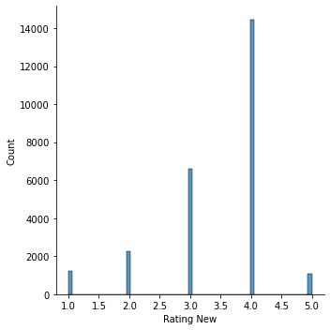

sns.catplot(x="Model", y="Rating New", data=df)

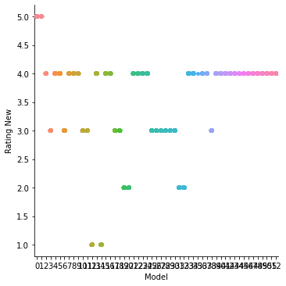

sns.boxplot(x="Reviews", y="Rating New", data=df)

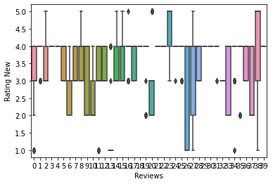

* Interpretation of the Results

In the graph we can see that most of the rating coming 4.

As Model, Review, Num _of_Ratings is object we need to encode it to int, for that I take LabelEncoder from sk learn.

import sklearn

from sklearn.preprocessing import LabelEncoder

lencode=LabelEncoder()

df['Model']=lencode.fit_transform(df['Model'])

df['Num_of_Ratings']=lencode.fit_transform(df['Num_of_Ratings'])

df['Reviews']=lencode.fit_transform(df['Reviews'])

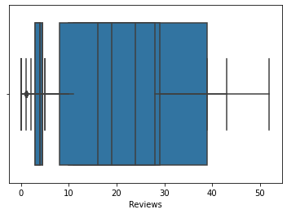

|  | **Model** | **Stars** | **Rating New** | **Num_of_Ratings** | **Reviews** |
| --- | --- | --- | --- | --- | --- |
| **Model** | 1.000000 | 0.202469 | 0.139641 | -0.010807 | -0.033939 |
| **Stars** | 0.202469 | 1.000000 | 0.984859 | 0.030515 | 0.118098 |
| **Rating New** | 0.139641 | 0.984859 | 1.000000 | 0.056753 | 0.116174 |
| **Num_of_Ratings** | -0.010807 | 0.030515 | 0.056753 | 1.000000 | 0.231049 |
| **Reviews** | -0.033939 | 0.118098 | 0.116174 | 0.231049 | 1.000000 |

After consider corelation we can check there is no outlier.

**Heatmap**

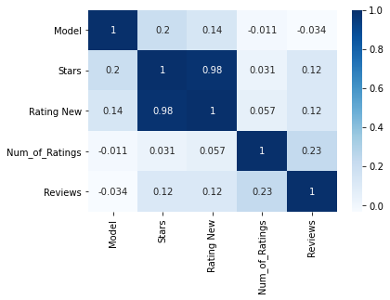

**CONCLUSION**

* Key Findings and Conclusions of the Study

R2 score of linear regression is

R2 score:: 0.9745942510343873

mean_squared_error is

error:

0.02028275074064433

R2 score of Lasso and Ridge

0.9743544142113998

0.9743544860114564

For ElasticNet

0.9743544561978105

For svr technique:- kernellist=['linear','poly','rbf']

0.9685977351545538

0.9388288211600813

0.9932701928285411

After ensemble process

R2 Score: 100.0

Cross Val Score: 100.0

Mean absolute error:: 0.11410932460629734

Mean squared error:: 0.02028275074064433

Root mean square:: 0.1424175225898988

Model:-

loaded_model = pickle.load(open('rating.pkl', 'rb'))

result = loaded_model.score(xtest, ytest)

print(result)

1.0

conclusion=pd.DataFrame([loaded_model.predict(xtest)[:],pred_decision[:]],index=["Predicted","Orginal"])

|  | **0** | **1** | **2** | **3** | **4** | **5** | **6** | **7** | **8** | **9** | **...** | **7670** | **7671** | **7672** | **7673** | **7674** | **7675** | **7676** | **7677** | **7678** | **7679** |
| --- | --- | --- | --- | --- | --- | --- | --- | --- | --- | --- | --- | --- | --- | --- | --- | --- | --- | --- | --- | --- | --- |
| **Predicted** | 4.0 | 4.0 | 3.0 | 2.0 | 4.0 | 4.0 | 1.0 | 4.0 | 3.0 | 3.0 | ... | 2.0 | 5.0 | 3.0 | 4.0 | 2.0 | 3.0 | 3.0 | 4.0 | 5.0 | 2.0 |
| **Orginal** | 4.0 | 4.0 | 3.0 | 2.0 | 4.0 | 4.0 | 1.0 | 4.0 | 3.0 | 3.0 | ... | 2.0 | 5.0 | 3.0 | 4.0 | 2.0 | 3.0 | 3.0 | 4.0 | 5.0 | 2.0 |

2 rows × 7680 columns

* Learning Outcomes of the Study in respect of Data Science

I had total 25597 data and I use 7680 for testing purpose , result is show identical I got 100% results. It might differ if I not done ensamble process, but model is ok to go.

* Limitations of this work and Scope for Future Work

As per the requirement I adjust the decimal value, so if I did not do that might be results little differ.

No all the customer rate the product so it does not mean data is exactly correct.

I think if we got proper rating from, we can improve this.

**Thank you**

Total code you can get from my github https://github.com/bishwa2017/Rating