**Pizza KPI**

**Total Revenue**

SELECT SUM(total_price) AS Total_Revenue FROM pizza_sales;



**Average Order Value**

SELECT SUM(total_price) / COUNT(DISTINCT order_id) AS Avg_Order_Value FROM pizza_sales;



**Total Pizza Sold**

SELECT SUM(quantity) AS Total_Pizza_Sold FROM pizza_sales



**Total Orders**

SELECT COUNT(DISTINCT order_id) AS Total_Orders FROM pizza_sales



**Average Pizzas Per Order**

SELECT CAST(CAST(SUM(quantity) AS DECIMAL(10,2)) /

CAST(COUNT(DISTINCT order_id) AS DECIMAL(10,2)) AS DECIMAL(10,2)) AS Avg_Pizzas_Per_Order FROM pizza_sales



**CHARTS REQUIREMENTS**

**Daily Trends**

SELECT DATENAME(DW, order_date) AS order_day, COUNT(DISTINCT order_id) AS Total_orders

FROM pizza_sales

GROUP BY DATENAME(DW, order_date)

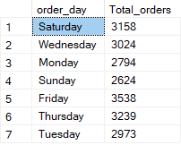

**Monthly Trend**

SELECT DATENAME(MONTH, order_date) AS Month_name, COUNT(DISTINCT order_id) AS Total_orders

FROM pizza_sales

GROUP BY DATENAME(MONTH, order_date)

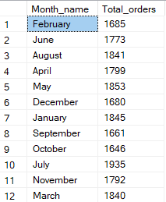

**Percentage of Sales(Revenue) by Category**

SELECT pizza_category ,SUM(total_price) as Total_sales, SUM(total_price)*100/ (SELECT SUM(total_price) FROM pizza_sales) AS PCT

FROM pizza_sales

GROUP BY pizza_category

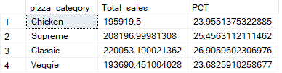

**Percentage of Sales(Revenue) by Size**

SELECT pizza_size ,CAST(SUM(total_price) AS DECIMAL(10,2)) AS Total_sales, CAST(SUM(total_price)*100/ (SELECT SUM(total_price) FROM pizza_sales) AS DECIMAL(10,2)) AS PCT

FROM pizza_sales

GROUP BY pizza_size

ORDER BY PCT DESC

**Top 5 pizza by Revenue**

SELECT TOP 5 pizza_name, SUM(total_price) AS Total_Revenue

FROM pizza_sales

GROUP BY pizza_name

ORDER BY Total_Revenue DESC

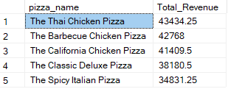

**Bottom 5 pizza by Revenue**

SELECT TOP 5 pizza_name, SUM(total_price) AS Total_Revenue

FROM pizza_sales

GROUP BY pizza_name

ORDER BY Total_Revenue ASC

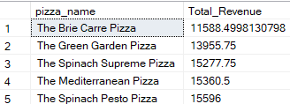

**Top 5 pizza by Quantity**

SELECT TOP 5 pizza_name, SUM(quantity) AS Total_Quantity

FROM pizza_sales

GROUP BY pizza_name

ORDER BY Total_Quantity DESC

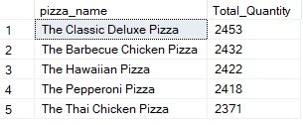

**Bottom 5 pizza by Quantity**

SELECT TOP 5 pizza_name, SUM(quantity) AS Total_Quantity

FROM pizza_sales

GROUP BY pizza_name

ORDER BY Total_Quantity ASC

