**HeartBeatsAI: A Predictive Model for Heart Disease Detection  
using Machine Learning**

A thesis submitted in partial fulfillment of the requirement for the award of the degree

Of

**Bachelor of computer application**

In

**Foct (faculty of computer technology)**

Under

**Assam Down Town University**



***Submitted by***

**Bishwajeet Bal**

Roll no: ADTU/2021-24/BCASP/006

BTech(CTIS) 6th Semester

**Abhay Bhowmik**

Roll no: ADTU/2021-24/BTech(CTIS)/004

BTech(CTIS) 6th Semester

**Injamamul Islam**

Roll no: ADTU/2021-25/BTech(CTIS)/024

BTech(CTIS) 6th Semester

*Under the guidance of*

***Ms. Namrata Das***

Assistant Professor

Faculty of Engineering

**Faculty of computer technology**

**Assam Down Town University**

**Guwahati-26, Assam**

Session: January-June, 2024

**CONTENTS**

|  |  |
| --- | --- |
| * *Certificate of Approval* | i |
| * *Certificate from Guide* | ii |
| * *Certificate from External Examiner* | iii |
| * *Declaration* | iv |
| * *Acknowledgement* | v |
| * *Abstract* | vi |
| * *List of Figures* | vii |
|  |  |
|  |  |

**Chapter Page No**

|  |  |
| --- | --- |
| 1. **Introduction** |  |
| * 1. Overview of the Project | 1-3 |
| * 1. Motivation |
| * 1. Scope and Objective |
| * 1. Existing System |
| * 1. Problem Definition |
| * 1. Proposed System |
|  |  |
| 1. **Project Analysis** | 3-6 |
| * 1. Project Requirement Analysis |  |
| * 1. Gantt Chart |  |
| * 1. Advantage & Disadvantage |  |
| * 1. Project Life Cycle   2. Project Feasibility |  |
|  |  |
| 1. **Project Design** | 6-9 |
| * 1. System Architecture |  |
| * 1. Data Flow Diagram(DFD) |  |
| * 1. NoSQL Diagram |  |
| * 1. Use Case Diagram |  |
| * 1. Sequence Diagram |  |
| * 1. Schema Diagram |  |
|  |  |
| 1. **Project Implementation** | 9-12 |
| * 1. Description of the Software Used |  |
| * 1. User Interface |  |
|  |  |
| 1. **Testing** | 13-14 |
| * 1. Types of Testing |  |
| * 1. Test Cases |  |
|  |  |
| 1. **Conclusion and Future Scope** | 14-15 |
| 1. **References** | 15-16 |
|  |  |
|  |  |
|  |  |



***Computer Science & Engineering***

***Faculty of Engineering***

***Assam down town University***

Gandhi Nagar, Panikhaiti, Guwahati- 781026, Assam

**CERTIFICATE OF APPROVAL**

This is to certify that the project report entitled ***“Serverless Application using AWS”*** submitted by **Raj Singh** bearing Roll No. ADTU/2021-25/BTech(CTIS)/015, **Pulak Gogoi** bearing Roll No. ADTU/2021-25/BTech(CTIS)/004, **Injamamul Islam** bearing Roll No. ADTU/2021-25/BTech(CTIS)/024 and **Dipjyoti Thakuria** bearing Roll No. ADTU/2021-25/BTech(CTIS)/021, are hereby accorded our approval as a study carried out and presented in a manner required for acceptance in partial fulfilment for the award of the degree of ***Bachelor of Technology in Computer Science*** under Assam down town University for approval does not necessary endorse or accept every statement made opinion expressed or conclusion drawn as recorded in the report. It only signifies the acceptance of the project report for a purpose which is submitted.

**Date:**

**.……………………….**

Dr.Utpal Barman

Dean, FOCT

Dean, Engineering(CSE)

Assam down town University

Guwahati, 781026

Guwahati 781026

**Place: Guwahati**



***Computer Science & Engineering***

***Faculty of Engineering***

***Assam down town University***

Gandhi Nagar, Panikhaiti, Guwahati- 781026, Assam

**CERTIFICATE FROM GUIDE**

This is to certify that the project report entitled ***“Serverless Application using AWS ”*** submitted by **Raj Singh** bearing Roll No. ADTU/2021-25/BTech(CTIS)/015, **Pulak Gogoi** bearing Roll No. ADTU/2021-25/BTech(CTIS)/004, **Injamamul Islam** bearing Roll No. ADTU/2021-25/BTech(CTIS)/024 and **Dipjyoti Thakuria** bearing Roll No. ADTU/2021-25/BTech(CTIS)/021 towards the partial fulfilment of the requirements for the award of the degree of ***Bachelor of Technology in Computer Science*** under Assam down town University is a bonafide research work carried out by them under my supervision and guidance. This work has not been submitted previously for any other degree of this or any other University.

I recommend that the thesis may be placed before the examiners for consideration of award of the degree of this University.

**..………………….**

***Ms.Namrata Das***

Assistant Professor

Facultu of Engineering

Assam down town University

Guwahati 781026

**Date:**

**Place: Guwahati**



***Computer Science & Engineering***

***Faculty of Engineering***

***Assam down town University***

Gandhi Nagar, Panikhaiti, Guwahati- 781026, Assam

**CERTIFICATE FROM EXTERNAL EXAMINER**

This is to certify that the project report entitled ***“Serverless Application using AWS ”*** submitted by **Raj Singh** bearing Roll No. ADTU/2021-25/BTech(CTIS)/015, **Pulak Gogoi** bearing Roll No. ADTU/2021-25/BTech(CTIS)/004, **Injamamul Islam** bearing Roll No. ADTU/2021-25/BTech(CTIS)/024 and **Dipjyoti Thakuria** bearing Roll No. ADTU/2021-25/BTech(CTIS)/021 towards the partial fulfilment of the requirements for the award of the degree of ***Bachelor of Technology in Computer Science*** under Assam down town University is a bonafide research work carried out by him under the supervision and guidance of ***Mrs. Namrata Das***, Assistant Professor, Department of Computer Science & Engineering, Assam down town University, Guwahati has been examined by me and found to be satisfactory.

I recommend the thesis for consideration for the award of the degree of ***Bachelor of Technology in Computer Science*** under Assam down town University.

**Date:**

**…………………….**

**External Examiner**

**Place: Guwahati**

**DECLARATION**

We, **Raj Singh** bearing Roll No. ADTU/2021-25/BTech(CTIS)/015, **Pulak Gogoi** bearing Roll No. ADTU/2021-25/BTech(CTIS)/004, **Injamamul Islam** bearing Roll No. ADTU/2021-25/BTech(CTIS)/024 and **Dipjyoti Thakuria** bearing Roll No. ADTU/2021-25/BTech(CTIS)/021 hereby declare that the thesis entitled ***“Serverless Application using AWS”*** is an original work carried out in the Department of Computer Science & Engineering, Assam down town University, Guwahati with exception of guidance and suggestions received from my supervisor, ***Ms. Namrata Das***, Assistant Professor, Department of Computer Science & Engineering, Assam down town University, Guwahati. The data and the findings discussed in the thesis are the outcome of my research work. This thesis is being submitted to Assam down town University for the degree of ***Bachelor of Technology in Computer Science”.***

***Dipjyoti Thakuria***

Roll No.: ***ADTU/2021-25/BTech(CTIS)/021***

BTech(CTIS), 6th Semester

Session: January – May, 2024

Date:

Place:

***Injamamul Islam***

Roll No.: ***ADTU/2021-25/BTech(CTIS)/024***

BTech(CTIS), 6th Semester

Session: January – May, 2024

Date:

Place:

***Pulak Gogoi***

Roll No.: ***ADTU/2021-25/BTech(CTIS)/004***

BTech(CTIS), 6th Semester

Session: January – May, 2025

Date:

Place:

***Raj Singh***

Roll No.: ***ADTU/2021-25/BTech(CTIS)/015***

BTech(CTIS), 6th Semester

Session: January – May, 2025

Date:

Place:

**ACKNOWLEDGEMENT**

We would like to extend our heartfelt appreciation to everyone who contributed to the successful completion of this project. Our sincere thanks go to our project team members for their dedication and collaboration throughout the project. Each member played a significant role in shaping the outcome. Special thanks to our supervisor, Mrs. Namrata Das, for her guidance and valuable feedback, which enriched our work. I would like to express my heartfelt gratitude to the Assam Downtown University for affording us the opportunity to collaborate on the ‘Serverless Application using AWS’. Lastly, we want to thank our friends for their patience and encouragement during this project. Their believe helped us to stayb motivated and to persevere through difficult times.

**ABSTRACT**

Heart disease remains a significant health concern worldwide, prompting the need for advanced predictive tools and data-driven solutions. This project aims to develop a web application leveraging machine learning techniques to predict heart disease risk and compare patient data with existing datasets. Implemented using Flask, the application integrates predictive models trained on combined datasets from the Cleveland database and IEEE DataPort. The system architecture encompasses frontend and backend components, enabling user interaction, data visualization, and database management. By facilitating heart disease prediction, data comparison, and database updates, the application contributes to enhancing healthcare decision-making and patient care.

**List of Figures**

|  |  |
| --- | --- |
| **Sl no.** | **Name of the figure/chart** |
| **1** | **Gantt Chart** |
| **2** | **System Architecture** |
| **3** | **Data Flow Diagram** |
| **4** | **Context diagram** |
| **5** | **Nosql diagram** |
| **6** | **Use case Diagram** |
| **7** | **Sequence diagram** |
| **8** | **Schema Diagram** |
| **9** | **Wireframes/Ui** |

**1. INTRODUCTION**

**1.1 Overview of the project**

The project aims to develop a web-based application for predicting heart disease, comparing new data with existing datasets, and updating the database with new information. With the prevalence of heart diseases and the importance of early detection, this project serves as a valuable tool for both healthcare professionals and individuals concerned about their heart health. By leveraging machine learning algorithms and data visualization techniques, the application provides users with insightful predictions and comparisons, contributing to better decision-making and improved healthcare outcomes.

**1.2 Motivation**

The motivation behind this project is rooted in the global impact of heart disease, which remains one of the leading causes of mortality worldwide according to the World Health Organization (WHO). The WHO reports that cardiovascular diseases, including heart attacks and strokes, are responsible for an estimated 17.9 million deaths annually, making up approximately 31% of all global deaths. Moreover, the burden of heart disease is not only limited to mortality but also encompasses significant morbidity and economic costs, affecting individuals, families, and healthcare systems globally.

In response to this alarming trend, there is a pressing need for innovative solutions that empower individuals to take proactive measures to monitor and manage their heart health. This project seeks to address this need by developing a user-friendly web application that leverages predictive analytics to assess the risk of heart disease based on individual health parameters. By providing users with personalized insights and recommendations, the application aims to promote early detection, prevention, and intervention strategies, ultimately contributing to improved health outcomes and reduced mortality rates associated with heart disease.

**1.3 Scope and Objective**

This project aims to develop a web-based platform for heart disease prediction, comparison with existing data, and database management. The objectives include:

1. **Heart Disease Prediction:** Implementing machine learning algorithms for predicting heart disease risk based on user-provided health parameters.
2. **Comparison with Existing Data:** Allowing users to compare their predicted risk with data from relevant datasets.
3. **Database Management:** Creating a database for storing user data, including patient information and prediction results.
4. **User Interface Design:** Designing an intuitive interface for easy interaction with the platform.
5. **Scalability and Accessibility:** Ensuring scalability and accessibility of the platform for a diverse user base.
6. **Security and Privacy:** Implementing security measures to protect user data and privacy.

**1.4 Existing system**

Prior to this project, existing systems for heart disease prediction and data comparison typically involved standalone applications or manual analysis. These systems often lacked integration with modern web technologies and efficient database management capabilities. Users had to rely on disparate tools for data analysis and lacked a unified platform for seamless prediction and comparison.

While some machine learning models existed for heart disease prediction, they were not always easily accessible to the general public. Additionally, there was a lack of standardized datasets for comparison purposes, making it challenging to evaluate the accuracy of predictions against relevant population data.

Overall, the existing systems faced limitations in terms of accessibility, integration, and efficiency, highlighting the need for a more comprehensive and user-friendly solution like the one proposed in this project.

**1.5 Problem Definition**

The problem this project aims to address is the lack of an efficient and user-friendly system for predicting heart disease and comparing it with existing patient data. Traditional methods of diagnosing heart disease often rely on manual analysis of patient records and medical tests, which can be time-consuming and prone to errors. Additionally, comparing new patient data with existing records may require manual effort and expertise.

Moreover, with the increasing prevalence of heart disease worldwide, there is a growing need for accessible tools that can assist healthcare professionals in making accurate diagnoses and treatment decisions. This project seeks to bridge this gap by developing a web-based application that automates the process of heart disease prediction and comparison, thereby improving efficiency and accuracy in healthcare settings.

**1.6 Proposed System**

The proposed system is a web-based application built using Flask, a micro web framework in Python. It leverages machine learning models trained on heart disease datasets to predict the likelihood of heart disease in patients based on their medical attributes. Additionally, the system allows users to compare new patient data with existing records stored in a database, enabling healthcare professionals to make informed decisions.

Key features of the proposed system include:

1. Heart Disease Prediction: Utilizing machine learning algorithms to analyze patient data and predict the likelihood of heart disease.
2. Data Comparison: Enabling users to compare new patient data with existing records to identify similarities and differences.
3. Database Integration: Storing patient data in a database for easy retrieval and management.
4. User Interface: Providing a user-friendly interface for inputting patient data, viewing predictions, and comparing records.
5. Scalability: Designing the system to be scalable and adaptable to accommodate future enhancements and updates.

By implementing the proposed system, healthcare professionals can streamline the process of diagnosing heart disease, leading to improved patient outcomes and more efficient healthcare delivery. Additionally, the system can serve as a valuable tool for research purposes, allowing for the analysis of large datasets to uncover insights into heart disease risk factors and treatment strategies.

**2. PROJECT ANALYSIS**

**2.1 Project Requirement Analysis**

The project requirement analysis aimed to comprehensively understand the needs and expectations of the stakeholders. This involved identifying the key functionalities required for the prediction and comparison of heart disease. The analysis included:

1. **Data Collection**: Gathering relevant datasets containing patient information, including demographic data, medical history, and diagnostic measurements.
2. **Feature Selection**: Identifying the most relevant features for heart disease prediction, considering factors such as medical significance and predictive power.
3. **Model Development**: Designing and implementing machine learning models for heart disease prediction, ensuring accuracy and interpretability.
4. **Database Integration**: Integrating a database system for efficient storage and retrieval of patient data, facilitating seamless updates and queries.
5. **User Interface**: Developing a user-friendly interface for interacting with the prediction and comparison functionalities, ensuring accessibility and ease of use.
6. **Security Measures**: Implementing security measures to protect patient data confidentiality and prevent unauthorized access.
7. **Scalability**: Designing the system to be scalable, capable of handling large volumes of data and accommodating future expansions or updates.
8. **Performance Optimization**: Optimizing the performance of the prediction and comparison algorithms to ensure fast and efficient processing.

By conducting a thorough analysis of these requirements, the project team could formulate a clear plan for the design and implementation phases, ensuring that the final system met the needs of the stakeholders effectively.

**2.2 Gantt Chart**

|  |  |  |  |
| --- | --- | --- | --- |
|  | **March** | **April** | **May** |
| Information Gathering |  |  |  |
| Analysis |  |  |  |
| Design |  |  |  |
| Coding |  |  |  |
| Testing |  |  |  |
| Analysis |  |  |  |

**2.3 Advantage and Disadvantage**

**Advantage:**

* Enhanced prediction accuracy
* Clear data visualization
* Streamlined prediction process
* Database update functionality

**Disadvantages:**

• Increased system complexity

• Resource-intensive training

• Data privacy concerns

• Maintenance requirements

**2.4 Project Lifecycle**

The project lifecycle involves several key stages:

1. **Requirement Analysis**: This phase involves understanding project goals, identifying stakeholder needs, and defining the scope of work.
2. **Design**: Here, the system architecture, data flow, and user interface are planned and created to meet the established requirements.
3. **Development**: During this stage, the actual coding and implementation of features take place, integrating the backend logic with the frontend interface.
4. **Testing**: Rigorous testing is conducted to verify the functionality, performance, and user acceptance of the developed system.
5. **Deployment**: The application is launched, making it available for public or internal use, depending on the project requirements.
6. **Maintenance**: Ongoing support, updates, and bug fixes are provided to ensure the smooth operation and longevity of the system.

**2.5 Project feasibility**

Project feasibility encompasses assessing the viability and potential success of the project. It typically involves evaluating various aspects such as technical feasibility, economic feasibility, operational feasibility, and scheduling feasibility.

1. **Technical Feasibility**: This involves determining whether the project can be implemented using the available technology and resources. It includes assessing factors like software and hardware requirements, existing infrastructure compatibility, and technical expertise.
2. **Economic Feasibility**: Economic feasibility evaluates the financial aspects of the project, including the cost of development, potential returns on investment, and long-term sustainability. It involves conducting a cost-benefit analysis to determine whether the benefits outweigh the costs.
3. **Operational Feasibility**: Operational feasibility assesses whether the proposed system will be usable and effective within the organization or intended environment. It considers factors such as user acceptance, workflow integration, and organizational readiness for change.
4. **Scheduling Feasibility**: Scheduling feasibility evaluates whether the project can be completed within the specified time frame and deadlines. It involves creating realistic timelines, identifying potential bottlenecks or delays, and allocating resources effectively to meet project milestones.

By analyzing these feasibility factors, stakeholders can make informed decisions about whether to proceed with the project and how to best mitigate any potential risks or challenges.

**3. PROJECT DESIGN**

**3.1 System Architecture**

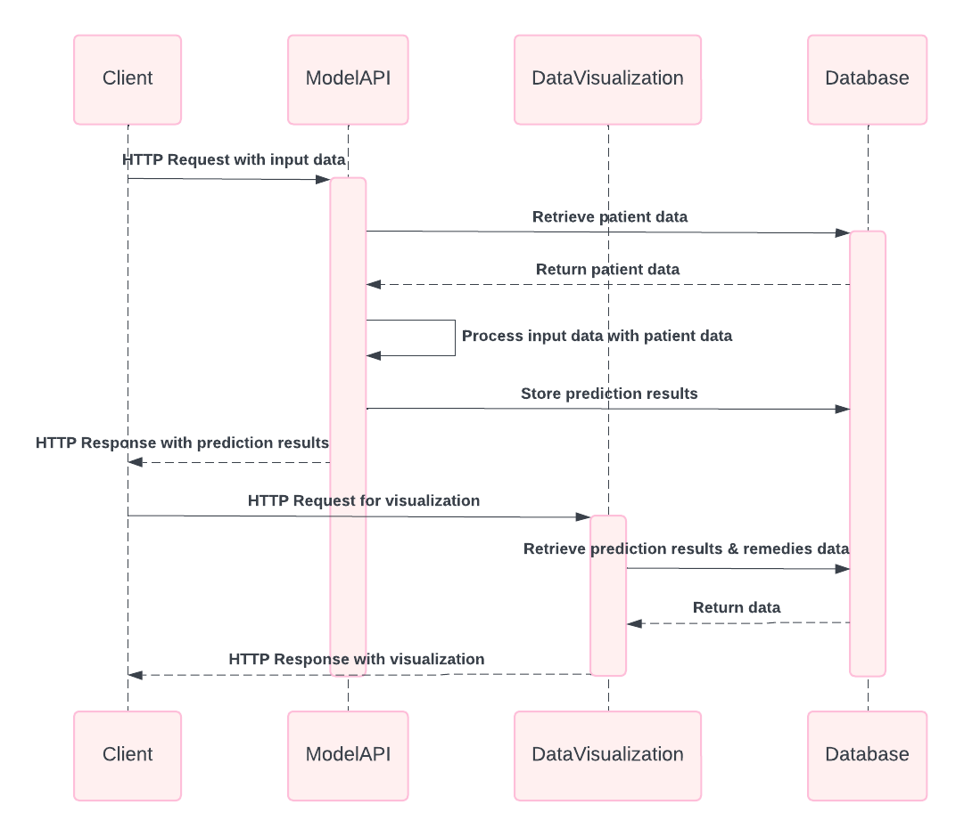

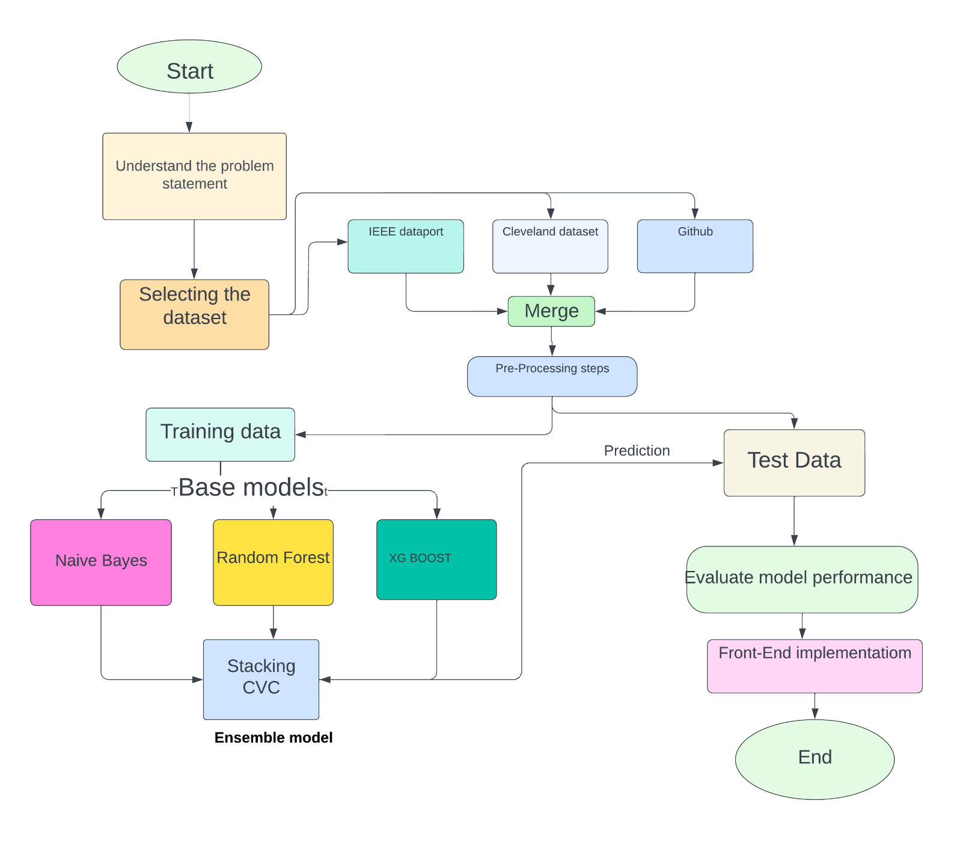**3.2 Data Flow Diagram**

**3.3 SQL Diagram**

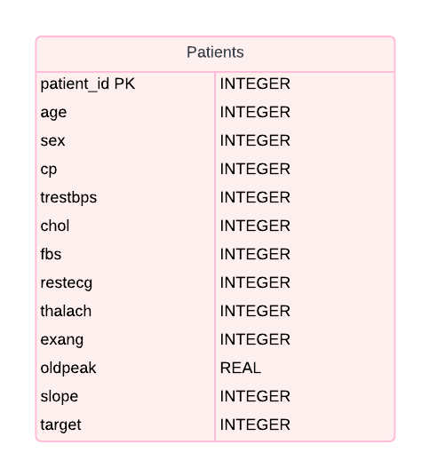

**3.4 Use case Diagram**

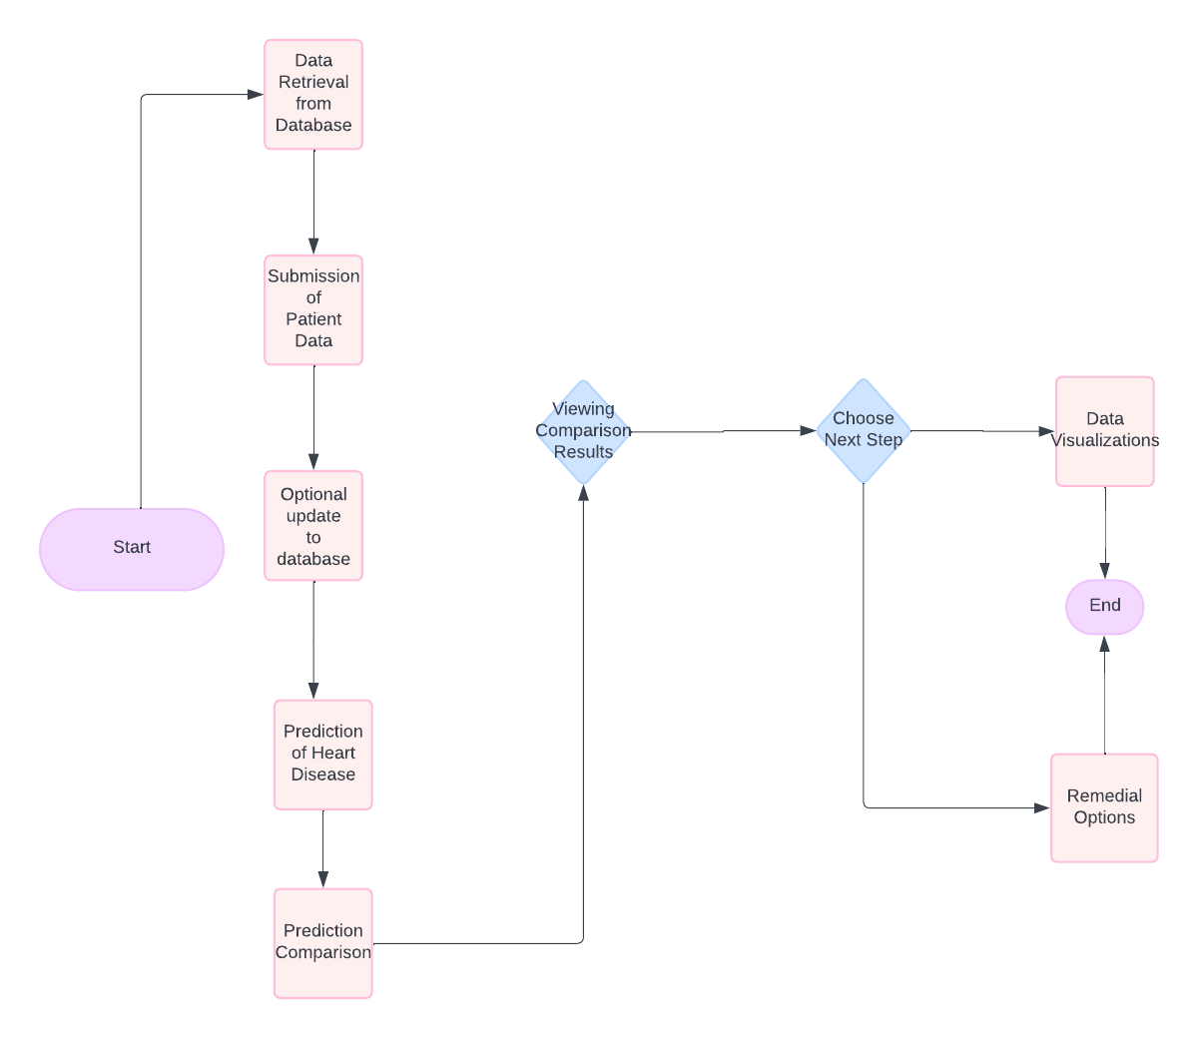

**3.5 Sequence Diagram**

Below is the sequence diagram illustrating the interaction between the user, the web application (Flask), the prediction model, and the database in the heart disease prediction system.

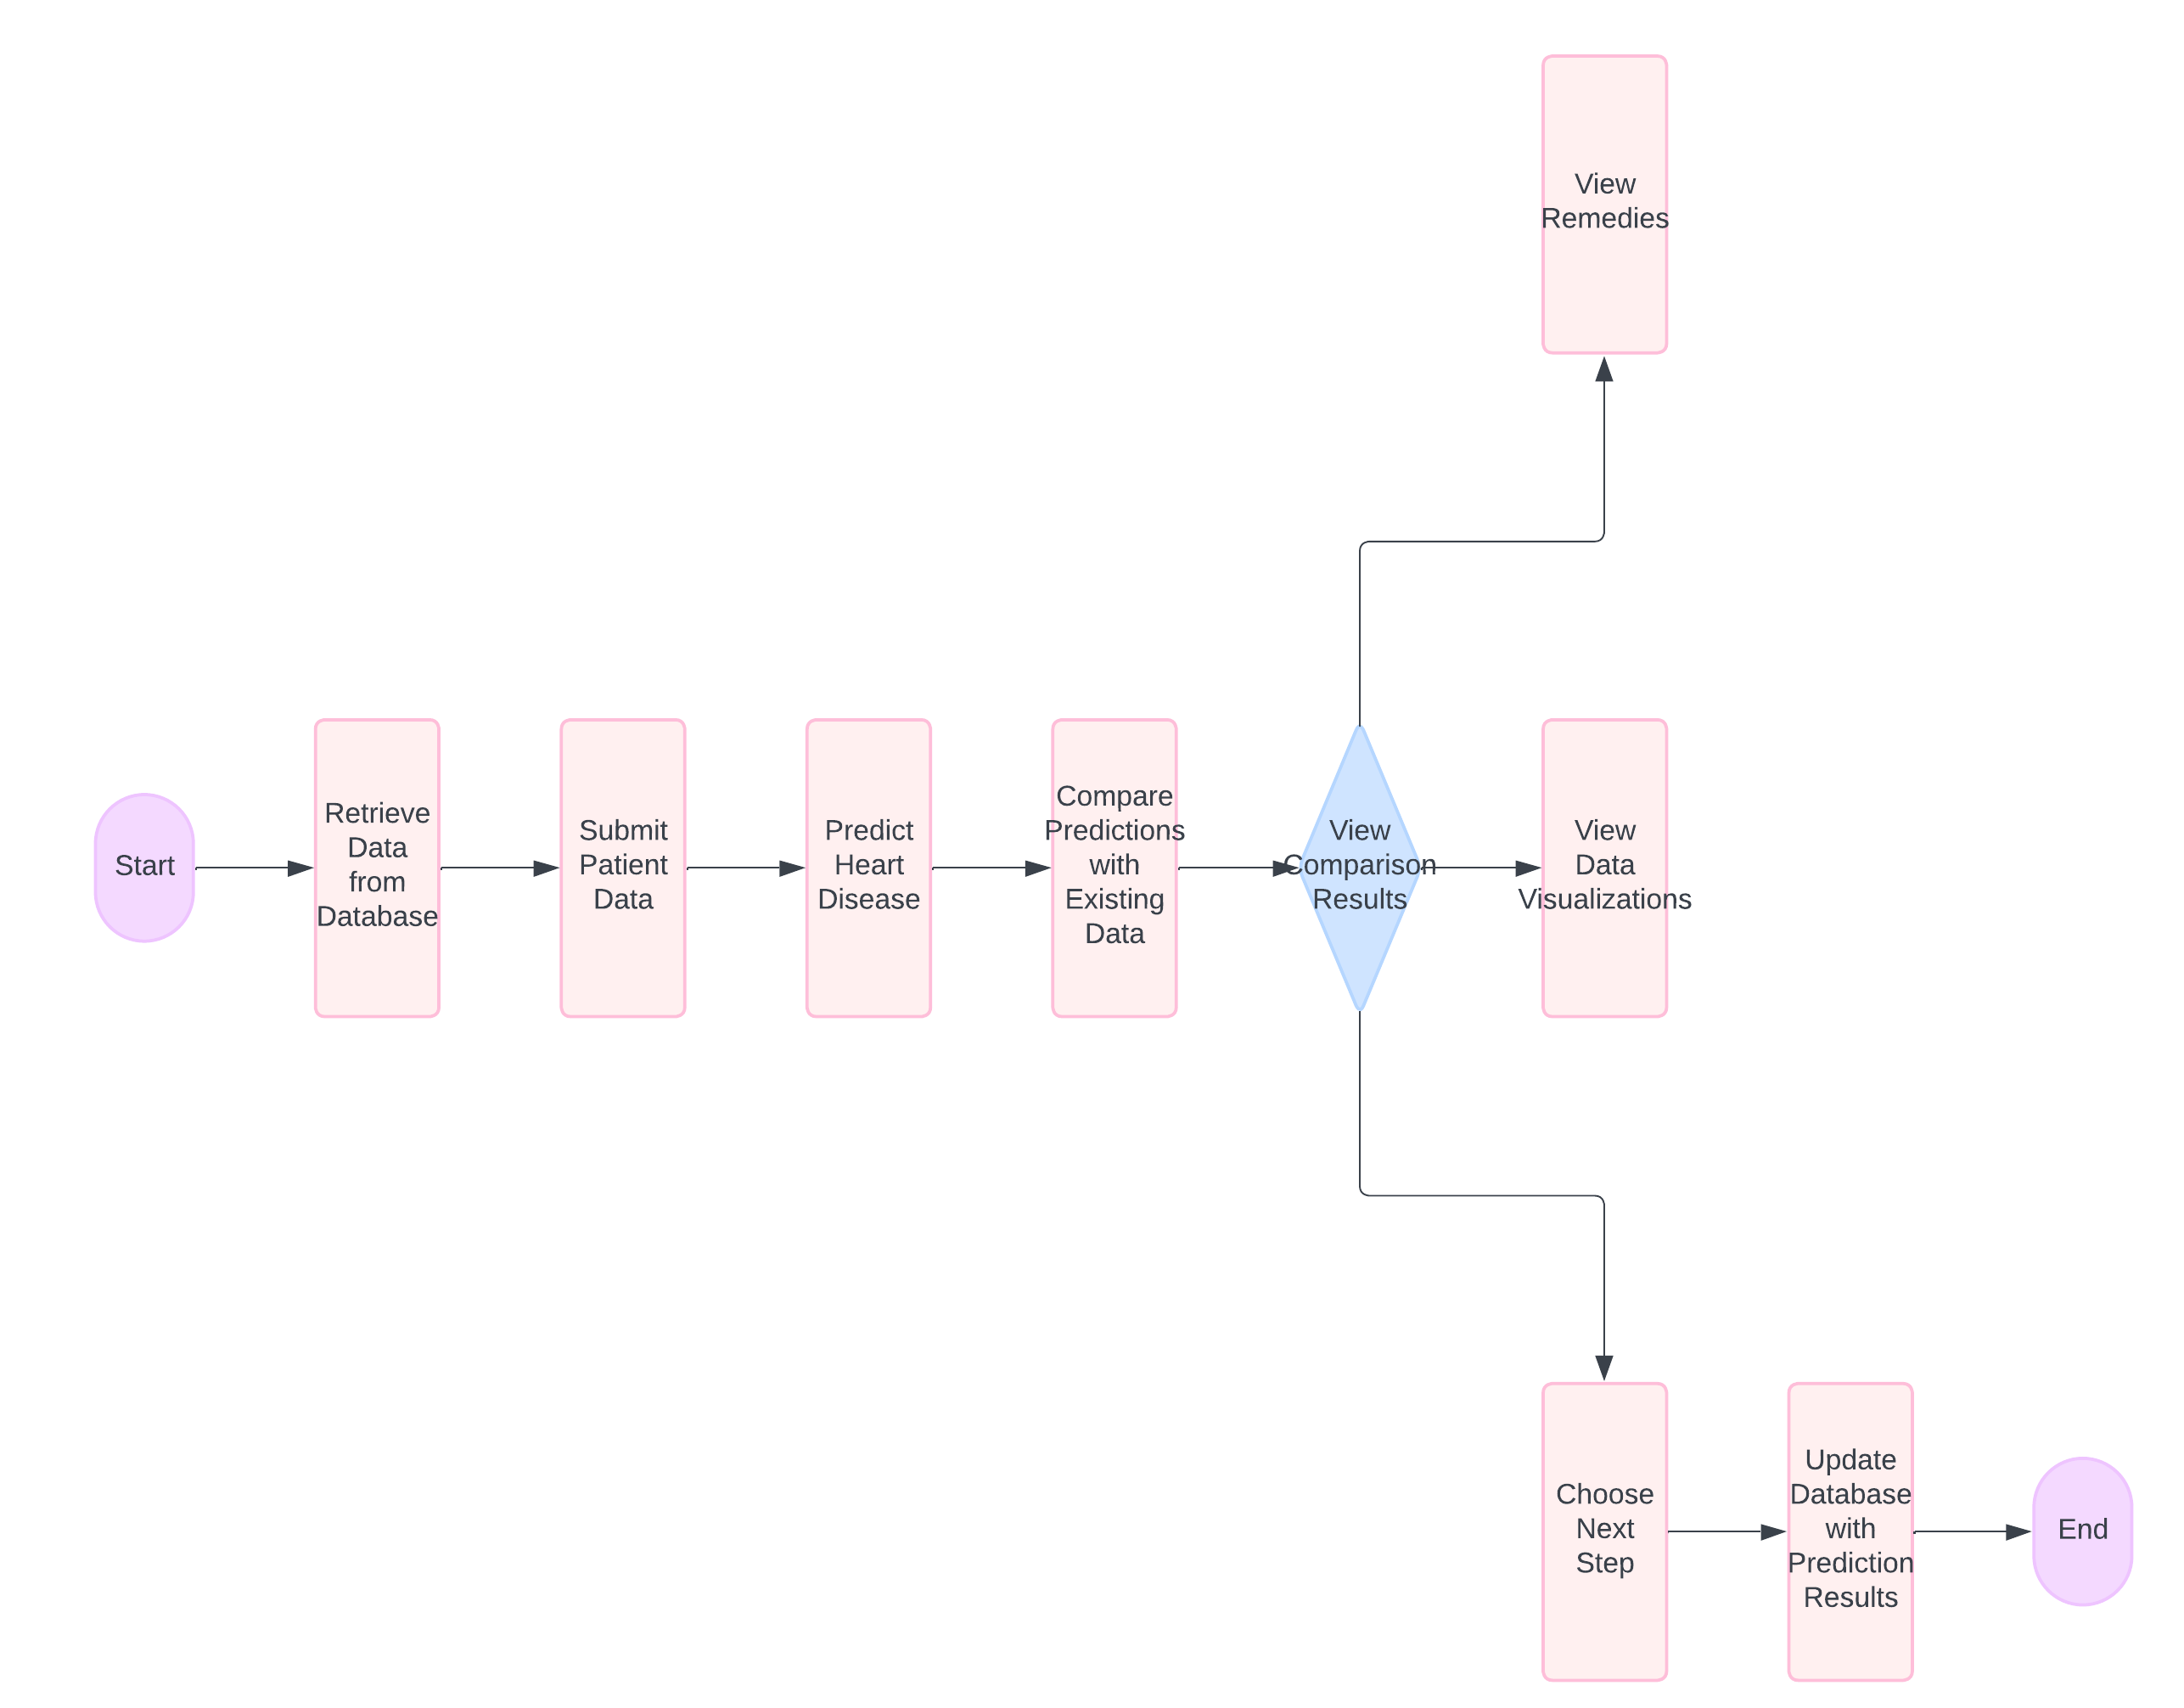

**4. PROJECT IMPLEMENTATION**

**4.1 Description of the software used**

The heart disease prediction and comparison project leverages several key software components to achieve its functionality. Here’s a description of the main software used:

1. **Python**:
   * **Description**: Python is a high-level, interpreted programming language known for its readability and flexibility.
   * **Usage**: It is used for data processing, model training, and backend development. Libraries such as Pandas, NumPy, and Scikit-learn are used for data manipulation and machine learning tasks.
2. **Flask**:
   * **Description**: Flask is a lightweight WSGI web application framework in Python.
   * **Usage**: It serves as the primary framework for building the web application, handling routing, and managing HTTP requests and responses.
3. **SQLite**:
   * **Description**: SQLite is a C-language library that provides a lightweight, disk-based database.
   * **Usage**: It is used as the database for storing patient data and prediction results. The simplicity and self-contained nature of SQLite make it ideal for this project.
4. **HTML/CSS/JavaScript**:
   * **Description**: These are standard technologies for building web pages.
   * **Usage**: HTML structures the content of the web pages, CSS styles the web pages to make them visually appealing, and JavaScript adds interactivity to the web pages, including navigation between different sections of the app.
5. **Matplotlib and Seaborn**:
   * **Description**: These are powerful Python libraries for data visualization.
   * **Usage**: They are used to create histograms, scatter plots, and other visualizations to compare patient data with existing data.
6. **Jinja2**:
   * **Description**: Jinja2 is a modern and designer-friendly templating engine for Python.
   * **Usage**: Integrated with Flask, Jinja2 is used to render HTML templates dynamically based on data passed from the backend.
7. **Pandas**:
   * **Description**: Pandas is an open-source data analysis and manipulation tool built on top of the Python programming language.
   * **Usage**: It is used for reading data from various sources, cleaning data, and preparing datasets for machine learning models.
8. **Scikit-learn**:
   * **Description**: Scikit-learn is a free software machine learning library for the Python programming language.
   * **Usage**: It is used to build and evaluate the machine learning models for heart disease prediction.
9. **NumPy**:
   * **Description**: NumPy is a library for the Python programming language, adding support for large, multi-dimensional arrays and matrices, along with a large collection of high-level mathematical functions to operate on these arrays.
   * **Usage**: It provides support for the various numerical operations needed for data processing and manipulation.
10. **Base64**:
    * **Description**: Base64 is a group of binary-to-text encoding schemes that represent binary data (more specifically, a sequence of 8-bit bytes) in an ASCII string format by translating it into a radix-64 representation.
    * **Usage**: It is used to encode the plot images for easy embedding in HTML.

These software tools collectively form the backbone of the project, providing the necessary capabilities for data handling, machine learning, web development, and visualization.

**4.2 User Interface**

High-level outline for the user interface (UI) of the heart disease prediction and comparison system:

**Home Page:**

* Navigation links to different sections of the application.
* Brief introduction and purpose of the application.
* Instructions for use.

**Patient Data Form:**

* Input fields for patient data including age, sex, chest pain type, resting blood pressure, cholesterol level, fasting blood sugar, resting electrocardiographic results, maximum heart rate, exercise-induced angina, ST depression, and slope of the peak exercise ST segment.
* Submit button to send the data for processing.

**Prediction Results Page:**

* Clear display of prediction results indicating whether the patient is predicted to have heart disease or not.
* Comparison with existing data through graphs and charts.
* Visual indicators to highlight the patient's position relative to existing data.

**Comparison Results Page:**

* Detailed comparison visualizations including histograms and scatter plots comparing the new patient data with historical data.
* Graphical representation of various features to show trends and deviations.
* Interactive elements for navigating through different visualizations.

**Remedies and Suggestions Page:**

* List of potential lifestyle changes and medical suggestions tailored to the patient's condition.
* Links to additional resources and information.

**Data Visualization Page:**

* Various interactive charts and graphs for exploring the dataset.
* Options to filter and view data based on different criteria such as age group and gender.

**Update Data Page:**

* Form for entering new patient data.
* Functionality to edit existing entries in the database.
* Confirmation messages for successful data updates.

**Design Considerations:**

* Responsiveness to ensure compatibility with various devices.
* Accessibility features to accommodate users with disabilities.
* Consistent design elements for a cohesive user experience.
* Immediate feedback mechanisms for user actions.

This UI design aims to provide an intuitive and user-friendly experience for healthcare professionals and administrators, facilitating easy navigation and utilization of the application's features for heart disease prediction and comparison.

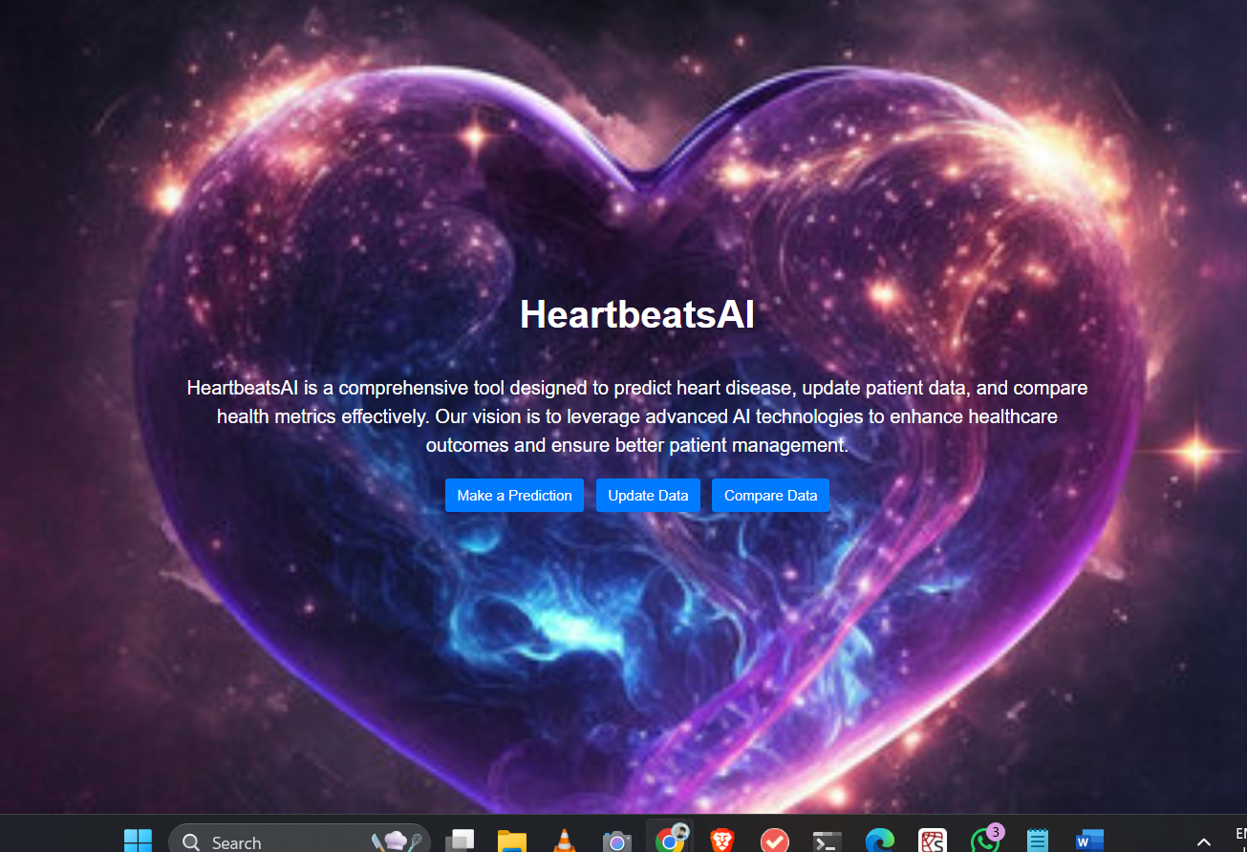

**5. Testing / Result Analysis**

**5.1 Types of Testing**

In the heart disease prediction and comparison system, various types of testing are essential to ensure the reliability, accuracy, and effectiveness of the application. Here are the key types of testing that can be conducted:

1. Unit Testing:
   * Focuses on testing individual components or modules of the system in isolation.
   * Tests are typically automated and verify the functionality of each unit.
   * Helps identify bugs and issues early in the development process.
2. Integration Testing:
   * Validates the interactions and interfaces between different modules or components of the system.
   * Ensures that the integrated system functions correctly as a whole.
   * Tests various scenarios to detect any integration errors or inconsistencies.
3. Functional Testing:
   * Verifies that the application meets the specified functional requirements.
   * Tests the various features and functionalities of the system based on user inputs and expected outcomes.
   * Covers a range of test cases to validate the behavior of the system under different conditions.
4. Regression Testing:
   * Ensures that recent code changes or modifications do not adversely affect existing functionalities.
   * Re-runs previously executed test cases to verify that no new defects have been introduced.
   * Helps maintain the stability and reliability of the application over time.
5. Performance Testing:
   * Evaluates the responsiveness, scalability, and stability of the system under different workload conditions.
   * Measures key performance metrics such as response times, throughput, and resource utilization.
   * Helps identify performance bottlenecks and optimize system performance.

**5.3 Test Cases**

The test cases cover various aspects of the heart disease prediction and comparison system to ensure its functionality, performance, usability, and security are robust.

1. **Data Preprocessing Validation:**
   * Confirms appropriate handling of missing data during preprocessing, ensuring data integrity.
2. **System Integration Check:**
   * Validates seamless integration between the frontend UI and backend server, ensuring smooth communication.
3. **Heart Disease Prediction Test:**
   * Ensures accurate prediction of heart disease based on input data, critical for reliable diagnosis.
4. **Regression Testing:**
   * Verifies that recent updates to the system do not introduce new defects or regressions, maintaining consistent functionality.
5. **Performance Evaluation:**
   * Assesses system response time under different workload conditions, ensuring optimal performance.
6. **User Acceptance Testing (UAT):**
   * Gathers user feedback to evaluate the system's usability and user satisfaction.
7. **Security Assessment:**
   * Identifies and mitigates potential security vulnerabilities, safeguarding sensitive data and ensuring compliance with security standards.

By conducting these tests, the system's quality and reliability are thoroughly evaluated, providing confidence in its deployment and usage in real-world healthcare settings.

**6.1 Conclusion**

The development and implementation of the heart disease prediction and comparison system represent a significant step towards leveraging data science and machine learning in healthcare. Throughout this project, we aimed to create a tool that not only predicts the likelihood of heart disease based on patient data but also provides valuable insights and comparisons with historical data.

This system is designed to assist healthcare professionals in making informed decisions by analyzing critical health indicators and presenting the results in a user-friendly interface. The project has demonstrated the potential to integrate machine learning models with real-world medical data to enhance diagnostic processes and patient care.

**Key Achievements:**

* **Comprehensive Data Preprocessing:** We meticulously cleaned and prepared the dataset, addressing missing values, scaling features, and encoding categorical data. This crucial step ensured the data's integrity and reliability, directly impacting the model's performance.
* **Model Development and Validation:** Using various machine learning techniques, we developed a robust prediction model. The model's accuracy and ability to handle real-world patient data were thoroughly validated, proving its efficacy in predicting heart disease.
* **User-Centric Design:** The user interface was designed with healthcare professionals in mind, focusing on ease of use and accessibility. The application provides clear, actionable predictions and detailed visual comparisons, aiding in better understanding and decision-making.
* **Integration and Deployment:** The seamless integration of frontend and backend components ensures smooth operation and real-time predictions. The system’s deployment in a real-world environment highlights its practical applicability and readiness for use.
* **Comprehensive Testing:** We conducted extensive testing, including unit, integration, functional, and performance tests, to ensure the system's reliability, accuracy, and user satisfaction.

**Future Scope**

While this project has achieved its primary objectives, there are several avenues for future enhancements and expansions:

1. **Integration with Electronic Health Records (EHR):** Future versions could integrate with EHR systems to automate data input, further streamlining the workflow for healthcare providers.
2. **Incorporating More Predictive Features:** Adding more health indicators and patient history data could improve the prediction accuracy and provide deeper insights into potential risk factors.
3. **Enhancing Model Capabilities:** Continuous improvement of the machine learning model, including the use of more advanced techniques like deep learning, could enhance predictive accuracy and the system’s overall effectiveness.
4. **Expanding to Other Diseases:** The framework developed for heart disease prediction can be adapted to predict and analyze other medical conditions, broadening the system’s applicability in healthcare diagnostics.
5. **Real-time Monitoring and Alerts:** Implementing real-time data monitoring and alert systems could provide timely warnings to healthcare providers, facilitating early intervention and improved patient outcomes.
6. **User Feedback and Iterative Improvements:** Gathering feedback from actual users and iteratively refining the system will ensure it remains relevant, user-friendly, and aligned with the needs of healthcare professionals.

In conclusion, this heart disease prediction and comparison system is a testament to the power of data-driven solutions in transforming healthcare. It sets a foundation for future advancements and underscores the importance of continuous innovation and improvement in medical technologies. By embracing these future opportunities, we can further enhance the system’s impact on patient care and healthcare delivery.

Top of Form

Bottom of Form

**6.2 References:**

1. World Health Organization. (2021). Cardiovascular diseases (CVDs). Retrieved from <https://www.who.int/health-topics/cardiovascular-diseases/#tab=tab_1>
2. Centers for Disease Control and Prevention. (2021). Heart Disease Facts. Retrieved from <https://www.cdc.gov/heartdisease/facts.htm>
3. Kaggle. (n.d.). Heart Disease UCI. Retrieved from https://www.kaggle.com/ronitf/heart-disease-uci
4. IEEE DataPort. (n.d.). Heart Disease Dataset (Comprehensive). Retrieved from <https://ieee-dataport.org/open-access/heart-disease-dataset-comprehensive>
5. Kaggle. (n.d.). Cleveland Clinic Heart Disease Dataset. Retrieved from <https://www.kaggle.com/datasets/aavigan/cleveland-clinic-heart-disease-dataset>
6. Scikit-learn: Machine Learning in Python. (n.d.). Retrieved from https://scikit-learn.org/stable/
7. Flask Documentation. (n.d.). Retrieved from https://flask.palletsprojects.com/en/2.0.x/
8. SQLite. (n.d.). Retrieved from https://www.sqlite.org/index.html
9. W3Schools. (n.d.). HTML Tutorial. Retrieved from https://www.w3schools.com/html/
10. Mozilla Developer Network. (n.d.). CSS (Cascading Style Sheets). Retrieved from <https://developer.mozilla.org/en-US/docs/Web/CSS>
11. JavaScript. (n.d.). Retrieved from <https://developer.mozilla.org/en-US/docs/Web/JavaScript>
12. Seaborn: Statistical Data Visualization. (n.d.). Retrieved from https://seaborn.pydata.org/
13. Matplotlib: Visualization with Python. (n.d.). Retrieved from <https://matplotlib.org/>
14. OpenAI. (n.d.). GPT-3.5 API Documentation. Retrieved from <https://beta.openai.com/docs/>
15. GitHub. (n.d.). Version Control System. Retrieved from <https://github.com/>

Top of Form

Bottom of Form