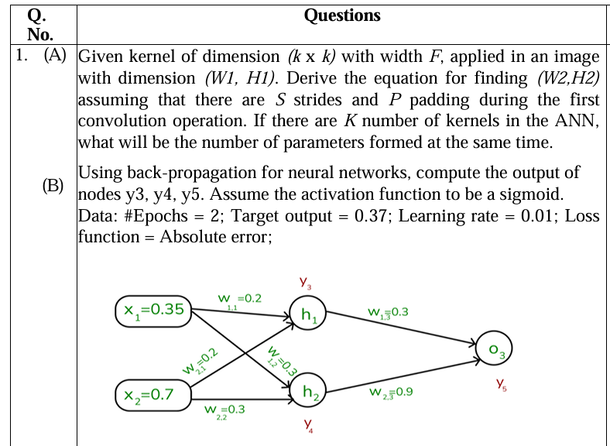Uploaded image
Q5 (a): Feature map dimensions and parameters
Convolutions use padding 0 and stride 1, so the output is W − K + 1. Pooling uses K×K with stride K, so the output is W/K. Each conv layer has K·K·(input depth)·N weights plus N biases. Pooling layers have no parameters.
Layer | Feature map dimension | Number of parameters
INPUT | 128 × 128 × 3 | 0
CONV-9-32 | 120 × 120 × 32 | (9·9·3 + 1)·32 = 244·32 = 7,808
POOL-2 | 60 × 60 × 32 | 0
CONV-5-64 | 56 × 56 × 64 | (5·5·32 + 1)·64 = 801·64 = 51,264
POOL-2 | 28 × 28 × 64 | 0
CONV-5-64 | 24 × 24 × 64 | (5·5·64 + 1)·64 = 1601·64 = 102,464
POOL-2 | 12 × 12 × 64 | 0
FC-10 | 10 | (12·12·64 + 1)·10 = 9217·10 = 92,170
FC-3 | 3 | (10 + 1)·3 = 33
The flattened input to FC-10 is 12·12·64 = 9,216.
Q5 (b): XOR of 3 variables with one hidden layer
3-bit XOR (parity) is 1 when an odd number of inputs are 1. It is not linearly separable, so a hidden layer is needed.
Construction. Use hidden units that count how many inputs are on. With n = 3 inputs, a hidden layer of n = 3 threshold units is enough:
- hᵢ = 1 if x₁ + x₂ + x₃ ≥ i, for i = 1, 2, 3 (weights 1, 1, 1; thresholds 1, 2, 3).
- Output: y = h₁ − h₂ + h₃, with threshold ≥ 1 (output weights +1, −1, +1, bias −0.5).
Check by sum of inputs:
Sum | h₁ h₂ h₃ | h₁ − h₂ + h₃ | y
0 | 0 0 0 | 0 | 0
1 | 1 0 0 | 1 | 1
2 | 1 1 0 | 0 | 0
3 | 1 1 1 | 1 | 1
So 3 hidden perceptrons + 1 output perceptron = 4 perceptrons suffice.
x1 ─┐ ┌─► h1 (θ=1) ──(+1)─┐
x2 ─┼─ all ──┼─► h2 (θ=2) ──(−1)─┼─► y (bias −0.5)
x3 ─┘ w=1 └─► h3 (θ=3) ──(+1)─┘
Every input connects to every hidden unit with weight 1. (In general, parity of n variables needs n hidden units with this design.)
Q5 (c): Next-character prediction with an RNN
i) Will shuffling the dataset improve accuracy? No. Order matters in a sequence, so shuffling characters inside a sequence destroys the dependencies the RNN must learn (shuffling whole independent sequences between epochs is fine, but it will not fix poor accuracy).
ii) Loss function. Categorical cross-entropy over a softmax output: L = −Σₜ log P(yₜ = true next character), summed or averaged over time steps. The task is multi-class classification over the character vocabulary.
iii) Dimension of the input sequence instances. Each input is a sequence of characters, where each character is a one-hot vector of size |V| (the vocabulary size), or an embedding of fixed size. So an instance has dimension T × |V| (sequence length × vocabulary), and the same input dimension k = |V| is used at every time step. Sequence lengths can vary between instances, and they are padded or truncated in a batch. The output at each step is also a |V|-dimensional vector.
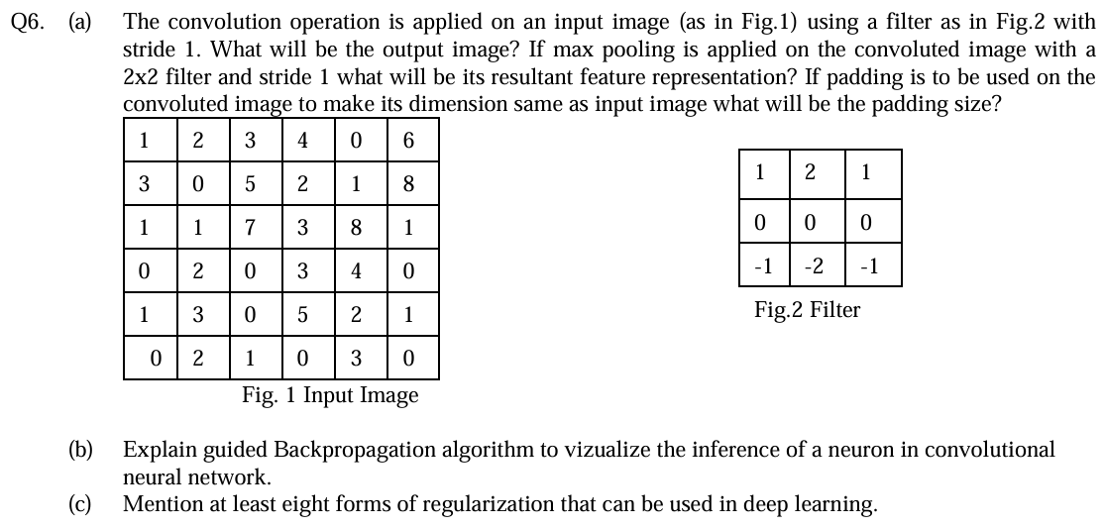Uploaded image
Q6 (a): Convolution, max pooling and padding
Input (6×6)
1 2 3 4 0 6
3 0 5 2 1 8
1 1 7 3 8 1
0 2 0 3 4 0
1 3 0 5 2 1
0 2 1 0 3 0
Filter (3×3)
1 2 1
0 0 0
-1 -2 -1
The output is (6 − 3)/1 + 1 = 4, so 4×4. Because the filter has a zero middle row, each output equals (top row · [1 2 1]) − (bottom row · [1 2 1]), taken over three consecutive columns. I used the cross-correlation form (no kernel flip), the usual CNN convention. Flipping gives the negative of every value below.
Let T(r, c) = rᵣ[c] + 2·rᵣ[c+1] + rᵣ[c+2] for each image row.
Row sums, written as the values for c = 1..4:
- Row 1: 1+4+3 = 8, 2+6+4 = 12, 3+8+0 = 11, 4+0+6 = 10, so [8, 12, 11, 10]
- Row 2: 3+0+5 = 8, 0+10+2 = 12, 5+4+1 = 10, 2+2+8 = 12, so [8, 12, 10, 12]
- Row 3: 1+2+7 = 10, 1+14+3 = 18, 7+6+8 = 21, 3+16+1 = 20, so [10, 18, 21, 20]
- Row 4: 0+4+0 = 4, 2+0+3 = 5, 0+6+4 = 10, 3+8+0 = 11, so [4, 5, 10, 11]
- Row 5: 1+6+0 = 7, 3+0+5 = 8, 0+10+2 = 12, 5+4+1 = 10, so [7, 8, 12, 10]
- Row 6: 0+4+1 = 5, 2+2+0 = 4, 1+0+3 = 4, 0+6+0 = 6, so [5, 4, 4, 6]
Output row i = Row i − Row (i+2):
Convolved output (4×4)
-2 7 1 -1
4 7 -2 1
6 13 11 9
-3 4 8 4
Check on the first entry: (1·1 + 2·2 + 3·1) − (1·1 + 2·2 + 3·1)... more precisely, top = 1+4+3 = 8, bottom (row 3) = 1+2+7 = 10, so 8 − 10 = −2. ✓
Max pooling (2×2, stride 1) gives a 3×3 output:
7 7 1
13 13 11
13 13 11
Details: max(−2,7,4,7) = 7, max(7,1,7,−2) = 7, max(1,−1,−2,1) = 1; max(4,7,6,13) = 13, max(7,−2,13,11) = 13, max(−2,1,11,9) = 11; max(6,13,−3,4) = 13, max(13,11,4,8) = 13, max(11,9,8,4) = 11.
Padding to restore the input size. Applying the filter to the 6×6 input gave 4×4, so to get 6×6 we need (6 − 3 + 2P)/1 + 1 = 6, which gives P = 1. (If padding is applied to the 4×4 convolved image to bring it back to 6×6, it is also 1 pixel on each side.)
Q6 (b): Guided backpropagation
Guided backpropagation visualises what input pattern a chosen neuron responds to. It combines ordinary backprop with the deconvnet idea.
Steps
- Run a forward pass with an image and record activations up to the target neuron.
- Set the gradient at that neuron to 1, and zero elsewhere in its layer.
- Backpropagate to the input pixels. At each ReLU, instead of the normal rule, apply a double mask:
Rˡ = (fˡ > 0) · (Rˡ⁺¹ > 0) · Rˡ⁺¹
Normal backprop keeps the gradient only where the forward activation was positive. A deconvnet keeps only where the incoming gradient is positive. Guided backprop keeps both conditions, so only positive gradients flowing through positively activated units survive.
4. The resulting map in input space shows the pixels that positively excite the neuron.
Why it works. Removing negative gradients drops the evidence that suppresses the neuron, which gives sharp, clean images of edges and parts that the neuron detects. It needs no extra training.
Q6 (c): Forms of regularisation
- L2 regularisation (weight decay): adds λ‖w‖² to the loss.
- L1 regularisation: adds λ|w|, giving sparse weights.
- Elastic net: a mix of L1 and L2.
- Dropout: randomly deactivates units during training.
- Early stopping: stop when validation loss starts to rise.
- Data augmentation: flips, crops, rotations, noise.
- Batch normalisation: gives a mild regularising effect through batch noise.
- Noise injection: add noise to inputs, weights or labels.
- Label smoothing: soften one-hot targets.
- Parameter sharing and tying: as in CNNs.
- Ensembling and bagging: average several models.
- Max-norm or gradient clipping constraints.

