**PROG3200 – Assignment 1**

**Name: Bishwajit Barua**

**Register number: 6397699**

**CPA program**

**Conestoga College**

**Date: October 11, 2018**

**Answer Question No 1:**

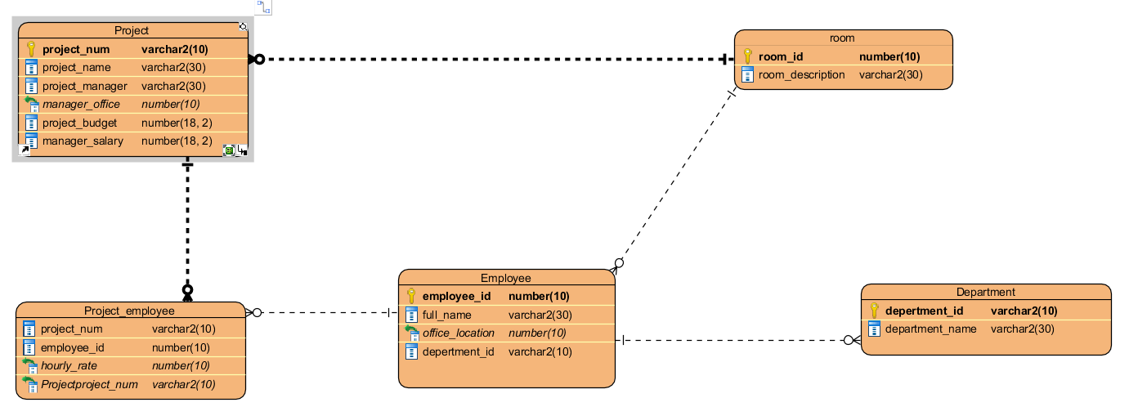

**Answer Question No 2:**

/*Table: project */

DROP TABLE project CASCADE CONSTRAINTS;

CREATE TABLE project (

project_num VARCHAR2 (10) CONSTRAINT project_num_pk PRIMARY KEY,

project_name VARCHAR2 (30) NOT NULL,

project_manager VARCHAR2 (30) NOT NULL,

manager_office INTEGER NOT NULL,

project_budget NUMBER(18,2) NOT NULL,

manager_salary NUMBER(18,2) NOT NULL

);

DESCRIBE project;

/*Table: department */

DROP TABLE department CASCADE CONSTRAINTS;

CREATE TABLE department (

depertment_id VARCHAR2 (10) CONSTRAINT depertment_id_pk PRIMARY KEY,

department_name VARCHAR2 (30)

);

DESCRIBE department;

/*Table: Room */

DROP TABLE room CASCADE CONSTRAINTS;

CREATE TABLE room (

room_id INTEGER CONSTRAINT room_pk PRIMARY KEY,

room_description VARCHAR2 (30) NOT NULL

);

DESCRIBE room;

/*Table: Employee */

DROP TABLE employee CASCADE CONSTRAINTS;

CREATE TABLE employee (

employee_id INTEGER CONSTRAINT employee_pk PRIMARY KEY,

full_name VARCHAR2 (30) NOT NULL,

office_location INTEGER NOT NULL,

depertment_id VARCHAR2(30) NOT NULL,

CONSTRAINT fk_depertment

FOREIGN KEY(depertment_id)

REFERENCES department(depertment_id),

CONSTRAINT fk_room

FOREIGN KEY(office_location)

REFERENCES room(room_id)

);

DESCRIBE employee;

/*Table: ProjectEmployee */

DROP TABLE project_employee CASCADE CONSTRAINTS;

CREATE TABLE project_employee (

project_num VARCHAR2 (10) NOT NULL,

employee_id INTEGER NOT NULL,

hourly_rate NUMBER(14,2)NOT NULL,

CONSTRAINT fk_project_num

FOREIGN KEY(project_num)

REFERENCES project(project_num),

CONSTRAINT fk_employee_id

FOREIGN KEY(employee_id)

REFERENCES employee(employee_id)

);

DESCRIBE project_employee;

/* ALL TABLE CREATED */

**Answer Question No 3:**

/*Data inserting start*/

/* Room */

INSERT INTO room VALUES (1, 'A Building Room 101');

INSERT INTO room VALUES (2, 'B Building Room 110');

INSERT INTO room VALUES (3, 'B Building Room 120');

INSERT INTO room VALUES (4, 'A Building Room 102');

INSERT INTO room VALUES (5, 'B Building Room 130');

INSERT INTO room VALUES (6, 'A Building Room 201');

INSERT INTO room VALUES (7, 'A Building Room 301');

INSERT INTO room VALUES (8, 'A Building Room 302');

INSERT INTO room VALUES (9, 'C Building Room 101');

INSERT INTO room VALUES (10, 'A Building Room 202');

INSERT INTO room VALUES (11, 'C Building Room 102');

INSERT INTO room VALUES (12, 'A Building Room 203');

INSERT INTO room VALUES (13, 'A Building Room 303');

INSERT INTO room VALUES (14, 'C Building Room 103');

INSERT INTO room VALUES (15, 'A Building Room 304');

INSERT INTO room VALUES (16, 'A Building Room 305');

INSERT INTO room VALUES (17, 'A Building Room 204');

SELECT *

FROM room;

/* Department */

INSERT INTO department VALUES ('M001', 'IT');

INSERT INTO department VALUES ('M002', 'Eng');

INSERT INTO department VALUES ('M003', 'Finance');

SELECT *

FROM Department;

/*project*/

INSERT INTO project VALUES ('001', 'Inventory System', 'Alan', 1, 5000000, 150000);

INSERT INTO project VALUES ('002', 'Client System', 'Betty', 2, 500000, 120000);

INSERT INTO project VALUES ('003', 'Financial System', 'Christine', 3, 1000000, 200000);

INSERT INTO project VALUES ('004', 'Delevery System', 'Alan', 1, 2000000, 150000);

INSERT INTO project VALUES ('005', 'Human Resource System', 'Dan', 4, 750000, 200000);

INSERT INTO project VALUES ('006', 'R AND D System', 'Edward', 5, 1000000, 175000);

COMMIT;

SELECT *

FROM project;

/* Employee */

INSERT INTO employee VALUES (101, 'Alice', 6,'M001');

INSERT INTO employee VALUES (102, 'Bob', 7,'M002');

INSERT INTO employee VALUES (103, 'Carl', 8,'M002');

INSERT INTO employee VALUES (104, 'Donna', 9,'M003');

INSERT INTO employee VALUES (105, 'Earl', 10,'M001');

INSERT INTO employee VALUES (106, 'Felicia', 11,'M003');

INSERT INTO employee VALUES (107, 'Gary', 12,'M001');

INSERT INTO employee VALUES (108, 'Hellen', 13,'M002');

INSERT INTO employee VALUES (109, 'Ivan', 14, 'M003');

INSERT INTO employee VALUES (110, 'Jill', 15,'M002');

INSERT INTO employee VALUES (111, 'Kevin', 16,'M002');

INSERT INTO employee VALUES (112, 'Lenny', 17,'M001');

COMMIT;

SELECT *

FROM employee;

/*project_employee*/

INSERT INTO project_employee VALUES ('001', 101, 20.00);

INSERT INTO project_employee VALUES ('001', 102, 25.00);

INSERT INTO project_employee VALUES ('001', 103, 30.00);

INSERT INTO project_employee VALUES ('002', 103, 20.00);

INSERT INTO project_employee VALUES ('002', 104, 15.00);

INSERT INTO project_employee VALUES ('003', 105, 25.00);

INSERT INTO project_employee VALUES ('003', 102, 21.00);

INSERT INTO project_employee VALUES ('003', 104, 20.00);

INSERT INTO project_employee VALUES ('004', 106, 25.00);

INSERT INTO project_employee VALUES ('004', 101, 21.00);

INSERT INTO project_employee VALUES ('004', 102, 22.00);

INSERT INTO project_employee VALUES ('004', 103, 25.00);

INSERT INTO project_employee VALUES ('005', 107, 30.00);

INSERT INTO project_employee VALUES ('005', 108, 20.00);

INSERT INTO project_employee VALUES ('005', 109, 20.00);

INSERT INTO project_employee VALUES ('005', 104, 20.00);

INSERT INTO project_employee VALUES ('006', 106, 21.00);

INSERT INTO project_employee VALUES ('006', 105, 21.00);

INSERT INTO project_employee VALUES ('006', 110, 20.00);

INSERT INTO project_employee VALUES ('006', 111, 25.00);

INSERT INTO project_employee VALUES ('006', 112, 23.00);

COMMIT;

SELECT *

FROM project_employee;

/*Data inserted*/

SELECT p.project_num AS "Project Num"

, p.project_name AS "Project Name"

, p.project_manager AS "Project Manager"

, TO_CHAR(p.manager_salary, '999,999,999') AS "Manager Salary"

, r.room_description AS "Manager Office"

, TO_CHAR(p.project_budget, '999,999,999') AS "Project Budget"

, e.full_name AS "Employee Name"

, e.depertment_id AS "Dept. Number"

, d.department_name AS "Dept. Name"

, TO_CHAR(pe.hourly_rate, '9,999.99') AS "Employee Project Hourly Rate"

, re.room_description AS "Employee Office"

FROM project p

INNER JOIN project_employee pe

ON p.project_num=pe.project_num

INNER JOIN employee e

ON pe.employee_id= e.employee_id

INNER JOIN department d

ON e.depertment_id=d.depertment_id

INNER JOIN room r

ON p.manager_office=r.room_id

INNER JOIN room re

ON e.office_location=re.room_id

ORDER BY p.project_num;

**Answer Question No 4:**

/*Question 4 : Answer- */

DROP VIEW project_size;

CREATE VIEW project_size

AS

SELECT p.project_name AS "Project Name"

, p.project_manager AS "Project Manager"

, TO_CHAR(p.project_budget, '999,999,999') AS "Project Budget"

, COUNT(*) AS "Number of Employee"

FROM project p, project_employee e

WHERE p.project_num=e.project_num

GROUP BY p.project_name, p.project_manager, TO_CHAR(p.project_budget, '999,999,999');

SELECT *

FROM project_size;

**Answer Question No 5:**

/*Question 5 : Answer- */

SELECT e.full_name AS "Employee Name"

FROM project p

INNER JOIN project_employee pe

ON p.project_num= pe.project_num

INNER JOIN employee e

ON pe.employee_id= e.employee_id

WHERE p.project_name='Financial System'