PROJECT PROPOSAL
WHITE CRANE TRAINING COLLECTIVE WEBSITE
Including the DBT Clinical Directory. Final Scope and Investment

Prepared by
Autolinium

Valid for 30 days from date of issue

Document Details
Field | Detail
Prepared for | White Crane Training Collective, Board of Directors
Prepared by | Autolinium
Document type | Final Project Proposal and Scope of Work
Version | 6.0
Date | August 2026
Status | Confirmed scope, issued for signature

This proposal reflects the scope agreed with Ronda Oswalt Reitz on behalf of the Board. It replaces every earlier version. It is written for a general reader, so it explains what the website will do and what it will cost, without technical detail that is not needed for a decision.

1. Purpose and Structure
This document sets out the website Autolinium will build for the White Crane Training Collective, and the investment required. Two groups are involved, and this proposal keeps them clearly separate throughout, as the Board asked.
Group | Responsibility
Board of Directors | Owns and funds the website in its entirety: the landing page, trainings, resources, and the clinical directory. Approves this proposal and any change to it.
White Crane Administrators | Appointed by the Board. Manage the landing page, trainings, resources page and the distribution list through the dashboard.
The Directorate | A separate group with one task only: reviewing team applications and maintaining the clinical directory. Has no role in training or the rest of the site.

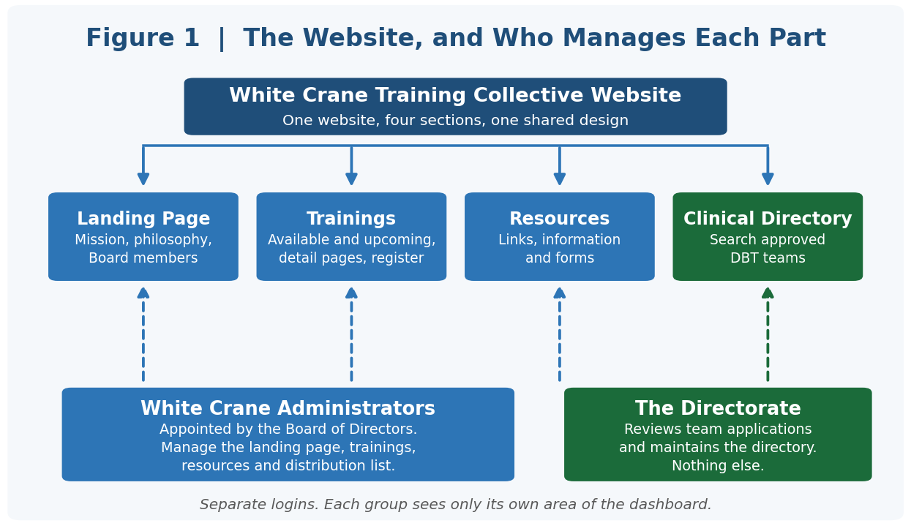
Figure 1. The four sections of the website, and who manages each one.
The dashboard reflects this structure directly. Administrators and the Directorate use separate logins, and each sees only its own area.

2. What You Are Getting
2.1 Landing Page
- Mission statement and guiding philosophy, with bulleted points on what you offer.
- An optional Board members page with photographs and biographies.
- All text editable by your administrators, so the Board's full mission, vision and values statement can be added whenever it is ready, at no extra charge.
2.2 Trainings
- A list of available trainings by title, date and time.
- A detail page for each, with description, objectives, agenda and trainers.
- A registration link on each, pointing to the platform you use this year.
- A separate list of upcoming trainings not yet open for registration.
- Fully managed by your administrators, no request to us needed for routine changes.
2.3 Clinical Directory
- A team application form, with the attestation of DBT fidelity your Directorate is drafting.
- A review dashboard where the Directorate approves, declines, or requests more information.
- A public, searchable directory showing agency name, location, and website or contact.
- A simple record of each team's attestation date, and a due-for-renewal view so the Directorate can follow up each year.
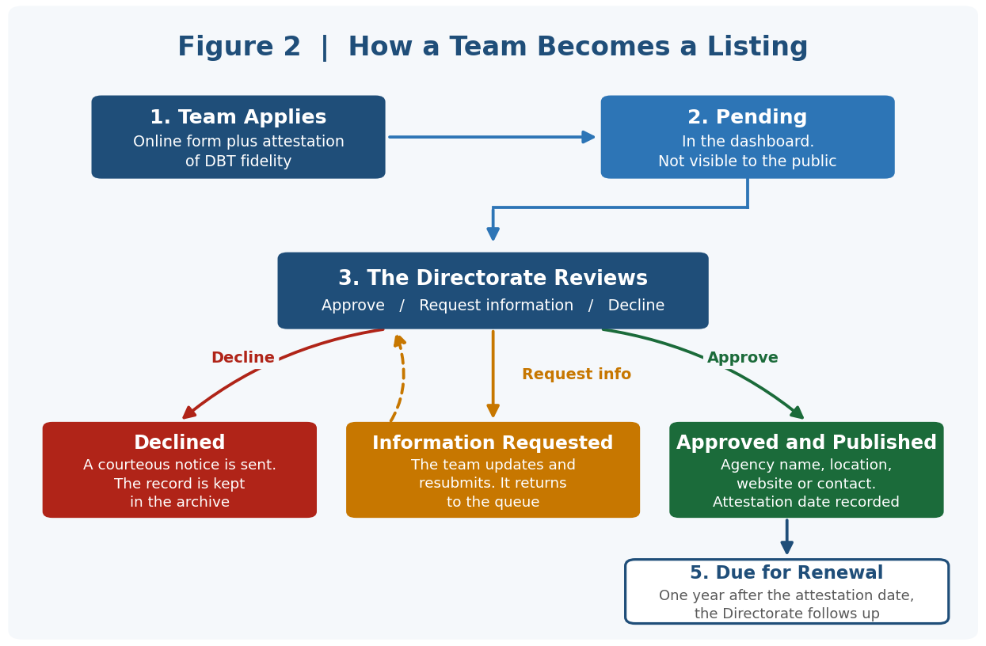
Figure 2. How a team becomes a listing, from application to publication.
2.4 Resources and Distribution List
- A resources page for links, information and downloadable forms.
- A distribution list, so visitors can sign up for updates and training announcements. Included at no additional charge.
Sending newsletters or marketing campaigns from the list is not part of this build, but the list itself will be ready and exportable whenever you want to use it.

3. Growing the Platform Later
These were discussed and are recorded here so nothing is lost. None are part of this build or this price. Each would be scoped and quoted separately when you are ready.
- Self-managed registration and payments: taking training fees on your own site through Stripe instead of an external platform. The site is already structured for this, so nothing will need to be rebuilt when you are ready.
- Fuller team listings: individual clinicians, licences, insurance accepted, and the search filters that go with them.
- Automated annual renewal: a scheduled email sequence and automatic listing expiry, in place of the Directorate following up manually.
- Directory membership: paid listing tiers, once the Board decides how that should work.

5. Timeline and What We Need From You
5.1 Four-Week Schedule
Week | What Gets Built
Week 1 | Setup, design applied, landing page, Application form
Week 2 | dashboard, review workflow, Public directory, trainings, resources,
Week 3 | Distribution list, Emails, content loaded, testing, your review and sign-off

The 3 weeks are counted from the day the items below are with us, not from the date of signature.
5.2 What We Need to Start
Item | When
First payment | Before work begins
Branding: logo, colours, fonts | Before work begins
Page content: mission text, training details, resource items | Before work begins
Attestation wording | Before work begins, or during Week 1 at the latest
Domain name | Before work begins

Bank details are not needed to start. If any item above arrives late, the delivery date moves by the same number of days.

