

**Ko.Chat**

Koya university

Faculty of engineering

Software department

Web development

Third Stage

(2021-2022)

***Prepared by:***

Bishwan Sherko

***Supervised by:***

Dr. Safar M. Asaad

Contents

Introduction: 3

Log-in: 4

Registering to the platform 5

Registration approval: part 1 6

Registration approval: part 2 7

Layout of the chatting platform: 8

DataBase: 9

head of the departments email & password: 9

user email & password: 9

Conclusion: 10

# Introduction:

Online chatting programs have taken over most of our conversations, we may all own or need an online chatting application or website to manage our business or daily tasks, my project was to create an online chatting platform for the faculty of engineering of Koya University, called KO.chat.

this chatting platform is only for students or teachers of the faculty of engineering, where students can talk to each other and to their teachers and vice versa, there are public and private groups or rooms in this platform, for example, students from all over the faculty can talk to each other in a public room that can fit all the students, and there are separate private rooms for students of the same department and another one for students of the same department and same stage, and students can easily talk to their teachers and their head of department and vice versa, and also the heads of the departments can talk to each other in private chats(conversation).

Everyone should register if he/she wants to register for the platform and after that his/her registration should get approved by the head of the department and only then he/she can join the platform.

And this project include (html,css,jquery,ajax,php) .

I totally avoided plagiarism while thinking about the conceptual idea and while writing the codes down.

# Log-in:

after entering the online chatting platform the first page that gets opened upon you is the log-in page as shown below, here the student should enter his/her E-mail and password, I added validation to this part so both the E-mail and the password should be valid and identical to what the student chose while signing up for the platform, even the smallest mistake in entering both can lead to error and the user cannot log in until a valid E-mail and password is entered.

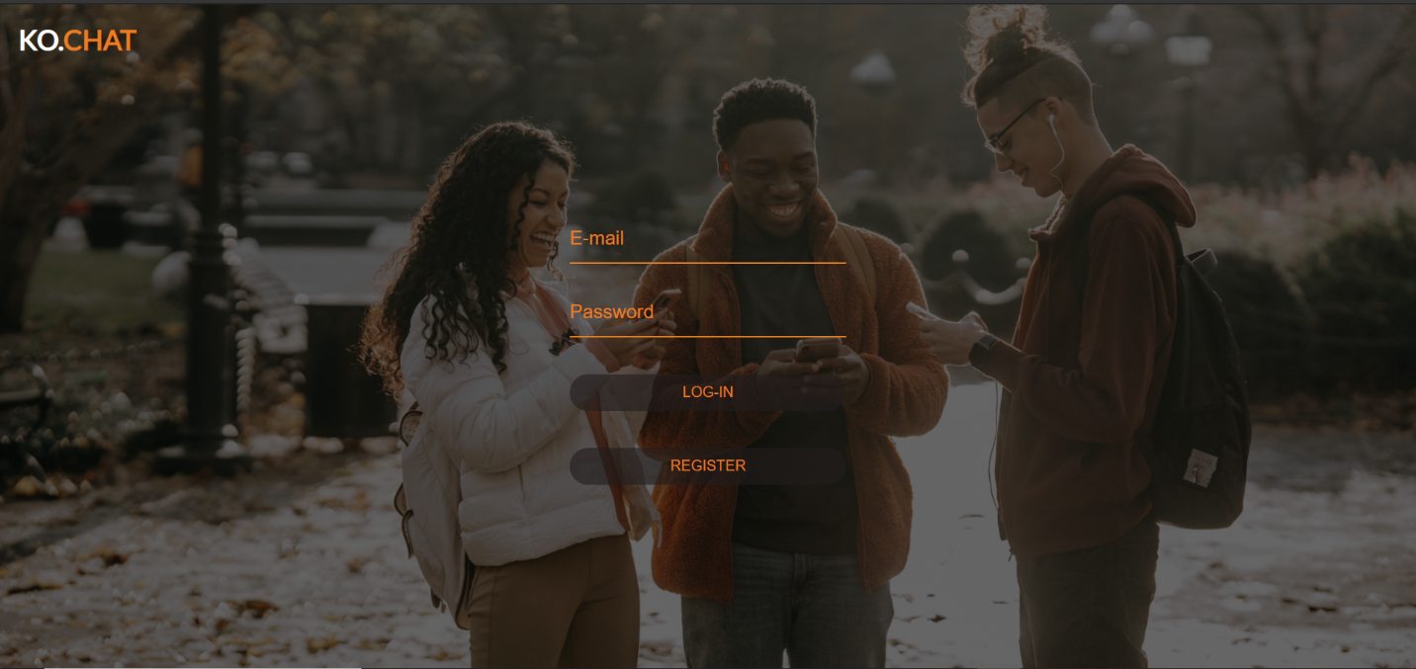

Registering to the platform:

if the user is all new and unfamiliar to the platform then the very first step is to register himself/herself to the platform by creating an account as shown in the figure below, I also used validation for this part, so if the email was previously used the program knows and alerts the user either that the email was registered previously or tells the user to use an unused E-mail for the registration step, the user then should fill the registration form properly and write down all the necessary information like (first and last name, E-mail Address, department and stage) and the user needs to enter a password and confirm it , these information are the fundamentals of qualification of the student into the suitable room( group chat).

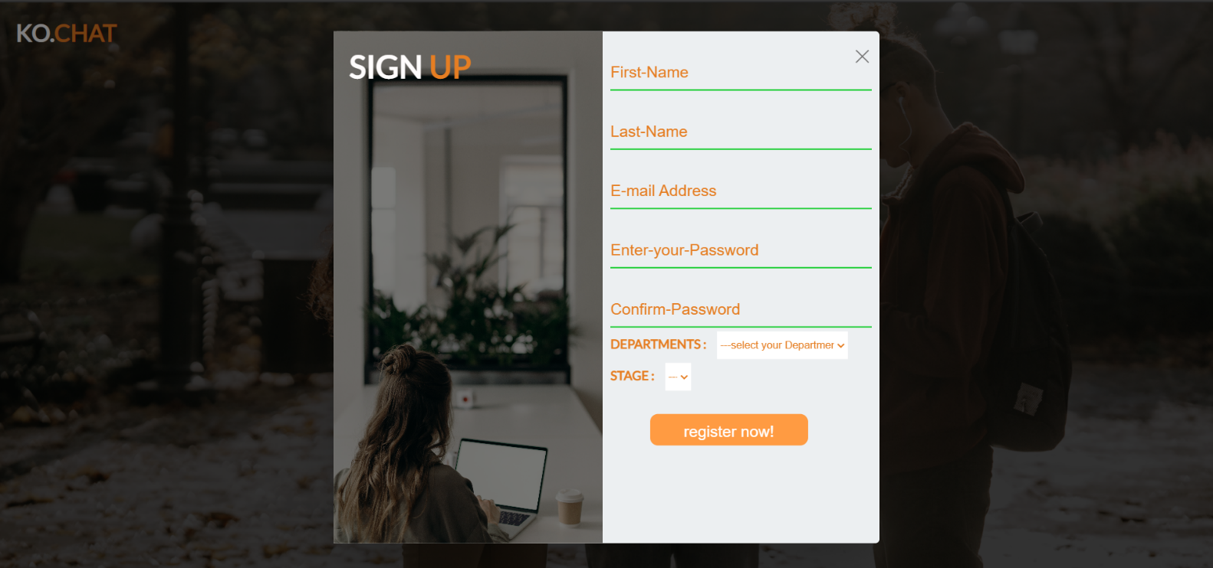

# 

# Registration approval: part 1

After the user or the student had successfully filled the registration form according to the instructions, the registration stage steps into the final phase and the user then has to wait for the head of his/her department to approve the registration so that the user can enter the platform, when the registration form is filled and submitted, the user gets notified that he/she should wait for the head of the department to approve the registration as shown in the figure below:

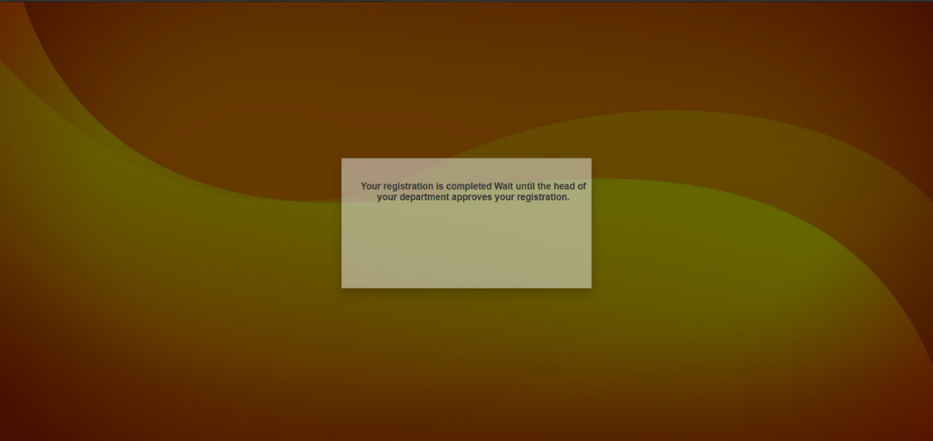

Registration approval: part 2

after the student completed filling the registration form, a request like notification is sent to the head of the department that shows the E-mail and the name of the user to the head, the head of the department accepts the request if he knew that the information are correct and the user is actually studying in that department, and he can refuse it if the user or the E-mail were unknown and the head of the department had no data of the user available, these requests are sent to the head according to the department that the user filled in the registration form, so the request of approval is sent to the head of the software department if only the student has filled software engineering in the form, and the same for all the other departments, this approval part is very important because if a mistake happens while filling the registration form the students doesn’t get approved and he/she doesn’t enter another room and all the other rooms are kept as private and as secure as possible, or even if the user did fill the form incorrectly on purpose and wanted to enter a certain room while he if from another department or he doesn’t even study in that university, the heads of the departments can help keeping the platform private and secure by rejecting fake accounts.

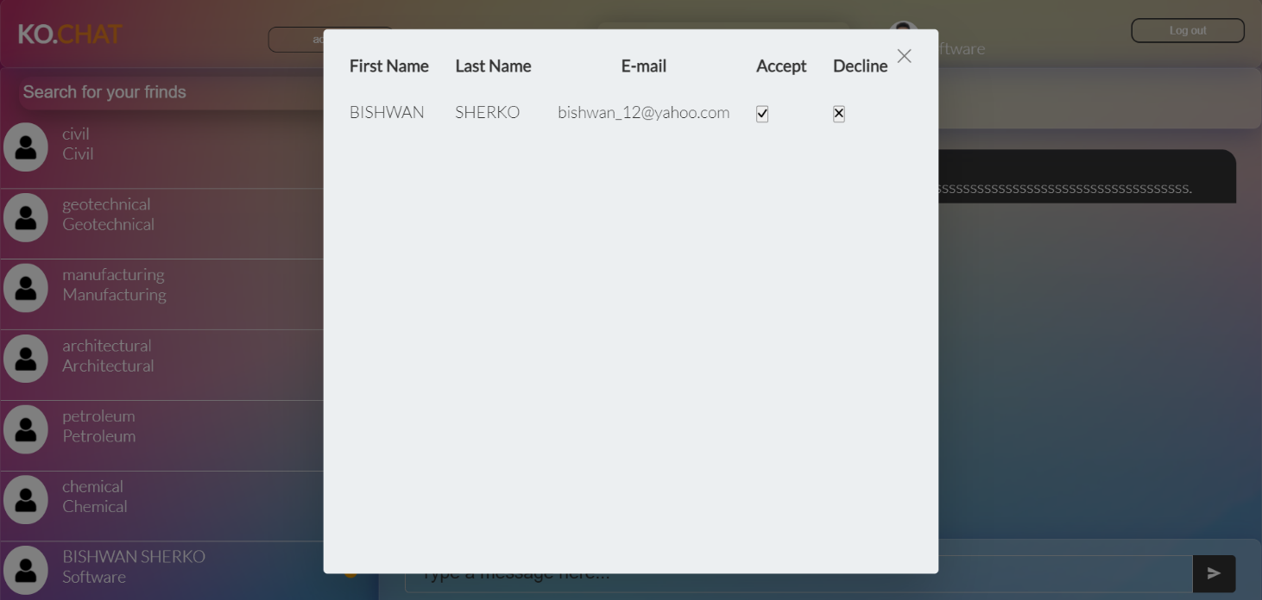This form below gets opened upon the head of the departments every time a user requests for approval:

Layout of the chatting platform:

After getting the registration request approved by your head of the department, the user now can freely use the chatting platform, after entering the platform, the user sees a window as shown below:

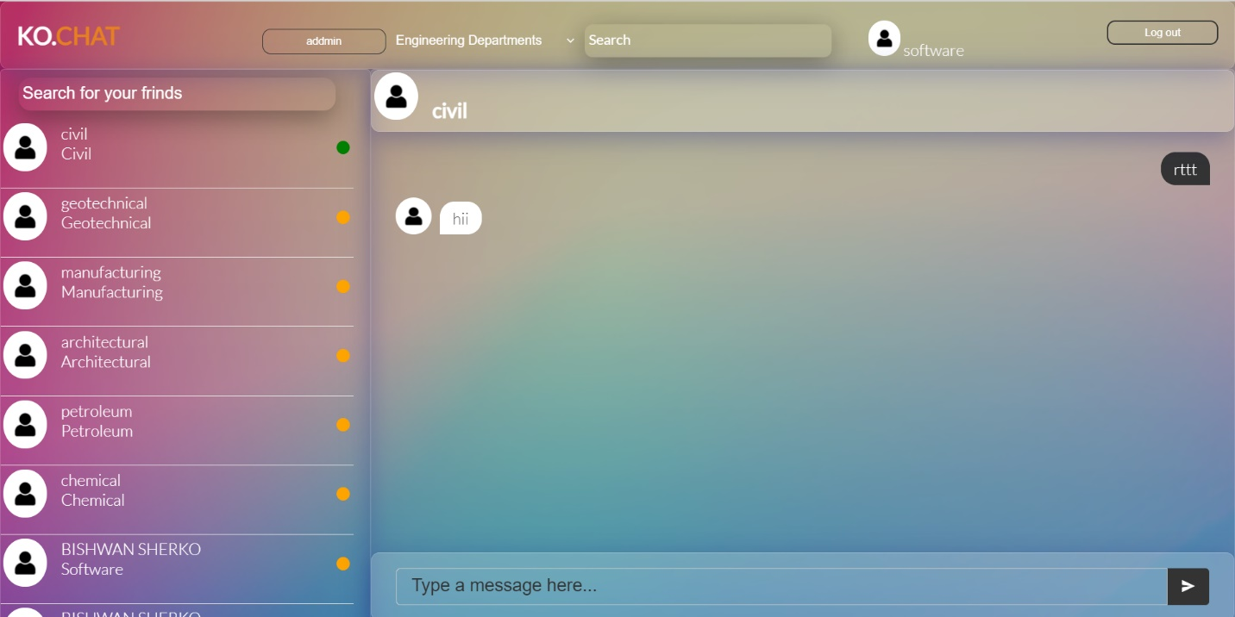

The layout of the platform consists of three main parts:

A-The header:   
This part consists of (the name of the user, the rooms or group chats, a search bar and a log out button)

B- On the left side the users that are registered are shown and you can talk to them and search for them.

C- On the right side you can chat with the user that you have selected before.

# DataBase:

We have a data base called project ,In the data base section we have three main tables called (user, yadag, message) Under the user table we have all the users that are registered and approved to the platform(including students and teachers and head of the departments). Under the Yadag table we have those users who registered but are yet to be approved by their head of department, once their registration is approved by their head of department their data will move into the User table. And the last one is Messages table, this table is used to save the messages that are sent between the users.

## head of the departments email & password:

software: ( [software@gmail.com , software](mailto:software@gmail.com%20%20,%20%20software) ).

civil: ( civil@gmail.com , [civil](mailto:software@gmail.com%20%20,%20%20software) ).

architectural: (  [architectural@gmail.com , architectural](mailto:software@gmail.com%20%20,%20%20software) ).

manufacturing: (  [manufacturing@gmail.com , manufacturing](mailto:software@gmail.com%20%20,%20%20software) ).

geotechnical: (  [geotechnical@gmail.com , geotechnical](mailto:software@gmail.com%20%20,%20%20software) ).

petroleum: (  [petroleum@gmail.com , petroleum](mailto:software@gmail.com%20%20,%20%20software) ).

chemical: (  [chemical@gmail.com , chemical](mailto:software@gmail.com%20%20,%20%20software) ).

## user email & password:

( [bishwan@gmail.com](mailto:bishwan@gmail.com) , bishwan )

Conclusion:

This project is a concept and we can say that this is just the tip of the iceberg, there are many features to be added to this project or to be developed to work better and stay up to date, I want make the circle bigger, I want to develop my project so that every student of Koya University can use this platform, not only the faculty of engineering, but students from all the other faculties.

I want to develop my project so that students can share files easily between them or they can create a shared file and the two person of the chat can edit the file simultaneously and they can see their edits, and I want to create a digital library in the platform so students can ask and download the book they want as a PDF file so that the students don’t spend as much money as before.

It is very handy to create an inner platform so student can post their questions and problems and ask for help, in a way that students from all over the university can help each other and start working in groups for a better learning and less average time consumed on a problem by the students.