**1. INTRODUCTION**

The purpose of writing a report is to offer the result of a research study or other meaningful inquiry is an organized fashion that is easy to read. Grouping your information into categories allows an audience to move through your finding in an orderly process. Assemble your data in logical categories. During the planning phase, take into account your audience may need explanation of technical terms you find commonplace. Your report should be easily understood by your audience. Report can be of various fields and it not resembles specific field but, covers the area of research and analysis. Staying on this fact we are writing this report about our computer game *‘LOCOMOTION’*.

Computer programming remains one of the most exciting and rapidly growing computer fields. It comprises the creation and representation of many programs from simple to complex, as well as modern techniques for rendering a digitize efforts. It has become a common element in user interfaces, industrial problem solving as well as funny gamming and complex processing applications.

**1.1 Backgrounds**

Development of the software consists of many interrelated task, product having high efficiency and low investment is exact requirement of the industry. Doesn’t matter how it is created but user just think about its output and efficient processing logic?

Gamming program now, becoming much more important in the sense that people needing a way to take a fun and entertainment in the short duration. Whenever any program able to do so it definitely becomes popular.so, gaming industry challenging the programmer to code having higher logic. If your competitor makes the right choices then you will be quickly overtaken.

Our project is based on movement of an object i.e. an animated locomotive. Movement is achieved by successive use of graphics functions like moving and jumping of objects in different road. For this Project, the coding is done in C++ language, which is the high level language. This report is thus submitted in order to give overall review of the project and its structure with the objective and output obtained.

**1.2. Objectives**

Objective of the system determines why this system is for but, it does mean that how the system exists. Many objectives exist if the system is created on the basis of various platforms or area. Doesn’t matter how many area do you have but the major concern is objective of the system need to be clear and concise.

In the context our game we try to make clear objective as possible. Investing lots more effort and achieving few object doesn’t seems to be proper. In some cases it may commit by the programmer even it is output of entire team. Some little mistake3s during the development may cause to become great failure so being conscious on that matter is the exact requirement of system’s objective.

Gamming program has the common objective like: giving much more entertainment but they always forgot the lifelong process learn. **Locomotion** game not has academic excellence but we know it can be the great entertainment source for the end user. Whenever required to enhance this product we will primarily focus on its ‘learn’ part because we unable to cover this yet.

Following are the objectives of our game:

* Making the brilliant concentration power of user
* Giving the lots of fun and enjoy at the certain period
* Makes the user to aspect much more in future
* Makes the user to adjust in complex interfaces
* Gathering the end users requirement for standard product for future

**1.3. Scope**

Main scope of this development of this product will determine the views of the users. We examine the fact that can be the great agreement between user and we will denote if they are agreeing or not. If not we have to thought about the mechanism to make them happy and feel satisfied. But, we still unable to examines that either this command line interface able to make them satisfied. Some scope is meant for the analysis rather than its practical aspects so, it may the one for us. We may commit many mistakes in the interfacing part but, we try to make the logical part powerful and also something different.

Scope of the study determines the coherence of task during project development. Scope of our product may be impractical. But its logical aspect exists for a long time. This project is just for the successive bridge for beginners but it doesn’t mean that it is nothing for present. We believe that improvement of the development of the previous project clearly seen by using this project. Doesn’t matter it is successful or not but, as a beginner developer their need to clearly improvement of our ability reading this report.

Limited scope always leads us to the competitive task because, everyone wants to go far. We are trying to create scope of this program instead of analyzing these limitations.

**2. LITERATURE REVIEW**

**2.1 Definition**

A literature review is a description of the literature relevant to a particular field or topic. It gives an overview of what has been said, who the key writers are, what are the prevailing theories and hypothesis, what questions are being asked, and what method and methodologies are and appropriate and useful.

**2.2 project scenario**

After being the part of information technology it was challenge for us to show our superiorly in the field of programming language. In the last project report we submit the project report of database management system (DBMS) and giving something new product was necessary for us so we decide to make something new. Being versatile doesn’t mean to become good at every field but it resembles to earn lot more knowledge for various fields. We have the concept of file and its storage in C, so it was miserable for us to develop entertainment program containing many screens as well as many alternative. We decide to reference from other game or project.

But that was not sufficient idea also a good one, because it reduces the analyzing power of us. Finally, we decide to make the program entitled” A LOCOMOTION” which, means it can move from one place to other. However fundamental requirement of gamming was to make the user satisfied and many more features as well as lot more fun. So, add the jumping facility for it.

We make the concept for doing so, but, we are empty in the sense where to start? At that time our respected class teacher suggests us for its initiation. We have done many manual activities such as outlining of the project, graph point search, background management, logic enhancement, level start up and effective finishing. We don’t know those games are possible using C++ because we were too young in programming language. Now, we know C++ is easiest language than C because of its real life appearance of things what we called object and the collection of those in one bucket called class.

**3. METHODLOGIES**

We had to implement various tactics and great considerations to meet with the objective of our project. As per our project, we were required to process through various individual techniques. Many ideas were implemented and especially graphical approach is generated. Some of the methodology adopted to get to the completion of our project is:

**3.1. Initial screen**

Great involvement of the user is possible if they feel something real and professional when they interact with our product. How many option they can use, either they are familiars with them or not and how efficient it can affordances to the user is the major consideration of the initial screen. We have the following features in initial screen design:

* Every option (buttons) has its affordances to reply fluency.
* Indicating selection gives the user based design.
* User can enter in any option scrolling any of them.
* Proper naming of the option which are user friendlier
* Specific selection instead of unused area of the screen

**3.2. Creating background**

Whenever we have the objective to publish our product in grater possible way then that team have the most basic mechanism to background management. For example: if we are presenting the wild animal as a character of our game generally it is suitable to manage background screen more natural as possible but, it is not the suitable solution for every problem. If we able to present our objects in good background screens, then it make the users more curious.

In our game:

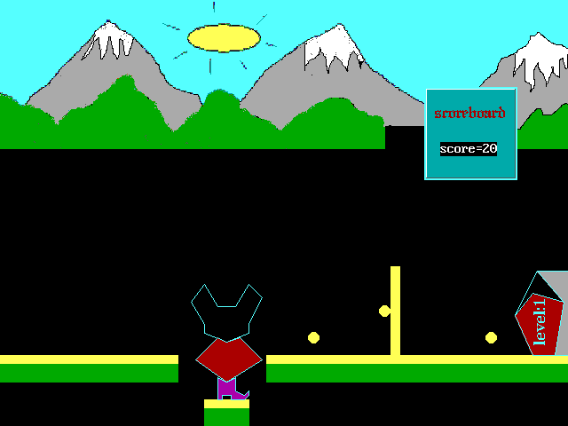

**Fig1: when user starts the project (at first level)**

We have the many background screens but, we would like present description of first. Here:

* Objects have the single surface road to move object.
* Coin is presented as its random look.
* Snow and hill is presented for its natural looks
* Cracking road is presented for the dangerous journey.
* Level: 1 is presented to show that it is the trial state or phase.
* Black background color replicates black head.

**3.3 Creating character:**

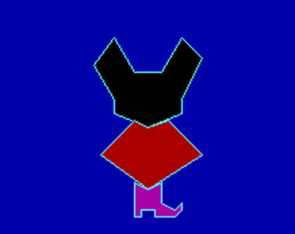

Fig2: Object Character

* Similarly, we got to draw the shape of the locomotive, which is actually the basic objective of our project. It can be got through by the use of different functions like, polygon& line ().
* Another basic objective of this project is to make the object moving and jumping. Then, it needs to move object according to the key instruction and thus, we used the same algorithm for these operations.

**3.4. State of this game**

State of the game is one of the most important parts where vendor have the responsibility to make it more clearly as possible. Commonly state of the game is the events which indicate the game from simplex to complex. Some user might think play because they are only interested in the upcoming complexity of the game. Does not matter how you make it possible but, make the clear state of your game to increase its lesion towards dynamic rather than static. Some game is created so fluency when they are played at initial, but they become less-popular only the cause is that they make it static. Some clever programmer always thinks about how to maintain flow of the program so they initiate many problems in different level for the end user. Exactly solving that problem in the game refers the entertainment phase in your program that’s why the reason you create this.

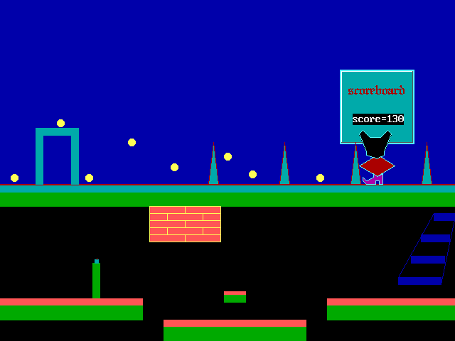

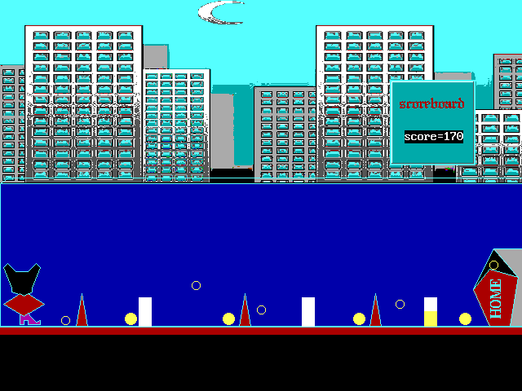

**Fig3: Changing flow of the program from one state to another**

**4. FINDING**

Finding states the result saying about the intervention’s effectiveness and explains how far the result may be generalized to others who have or could receive the intervention. It may allow significance of the result of the study to others in different way.

In our game it was nightmare task for us to allowing the object to move from one place to another as well as jump. In this development initially we are full of fear and careful to become failure in any step that might came. What kind of gain we exactly earn we don’t know but, we are sure at least it is the bridge to cross the milestone. We want to develop the game which have many features as commonly the game have, although there was lot more limitation in our compiler-even we don’t able to do so. In the system development phase analysis of the project is critical and important task than core codding-only to way to become stable at our job. Following are the list of discovered or researched of our game project:

* Concept exploration is much more critical and important than its designing part. In the case of the gamming program the clear concept makes the user feel happy also, it needs to be different.
* Determining the stages of the game is more important than caption help during the playing of the game. User needs to be clear about the aspects of the game and wants a multiple options for its existence.
* Doesn’t matter where we put the primary logic of the game but, appearing and disappearing of the object must be meaningful. User are excited where the new concept and phenomenon of this game is coming.
* Adding a squirt of oil to my bicycle make its pedal easier but, it doesn’t mean that dumping a gallon of oil make its peddle itself. So, we avoid for creating lot of windows adding a road at the top, instead in next screen.
* If there are the several alternative in game and also successful user try to use it to find out actual part of our game. So, don’t give the alternative way. If you are doing so, just makes it risky.
* Avoid to stay in the weakness option usually some small game might have. Some games have the limited access, if user wants to use the game in their own way the option should be in open state. It doesn’t mean that allowing access to the user in unbalanced way.

**4.1 Limitations & suggestions**

It has been worked with great effort to meet out the objective of project. Though, it is itself found something, somewhere incomplete with the way the project has been outputted. Some of my considerations are:

* The project was limited with command line interface (keyboard) only. Instead of making mouse initialize tools it has not been done so.
* Also, being the graphical project, there is limitation of use of graphics in a proper way.
* But, the limitation was not only with our effort. Instead, there is also not a good support from compiler to create more superior objects and more artistic design.
* I would therefore like to suggest for the modification of this project with the implementation of 2D/3D objects and their transformations that would make it move and jump having less condition at higher efficiency.

**4.2 Work plan and schedule**

Our project had been started from the 1st week of December and finished within 4 months. The work plan, time description, timeline of the total project can be shown through this Gantt chart:

**GANTT CHART**

|  |  |  |  |  |  |  |
| --- | --- | --- | --- | --- | --- | --- |
| S.N. | Objective Name | Start Date | Duration | DEC/APPRIL | | |
| 1st month | 2nd month | 3rd  month |
| 1. | Self-Research and Study works | 13-10-2013 | 15 days | 20% |  |  |
| 2. | Designing the Layout of the Project | 28-10-2013 | 30 days | 33% |  |  |
| 3. | Programming the Application | 28-01-2014 | 30 days |  | 68  % |  |
| 4. | Testing and Modifications | 28-02-2014 | 13 days |  |  | 90  % |
| 5. | Presentation | 11-03-2014 | 2 days |  |  | 100% |

Table1: Gantt chart

**5. CONCLUSION AND RECOMMENDATION**

This project report is meant for how we develop our system and why we use this concept, actually real application of this project may be not practicable but we want to express a module for future to prove that how database is good and powerful as well as challengeable .gamming software replicates the way to get fun, learn and entertainment. We want to express our vision and idea to demonstrate C++ programming knowledge of the student who, are still at initial phase.

**5.1 conclusions**

Game itself is challenging to develop because there needs many aspects and especially its graphical scenario. Today many games are available which indicates the life events and story. People like to play that game where some interesting tragic part is attached.

Although these situations we have, we can make the game ourselves making its logical aspects powerful for all those traditional games. After preparing this game we arrive at the conclusion that it is not easy to make any kind of gamming program. It requires many more real and dream works for its existence. Whenever you want to add or experiment the features towards your game. It might take to bring much risk for your program.

Finally we make the conclusion that jumping, moving object from one place to another is quite easy task but, managing it in some limited port view is miserable task for developer.

During the development we encounter in many types of problem but, we solve that using our own logic. We know, we are failure to give quick and easy logic because algorithms used by us are not good in terms efficiency. Project must have to be efficient and effective instead of only thinking about output oriented activity. How we solve those problems? Its answer is simple-team work.

**5.2. Recommendation**

We recommend for the junior student for the preparing manuscript for their dream work and latter it will be easy for analysis. Making the object portable, movable and jumpable is not an easy task that you might think them to be. If the clear aspects are implemented, it gives better performance. We are sorry for any kind of unwanted mistakes, we may have done. But, we are careful to arrive any kind of logic less errors. Collecting coins and updating score is easy task in the C++ programming but, appearance and disappearance of the coin was difficult task for us.

Peoples need such a game which has the intelligence to find out unexpected errors and have various platforms as well. It is less successful program than Mario game-reference game for us.

Jumping and moving object is also slow and not replicates any kind of effective affordances.

So, in some prospective our program is failure to carry out some features and weak in the sense of its interfaces. But, we are sure it is good for some prospective. Such as technical man powers and also who are junior in C++, can achieve high advantages from this game.

We want to make this project good and powerful as compare to others and we feel that we are unable to make it as our dream and expectation. Thus, there also exists some space for future enhancement of our project. We suggest those students who want to make the project in C++, use this concept and make a more powerful game better than Mario and anything else.

Despite all those restrictions and some limitations, this project runs successfully without any bugs and errors.

**6. Appendix-I**

**PROGRAM FUNCTIONS**

|  |  |  |
| --- | --- | --- |
| **Functions** | **Header file** | **Remark** |
| Line() | Graphics.h | Draws line between two coordinates using line drawing algorithm |
| Circle() | " | Draws circle of given radius |
| Pie slice() | " | Draws pie slice |
| Rectangle() | " | Draws rectangle of defined size |
| Setfilfill() | " | Fills an enclosed area |
| Setfillstyle() | " | Sets current fill pattern and color |
| Setlinestyle() | " | Sets current line drawing style |
| Setcolor() | " | Sets current text/line color |
| Draw/fillpoly() | " | Draw and fill the specific area |
| Bar() | " | Draw a bar |
| Getch() | Conio.h | Get a character to terminate |
| Delay() | Dos.h | Delays viewport of given time |
| Exit(0) | Process.h | Exit the program when it is called |

Table2: program function

**7. Appendix-II**

**OUTPUT OF THE PROJECT**

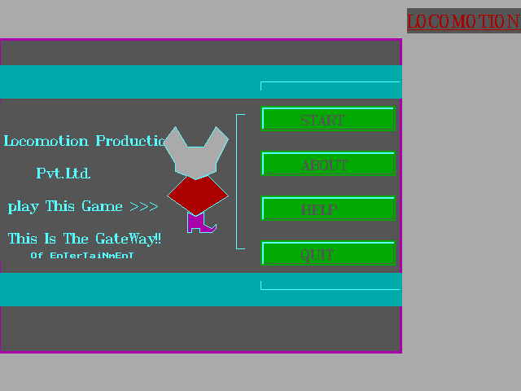

**Fig4: User interface for initial**

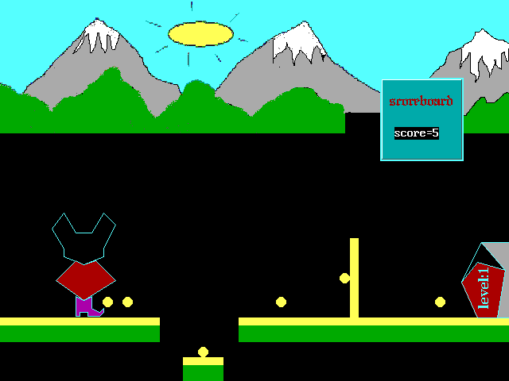

**Fig5: moving character at trial phase**

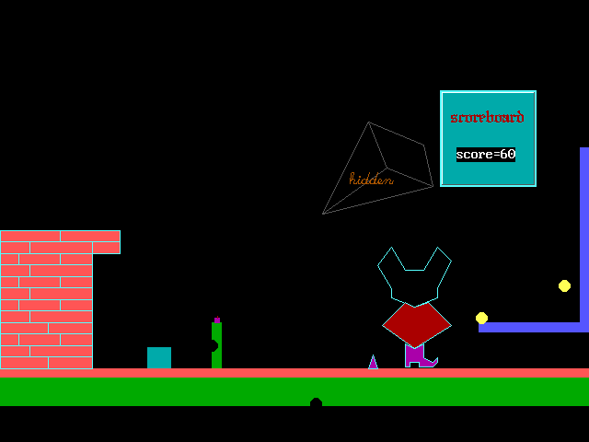**Fig6: Completing level 1 (2 coin remaining)**

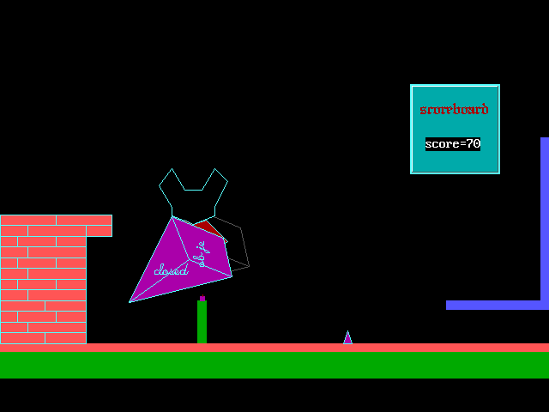

**Fig7: Flying for the next level through special key**

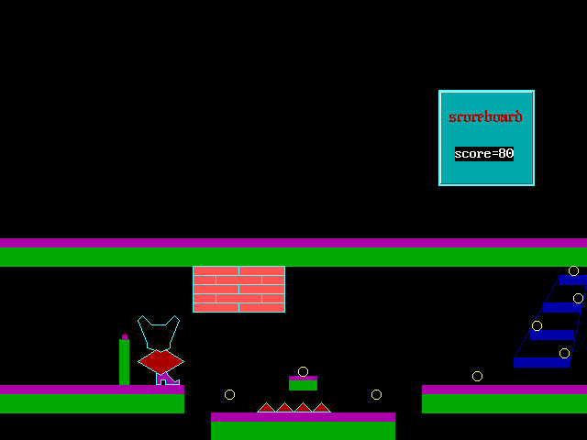

**Fig8: object suffering narrow from road becoming small and crossing big throne**

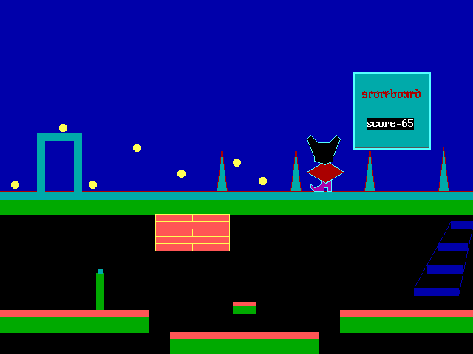

**Fig9: object moving on the sky road for final stage**

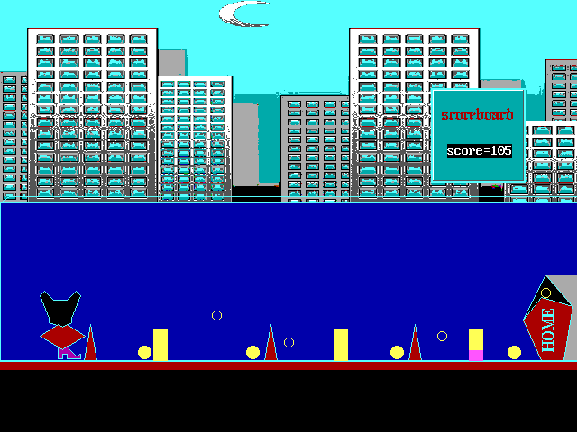

**Fig10: object moving on most dangerous final journey**