Compress, Shake, Twist: short report
VQE
Quantum Bears, Missouri State University
October 24, 2026

Aim
The question: how close can VQE get to the exact ground state energy of LiH, CH4 and N2 on a noisy quantum computer? Three steps:
- Compress: the molecule symmetry removes qubits and moves that can never contribute, without changing the answer.
- Shake: a small generative model (a transformer) writes short circuits, learning from their noisy scores which moves are worth their CNOTs.
- Twist: VQE fine tunes the angles of the chosen circuit.

Setup
Molecule | Electrons in orbitals | Qubits, plain to compressed | Moves (UCCSD), plain to compressed | Correlation energy to recover
LiH | 2 in 5 | 10 to 6 | 24 to 10 | 20.2 mHa
CH4 | 8 in 8 | 16 to 12 | 360 to 96 | 78.5 mHa
N2 | 10 in 8 | 16 to 11 | 315 to 53 | 156.7 mHa
Every error is the distance from the exact energy in the same orbitals (CASCI), in mHa. Chemical accuracy is 1.6 mHa.
Noise model. Every CNOT fails with probability p (0.1% to 0.5%), every single qubit gate with 0.1%. The chance of a clean run is F = (1 − p)^N_CNOT × 0.999^N_1q; error mitigation turns that into an error bar c₁/(F√S) with S = 10⁸ shots. Total error = the circuit’s own error + the error bar. “Hopeless” means an error bar of 100,000 mHa or more.
Three parts:
- Part 1: no noise.
- Part 2: noise added at the end; the optimizers see exact energies.
- Part 3: noise from the start; every energy and gradient the optimizers see is a noisy measurement (10⁶ shots), at 0.2% CNOT error.
The routes compared: plain VQE, compressed VQE, and compress, shake, twist.

Part 1: no noise
Compression on a perfect computer: does it change the answer, and how much does it save?
Molecules | CNOT, plain | CNOTs, compressed | Error, both
LiH | 346 | 118 | 0.000 mHa
CH4 | 6,772 | 3,326 | 0.185 mHa
N2 | 5,994 | 1,710 | 2.154 mHa
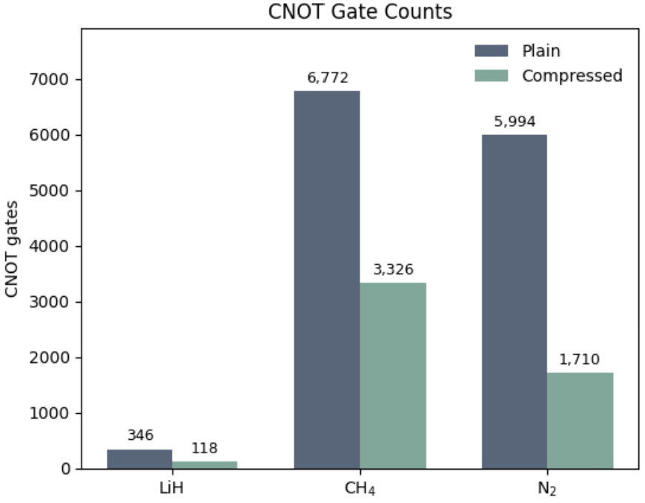

Compression gives the same energy with fewer qubits, moves and CNOTs (N2: 5 qubits, 83% of the parameters and 71% of the CNOTs saved).

Part 2: noise added at the end
Total error in mHa from 0.1% to 0.5% CNOT error, seed 0
Molecule, CNOT error | Plain VQE | Compressed VQE | Compress, shake, twist
LiH, 0.1% | 2.1 | 1.1 | 1.2
LiH, 0.2% | 3.3 | 1.2 | 1.3
LiH, 0.3% | 5.0 | 1.4 | 1.4
LiH, 0.4% | 7.7 | 1.6 | 1.5
LiH, 0.5% | 11.8 | 1.8 | 1.7
CH4, 0.1% | hopeless | 772.8 | 41.5
CH4, 0.2% | hopeless | 25462.6 | 515
CH4, 0.3% | hopeless | hopeless | 63.3
CH4, 0.4% | hopeless | hopeless | 67
CH4, 0.5% | hopeless | hopeless | 75.7
N2, 0.1% | hopeless | 63.7 | 28.3
N2, 0.2% | hopeless | 372.7 | 38.9
N2, 0.3% | hopeless | 2236.2 | 49.3
N2, 0.4% | hopeless | 13494.3 | 55.3
N2, 0.5% | hopeless | 81,632.9 | 57.8
For CH4 and N2 the compressed circuit is nearly exact on paper but carries 1,792 to 3,490 CNOTs, so its error bar grows exponentially with the noise. The shake writes short circuits (N2 at 0.5%: 7 moves, 180 CNOTs) that keep a small error bar. For LiH compression alone is enough.

Part 3: noise from the start, 0.2%
Total error in mHa; three seeds at 200 rounds, 600 rounds, with 3 seeds.
Molecule | Plain VQE | Compressed VQE | Shake, 20 rounds | Shake, 600 rounds
LiH | 3.58 to 3.80 | 1.3, 1.3, 1.3 | 2.3, 2.4, 2.8 | 2.2
CH4 | hopeless | 28607.3, 28680.2, 28905.3 | 92.7, 94.2, 95.5 | 94.1
N2 | hopeless | 785.4, 1112.5, 1273.4 | 99.1, 68.7, 96.1 | 57.1

What the shake picks, and what the twist does
The heat maps (Part 2 at 0.5%): one row per compressed move, one column per training round; the colour is how many of the round’s 32 circuits use the move.

LiH: from 10 moves to 8. The circuits are short enough that almost every move pays off; only the two single moves into level 5 are dropped.

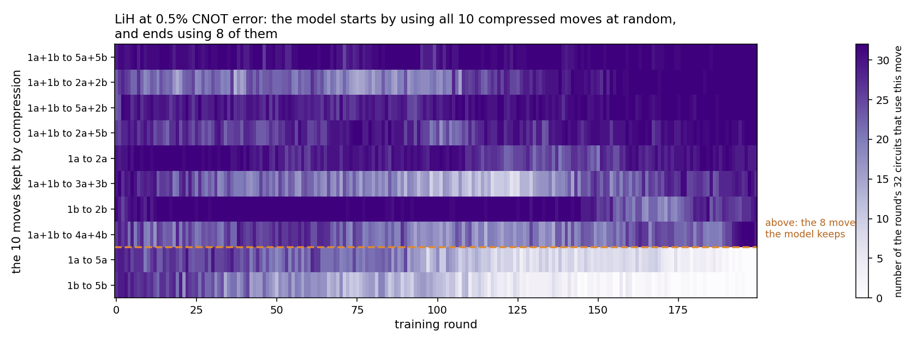
LiH at 0.5%, Part 2: the moves the shake uses, round by round

CH4: from 96 moves to 3. At 0.5% almost every CH4 move costs more in noise than it gains; the model ends with 2a+2b to 5a+5b, 2a+1b to 5a+8b and 1a+4b to 8a+7b. This is a dramatic deduction of number of essential moves that affect the outcome of the circuit.
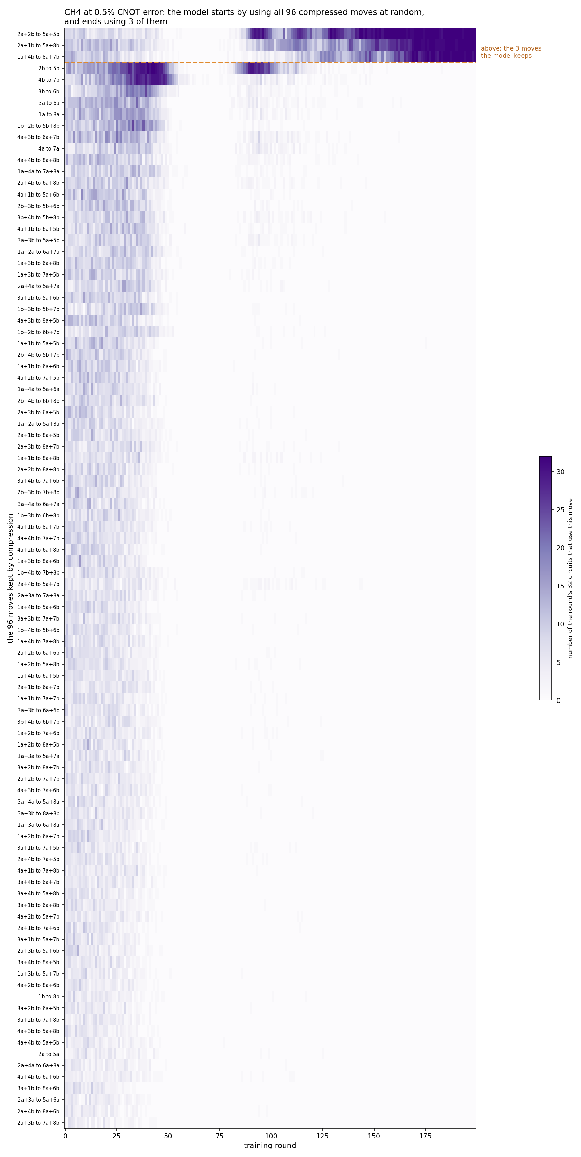
CH4 at 0.5%, Part 2: the moves the shake uses, round by round

N2: from 53 moves to 5, all taking electrons out of the π bonds (levels 3, 4) into the π antibonds (levels 6, 7). Similar to the CH4, the training indicates the reduction of essential moves are dramatically reduced from all possible moves.
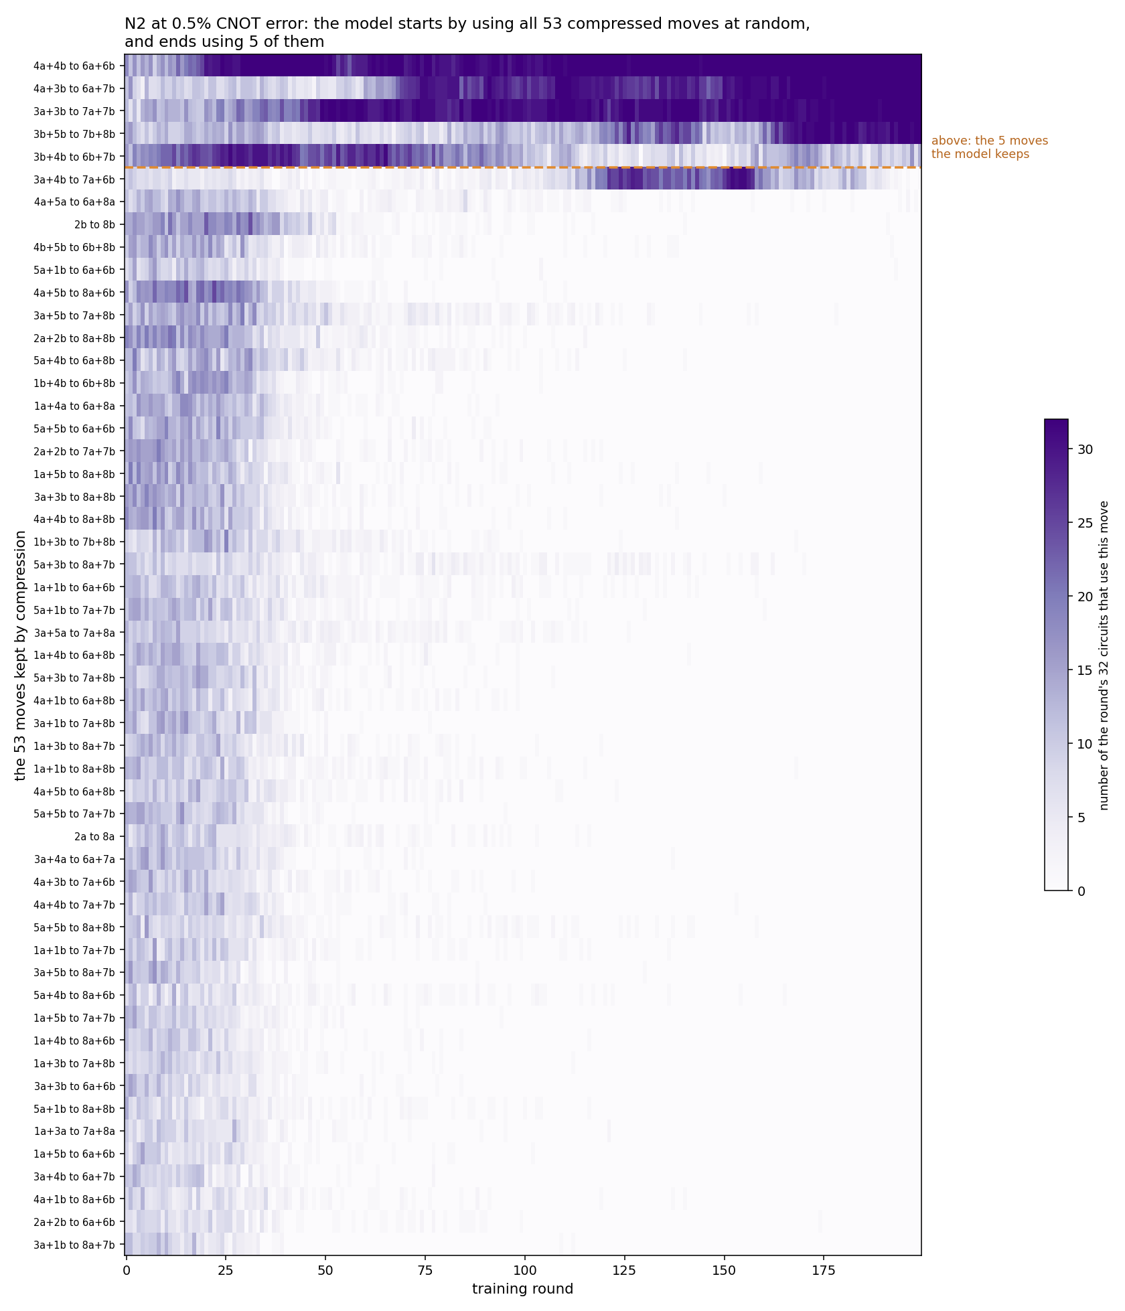
N2 at 0.5%, Part 2: the moves the shake uses, round by round

We can summarize the top moves for each “shake” training by the molecules as drawn below:
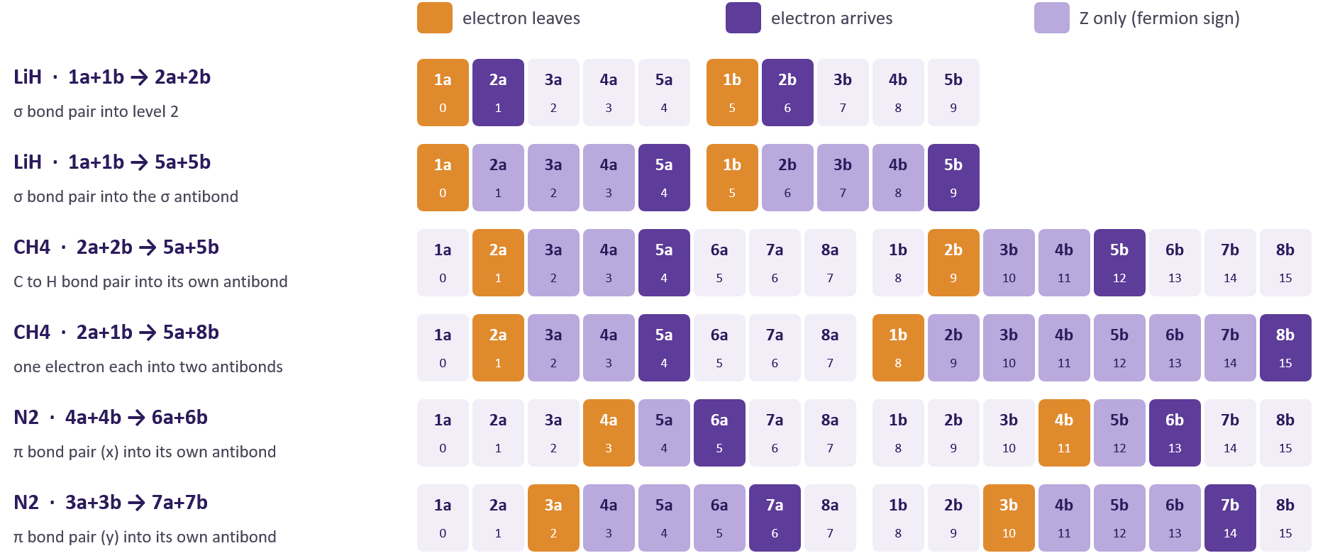

Each move represents a new design in the circuit, for example “4a to 6a” means a rotation of two Pauli strings connecting q3 to q5 through q4 intermediary:
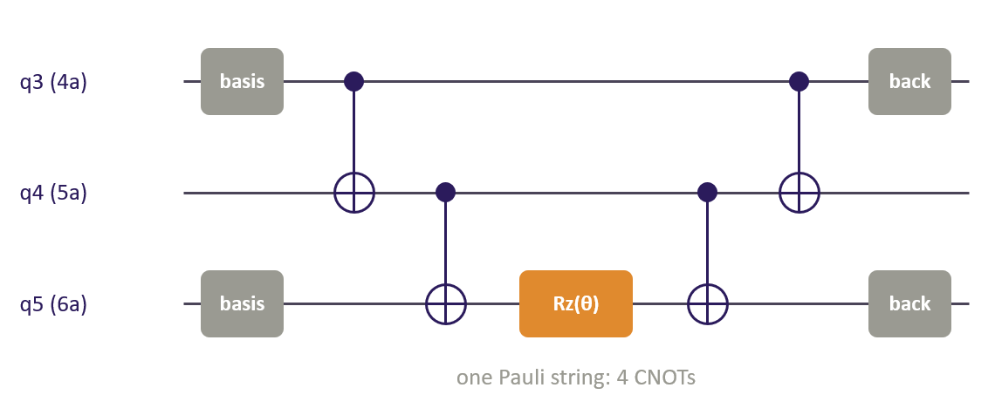

With noise from the start (N2, Part 3 at 0.2%, 600 rounds), the model sees only noisy scores and still ends on the two key π bond moves, 4a+4b to 6a+6b and 3a+3b to 7a+7b; its best circuit in training has a true total error of 62.2 mHa.
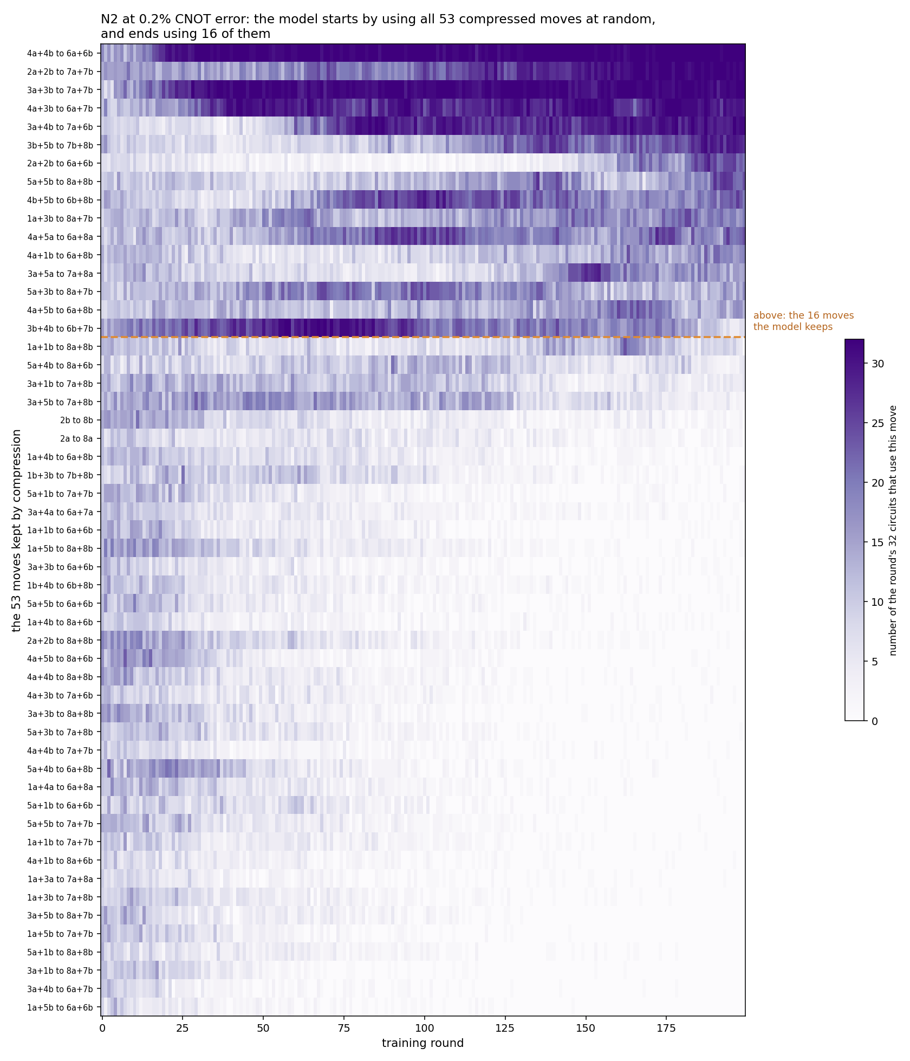
N2 at 0.2%, Part 3: the moves the shake uses, round by round

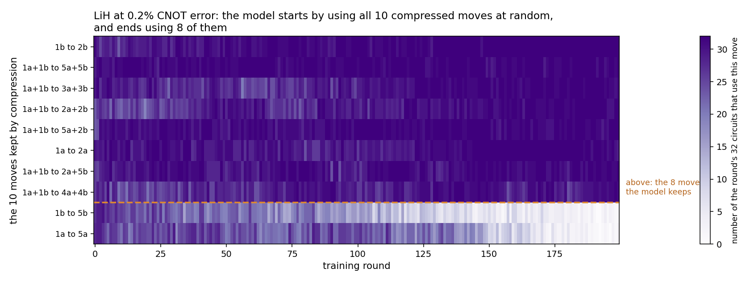LiH at 0.2%, Part 3: the moves the shake uses, round by round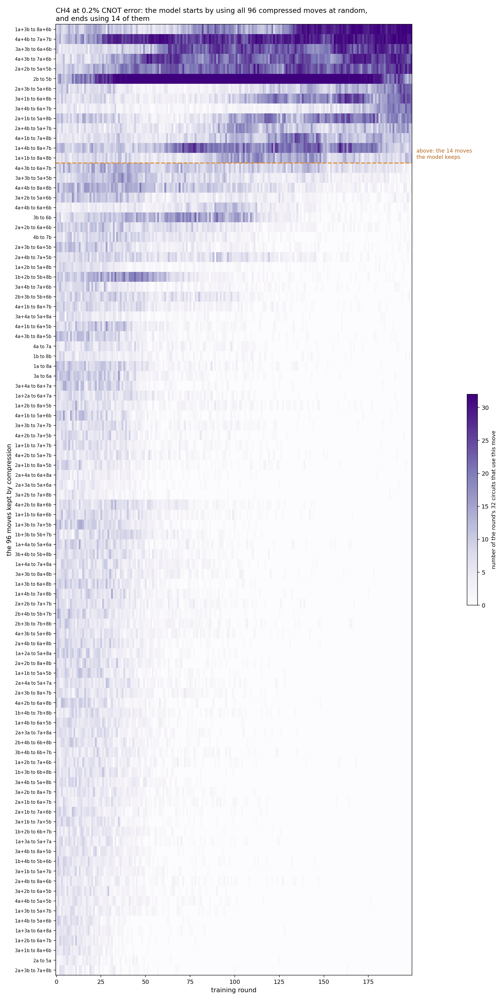
CH4at 0.2%, Part 3: the moves the shake uses, round by round

In general, they are quite consistent with the map without the noise as there is large reduction of move after gen AI training. That said, there are some differences. There are more relevant moves that could be included. In comparison with VQE or compress VQE with noise, this shows that gen AI in addition to the compression is essential for VQE as a preprocessing step.

The twist only tunes the angles of the circuit the shake chose. For LiH and CH4 the shake’s quick fit already converges, so the twist adds nothing. As a last part of the work, we test the progression or the evolution of the twist process for all three molecules with two sets of noise level, 0.002 and 0.005. The vertical line indicates the quick fit furnaced by generative AI process (shake). In general, the majority of correction has been already made by the gen AI prior to the fine tuninig done by VQE as evidence by minimum correction made after the vertical line. This again emphasis the importance of using gen AI specially under noisy environment.
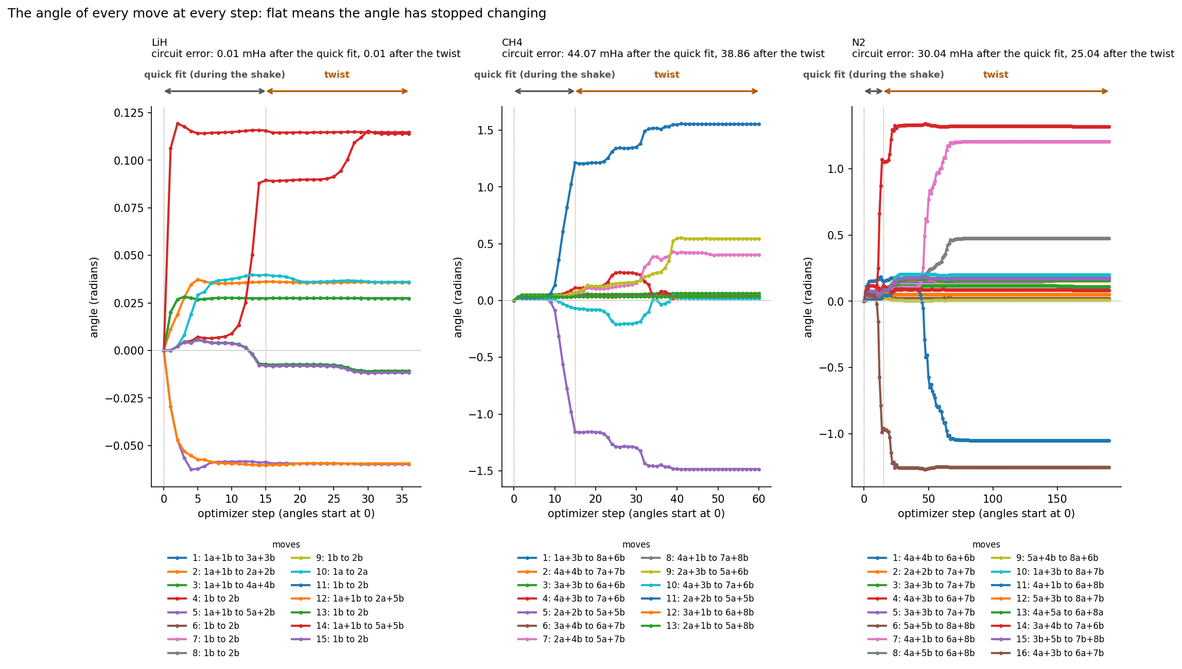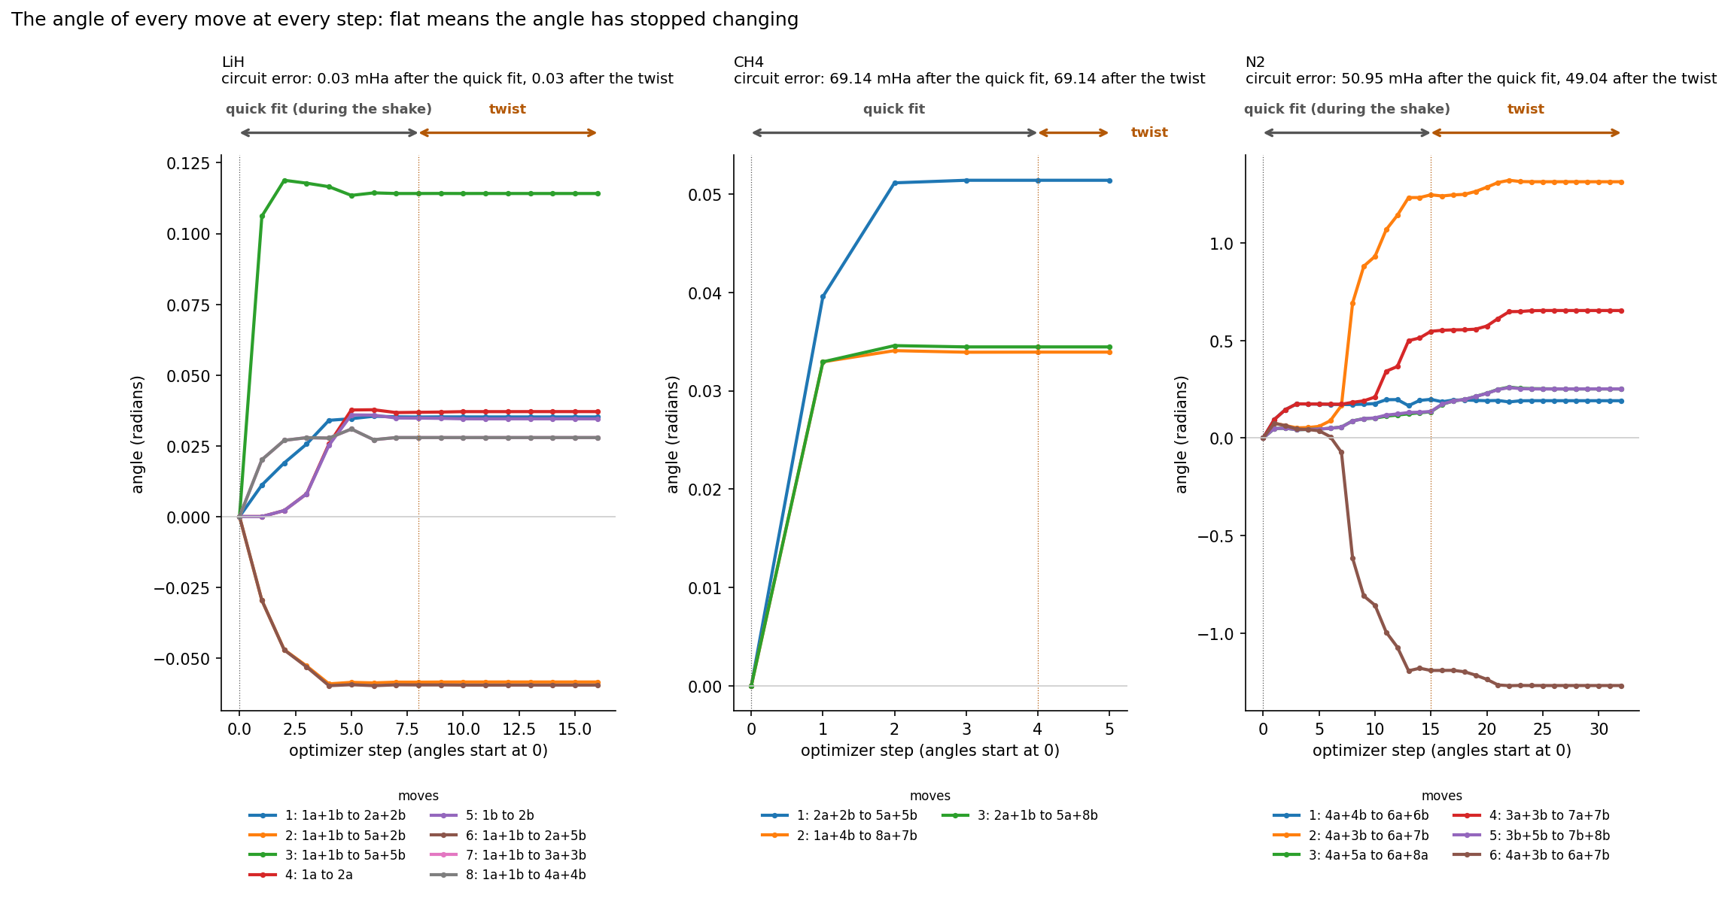
The angle of every move at every optimizer step, LiH, CH4 and N2

Conclusions (to revise with the teams’ results)
- Compression is exact and always pays: the same energy with fewer qubits, moves and CNOTs.
- Under noise, VQE cannot optimize long circuits; choosing a short circuit is a discrete decision that gradients cannot make. The shake makes it from scores alone, and for N2 it finds the π bond design under both noise models.
- LiH needs no shake: compression alone reaches chemical accuracy.
The numbers and figures will be replaced with the teams’ results, and these conclusions revised to match.

Team Information
Quantum Bears | Affiliation | Department | Career Level
Henry Hare | Missouri State University | Computer Science | Junior, Undergraduate
Bishwash Devkota | Missouri State University | Physics, Astronomy and Materials Science | 1st Year Masters
Orion Brewer | Missouri State University | Computer Science | Freshman, Undergraduate
Asyl Ablai | Missouri State University | Chemistry and Biochemistry | Sophomore, Undergraduate

Submission Category: Raising Stars

Motivation behind this project:
Symmetry is a big part of molecules and chemistry; if they lose symmetry or lose a bonded atom, they’ll be charged, making them unstable. If the molecule is polar, it’ll also be unstable, and symmetry, like in Methane (CH4), helps reduce polarity as it cancels out the differences in the electronegativity between Carbon and Hydrogen.
Therefore, we used symmetry to actually decrease the number of qubits that will be used, and we also used triple bonded with a lone pair on both nitrogens aligning with a linear structure (Nitrogen gas, N2), that is also sp hybridized, and single bonded molecule that is sp3 hybridized with tetrahedral structure (Natural gas, CH4) so that we see more variety in the data as the electrons moving in between these orbitals make the energy required different.
As Lithium hydrogen (LiH) atoms are so small the compression doesn’t matter, but because N2 and CH4’s hybridizations are different we can get a lot of data of how these electrons are moving throughout the noise.

Acknowledgement
AI assistance (Claude, Anthropic) was used to assist the code preparation. The framework, calculations, data generation and analysis are the group’s, who take the responsibility for the scientific content.

