


Project And Professionalism

Project Report: Cafe Counter-Service

Order and Billing System

Name : Bishwo Raj Dhami
Student Number : 2413996
Supervisor : Santosh Sapkota
Reader : Biraj Dulal
Date : 06/03/2026

Table of Contents
1. Introduction 3
1.1 Aims and Objectives 3
1.2 Problem Statement 4
1.3 System as a Solution 5
2. Technology Stack 5
3. System Architecture 6
3.1 Client Tier (Frontend) 6
3.2 Application Tier (Backend) 7
3.3 Data Tier (Database) 7
4. System Artefact Feature Documentation 8
4.1 Authentication and User Management 8
4.2 Cashier Domain Features 9
Order Taking 9
Table Booking 9
Order Queue 10
Payment Processing 10
Refund Management 10
Cash Closing 10
4.3 Manager / Admin Domain Features 11
Business Insights Dashboard 11
Menu Management 11
Staff Management 12
Discount Setup 12
Settings 12
4.4 Chef / Kitchen Domain Features 12
Kitchen Display System 12
Item Availability Control 12
Order History 13
Kitchen Settings 13
4.5 Stock and Inventory Management 13
Product Catalogue 13
Batch Tracking 13
Automated Daily Deduction 13
Stock Transactions 14
Stock Detail Drawer 14
5. System Design 14
5.1 Functional Decomposition Diagram 14
5.2 Entity Relationship Diagram (ERD) 15
5.3 Use Case Diagram 15
5.4 Activity Diagram 16
5.5 Sequence Diagram 17
5.6 Class Diagram 18
5.7 Work Breakdown Structure (WBS) 20
6. Data Design 21
Database Tables 21
Key Design Decisions 22
7. Wireframes 23
Key Screens 23
8. Security Considerations 24
Authentication Security 24
API Security 24
Frontend Security 24
Privacy & Data Security 25
9. Conclusion 25

1. Introduction
This document presents the detailed system design and artefact description for the Cafe Counter-Service Order and Billing System. It covers the project background, objectives, technical architecture, feature implementation, and design decisions made throughout the development of a fully operational web-based café management platform.

1.1 Aims and Objectives
The primary aim of this project is to design and develop a comprehensive, role-based, digital Cafe Management System that streamlines day-to-day café operations from order placement to shift-end financial reconciliation.
Specific Objectives:
- Streamline the ordering process Provide cashiers with a fast, touch-friendly digital menu interface to minimise manual entry errors and reduce customer wait times.
- Enable real-time kitchen communication Automatically route orders to a Kitchen Display System (KDS) the moment they are placed, eliminating the need for handwritten tickets or verbal relay.
- Automate financial accuracy Handle VAT calculation, service charges, discount application, and split-payment scenarios programmatically, eliminating arithmetic errors common in manual billing.
- Centralise management control Provide managers with a single dashboard to oversee staff accounts, menu configuration, pricing, tax settings, discounts, and business analytics.
- Track and manage inventory Implement an automated stock tracking system using batch-based FIFO (First-In, First-Out) deduction with expiry management, low-stock alerts via email, and a background worker for daily usage deductions.
- Improve accountability and auditability Log every significant action (sales, refunds, cash closings, stock changes) and attribute them to specific users, enabling full operational transparency.
- Generate business insights Provide managers with time-range-filtered sales reports, top-selling item analysis, busiest hour breakdowns, payment method distributions, and category-level revenue figures.

1.2 Problem Statement
Traditional café operations often rely on fragmented or entirely manual systems, creating several recurring operational problems:
Problem | Impact
Manual Errors | Handwritten tickets or disconnected systems lead to order mistakes and communication gaps between waiting staff and the kitchen.
Inventory Mismatch | Absence of real-time stock tracking causes unexpected shortages or excessive waste through untracked food decay.
Financial Discrepancies | Manual cash handling and end-of-day reconciliation are prone to human error, discrepancy concealment, or petty theft.
Service Delays | Inefficient payment processing and order-to-kitchen routing slow down customer throughput, reducing revenue.
Limited Business Insights | Difficulty analysing which items are popular or profitable without digitised transactional data.
Staff Accountability Gaps | No mechanism to link individual staff actions (orders taken, refunds processed) to user accounts.
In the specific context of small-to-medium cafés operating in Nepal, these issues are compounded by the use of multiple payment methods (cash, card, and local mobile wallets such as eSewa and Khalti), which are difficult to reconcile manually at shift end.

1.3 System as a Solution
The proposed and implemented system addresses all of the above issues through a unified web-based application with a React frontend and an ASP.NET Core backend. It automates the entire café workflow from order placement to payment, inventory tracking, and financial reporting.
Key solution areas:
- Digital Ordering Interface Cashiers use a categorised, touch-friendly screen to place orders which are routed instantly to the kitchen, with support for dine-in table assignment and takeaway.
- Real-Time Synchronisation The Kitchen Display System (KDS) reflects new orders immediately without requiring any page refresh, keeping kitchen staff updated at all times.
- Automated Financial Calculations The system automatically computes VAT, service charges, booking charges, and applies applicable discounts. Split-payment scenarios (splitting a bill among multiple payers with different payment methods) are handled in a single transaction.
- Centralised Management Managers control prices, staff roles, tax settings, discount schedules, and stock levels from a role-restricted dashboard.
- Automated Stock Management A background service runs nightly to auto-deduct daily usage from inventory, expiry dates are tracked per batch, and email alerts notify managers when stock falls below the reorder threshold.
- Full Accountability Every sale, refund, cash closing, and stock transaction is logged against the acting user, with timestamps and audit trails.

2. Technology Stack
Layer | Technology | Details
Frontend | React 18 | Single Page Application (SPA), component-based UI
Routing | React Router v6 | Client-side routing with role-based protected routes (RoleBasedRoute)
Backend | ASP.NET Core 8 (.NET 8) | RESTful API, controller-based MVC architecture
ORM | Entity Framework Core | Code-first database interaction, parameterised queries
Database | Microsoft SQL Server | Relational database, UTC timestamp storage
Authentication | JWT Bearer Tokens | Stateless authentication using HS256-signed JSON Web Tokens
Password Security | ASP.NET Identity PasswordHasher<User> | PBKDF2 hashing passwords never stored in plain text
Email | Custom EmailService | Gmail SMTP integration used for OTP delivery and stock alerts
Background Services | StockAutoDeductionService | ASP.NET Core Hosted Service runs daily at 23:00 UTC
API Documentation | Swagger / OpenAPI | Auto-generated interactive API docs in Development mode
Cross-Origin Policy | CORS | Configured to allow frontend at http://localhost:3000
Icons | React Icons | Consistent iconography across all UI components
Time Zone | Nepal Standard Time (UTC+5:45) | All Business Insights queries use Nepal Time ZoneInfo

3. System Architecture
The system follows a classic three-tier architecture:

3.1 Client Tier (Frontend)
The user interface is built as a React Single Page Application (SPA). It handles the presentation layer and client-side navigation.
- Routing: Managed by React Router, which implements Role-Based Routes to ensure users only access authorized views.
- Key Interfaces:
  - Cashier Dashboard: For order entry and point-of-sale operations.
  - Manager Dashboard: For administrative tasks and reporting.
  - Chef Interface: For real-time order management in the kitchen.

3.2 Application Tier (Backend)
The logic layer is powered by .NET Core 8, serving as the bridge between the user interface and the database.
- Request Pipeline: Incoming HTTP requests pass through a robust middleware stack including JWT Authentication, CORS policies, and Authorization before reaching the API Controllers.
- Core Logic: The backend consists of 15 Controllers and 3 specialized Services, utilizing EF Core (ORM) for data mapping.
- Automation: Includes a Background Worker (StockAutoDeductionService) that handles asynchronous tasks like inventory updates without blocking the main user flow.
- Communication: Interacts with the Client Tier via RESTful APIs using JSON payloads and JWT Bearer tokens for security.

3.3 Data Tier (Database)
The persistence layer is managed by SQL Server, structured for data integrity and consistency.
- Schema: The database comprises 18 Tables linked via Foreign Keys, with all time-sensitive data stored using UTC Timestamps for global synchronization.
- Implementation: Developed using the Code-First approach with Entity Framework Core, where the ApplicationDbContext defines the database structure directly from the application code.

Middleware Pipeline (Program.cs):
- UseHttpsRedirection Forces secure transport
- UseCors("Localhost3000") Restricts cross-origin access to the known frontend origin
- UseAuthentication Validates JWT Bearer tokens on every request
- UseAuthorization Enforces role-based access at controller/endpoint level
- MapControllers Routes requests to the appropriate controller actions
Services registered:
- IPasswordHasher<User> Scoped, used by LoginController
- IEmailService / EmailService Singleton, used for OTP emails and stock alerts
- StockService Scoped, encapsulates all stock business logic
- StockAutoDeductionService Hosted (background) service

4. System Artefact Feature Documentation

4.1 Authentication and User Management
The system uses a secure, multi-step authentication flow with role-based access control.
Registration and Email Verification: - New managers register with an email and password via the /api/login/register endpoint. - Upon registration, the backend sends a 6-digit OTP to the provided email address using EmailService (Gmail SMTP). - The user is redirected to an OTP verification page (VerifyEmail) and must confirm their email before accessing the system. - The User entity stores EmailVerified, OTP, and OTPExpiry fields to manage this flow securely.
First-Login Staff Flow: - Managers can create staff accounts (Cashier, Chef) with a temporary password. - The IsFirstLogin flag on the User entity is set to true for manager-created accounts. - On first login, staff are redirected to FirstLoginOTP and forced to set a new personal password before accessing any module. This prevents managers from retaining access to staff accounts.
Forgot Password / OTP Reset: - A multi-step password reset flow: user submits their email → receives an OTP → verifies OTP → sets a new password. - The endpoint returns a generic message (“If an account exists…”) regardless of whether the email is found, preventing user enumeration attacks.
JWT Token: - Upon successful login, the server generates a signed JWT containing the user’s Id, Email, and Role. - Tokens are validated on every API request by the JWT middleware configured in Program.cs. - Role claims are used by both the backend (authorization attributes) and frontend (React RoleBasedRoute component) to enforce access boundaries.
Roles and Access Boundaries:
Role | Accessible Modules
Manager | Business Insights, Menu Management, Staff Management, Stock Tracking, Discount Setup, Settings, Cash Closing Reports
Cashier | Order Taking, Order Queue, Table Booking, Payment Processing, Refund Management, Cash Closing
Chef | Kitchen Display System, Item Availability, Order History, Kitchen Settings

4.2 Cashier Domain Features

Order Taking
The Order Taking interface is the primary cashier tool for creating new customer orders.
- Menu Display: Items are displayed in a categorised grid, fetched from the backend and filtered by selected category tab. Items marked IsAvailable = false are greyed out and unselectable.
- Order Type: The cashier selects either Dine-In or Takeaway before building the order.
- Table & Seat Assignment: For dine-in orders, the cashier selects the floor and table/seat from a live visual seat map. Seats show real-time status (Available, Reserved, Occupied) fetched from TableSeats.
- Item Customisation: Each item added to the order supports a special request text field (e.g., “no onions”, “extra hot”) which is transmitted to the kitchen with the order.
- Automatic Calculations: The order subtotal, VAT (configurable rate from Settings), and service charge are computed in real time as items are added or removed.
- Discount Application: Available discounts (from DiscountsController) are listed and can be applied to the order, supporting both percentage-off and fixed-amount discount types.
- Order Submission: Orders are sent to POST /api/cashier/orders, persisted to the database, and simultaneously appear on the Kitchen Display System.

Table Booking
A dedicated table reservation management system for managing floor capacity.
- Multi-Floor Support: Tables are organised by floor zones. Each floor has configurable seats.
- Booking Creation: Cashiers can create a booking with customer name, phone number, start time, and duration. A booking charge is applied and linked to the resulting order.
- Seat Status Tracking: Seats transition through statuses: Available → Reserved → Occupied. When a booking order is marked Ready, an AutoReleaseAt timestamp is set (ReadyAt + 30 minutes), after which the seat automatically reverts to Available.
- Booking Lifecycle: Bookings can be completed or cancelled, with all state changes logged in TableBookings and TableSeats tables.

Order Queue
Displays all active (unpaid) orders for cashier oversight.
- Shows order card with: order number, order type, table/seat, items, total, and status badge.
- Cashiers can navigate directly from a Ready order to the Payment Processing tab.
- Completed and cancelled orders are filtered out; only actionable orders are shown.

Payment Processing
A comprehensive payment module supporting multiple methods and complex billing scenarios.
- Payment Methods: Cash, Card, and Mobile Wallet (eSewa, Khalti, IME Pay).
- Split Bill: The bill can be split among multiple payers. Each split can use a different payment method (e.g., one person pays by card, another by eSewa). The system records each split as an individual BillSplit record linked to the parent Payment.
- Receipt Generation: A full digital receipt is generated as HTML and printed via an iframe breaking down: item names & quantities, subtotal, VAT amount, service charge, booking charge, and grand total.
- Kitchen Order Ticket (KOT): A separate kitchen-facing printout (handlePrintKOT) with item names, quantities, special requests, and order type. This replaces paper carbon-copy tickets, reducing paper waste.
- Transaction Recording: All payments are saved to the Payments table with method, amount, split status, and timestamp.

Refund Management
- Full Refund: Reverses an entire completed order, logging reason and timestamp.
- Partial Refund: Cashiers can select individual line-items from an order and specify quantities, allowing precise refunds for disputed items.
- Audit Trail: Each refund creates a Refund record (type, reason, total, date) and corresponding RefundItem records (name, quantity, amount per line), giving managers a full refund log.

Cash Closing
A shift-end financial reconciliation tool.
- System Totals: The system calculates expected cash, card, and mobile sales for the day from the Payments table.
- Physical Count: The cashier enters the actual cash amount counted in the drawer.
- Expenses: Any cash paid out during the shift (vendor payments, small purchases) is recorded as CashExpenses.
- Discrepancy Report: The system computes: Closing Balance = Opening Cash + Cash Sales − Cash Expenses. Any difference between the system expected value and the actual cash counted is flagged as a discrepancy.
- Opening Balance: The previous day’s closing balance is automatically carried forward as the next day’s opening balance. Managers can override the opening balance with a logged reason.
- Historical Reports: All cash closing records are stored in CashClosings and accessible to managers via the settings page.

4.3 Manager / Admin Domain Features

Business Insights Dashboard
A comprehensive analytics module providing business performance visibility.
- Date Range Filtering: Supports Daily, Weekly, Monthly, Yearly, and Custom date range views. All calculations are performed in Nepal Standard Time (UTC+5:45) for accuracy.
- Key Performance Indicators (KPIs): Total Sales (NRP), Total Orders, and Average Order Value displayed as summary cards at the top.
- Sales Chart: A line/bar chart showing sales over time broken down by hour (daily), by date (weekly/monthly), or by month (yearly).
- Top 5 Items: Ranked by quantity sold, showing name, units sold, and revenue contribution.
- Busy Hours: A bar chart showing order volume by hour of day, identifying peak service periods.
- Payment Method Distribution: Breakdown of revenue by Cash, Card, and Mobile payments.
- Category Sales: Revenue and items sold per menu category.
- Order Type Breakdown: Dine-In vs Takeaway split by count and revenue.
- Booking Revenue: Total booking charges collected and number of table bookings in the period.

Menu Management
Full CRUD control over the menu.
- Categories: Create, rename, and delete menu categories. Categories appear as filter tabs on the Order Taking screen.
- Menu Items: Add items with name, price, category, availability toggle, and VAT-exempt flag (IsVatExempt). VAT-exempt items are excluded from the VAT calculation even when the global VAT rate is set.
- Image Support: Item images can be uploaded and displayed on the Order Taking grid.
- Availability Toggle: Items can be instantly toggled as available/unavailable without deletion. Unavailable items are hidden from cashiers.

Staff Management
- View all registered staff members with their roles and account status.
- Create new staff accounts with a temporary password (triggers IsFirstLogin flow).
- Edit staff roles (promote/demote between Cashier, Chef, Manager).
- Deactivate accounts without deletion, preserving audit history.

Discount Setup
- Discount Types: Percentage (e.g., 10% off) or Fixed Amount (e.g., NRP 50 off).
- Offer Types: Individual (applies to selected menu items) or Combo (applies when a combination of items is present in the order).
- Date Scheduling: Optional start and end dates for time-limited promotions.
- Minimum Purchase: Optional minimum order threshold before the discount activates.
- Item Linking: Each discount can be linked to one or more specific menu items via DiscountMenuItems join table.

Settings
System-wide configuration:
- VAT Rate: Global percentage applied to all non-exempt items.
- Service Charge: Optional percentage added to all orders.
- Currency: Symbol displayed throughout the UI (default: NRP).
- Opening Balance Override: Managers can manually set the next day’s opening cash balance with a reason logged for audit purposes.
- Cash Closing History: Paginated list of all historical cash closing records.

4.4 Chef / Kitchen Domain Features

Kitchen Display System
The real-time order board for kitchen staff.
- Fetches all active (non-cancelled, non-completed) orders automatically.
- Each order card displays: order number, type (Dine-In/Takeaway), table/seat, items with quantities, any special requests, time elapsed since order placement, and current status.
- Status Progression:
Pending → Preparing → Ready
Kitchen staff update status via button click. When marked Ready, the cashier’s Order Queue is updated and the seat ReadyAt timestamp is recorded.
- Orders are colour-coded by status for quick visual scanning.

Item Availability Control
- Displays all menu items grouped by category.
- Chefs can instantly toggle items to Out of Stock, preventing further orders from being placed.
- Changes are persisted to the MenuItems.IsAvailable field via PATCH /api/chef/items/{id}/availability.

Order History
- View chronologically ordered list of completed/cancelled orders.
- Filter by date and order type.
- Useful for chefs to reference previously completed orders or track cooking patterns.

Kitchen Settings
- Allows chefs to configure display preferences (e.g., auto-refresh interval, sound alerts for new orders).

4.5 Stock and Inventory Management
The stock management system is a major advanced feature implemented beyond the original design. It provides professional-grade inventory tracking for a café environment.

Product Catalogue
Each stock product (Product model) records: - Name, Category, Unit (e.g., kg, litres, pcs) - Supplier name (can be overridden per batch) - Shelf Life (days) used to calculate expected expiry on received batches - Minimum Stock Level triggers email reorder alert when total stock falls below this threshold - Daily Usage Rate used by the background auto-deduction worker - Reorder Days how many days before expiry/stock-out to send a reorder alert - IsArchived soft deletion flag; archived products are hidden from the interface but historical transactions are preserved

Batch Tracking
Stock is received and tracked in named batches (StockBatch model): - Quantity (remaining) - Received Date and Expiry Date - Cost Per Unit enables inventory value KPI tracking - Supplier (per-batch override) - Notes free-text field for delivery notes - IsActive auto-set to false when quantity reaches 0 or batch expires
FIFO Deduction: When stock is consumed, the system deducts from the oldest non-expired active batch first, ensuring stock rotation.

Automated Daily Deduction
StockAutoDeductionService is an ASP.NET Core Hosted Service that runs every night at 23:00 UTC: 1. Queries all products with a DailyUsageRate > 0. 2. Checks if today’s deduction has already been performed (LastAutoDeductionDate). 3. Deducts the daily usage from active batches (FIFO order). 4. Logs each deduction as a StockTransaction record. 5. Checks if post-deduction stock is below MinStockLevel if so, sends an email alert via EmailService.

Stock Transactions
Every stock movement (receive, manual adjustment, auto-deduction) creates a StockTransaction record for a full audit trail, including: product, batch, action type, quantity changed, timestamp, and notes.

Stock Detail Drawer
A side panel view showing: - Full batch list with expiry pills (colour-coded: green = fresh, amber = expiring soon, red = expired) - Total current stock value (quantity × cost per unit across all batches) - Transaction history for the product - Quick reorder pre-fill form

5. System Design
The following sections describe each design diagram. Figure placeholders are provided for the student to insert their own diagram images.

5.1 Functional Decomposition Diagram
The Functional Decomposition Diagram breaks the system down into its top-level subsystems and their constituent functions. The four primary subsystems are:

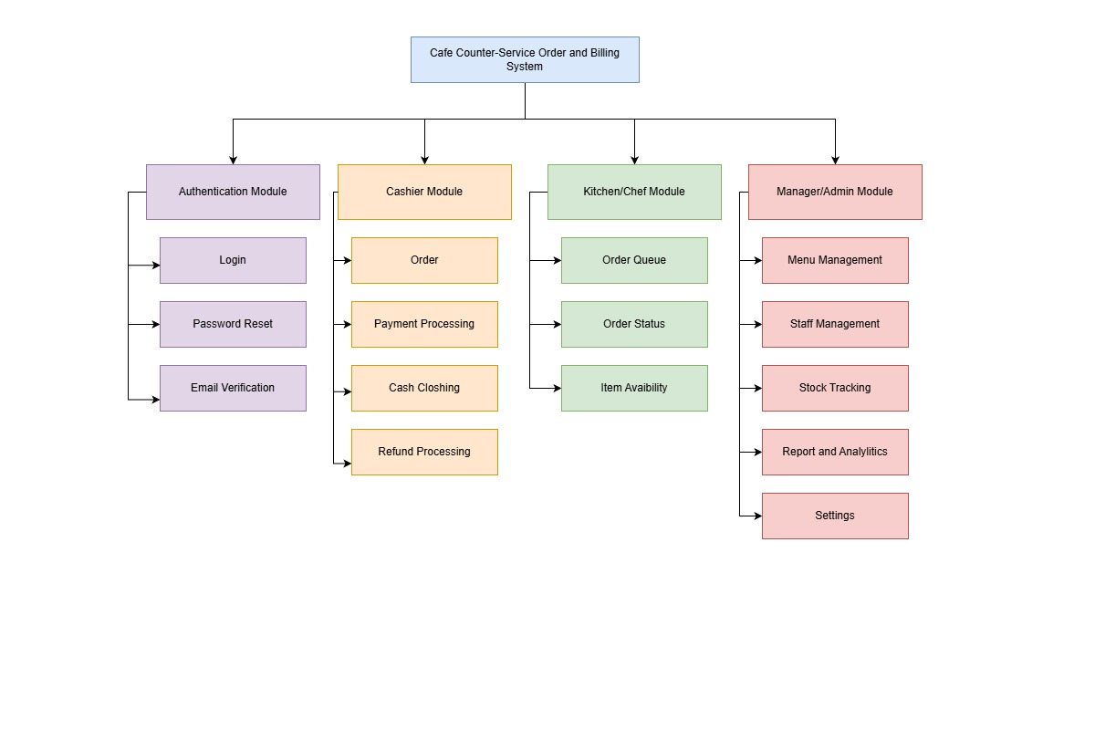
[Figure 5.1: Functional Decomposition Diagram]

5.2 Entity Relationship Diagram (ERD)
The ERD models the full data structure supporting the system. Key entities and their primary relationships are as follows:

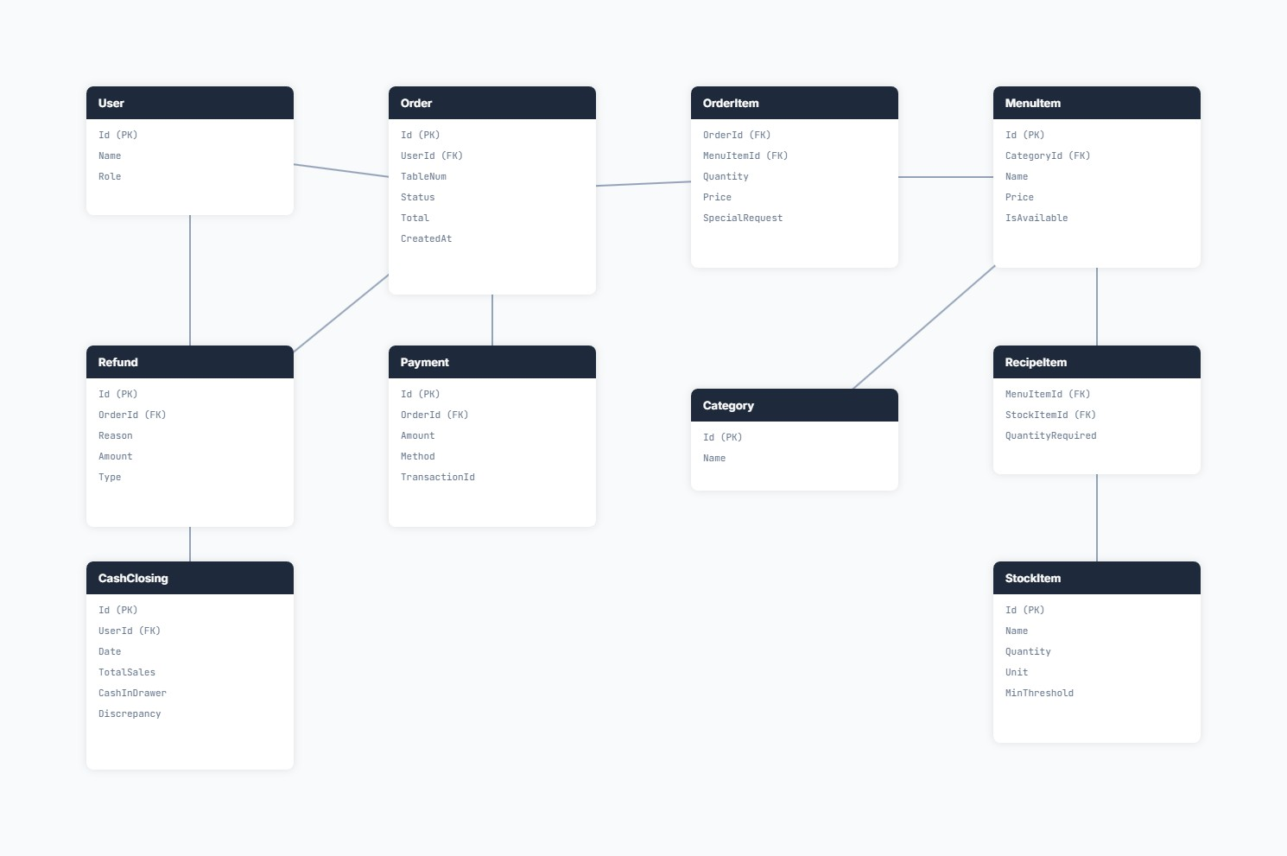
[Figure 5.2: Entity Relationship Diagram]

5.3 Use Case Diagram
The Use Case Diagram illustrates the interactions between the three primary actors and the system use cases.

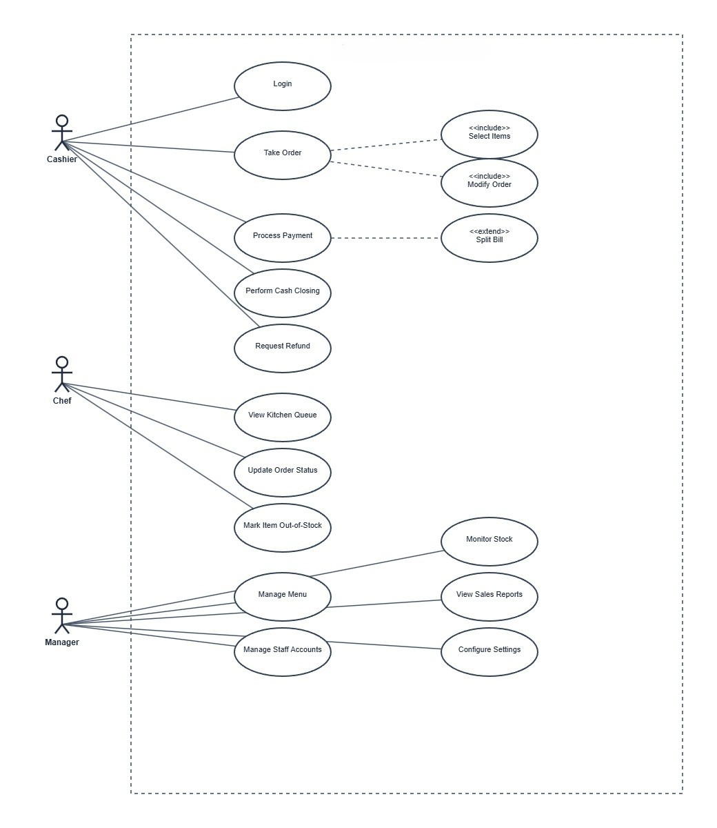
[Figure 5.3: Use Case Diagram]

5.4 Activity Diagram
Two key lifecycle flows are illustrated:

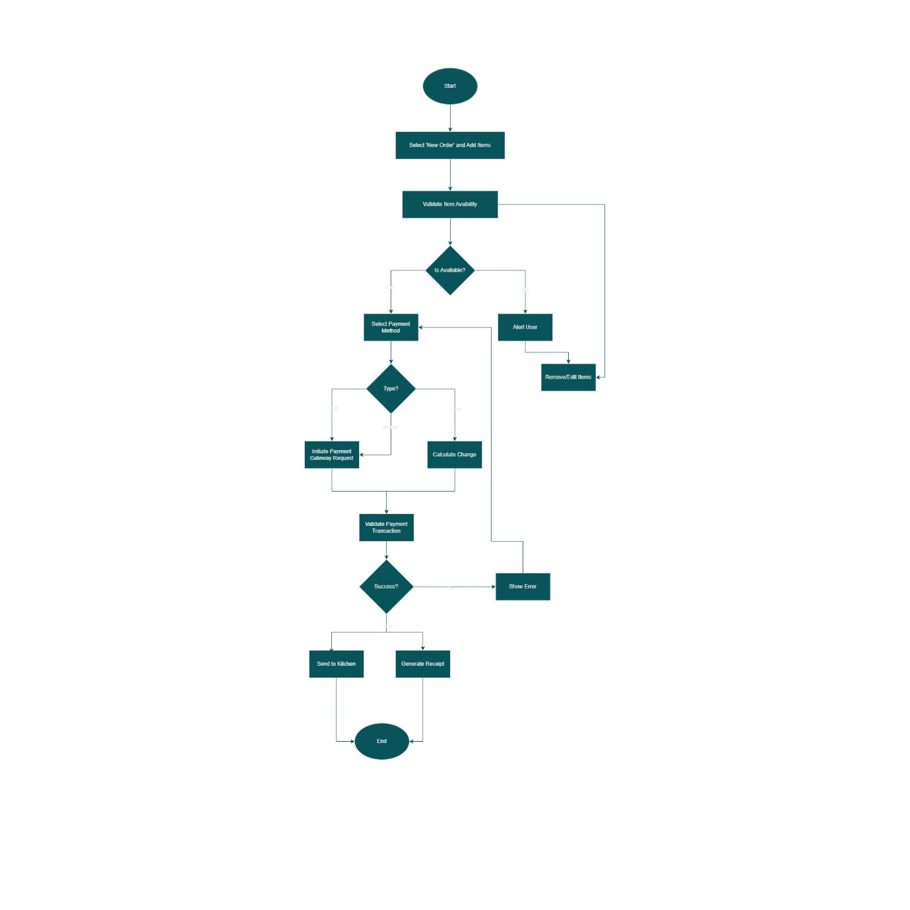
[Figure 5.4: Activity Diagram Order Lifecycle]

5.5 Sequence Diagram
The Sequence Diagram illustrates the chronological message flow during the Place Order operation.
Participants: Browser (React), CashierOrdersController, ApplicationDbContext (SQL Server)

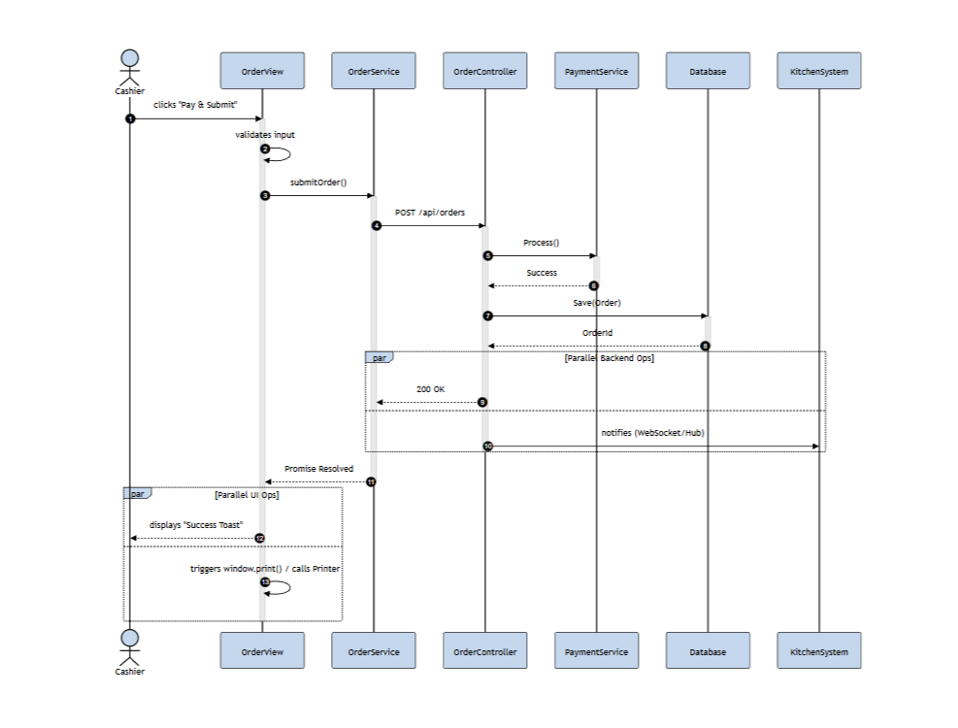
[Figure 5.5: Sequence Diagram Place Order]

5.6 Class Diagram
The Class Diagram depicts the key domain model classes, their attributes, and relationships.
Primary Model Classes:
Class | Key Attributes
User | Id, Email, Password, Role, EmailVerified, IsFirstLogin
MenuItem | Id, Name, Price, Category, IsAvailable, IsVatExempt
Category | Id, Name, CreatedAt
Order | Id, UserId, OrderType, TableNumber, Status, Subtotal, Tax, ServiceCharge, BookingCharge, Total, PaymentStatus
OrderItem | Id, OrderId, MenuItemId, Name, Quantity, Price, SpecialRequest
Payment | Id, OrderId, Amount, Method, MobilePaymentApp, IsSplit, SplitCount
BillSplit | Id, PaymentId, Amount, Payer
Refund | Id, OrderId, TotalAmount, RefundType, Reason, RefundDate
RefundItem | Id, RefundId, OrderItemId, Name, Quantity, Amount
CashClosing | Id, Date, TotalSales, CashInDrawer, OpeningCash, CashExpenses, CashSales, CardSales, MobileSales
TableBooking | Id, FloorName, TableNumber, SeatNumber, CustomerName, CustomerPhone, StartTime, EndTime, Status, OrderId
TableSeat | Id, FloorName, TableNumber, SeatNumber, Status, OrderId, BookingId, OccupiedAt, AutoReleaseAt
Product | Id, Name, Category, Unit, MinStockLevel, ShelfLifeDays, DailyUsageRate, IsArchived
StockBatch | Id, ProductId, Quantity, ReceivedDate, ExpiryDate, CostPerUnit, IsActive, Supplier
StockTransaction | Id, ProductId, BatchId, ActionType, QuantityChanged, Timestamp
Discount | Id, Name, DiscountType, OfferType, Value, StartDate, EndDate, MinPurchaseAmount, Active
DiscountMenuItem | Id, DiscountId, MenuItemId
Setting | Id, Key, Value, UpdatedAt

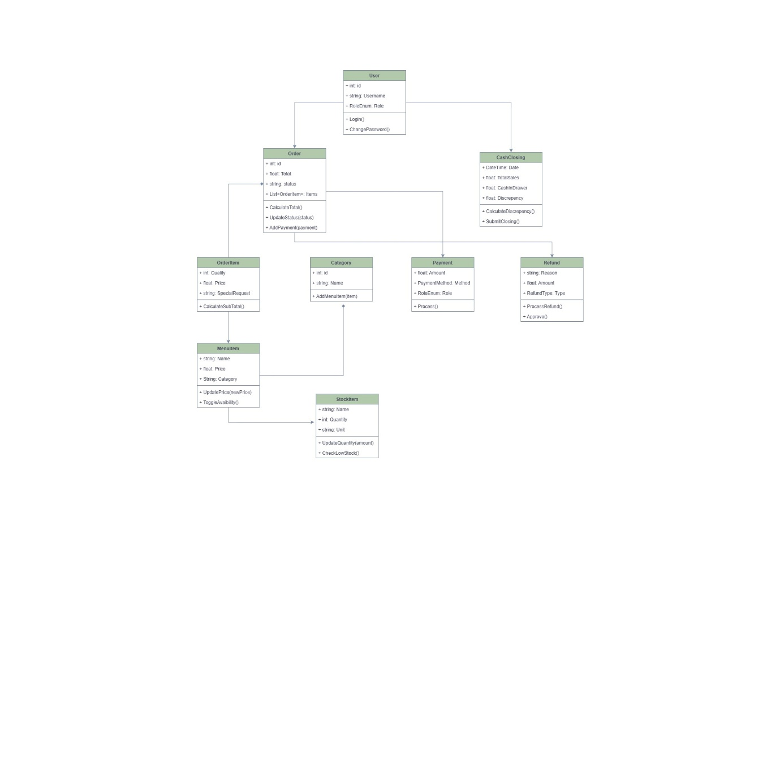
[Figure 5.6: Class Diagram]

5.7 Work Breakdown Structure (WBS)
The WBS outlines the sequential phases of the project from conception to delivery.
Phase 1 Analysis - Requirements gathering - stakeholder identification (cashier, manager, chef) - Problem domain research (café operations, Nepali payment landscape)
Phase 2 Design - System architecture planning - ERD design, use case modelling - Wireframing (Figma) - Technology stack selection
Phase 3 Implementation - Backend: Database setup (migrations), model creation, controller implementation × 15, service layer (Email, Stock), background worker - Frontend: React component development × 30+, role-based routing, API integration, UI/UX styling
Phase 4 Advanced Features - Stock management with batch tracking and FIFO deduction - Email verification and OTP flows - Discount and combo offer system - Table booking and seat management - Business insights with Nepal-time-aware analytics
Phase 5 Testing - Manual functional testing per role - API endpoint testing via Swagger - Edge case testing (split payments, partial refunds, stock expiry)
Phase 6 Documentation - Code commenting - API documentation (Swagger) - Artefact Design Report (this document)

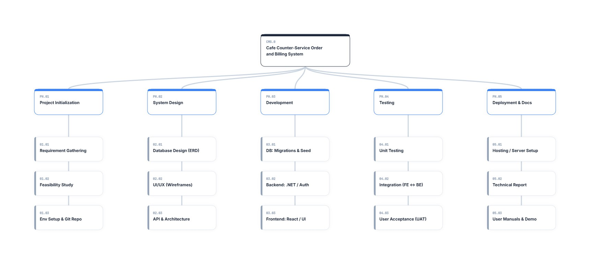
[Figure 5.7: Work Breakdown Structure Diagram]

6. Data Design
The data layer is managed entirely through Entity Framework Core (code-first approach) backed by Microsoft SQL Server. The ApplicationDbContext class defines 18 DbSet properties corresponding to the 18 database tables.

Database Tables
Table | Purpose
Users | Staff account credentials, roles, and email verification state
MenuItems | Café menu catalogue with pricing, availability, and VAT flags
Categories | Menu item groupings (e.g., Coffee, Snacks, Beverages)
Orders | Core transactional record each customer order
OrderItems | Line items within an order (price snapshot at time of order)
Payments | Payment transactions, method, and split metadata
BillSplits | Individual payer records for split-payment orders
Refunds | Refund header record type, reason, total
RefundItems | Line-item refund records
CashClosings | End-of-shift financial reconciliation records
TableBookings | Customer table reservation records
TableSeats | Real-time table/seat status and occupancy data
Products | Stock product catalogue
StockBatches | Individual delivery batches with expiry and cost data
StockTransactions | Full audit log of all stock movements
Discounts | Discount scheme definitions
DiscountMenuItems | M:M join table between discounts and menu items
Settings | Key-value store for system-wide configuration

Key Design Decisions
- Price Snapshots: OrderItem.Price stores the price at the time of ordering, not a foreign key to the current menu price. This ensures historical order data is never corrupted by future price changes.
- UTC Storage: All timestamps are stored in UTC. The BusinessInsightsController converts to Nepal Standard Time (UTC+5:45) for reporting.
- Soft Deletion: Products use IsArchived = true instead of hard deletion to preserve the integrity of historical stock transactions.
- Setting Key-Value Store: The Settings table uses a flexible key-value design so new system settings can be added without database schema changes.
- FIFO Stock Deduction: Stock batches are ordered by ReceivedDate ASC and deducted sequentially, ensuring oldest stock is consumed first to minimise waste.

7. Wireframes
The wireframes represent the structural layout of the main interface components. The overall layout follows a consistent shell:
Main Layout: - Header Fixed top bar with the role-based dashboard title and a Sign Out button. - Top Navigation (Tabs) Horizontal tab bar using icons and labels to switch between modules (e.g., “Take Orders”, “Order Queue”, “Reports”). - Content Area The main section below the navigation bar where the active module renders.

Key Screens





8. Security Considerations
Security has been considered at every layer of the application.

Authentication Security
- JWT Bearer Tokens are used for stateless authentication. Tokens are signed with a symmetric HS256 key configured in appsettings.json. Token validation enforces issuer, audience, lifetime, and signing key checks.
- Password Hashing: ASP.NET Identity’s IPasswordHasher<User> is used, which applies PBKDF2 with HMAC-SHA256 and a random salt. Passwords are never stored or transmitted in plain text.

API Security
- SQL Injection Prevention: All database queries use Entity Framework Core’s LINQ-to-SQL pipeline which fully parameterises queries, eliminating SQL injection risk.
- CORS Policy: Configured in Program.cs to explicitly whitelist only http://localhost:3000. In production, this would be set to the deployed frontend domain.
- Role-Based Authorisation: Each controller endpoint is protected by [Authorize(Roles = "...")] attributes, preventing cross-role data access at the API level.

Frontend Security
- XSS Protection: React’s JSX rendering escapes all dynamic content by default. The exception is the receipt HTML generated for printing via iframe and document.write() this is a known consideration and should ensure all user-supplied content (e.g., special requests) is sanitised before inclusion.
- Route Protection: The React RoleBasedRoute component checks the JWT role claim on the client side and redirects unauthorised users, preventing UI-level access violations.

Privacy & Data Security
- User Enumeration Prevention: The “Forgot Password” endpoint returns an identical generic response regardless of whether the submitted email exists in the database, preventing enumeration of valid accounts.
- First-Login Enforcement: Staff created by managers must change their temporary password on first login, ensuring the manager cannot retain ongoing access to staff accounts.

9. Conclusion
The Cafe Counter-Service Order and Billing System was successfully designed and implemented as a full-stack web application. The system covers the complete operational lifecycle of a modern café from customer order placement and kitchen preparation through to payment processing, inventory management, and business analytics.
The artefact goes significantly beyond a basic proof-of-concept, delivering production-quality features including: email-verified user registration, multi-batch inventory tracking with automated nightly FIFO deduction, a real-time Kitchen Display System, complex split-payment processing, table booking with seat auto-release, comprehensive discount management, and a shift-end cash closing reconciliation workflow.
The technology choices ASP.NET Core 8 with React 18 provide a scalable, maintainable, and secure foundation. Security has been embedded at every layer, from PBKDF2-hashed passwords and JWT authentication through to SQL-injection-proof ORM queries and CORS restrictions.
The system effectively addresses all five problem areas identified in the problem statement and delivers measurable improvements in operational efficiency, financial accuracy, and business visibility for small-to-medium café environments.

