# 0Testing

## black box testing

* It is a method of software testing that examines the functionality of an application without looking into its internal structure. Of workings.
* This method is applied at every level of software testing. Like unit, integration, system and acceptance.
* Tests are based on requirement and functionality.

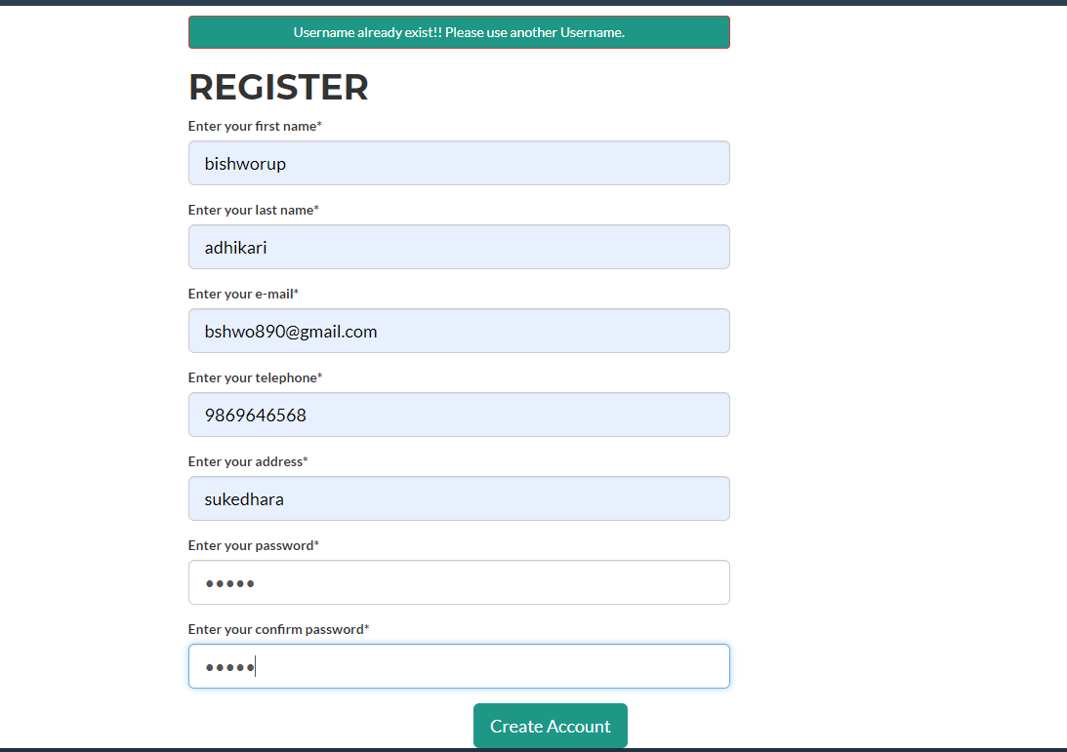

Figure :register form

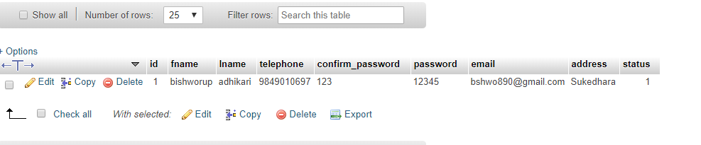

Figure :user register database

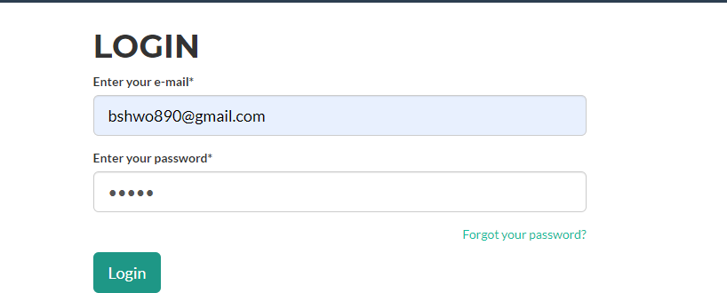

Figure :login form

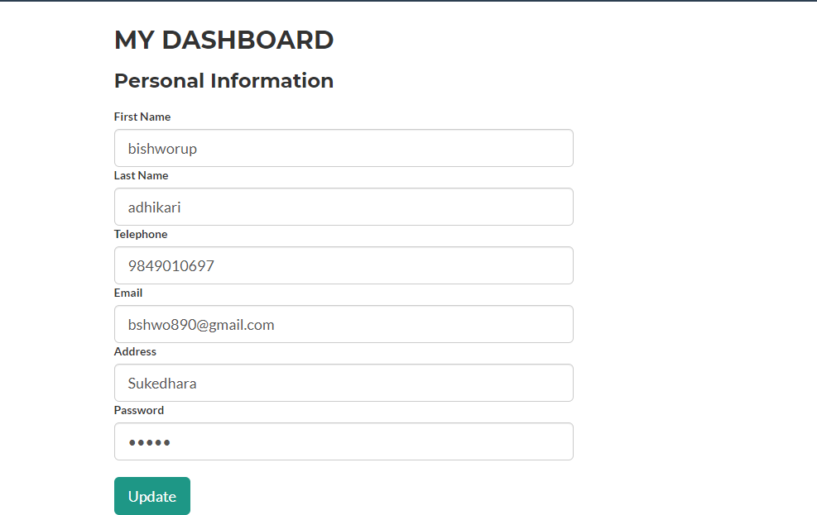

Figure :personal dashboard



Figure :parking area

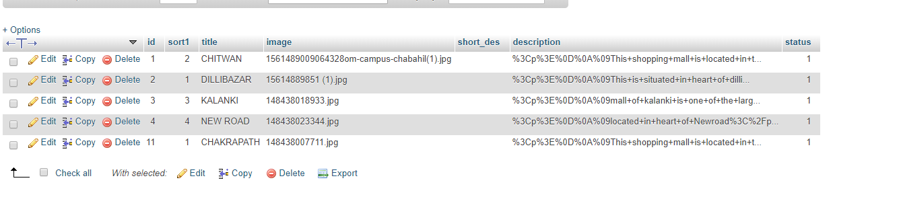

Figure :parking area database

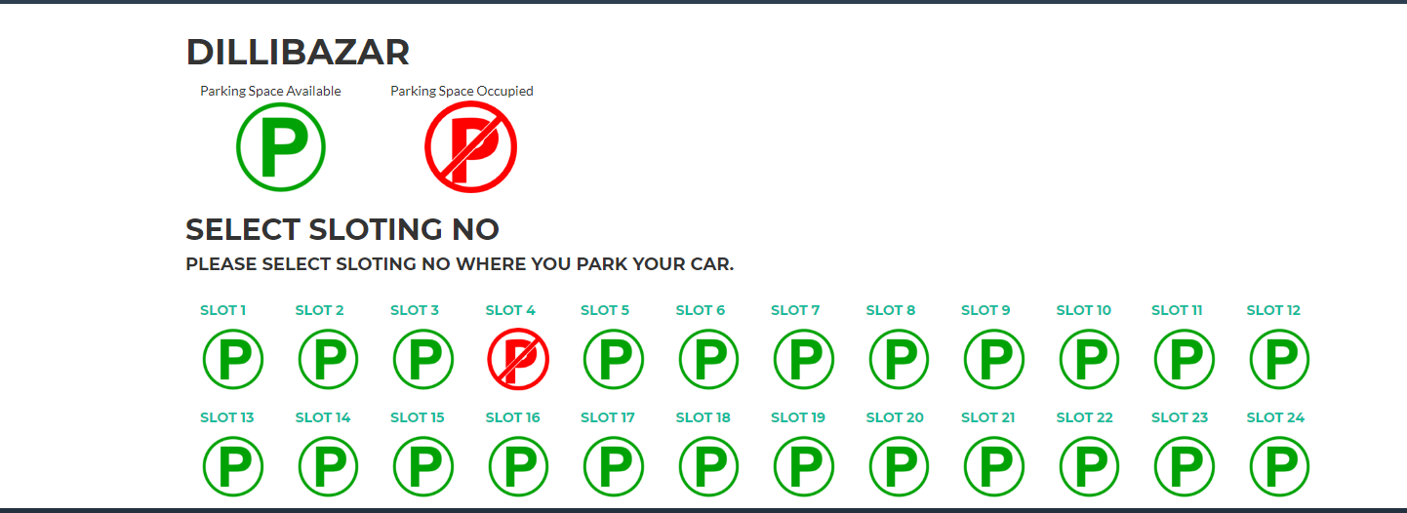

Figure :parking slot

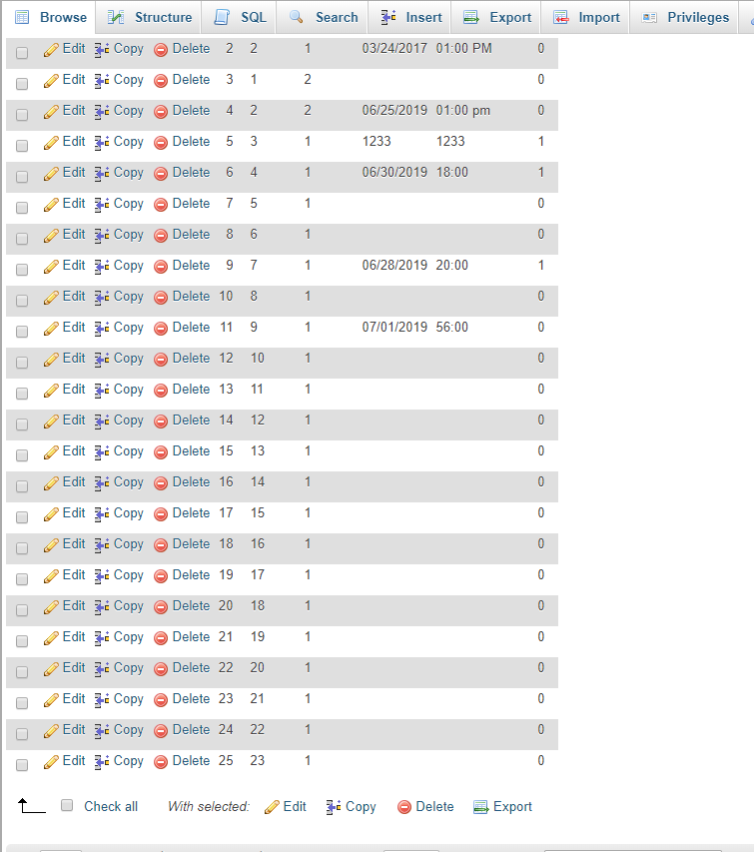

Figure :slot database

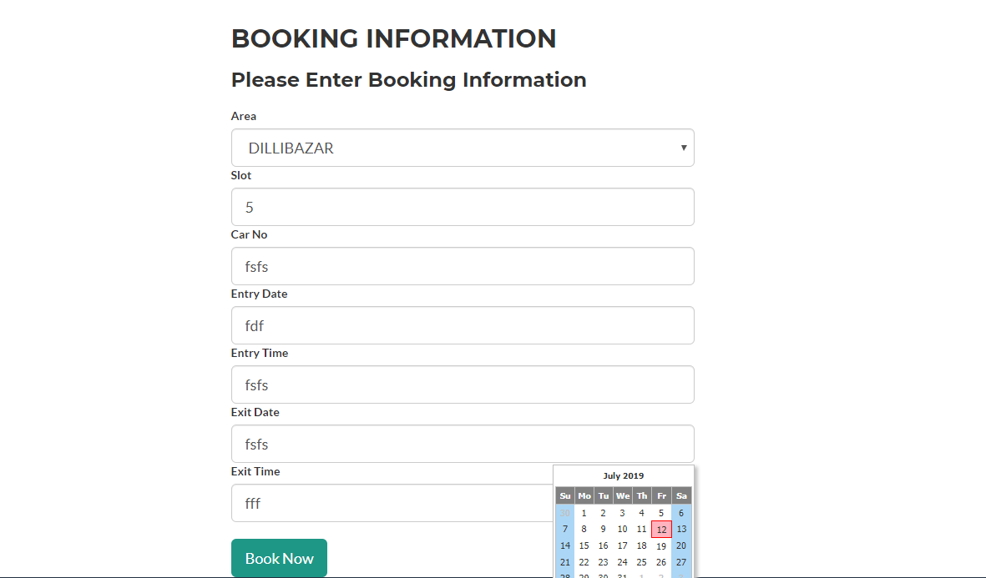

Figure :booking information

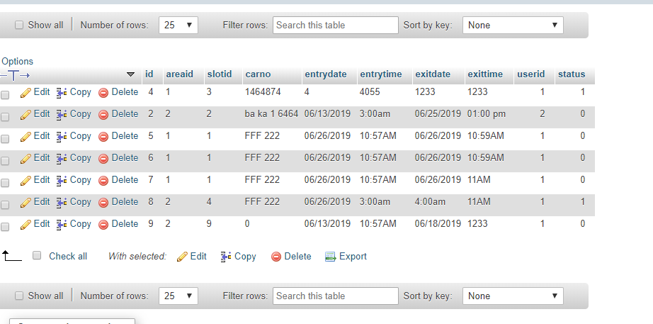

Figure :booking information database

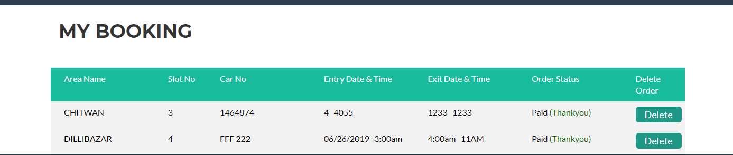

Figure :my booking



Figure :where booking info came from

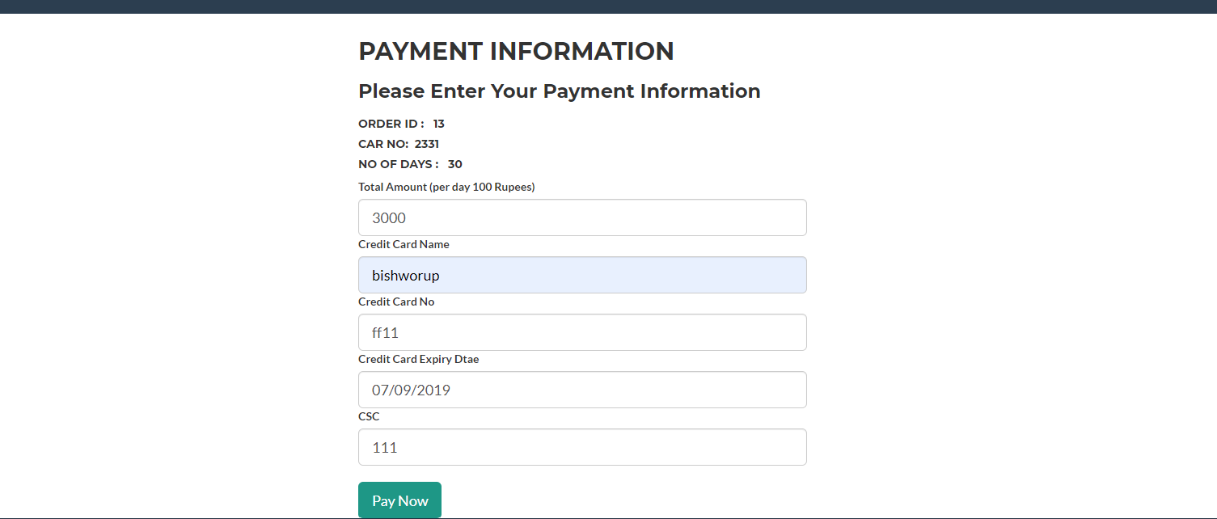

Figure :payment information

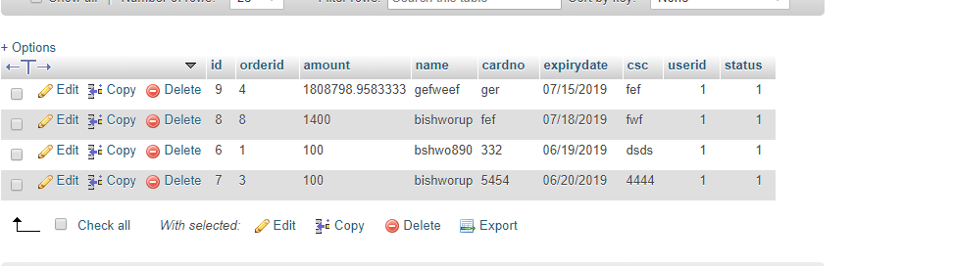

Figure :payment table

## Unit testing

* It focuses on the smallest element of software design modules.
* It makes heavy use of white box testing done in internal code of structure.
* For example, software engineer divide in different that is each module to be tested and all has to be integrated and the output is given
* This module will be tested based on test cases.
* The cases are interface, local data structure, error handling path, boundary condition.