
NATIONAL UNIVERSITY OF TECHNOLOGY
GROUP MEMBERS:
- Bisma Fatima (F24605036)
- Javeria Faisal (F24605017)
- Sawera Anwar (F24605043)
- Ayesha Imran (F24605019)
CLASS:
CS-A 24
COURSE:
Computer Network CS-270
SUBMITTED TO:
SIR NAVEED YOUSAF
DATE:
20- December-2025

PROJECT:
Software-Defined Networking (SDN): Current Research and Developments

Abstract
Software-Defined Networking (SDN) is an emerging network architecture that separates the control plane from the data plane, allowing centralized and programmable network management. Traditional networks rely on distributed control mechanisms that are complex to manage and difficult to scale. SDN overcomes these limitations by introducing a centralized controller that manages network behavior through software. This project report reviews current research work in SDN, focusing on architecture, routing and forwarding mechanisms, performance optimization, scalability, and security challenges. Several recent research papers are analyzed to understand ongoing developments and open research issues. The study shows that SDN improves flexibility, network utilization, and management efficiency, but still faces challenges related to controller scalability, security, and real-world deployment. Future research directions aim to make SDN more reliable, secure, and suitable for large-scale networks.

1. Introduction
Computer networks are the backbone of modern communication systems. With the rapid growth of cloud computing, data centers, and Internet services, traditional network architectures have become difficult to manage. In conventional networks, control logic is embedded inside network devices such as routers and switches, making configuration and troubleshooting complex.
Software-Defined Networking (SDN) is a new approach that simplifies network management by separating the control plane from the data plane. The control plane is centralized in a software-based controller, while network devices only forward packets based on rules provided by the controller. Due to its flexibility and programmability, SDN has become an active area of research in computer networks.

2. Overview of Software-Defined Networking
SDN is based on three main components:
- Data Plane: Consists of switches and routers that forward packets.
- Control Plane: A centralized SDN controller that makes routing and forwarding decisions.
- Application Plane: Network applications that define policies and network behavior.
The communication between the controller and network devices is commonly done using protocols such as OpenFlow. This architecture allows network administrators to manage the entire network through software.

3. Working of SDN Architecture
In SDN, when a packet arrives at a switch, the switch checks its flow table. If no matching rule is found, the packet is forwarded to the controller. The controller then decides how the packet should be handled and installs a new rule in the switch. This process enables dynamic and intelligent traffic management.
Advantages of SDN:
- Centralized network control
- Easy network configuration
- Better traffic optimization
- Support for innovation and research

4. Working of SDN Architecture
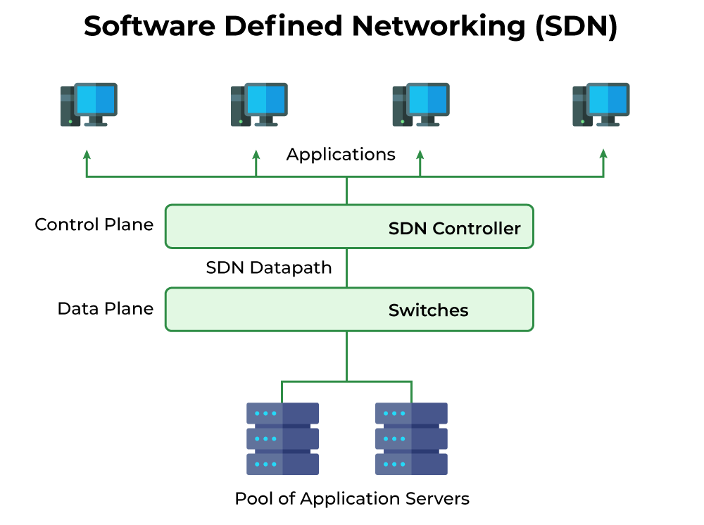
Figure 1: Architecture of Software-Defined Networking (SDN)
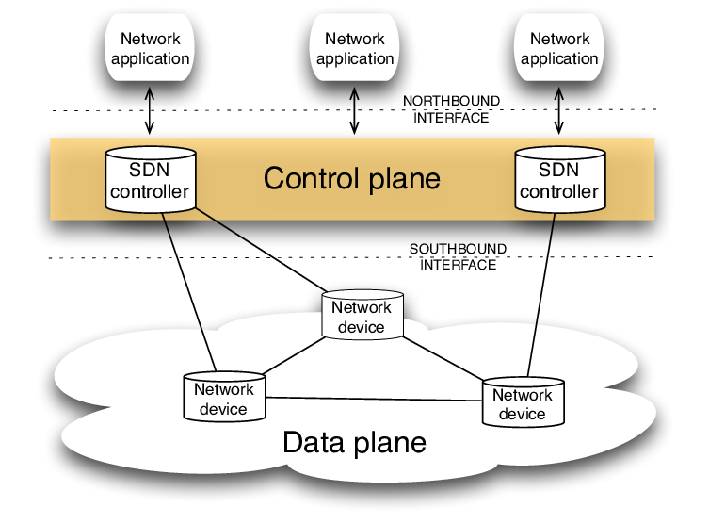
Figure 2: SDN control plane, data plane and northbound/southbound interfaces

5. Literature Review (Research Paper Analysis)
Paper 1: Software-Defined Networking: A Survey
Focus: Overview of SDN concepts and architecture.
Findings: SDN simplifies network management and increases flexibility.
Limitation: Scalability and controller failure issues.
Paper 2: OpenFlow-Based SDN Architecture and Performance Analysis
Focus: Performance evaluation of OpenFlow-enabled networks.
Findings: Improved throughput and dynamic traffic control.
Limitation: Increased controller-switch communication overhead.
Paper 3: Security Challenges in Software-Defined Networking
Focus: Security vulnerabilities and protection mechanisms in SDN.
Findings: Centralized control introduces new attack surfaces.
Limitation: Security mechanisms increase processing overhead.
Paper 4: Scalability and Performance Optimization in SDN Controllers
Focus: Improving controller scalability using distributed architectures.
Findings: Distributed controllers improve reliability and performance.
Limitation: Synchronization complexity between controllers.

6. Comparison with Traditional Networks
Feature | Traditional Network | SDN
Control | Distributed | Centralized
Configuration | Manual | Software-based
Flexibility | Low | High
Scalability | Limited | High

7. Security Issues and Challenges
Despite its advantages, SDN faces several challenges:
- Single point of failure at the controller
- Security threats to controller and communication channels
- Scalability issues in large networks
- Lack of standard security frameworks

8. Future Research Scope
Current research in SDN is focused on:
- AI and Machine Learning-based SDN controllers
- Secure and fault-tolerant SDN architectures
- SDN for 5G/6G and IoT networks
- Large-scale real-world SDN deployments

9 Conclusion
Software-Defined Networking represents a major shift from traditional network design. Research shows that SDN provides improved flexibility, programmability, and efficient network management. However, issues related to security, scalability, and reliability still need attention. Ongoing research efforts aim to overcome these challenges and make SDN a practical solution for future networks.

10. References (IEEE Style)
[1] N. McKeown et al., “OpenFlow: Enabling Innovation in Campus Networks,” IEEE, 2008.
[2] T. Nadeau and K. Gray, SDN: Software Defined Networks, O’Reilly Media.
[3] D. Kreutz et al., “Software-Defined Networking: A Comprehensive Survey,” Proceedings of the IEEE.
[4] S. Scott-Hayward et al., “SDN Security: A Survey,” IEEE Communications Surveys.

