|  |  |  |
| --- | --- | --- |
|  | **ASSIGNMENT 02** |  |
|  | Marks: 10 (CLO-1, PLO-2, C3) |  |

**Supervised Machine Learning**

|  |
| --- |
| Read Carefully:   * This assignment has **FOUR questions** that you have to **answer** and submit on **LMS**. * The deadline for this assignment is *before* or *on* **Sunday November 26, 2023 (12:00 a.m).** * **WARNINGS**:   + This is an individual assignment; you must solve it by yourself. Any form of **plagiarism** will result in receiving zero in the assignment.   + Late submission will not be accepted. Any assignment submitted after the cutoff time will receive zero.   + **Incomplete** assignments will not be accepted and will receive **zero**.   + Do not **alter** the sequence of questions and **illegitimate** **handwriting** is not acceptable. |

**Problem No. 1 (Decision Tree)**

Every year, many people are spending a lot of money and energy on selecting and buying holiday gifts for friends, relatives, and associates. Instead of agonizing over this, one person decided to collect data and construct a decision tree for this. It is a first attempt, so there is room for improvement.

The data are based on last year’s decisions, and the person uses the following attributes and outcome to record the decision for the set of potential recipients Person 1, …, Person 15:

* **Gift-Received** {Great | So-So | Crummy |None}: Did I receive a gift from that person the year before, and how much did I like their gift?
* **Closeness** {Close | Medium | Distant}: How close am I to this person?
* **Gift-Given** {Expensive | Moderate | Cheap | Recycled | None}: What kind of gift did I give them the year before?
* **Still-Alive** {Yes | No}: No point in giving a gift to that great-granduncle who died last spring.
* **Outcome** {Gift | No-Gift}: Suggests what to do this year for that person.

Table 1: Gift dataset

|  |  |  |  |  |  |
| --- | --- | --- | --- | --- | --- |
| **Person** | **Gift-Received** | **Closeness** | **Gift-Given** | **StillAlive** | **Outcome** |
| 1 | None | Close | Expensive | Yes | No-Gift |
| 2 | Great | Distant | None | Yes | No-Gift |
| 3 | Crummy | Close | Recycled | Yes | Gift |
| 4 | So-So | Medium | Moderate | Yes | Gift |
| 5 | Great | Distant | Expensive | No | No-Gift |
| 6 | Crummy | Medium | Expensive | Yes | Gift |
| 7 | Crummy | Close | Recycled | Yes | Gift |
| 8 | None | Distant | None | Yes | No-Gift |
| 9 | Crummy | Distant | None | No | No-Gift |
| 10 | Great | Close | Moderate | Yes | Gift |
| 11 | So-So | Close | Moderate | Yes | Gift |
| 12 | None | Medium | Recycled | No | No-Gift |
| 13 | None | Close | None | Yes | No-Gift |
| 14 | So-So | Distant | Recycled | Yes | Gift |
| 15 | Great | Medium | None | Yes | No-Gift |

1. Calculate the **Entropy** and **Information Gain** value of the attributes.
2. Based on the Information Gain values calculated in question 1, draw a decision tree.
3. Based on your decision tree, what is the predicted outcome? What is yourexplanation for the prediction?.

Table 2: Gift test set

|  |  |  |  |  |  |
| --- | --- | --- | --- | --- | --- |
| **Test Case** | **Gift-Received** | **Closeness** | **Gift-Given** | **StillAlive** | **Outcome** |
| 1 | None | Medium | Recycled | Yes | ? |
| 2 | Great | Close | Expensive | Yes | ? |
| 3 | So-So | Medium | Recycled | Yes | ? |
| 4 | Crummy | Distant | Moderate | Yes | ? |
| 5 | So-So | Distant | Moderate | No | ? |

**Problem No. 2 (Naïve Bayes Classifier)**

Apply the Nave Bayes classifier for the following Pie dataset, in order to determine the class of the following object:

**x= [crust-size = thick, crust-shade = gray, filling-size = thin, filling shade = white, shape = square]**

Table 3: Pie Dataset

|  |  |  |  |  |  |  |
| --- | --- | --- | --- | --- | --- | --- |
| **Example** | **Crust** | | **Filling** | | **Shape** | **Class** |
| **Size** | **Shade** | **Size** | **Shade** |
| Exl | Thick | Gray | Thick | Dark | Circle | Positive |
| Ex2 | Thick | White | Thick | Dark | Circle | Positive |
| Ex3 | Thick | Dark | Thick | Gray | Triangle | Positive |
| Ex4 | Thin | White | Thin | Dark | Circle | Positive |
| Ex5 | Thick | Dark | Thin | White | Square | Positive |
| Ex6 | Thick | White | Thin | Dark | Carcle | Positive |
| Ex7 | Thick | Gray | Thick | White | Circle | Negative |
| Ex8 | Thick | White | Thick | Gray | Square | Negative |
| Ex9 | Thin | Gray | Thin | Dark | Triangle | Negative |
| Ex10 | Thick | Dark | Thick | White | Circle | Negative |
| Ex11 | Thick | White | Thick | Dark | Square | Negative |
| Ex12 | Thick | White | Thick | Gray | Triangle | Negative |

**Problem No. 3 (K-Nearest Neighbour Classifier)**

Please Show the detailed process of using K-Nearest Neighbour Classifier to predict the test instance X = (Spee = 5.20, Weight = 600) is qualified or not, by setting k = 1, 3, 5 respectively.

Table 4: Qualification for race

|  |  |  |  |
| --- | --- | --- | --- |
| **ID** | **Speed** | **Weight** | **Qualified** |
| 1 | 2.50 | 600 | No |
| 2 | 3.75 | 800 | No |
| 3 | 2.25 | 550 | No |
| 4 | 3.25 | 825 | No |
| 5 | 2.75 | 750 | No |
| 6 | 4.50 | 500 | No |
| 7 | 3.50 | 525 | No |
| 8 | 3.00 | 325 | No |
| 9 | 4.00 | 400 | No |
| 10 | 4.25 | 375 | No |
| 11 | 2.00 | 200 | No |
| 12 | 5.00 | 250 | No |
| 13 | 8.25 | 850 | No |
| 14 | 5.75 | 875 | Yes |
| 15 | 4.75 | 625 | Yes |
| 16 | 5.50 | 675 | Yes |
| 17 | 5.25 | 950 | Yes |
| 18 | 7.00 | 425 | Yes |
| 19 | 7.50 | 800 | Yes |
| 20 | 7.25 | 575 | Yes |

**Problem No. 4 (Neural Network)**

Apply backpropagation algorithm to find error for neural network mentioned in the figure. Consider Consider following values for various parameters.

|  |  |
| --- | --- |
| **Input Layer:** | I1 = 1  I2 = 1 |
| **Hidden Layer:** | H1, H2 and H3 |
| **Output Layer:** | O = 0 (Zero) |
| **Connections:** | W1= 0.8, W2 = 0.4, W3 = 0.3  W4 = 0.2 W5 = 0.9 W6 = 0.5  W7 = 0.3 W8 = 0.5 W9 = 0.9 |

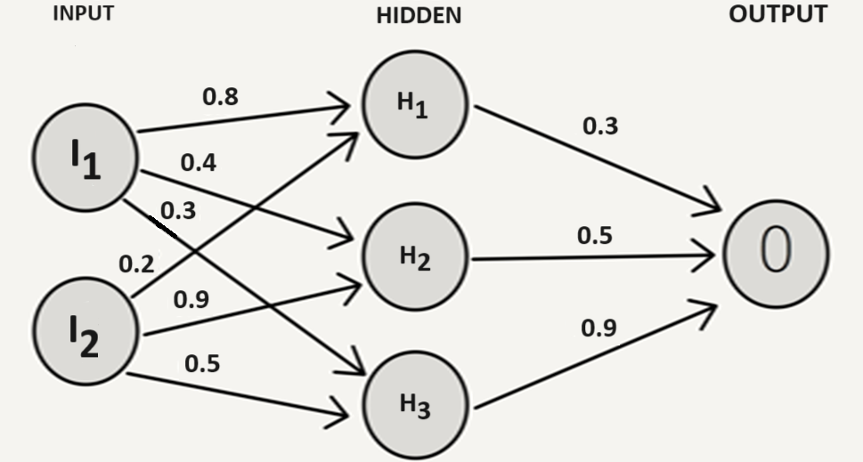

Assume that the neurons have a Sigmoid activation function and

1. Perform a forward pass on the network.
2. Perform a reverse pass (training) once (Target = 0.0).
3. Perform a further forward pass and comment on the result.