**Customers Management System**

Following are the requirements for the Mini Project.

1. First Menu should have options for Binary Search Tree and AVL Tree

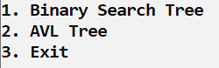

1. On Selecting option 1 or option 2 further sub menu should be to load the data and it loads the data from the CSV file accordingly.

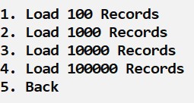

1. On selecting any type of records further sub menu should be

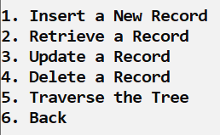

1. If you select option 1 then it takes information of all the fields of a record.

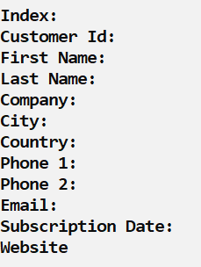

1. If you select option 2, 3, or 4 then it takes information of just the index of the record and performs the operation accordingly.



1. If you select option 5, then it shows further sub menu and performs the operations accordingly.

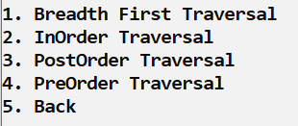

1. On performing any of the CRUD operations you have to print the execution time at the end of each operation. For that you can store the system time at the start of the execution and then again store the system time at the end of the execution of the function. Its difference will give you the execution time.