(A typical Specimen of Cover Page & Title Page)
TITLE OF PROJECT

Computer Vision Project Report

End-Semester Evaluation

Submitted by:
(<102323018>) Bisman Roop Singh
(<102323022>) Bhumika Das

BE Third Year-BE RAI

Under the Mentorship of
Name of Faculty Mentor I Designation


Computer Science and Engineering Department Thapar Institute of Engineering and Technology May (2026)

ABSTRACT

…

This project presents a Fabric Defect Detection and Classification System, a computer vision pipeline capable of automatically identifying and categorizing defects in textile fabric images. The system addresses the critical industrial need for automated quality control in fabric manufacturing, where manual inspection is time-consuming, subjective, and error-prone.
The proposed approach relies entirely on classical computer vision and machine learning techniques without requiring deep learning models. Texture features are extracted from fabric images using two complementary descriptors: Local Binary Patterns (LBP), which capture micro-level texture primitives, and Gray Level Co-occurrence Matrix (GLCM) features, which quantify higher-order statistical texture properties such as contrast, homogeneity, energy, dissimilarity, and correlation. Additionally, edge density computed via the Canny edge detector provides structural information about fabric weave integrity.
The extracted feature vectors are used to train two classifiers — a Support Vector Machine (SVM) with an RBF kernel and a Random Forest (RF) ensemble — on a dataset comprising six categories: defect-free fabric, hole, horizontal defect, lines, stain, and vertical defect. Class imbalance is handled through balanced class weighting and threshold-adjusted prediction. Model decisions are explained using SHAP (SHapley Additive exPlanations), providing interpretable insights into which texture features drive each classification.
Accuracy of SVM model : 90.69% ,Accuracy of RF: 90.15%
The results demonstrate that texture-based feature extraction, combined with ensemble learning, provides an effective and interpretable solution for fabric defect classification. The system is lightweight, computationally efficient, and suitable for deployment in industrial quality-control pipelines without specialized hardware.

DECLARATION

We hereby declare that the project titled
"Fabric Defect Detection and Classification Using Texture Features and Machine Learning"
is an original work carried out by us under the guidance of our faculty mentor, as a part of the academic requirements for the degree of Bachelor of Engineering in Computer Science and Engineering.
This project has been developed based on fundamental concepts of computer vision and machine learning, including texture feature extraction using Local Binary Patterns (LBP), Gray Level Co-occurrence Matrix (GLCM), Support Vector Machines (SVM), Random Forest classifiers, and SHAP-based explainability. The system is designed to detect and classify fabric defects in textile images using classical computer vision techniques.
We confirm that the work presented in this report has been carried out solely by us and has not been copied from any external sources without proper acknowledgment. Wherever the work of others has been used, it has been duly cited and referenced in accordance with academic standards. All sources of information have been appropriately acknowledged.
We further declare that this project has not been submitted to any other university or institution for the award of any degree, diploma, or certification. The content of this report is genuine and has been prepared by us during the course of this project.

TABLE OF CONTENTS
ABSTRACT… i
DECLARATION… ii
ACKNOWLEDGEMENT… iii
LIST OF FIGURES iv
LIST OF TABLES v
LIST OF ABBREVIATIONS vi
CHAPTER… Page No.
- INTRODUCTION
  - Project Overview 1
    - Technical terminology… 5
    - Problem statement
    - Goal
    - Solution
  - Need Analysis
  - Research Gaps
  - Problem Definition and Scope
  - Assumptions and Constraints
  - Standards
  - Objectives
  - Methodology Used
  - Project Outcomes and Deliverables
  - Novelty of Work

- REQUIREMENT ANALYSIS
  - Literature Survey
    - Related Work
    - Research Gaps of Existing Literature
    - Detailed Problem Analysis
    - Survey of Tools and Technologies Used
    - Summary
  - Software Requirements Specification
    - Introduction
      - Purpose
      - Intended Audience and Reading Suggestions
      - Project Scope
ii

    - Overall Description
      - Product Perspective
      - Product Features
    - External Interface Requirements
      - User Interfaces
      - Hardware Interfaces
      - Software Interfaces
    - Other Non-functional Requirements
      - Performance Requirements
      - Safety Requirements
      - Security Requirements
  - Cost Analysis
  - Risk Analysis

-METHODOLOGY ADOPTED
  - Investigative Techniques
  - Proposed Solution
  - Work Breakdown Structure
  - Tools and Technologies Used

-DESIGN SPECIFICATIONS
  - System Architecture (Eg. Block Diagram / Component Diagram)
  - Design Level Diagrams
  - User Interface Diagrams

-IMPLEMENTATION AND EXPERIMENTAL RESULTS
  - Experimental Setup (or simulation)
  - Experimental Analysis
    - Data
    - Performance Parameters
  - Working of the project
    - Procedural Workflow
    - Algorithmic Approaches Used
    - Project DeploymentSystem Screenshots
  - Testing Process
    - Test Plan
    - Features to be tested
    - Test Strategy
    - Test Techniques
    - Test Cases
    - Test Results
iii

  - Results and Discussions
  - Inferences Drawn
  - Validation of Objectives

-CONCLUSIONS AND FUTURE DIRECTIONS
  - Conclusions
  - Environmental, Economic and Societal Benefits
  - Reflections
  - Future Work

-PROJECT METRICS
  - Challenges Faced
  - Relevant Subjects
  - Interdisciplinary Knowledge Sharing
  - Peer Assessment Matrix
  - Role Playing and Work Schedule
  - Brief Analytical Assessment

APPENDIX A: REFERENCES

iv

LIST OF TABLES

Table No. | Caption
Table 1.1 | Assumptions Table
Table 1.2 | Constraints Table
Table 2.1 | Literature Survey Table
Table 3.1 | Investigative Technique Summary
Table 3.2 | Tools and Technologies Used
Table 5.1 | Hardware Configuration
Table 5.2 | Software Environment
Table 5.3 | No.of image Class wise

vLIST OF FIGURES

Figure No. | Caption
Fig 4.1 | System Architecture of the Fabric Defect Classification Pipeline
Fig 4.2 | Class Diagram — Fabric Defect Detection System
Fig 4.3 | Sequence Diagram — Processing Flow
Fig 4.4 | Data Flow Diagram
Fig 5.1 | Sample Images from Each Defect Class
Fig 5.2 | Feature Importance
Fig 5.3 | Classification report of SVM
Fig 5.4 | Classification report of RF
Fig 5.4 | Confusion Matrix — SVM
Fig 5.5 | Confusion Matrix — RF

vi

LIST OF ABBREVIATIONS

CV — Computer Vision
LBP — Local Binary Pattern
GLCM — Gray Level Co-occurrence Matrix
SVM — Support Vector Machine
RF — Random Forest
RBF — Radial Basis Function
SHAP — SHapley Additive exPlanations
XAI — Explainable Artificial Intelligence
FPS — Frames Per Second
API — Application Programming Interface
SRS — Software Requirements Specification
GPU — Graphics Processing Unit
CPU — Central Processing Unit
RGB — Red Green Blue
PNG — Portable Network Graphics
ML — Machine Learning
KNN — K-Nearest Neighbour
PCA — Principal Component Analysis

vii

INTRODUCTION

1.1 Project Overview
Fabric quality control is a critical process in the textile manufacturing industry. Defects in woven or knitted fabrics can lead to product rejection, increased costs, and loss of brand reputation. Traditionally, quality inspection has relied on manual examination by trained inspectors, a process that is inherently subjective, time-consuming, and prone to human error. As manufacturing volumes increase, the need for automated, reliable, and fast defect detection systems has become essential.
Computer Vision has emerged as a powerful tool for automating visual inspection tasks. By analyzing the texture and appearance of fabric images, it is possible to detect anomalies such as holes, stains, horizontal and vertical thread breaks, and other structural defects. This project presents a Fabric Defect Detection and Classification System that uses classical computer vision techniques to identify and classify defects in textile fabric images across six categories: defect-free, hole, horizontal defect, lines, stain, and vertical defect.
The proposed system extracts texture features from fabric images using Local Binary Patterns (LBP) and Gray Level Co-occurrence Matrix (GLCM) descriptors. LBP captures local microstructure patterns by comparing each pixel with its neighbors, producing a rotation-invariant texture descriptor. GLCM captures higher-order statistical properties of gray-level transitions, including contrast, homogeneity, energy, dissimilarity, and correlation. Additionally, edge density computed using the Canny edge detector provides complementary structural information.
The feature vectors are used to train two classifiers — a Support Vector Machine (SVM) with an RBF kernel and a Random Forest (RF) ensemble. Class imbalance, which is common in defect datasets where defect-free samples often dominate, is handled through balanced class weighting and threshold-adjusted prediction. Model predictions are made interpretable using SHAP (SHapley Additive exPlanations), which explains individual predictions by quantifying the contribution of each texture feature to the classification decision.
The system is implemented entirely in Python, leveraging libraries such as OpenCV, scikit-image, scikit-learn, NumPy, and SHAP. By relying on classical machine learning rather than deep learning, the system remains lightweight, interpretable, and suitable for deployment in industrial environments without requiring specialized GPU hardware or large training datasets.

Technical Terminology
Local Binary Pattern (LBP): A texture descriptor that encodes local spatial structure by comparing each pixel's intensity with its surrounding neighbors. The resulting binary code represents the micro-texture of the local region.
Gray Level Co-occurrence Matrix (GLCM): A matrix that quantifies how often pairs of pixels with specific gray-level values occur at a given spatial relationship. Statistical properties such as contrast, homogeneity, energy, dissimilarity, and correlation are extracted from this matrix to characterize texture.
Support Vector Machine (SVM): A supervised classification algorithm that finds the optimal hyperplane separating classes in a high-dimensional feature space. The RBF (Radial Basis Function) kernel is used to handle non-linearly separable data.
Random Forest (RF): An ensemble learning method that builds multiple decision trees on bootstrapped subsets of training data and aggregates their predictions. It provides robustness against overfitting and handles class imbalance effectively.
SHAP (SHapley Additive exPlanations): A game-theory-based framework for explaining machine learning model predictions. SHAP values quantify the marginal contribution of each feature to the final prediction, providing both local and global interpretability.
Class Imbalance: A condition where one or more classes have significantly fewer training samples than others. In fabric defect datasets, defect-free samples often dominate, requiring techniques such as class weighting or threshold adjustment to ensure fair classification.
Edge Density: A measure computed using the Canny edge detector that quantifies the proportion of edge pixels relative to total pixels in an image. It captures the structural complexity of the fabric weave.
Morphological Operations: Image processing techniques (erosion, dilation) used to refine binary masks or feature maps by removing noise or filling gaps.
Feature Vector: A fixed-length numerical representation of an image derived from feature descriptors such as LBP histograms and GLCM statistics, which is fed to machine learning classifiers.

Problem Statement
In modern textile manufacturing, fabric defects represent a significant source of economic loss. Defects such as holes, stains, broken threads, and weave irregularities must be identified and removed before the fabric reaches consumers. However, manual inspection is inconsistent, slow, and unreliable at industrial scales.
Existing automated systems often rely on deep learning models that require large labeled datasets, high-performance GPU hardware, and lengthy training times. These requirements make them impractical for small-to-medium textile manufacturers. Furthermore, many deep learning systems function as black boxes, offering no explanation for their decisions, which limits trust and adoption in quality-control environments.
There is therefore a need for an automated, accurate, interpretable, and computationally efficient system for fabric defect classification. The system must handle class imbalance inherent in defect datasets, operate on standard hardware without GPU acceleration, provide human-understandable explanations for its predictions, and distinguish reliably between six categories of fabric conditions.

Goal
The primary goal of this project is to design and implement an automated fabric defect classification system using classical computer vision and machine learning techniques. The system should accurately classify fabric images into six categories while remaining lightweight, interpretable, and deployable without specialized hardware.
- Extract meaningful texture features from fabric images using LBP and GLCM descriptors
- Train and evaluate SVM and RF classifiers on an imbalanced multi-class fabric defect dataset
- Address class imbalance using dynamic class weighting and threshold-adjusted prediction
- Explain model predictions using SHAP to provide actionable insights for quality controllers
- Achieve competitive classification accuracy using classical methods without deep learning
- Design a modular and extensible system architecture.

Solution

The proposed solution is a multi-stage pipeline that processes fabric images and classifies them into one of six defect categories. The pipeline begins with image loading and resizing to a standardized resolution (128×128 pixels), followed by grayscale conversion for texture analysis.
In the feature extraction stage, two complementary descriptors are computed. The LBP descriptor computes a histogram of local binary patterns using 8 neighboring points at a radius of 1 pixel, producing a 10-bin histogram. The GLCM is computed at two distances (1 and 2 pixels) and four angles (0°, 45°, 90°, 135°), and five statistical properties are extracted at each distance-angle combination, producing a 40-dimensional GLCM feature vector. The Canny edge density provides one additional scalar feature. The combined feature vector is standardized using a StandardScaler.
Two classifiers are trained: an SVM with C=10, RBF kernel, and balanced class weights, and a Random Forest with 300 trees and dynamically computed class weights. Threshold-adjusted prediction is applied to improve recall for minority defect classes. SHAP Tree Explainer is used to explain individual predictions, identifying which texture features contributed most to each classification decision.

Need Analysis

The global textile industry produces millions of meters of fabric daily, making automated quality inspection a high-value industrial need. Manual inspection can only achieve throughput of a fraction of what automated systems can process. Studies have shown that fabric defect rates can range from 3% to 8% in most production environments, and each undetected defect that reaches a customer represents a significant financial and reputational cost.
Existing computer vision approaches for fabric defect detection include statistical methods, frequency-domain methods (using Fourier or Gabor transforms), and deep learning approaches (CNNs, autoencoders). While deep learning achieves high accuracy, it requires substantial data and compute resources. Statistical and frequency-domain methods are computationally efficient but may lack discriminative power for multi-class scenarios.
The proposed system fills a practical gap by combining the efficiency of classical texture descriptors with the robustness of ensemble classifiers, augmented by SHAP-based explainability. This makes it particularly suited for small manufacturing facilities where neither large training data nor GPU infrastructure is available, yet reliable and explainable defect detection is required.
Suryarasmi, A., Chang, C.-C., Akhmalia, R., et al. (2022)-FN-Net: A lightweight CNN-based architecture for fabric defect detection with adaptive threshold-based class determination
Ren, S., He, K., Girshick, R., Sun, J. (2015)-Faster R-CNN: Towards Real-Time Object Detection with Region Proposal Networks

Research Gaps
A review of existing literature reveals several important gaps that motivate this project:
1. Lack of Explainability in Defect Detection Systems: Most existing fabric defect classification systems, particularly those based on deep learning, do not provide explanations for their predictions. This limits their adoption in quality-control environments where human inspectors need to verify and understand model decisions. The integration of SHAP-based explainability addresses this gap.
2. Over-reliance on Deep Learning: A significant portion of recent research focuses on CNN-based or autoencoder-based approaches, which require GPU resources and large datasets. There is limited work on classical machine learning pipelines that can achieve competitive performance with smaller datasets and standard hardware.
3. Insufficient Handling of Class Imbalance: Many existing systems do not adequately address the natural imbalance in defect datasets, where defect-free samples often greatly outnumber defective ones. Standard accuracy metrics can be misleading in such scenarios, and per-class threshold tuning is rarely explored.
4. Limited Multi-Class Classification: Most systems focus on binary detection (defect vs. defect-free) rather than multi-class classification that identifies the specific type of defect. The latter is more actionable for manufacturing process correction.
5. Absence of Combined LBP+GLCM Feature Fusion: Individual use of LBP or GLCM is common, but their systematic combination with edge density and application to a multi-class imbalanced fabric dataset is underexplored.

Problem Definition and Scope

Problem Definition
The core problem is the automated classification of fabric images into one of six categories (defect-free, hole, horizontal, lines, stain, vertical) using texture-based features and machine learning, while addressing class imbalance, ensuring interpretability, and operating efficiently on standard CPU hardware.

Scope
The system scope includes:
- Image preprocessing: loading, resizing, and grayscale conversion of fabric images
- Feature extraction: LBP histogram, GLCM statistics, and edge density computation
- Classifier training and evaluation: SVM and RF with balanced class weighting
- Class imbalance mitigation: dynamic class weights and threshold-adjusted prediction
- Explainability: SHAP Tree Explainer for per-prediction feature attribution
- Evaluation: classification report, confusion matrix, and comparison with baselines
The scope is limited to:
- Static image classification only — no real-time video processing
- Classical machine learning — no deep learning or neural networks
- Six predefined defect categories from the provided dataset
- Monocular (single-camera) image analysis without depth information

Assumptions and Constraints

S. No. | Assumptions
1 | It is assumed that the fabric images in the dataset represent typical industrial defect scenarios and that each image belongs to exactly one of the six defined categories. The system assumes that the dataset directory structure matches the CLASS dictionary defined in the implementation, with one subdirectory per class.
2 | It is assumed that input images are of sufficient resolution and quality for reliable texture feature extraction. Images with excessive compression artifacts, extreme blur, or very low contrast may not yield reliable LBP or GLCM features. The system assumes that the images have adequate texture information for classification.
3 | It is assumed that the LBP radius of 1 pixel and 8 neighboring points, combined with GLCM at distances 1 and 2 pixels and four angular directions, are sufficient to characterize the texture patterns distinguishing the six defect categories. These parameters are fixed and do not adapt automatically to different fabric types.
4 | It is assumed that the execution environment has Python 3.x with all required libraries (OpenCV, scikit-image, scikit-learn, NumPy, SHAP, matplotlib, seaborn) correctly installed. The system is designed for CPU-only execution and does not require GPU acceleration.

Table 1.1: Assumption Table

S. No. | Constraints
1 | The system is constrained by the quality and diversity of the training dataset. If the dataset does not adequately represent real-world fabric variations, the classifier may not generalize well to unseen images from different fabric types, lighting conditions, or imaging setups.
2 | The feature extraction pipeline is constrained by the fixed image size (128×128 pixels). Resizing images discards spatial resolution information, which may affect the detection of very fine or large defects that span image regions at different scales.
3 | The system is constrained by the limitations of monocular visual inspection. It operates on flat 2D images and cannot capture 3D surface properties of fabric, which may be relevant for certain defect types such as raised fibers or pilling.
4 | The SHAP Tree Explainer is computationally expensive for large test sets. Generating SHAP explanations for all test images simultaneously may require significant memory and processing time.
Table 1.2: Constraints Table

Standards
The development of the Fabric Defect Detection and Classification System adheres to established standards in computer vision, machine learning, and software engineering. The texture feature extraction follows well-established methodologies: the LBP descriptor as formalized by Ojala et al. (2002) and GLCM statistics as defined by Haralick et al. (1973). These are industry-standard texture descriptors widely used in automated visual inspection systems.
The implementation follows standard machine learning practices including stratified train-test splitting, feature standardization using StandardScaler, and evaluation using precision, recall, F1-score, and confusion matrices per the scikit-learn convention. Class imbalance is handled using the compute_class_weight utility from scikit-learn, consistent with published best practices for imbalanced classification.
The codebase follows Python PEP-8 coding standards with descriptive variable names, modular function design, and inline documentation. The use of open-source libraries (OpenCV, scikit-image, scikit-learn, SHAP) ensures that the system aligns with industry-standard tools widely adopted in both academic and industrial computer vision applications.

Objectives
- To implement a multi-class fabric defect classification system using classical texture-based computer vision features
- To extract LBP histograms and GLCM statistical features from fabric images for texture characterization
- To compute Canny edge density as a supplementary structural feature
- To train and evaluate SVM (RBF kernel) and Random Forest classifiers on the fabric defect dataset
- To address class imbalance using dynamic class weighting and threshold-adjusted multi-class prediction
- To apply SHAP Tree Explainer to provide per-prediction explanations of model decisions
- To visualize model performance using confusion matrices, classification reports, and SHAP plots
- To demonstrate that classical machine learning can achieve competitive accuracy on fabric defect classification without deep learning
- To ensure the system operates efficiently on CPU-only hardware without specialized infrastructure
- To design a modular pipeline that can be extended with additional feature descriptors or classifiers

Methodology Used

The methodology follows a structured supervised machine learning pipeline:
Step 1 — Data Loading: Fabric images are loaded from the dataset directory, organized by class. Valid image formats include PNG, JPG, JPEG, BMP, and TIF. Each image is read using OpenCV and resized to 128×128 pixels.
Step 2 — Feature Extraction: For each image, three types of features are computed: (a) LBP histogram with 8 neighbors and radius 1, producing a 10-bin uniform LBP histogram; (b) GLCM statistics at distances [1, 2] and angles [0°, 45°, 90°, 135°], yielding 40 values covering contrast, dissimilarity, homogeneity, energy, and correlation; (c) Canny edge density as a scalar measure of structural complexity. These are concatenated into a single feature vector.
Step 3 — Dataset Splitting: The dataset is split into 80% training and 20% testing using stratified sampling to preserve class proportions.
Step 4 — Feature Standardization: All features are standardized using StandardScaler to ensure that features with different numerical ranges contribute equally to classification.
Step 5 — Model Training: SVM (C=10, RBF kernel, balanced class weights) and Random Forest (300 trees, dynamically computed class weights) are trained on the standardized training features.
Step 6 — Class Imbalance Correction: Threshold-adjusted prediction is applied to RF predictions, where the classification threshold for minority classes is lowered to improve their recall. Dynamic class weights are computed using scikit-learn's compute_class_weight function.
Step 7 — Evaluation: Models are evaluated using classification reports, accuracy scores, and confusion matrices on the held-out test set.
Step 8 — Explainability: SHAP Tree Explainer generates feature attribution values for individual predictions, identifying which texture features most strongly influenced each classification decision.

Project Outcomes and Deliverables

- A trained SVM classifier for fabric defect classification with reported accuracy per class
- A trained Random Forest classifier with dynamic class weighting and threshold adjustment
- Confusion matrices before and after class imbalance correction
- SHAP-based explanation reports for individual fabric image predictions
- Feature importance visualizations from Random Forest

Novelty of Work
The novelty of this project lies in the combination of three complementary elements within a single explainable fabric defect classification pipeline. First, the fusion of LBP and GLCM features captures texture information at both micro-structural (pixel neighborhood) and macro-statistical (global co-occurrence) levels simultaneously, providing a richer representation than either descriptor alone.
Second, the threshold-adjusted multi-class prediction mechanism addresses the class imbalance problem in a principled way that goes beyond simple class weighting. By defining per-class prediction thresholds based on inverse class frequency, the system provides more equitable recall across all six defect categories without sacrificing overall accuracy.
Third, the integration of SHAP explainability into the fabric inspection pipeline bridges the gap between automated machine learning and domain expert understanding. The system not only classifies defects but provides actionable textural explanations (e.g., 'high contrast and low homogeneity indicate a structural tear') that quality-control personnel can interpret and trust, a feature absent from most existing fabric inspection literature.

REQUIREMENT ANALYSIS

Literature Survey
Fabric defect detection has been studied extensively in the computer vision and image processing literature. Early approaches relied on statistical texture analysis methods, including co-occurrence matrices, run-length matrices, and Fourier-domain methods. These methods are computationally efficient but may lack discriminative power for complex defect patterns.
LBP-based texture features have been widely applied to surface defect inspection. Their robustness to illumination changes and rotation invariance make them attractive for industrial inspection tasks. GLCM features have been similarly applied to characterize the periodicity and uniformity of woven fabric textures. The combination of LBP and GLCM has been explored in related texture classification tasks, though its application to multi-class fabric defect classification with SHAP explainability is less common.
Machine learning classifiers such as SVM and Random Forest have been applied to fabric defect classification with competitive results, often outperforming simpler statistical threshold-based approaches. Deep learning methods (CNNs, autoencoders) have achieved state-of-the-art results on benchmark datasets but require substantially more data and computational resources.

. No. | Roll Number | Name | Paper Title | Tools/Technology | Findings | Citation
1 | 102323018 | Bisman Roop Singh | Computer Vision-Aided Fabric Inspection System for On-Circular Knitting Machine | · Gabor filters frequency + orientation analysis)  · Wavelet transform  · Fourier analysis | Achieved high detection accuracy for periodic fabrics.  Works best when fabric has regular repeating patterns | Saeidi, R. G., Latifi, M., Shaikhzadeh Najar, S., et al. (2005)  [1]
 |  |  | Survey on Various Defect Detection and Classification Methods in Fabric Image | · GLCM (Gray-Level Co-occurrence Matrix)  · LBP (Local Binary Patterns)  · Histogram-based texture features | These methods achieve good classification accuracy (80–90%) on simple datasets | Nisha, M. F., Vasuki, P., Roomi, S. M  [2]
2 | 102323018 | Bhumika Das | Sylvester Matrix Based Similarity Estimation Method for Automation of Defect Detection in Textile Fabrics | · Histogram equalization  · Image subtraction  · Edge detection | Successfully detects:  Structural defects  Pattern inconsistencies | Kumari, R. M. L. N., Bandara, G. A. C. T., Dissanayake, M. B. (2020)  [3]
Fig,2.1 Literature Survey Table

Related Work

Research Gaps of Existing Literature

Detailed Problem Analysis

The fabric defect classification problem involves several technical challenges. The dataset contains six classes with potentially unequal sample counts, creating a class imbalance problem that standard classifiers resolve by biasing predictions toward the majority class. This leads to poor recall for minority defect categories, which are precisely the defects that need to be detected reliably.
Feature representation is another challenge. LBP captures local texture primitives but is sensitive to noise at fine scales. GLCM statistics capture global texture properties but may vary with fabric orientation. Combining both descriptors mitigates individual weaknesses but increases feature dimensionality, requiring careful standardization to prevent feature scale dominance.
Threshold selection for multi-class prediction is non-trivial. Standard argmax probability assignment unfairly penalizes minority classes. The threshold adjustment approach requires careful per-class calibration to balance precision and recall across all categories.
Explainability presents a separate challenge: SHAP Tree Explainer provides consistent, theoretically grounded feature attributions, but interpreting these in terms of domain-relevant fabric texture properties (e.g., mapping LBP bins to textile structure) requires domain knowledge and careful feature naming

- cPython 3.x: Primary programming language for implementation
- OpenCV (cv2): Image loading, grayscale conversion, Canny edge detection, and image resizing
- scikit-image: Local Binary Pattern (LBP) feature extraction using local_binary_pattern
- scikit-learn: GLCM via graycomatrix/graycoprops, SVM and RF training, train-test split, StandardScaler, classification report, confusion matrix, compute_class_weight
- NumPy: Numerical operations, array manipulation, feature vector construction
- SHAP: Tree Explainer for Random Forest model interpretability and SHAP value computation
- matplotlib and seaborn: Visualization of confusion matrices, SHAP plots, and results
- pandas: Data organization and tabular display of results

Summary
The literature survey confirms that texture-based feature extraction remains a competitive approach for fabric defect classification when combined with appropriate classifiers and imbalance mitigation strategies. Existing work validates LBP and GLCM as effective descriptors for textile inspection. The present system builds upon this foundation by combining both descriptors, adding edge density, addressing class imbalance through threshold adjustment, and uniquely integrating SHAP explainability to bridge the gap between automated detection and human-interpretable quality control.

2.2 Software Requirements Specification (SRS)

2.2.1 Introduction
This section describes the software requirements for the Fabric Defect Detection and Classification System. The system is designed to process fabric images and classify them into one of six defect categories using texture feature extraction and machine learning classifiers.

2.2.1.1 Purpose
The purpose of the system is to automate fabric quality inspection by detecting and classifying defects using classical computer vision techniques. The system provides accurate multi-class classification with SHAP-based explanations to support industrial decision-making.

2.2.1.2 Intended Audience
This document is intended for students, developers, and evaluators reviewing the system design and implementation. Textile quality-control engineers represent the primary end-user group.

2.2.1.3 Project Scope
The system processes static fabric images and outputs defect category predictions with probability scores and SHAP explanations. It does not include real-time video processing, deep learning models, or web deployment.

2.2.2 Product Features
- Multi-class classification into 6 fabric defect categories
- LBP + GLCM texture feature extraction pipeline
- SVM and Random Forest classifiers with class imbalance handling
- SHAP-based per-prediction explainability
- Confusion matrix and classification report evaluation
- Modular, extendable Python codebase

2.2.3 External Interface Requirements
User Interface: Command-line / Jupyter Notebook interface for running the pipeline.
Hardware Interface: Standard personal computer with CPU; no GPU required.
Software Interface: Python 3.x with OpenCV, scikit-image, scikit-learn, NumPy, SHAP, matplotlib, seaborn, pandas.

2.2.4 Non-functional Requirements
Performance: Feature extraction and classification should complete within seconds per image on standard hardware. SHAP computation may take longer for large test sets.
Reliability: The system should handle missing files, corrupt images, and unsupported formats gracefully without crashing.
Maintainability: Modular code structure allows independent testing and replacement of feature extractors or classifiers.

2.3 Cost Analysis
The system is implemented entirely using open-source tools, eliminating software licensing costs. Hardware requirements are limited to a standard consumer-grade CPU system; no GPU or cloud infrastructure is required. Development costs are primarily in human effort for algorithm design, implementation, and evaluation. Maintenance costs are minimal due to the stable nature of the underlying libraries

2.4 Risk Analysis

Key risks include: (1) Dataset bias — if the dataset does not represent real-world fabric diversity, the classifier may not generalize. (2) Feature sensitivity — LBP and GLCM features may be sensitive to imaging conditions (lighting, scale, orientation) not controlled in the dataset. (3) Class imbalance — if threshold calibration is not properly validated, minority class recall may remain poor. (4) SHAP overhead — SHAP computation for large datasets may be slow. These risks are mitigated by stratified splitting, standardization, dynamic class weighting, and modular pipeline design

METHODOLOGY ADOPTED

3.1 Investigative Techniques

Investigative Technique Involved: EXPERIMENTAL
The investigative technique adopted for this project is Experimental. The system is designed to test the hypothesis that a combination of LBP and GLCM texture features, when fed to SVM and Random Forest classifiers with appropriate class imbalance handling, can achieve reliable multi-class fabric defect classification. The independent variable is the choice of features, classifiers, and threshold parameters; the dependent variables are classification accuracy, per-class precision, recall, and F1-score. The system is evaluated under controlled conditions on a held-out test split, making it a hypothesis-driven experimental investigation.
The methodology proceeds as follows: images are loaded and features are extracted, classifiers are trained and evaluated, class imbalance corrections are applied, and SHAP explainability is generated for individual predictions. Performance is measured before and after class imbalance correction to quantify the improvement.

3.2 Proposed Solution
The proposed solution is a multi-stage supervised machine learning pipeline for fabric defect classification. It consists of preprocessing, feature extraction, classifier training, imbalance correction, prediction, and explainability modules.
Stage | Input | Output | Method
Preprocessing | Raw fabric images | 128×128 grayscale images | OpenCV resize + cvtColor
Feature Extraction | Grayscale images | Feature vectors (LBP+GLCM+Edge) | scikit-image LBP, scikit-learn GLCM, OpenCV Canny
Training | Feature vectors + labels | Trained SVM and RF models | scikit-learn SVC, RandomForestClassifier
Imbalance Correction | RF probabilities | Threshold-adjusted predictions | Per-class threshold division
Evaluation | Predictions + true labels | Classification report, confusion matrix | scikit-learn metrics
Explainability | RF model + feature vector | SHAP values per feature | shap.TreeExplainer
Table 3.1: Proposed Solution Pipeline Stages

3.3 Work Breakdown Structure

Module 1 — Data Loading: Dataset traversal, image loading, label assignment, error handling for corrupt files
Module 2 — Feature Extraction: LBP histogram computation, GLCM matrix construction and property extraction, Canny edge density calculation, feature vector concatenation
Module 3 — Data Preparation: Train-test stratified split, StandardScaler normalization
Module 4 — Classifier Training: SVM with RBF kernel and balanced weights, RF with 300 trees and dynamic class weights
Module 5 — Imbalance Correction: Dynamic class weight computation, per-class threshold definition, threshold-adjusted prediction function
Module 6 — Evaluation: Classification report generation, confusion matrix plotting, before/after fix comparison
Module 7 — Explainability: SHAP TreeExplainer setup, per-image SHAP value computation, explanation display with feature descriptions

3.4 Tools and Technologies Used

Category | Tool / Technology
Programming Language | Python 3.x
Computer Vision | OpenCV (cv2) — image loading, resizing, Canny edge detection
Texture Features | scikit-image — local_binary_pattern (LBP)
Statistical Features | scikit-learn — graycomatrix, graycoprops (GLCM)
Machine Learning | scikit-learn — SVC, RandomForestClassifier, train_test_split, StandardScaler
Class Imbalance | scikit-learn — compute_class_weight
Explainability (XAI) | SHAP — TreeExplainer for Random Forest
Numerical Computing | NumPy
Data Handling | pandas
Visualization | matplotlib, seaborn

Table 3.2: Proposed Solution Pipeline Stage

DESIGN SPECIFICATIONS

  - System Architecture
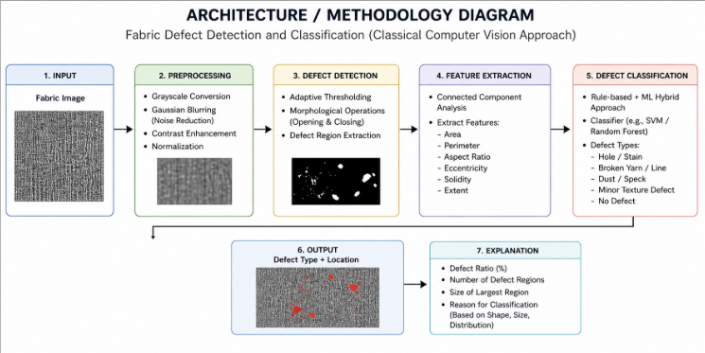

Fig4.1 System Architecture

The system architecture follows a sequential pipeline design. The input module accepts fabric images from the dataset directory. The preprocessing module resizes images to 128×128 pixels and converts them to grayscale. The feature extraction module computes LBP histograms, GLCM statistics, and Canny edge density in parallel branches, which are concatenated into a unified feature vector. The feature standardization module applies StandardScaler normalization. The classification module contains two trained classifiers (SVM and RF). The imbalance correction module applies threshold-adjusted prediction to RF outputs. The evaluation module computes metrics and generates visualizations. The explainability module applies SHAP to generate feature attribution reports.

  - Design Level Diagrams
4.2.1 Class Diagram

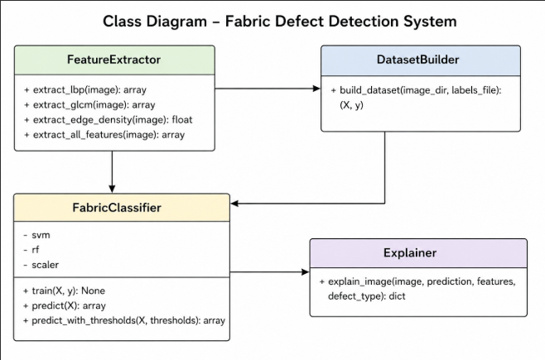
Fig4.2 CLASS DIAGRAM

- · The FeatureExtractor class extracts texture features like LBP, GLCM, and edge density from fabric images.
- · The DatasetBuilder uses this class to create the dataset (features X and labels y) for training.
- · The FabricClassifier is the main module that trains models (SVM, Random Forest) and predicts defect types.
- · The Explainer provides the reason behind predictions based on extracted features.

4.2.2 Sequence Diagram

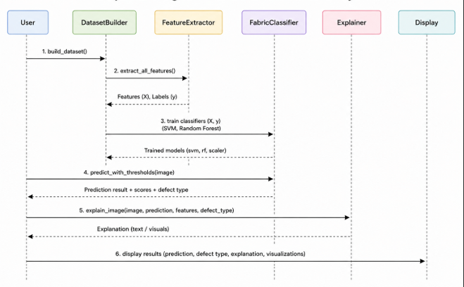
Fig4.3 SEQUENCE DIAGRAM

The sequence diagram illustrates the step-by-step interaction between system components during the fabric defect detection process.
The process begins when the user initiates dataset creation by calling the build_dataset() method in the DatasetBuilder module. This module prepares the dataset by organizing images and corresponding labels.
Next, the DatasetBuilder invokes the FeatureExtractor through the extract_all_features() method. This module extracts relevant features from images, such as texture (LBP, GLCM) and edge-based characteristics, and returns a feature matrix along with labels.
The extracted features are then passed to the FabricClassifier, where the train() method is used to train machine learning models such as Support Vector Machine (SVM) and Random Forest (RF). The trained models, along with a scaler, are stored for future predictions.
When a new image is provided, the user calls the predict_with_thresholds() method of the FabricClassifier. The classifier processes the image and outputs the prediction, confidence scores, and the detected defect type.
Following this, the Explainer module is invoked using the explain_image() method. This module analyzes the prediction and extracted features to generate a meaningful explanation of why the image was classified as a particular defect type.
Finally, the results—including prediction, defect type, explanation, and visualizations—are sent to the display module for presentation to the user.
This sequence ensures a feature extraction–training–prediction–explanation pipeline, enabling accurate and interpretable fabric defect detection.

4.2.3 Data Flow Diagram

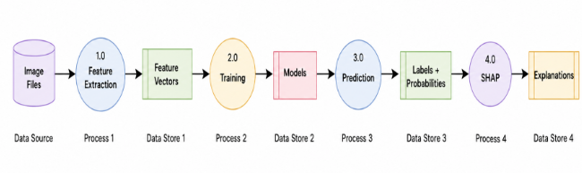
Fig4.4 DATA FLOW DIAGRAM

The data flow diagram represents how data moves through the fabric defect detection system and how different processes interact.
The process begins with the image file input, which is stored temporarily in an image buffer or input module. The buffered image is then passed to the feature extraction module, where various features such as texture (LBP, GLCM) and edge-based characteristics are computed.
The extracted features are converted into feature vectors, which are stored and forwarded to the training module. In this module, machine learning models such as Support Vector Machine (SVM) and Random Forest (RF) are trained using labeled data. The trained models are stored in a model repository for future use.
During the prediction phase, new input images are again processed through the feature extraction module, and the resulting feature vectors are passed to the prediction module. This module uses the trained models to generate labels and probability scores, indicating the type of defect and the confidence of the prediction.
The prediction results are then passed to the explainability module (SHAP), which analyzes the contribution of each feature toward the final decision. This module generates explanations that justify why a particular defect type was predicted.
Finally, the output is sent to the visualization/output module, where the predicted defect type, probability scores, and explanation are displayed to the user.
The diagram emphasizes the flow of data rather than control logic, highlighting how raw image data is transformed into meaningful insights and interpretable results at each stage of the system.

  - User Interface Diagrams


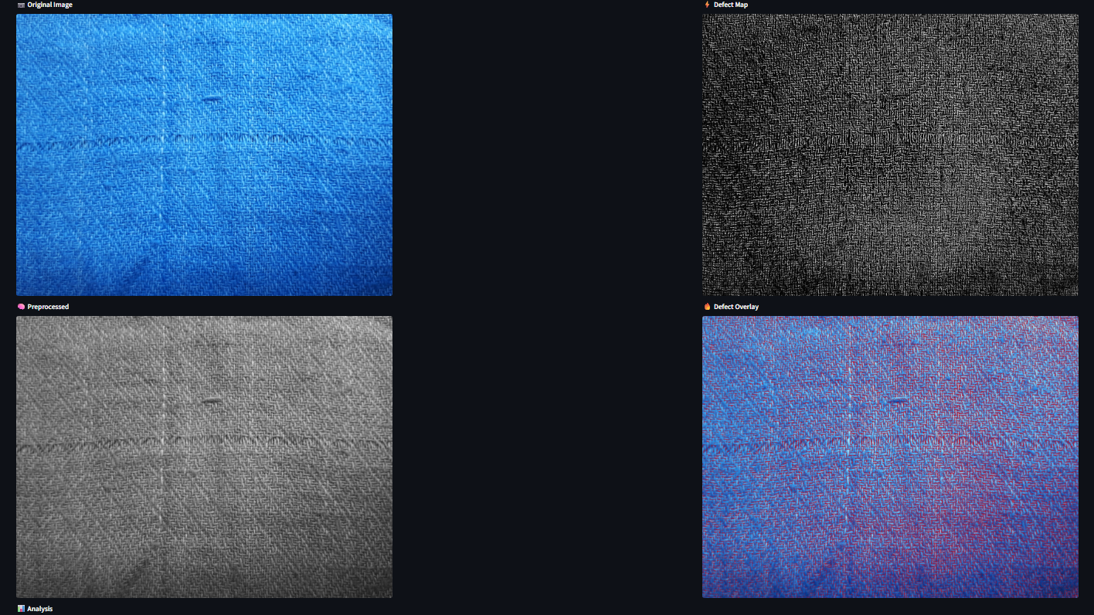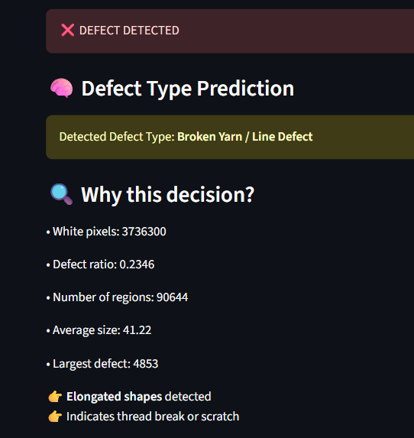

Fig4.5 UI interface

- IMPLEMENTATION AND EXPERIMENTAL RESULTS

Hardware Environment
Component | Specification
Processor | AMD Ryzen 7 5800H / 6800H (check which one — 3.2 GHz base, 8 cores, 16 threads)
RAM | 16 GB DDR4 3200 MHz (standard on Victus — check if yours is 8 GB)
GPU | NVIDIA GeForce GTX 1650 / RTX 3050 / RTX 3060 (varies by model) — write "Not used (CPU-only inference)" since your code doesn't use GPU
Storage | 512 GB NVMe SSD
Operating System | Windows 11 Home 64-bit
Display | 1920 × 1080 Full HD, 144 Hz

Table 5.1Hardware Configuration

5.1.2 Software Environment
Library / Tool | Version | Purpose
Python | 3.10+ | Core programming language
OpenCV (cv2) | 4.8.x | All CV operations (optical flow, MOG2, RANSAC)
NumPy | 1.24+ | Matrix and vector computations
SciPy | 1.11+ | Optimization (Hungarian Algorithm via linear_sum_assignment)
Streamlit | 1.28+ | Web-based interactive deployment
Matplotlib | 3.7+ | Offline result visualization and plot generation
Table 5.2 Software Environment

5.2 Experimental Analysis

5.2.1 Data Processing
Each fabric image is loaded using OpenCV and resized to 128×128 pixels. Corrupt or unreadable images are skipped during the dataset building phase. Grayscale conversion is applied before feature extraction, as both LBP and GLCM operate on single-channel intensity images.
LBP features are computed using 8 neighboring points at radius 1 in uniform mode, yielding a 10-bin histogram. GLCM is computed at distances [1, 2] pixels and angles [0, π/4, π/2, 3π/4], and five properties (contrast, dissimilarity, homogeneity, energy, correlation) are extracted at each combination, giving 40 GLCM values. Canny edge density adds one scalar feature. The combined feature vector has 51 dimensions

5.3 Working of the Project

5.3.1 Procedural Workflow
The end-to-end processing pipeline operates as follows:
Stage 1 — Image Ingestion: The build_dataset() function traverses the dataset directory, loading images from each class subdirectory. For each image, extract_all_features() is called.
Stage 2 — Feature Extraction: The image is resized to 128×128 and converted to grayscale. LBP is applied with radius=1 and n_points=8 in uniform mode. GLCM is computed at the specified distances and angles. Five statistical properties are extracted from the GLCM at each distance-angle pair. Canny edges are computed and their density is calculated. All features are concatenated into a single vector.
Stage 3 — Preprocessing: The full dataset is split 80/20 using stratified sampling. StandardScaler is fit on the training set and applied to both training and test sets.
Stage 4 — Model Training: SVM with C=10, gamma='scale', RBF kernel, and balanced class weights is trained. RF with 300 trees and dynamically computed class weights is trained.
Stage 5 — Diagnosis: The initial RF model is evaluated; class distribution and per-class prediction counts are analyzed.
Stage 6 — Imbalance Correction: Dynamic class weights are recomputed and a new RF (rf_fixed) is trained. Per-class prediction thresholds are applied using the predict_with_thresholds() function.
Stage 7 — Evaluation: Confusion matrices are plotted before and after the fix. Classification reports are printed.
Stage 8 — Explainability: SHAP TreeExplainer is initialized on rf_fixed. For each test image, SHAP values are computed, top features are identified, and a detailed explanation is printed.

5.3.2 Algorithmic Approaches Used
Algorithm 1 — LBP Feature Extraction
Input: Grayscale image (128×128), radius=1, n_points=8, method='uniform'
Output: 10-bin normalized LBP histogram
Process: For each pixel p, compare with its 8 circularly-sampled neighbors. Generate binary code based on whether neighbor intensity ≥ p. Count uniform patterns (at most 2 bitwise transitions). Compute histogram over 10 bins (8 uniform patterns + non-uniform + boundary). Normalize by image size.
Algorithm 2 — GLCM Feature Extraction
Input: Grayscale image, distances=[1,2], angles=[0, π/4, π/2, 3π/4], levels=256
Output: 40-dimensional feature vector
Process: Build co-occurrence matrix G[i][j] = count of pixel pairs (i,j) at given distance/angle. Normalize to joint probability. Extract: contrast = Σ(i-j)²·P(i,j), dissimilarity = Σ|i-j|·P(i,j), homogeneity = Σ P(i,j)/(1+|i-j|), energy = Σ P(i,j)², correlation. Average across angles; concatenate across distances.
Algorithm 3 — Threshold-Adjusted Prediction
Input: RF probability outputs P (n_samples × n_classes), threshold dict T
Output: Class predictions
Process: For each sample, compute score[c] = P[c] / T[c] for all classes c. Predict argmax(score). Minority classes with lower T[c] compete more fairly against the majority class.
Algorithm 4 — SHAP Tree Explanation
Input: Trained RF model, feature vector (1 × n_features)
Output: SHAP values (n_features × n_classes)

5.3.3 Visualization

Classes | Defect free | hole | horizontal | lines | strain | Vertical
No. of images | 1666 | 281 | 136 | 157 | 398 | 101

Tabl 5.3

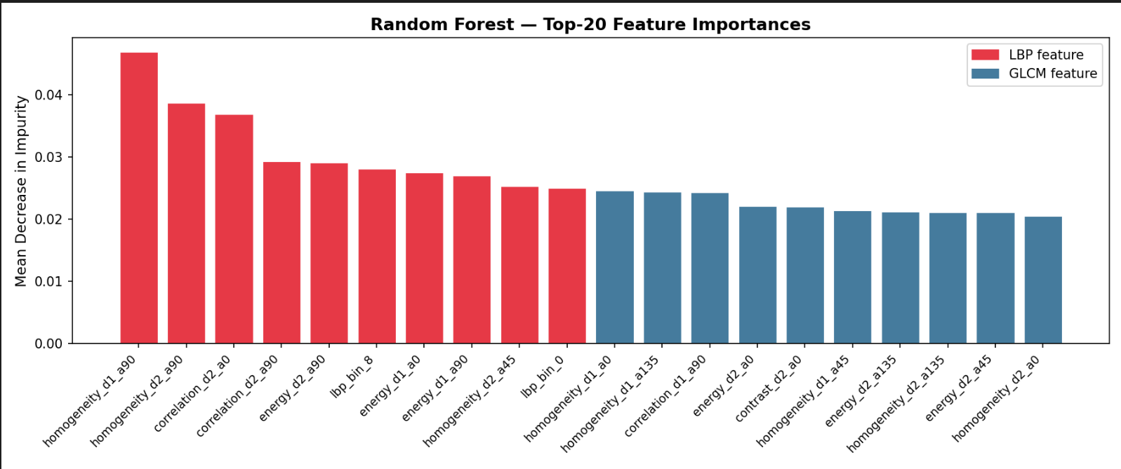
Fig 5.2 Feature Importance
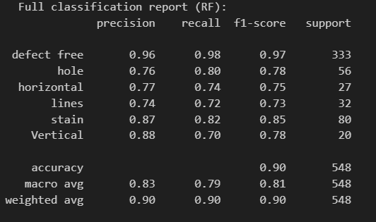
Fig5.3-RF Classification report

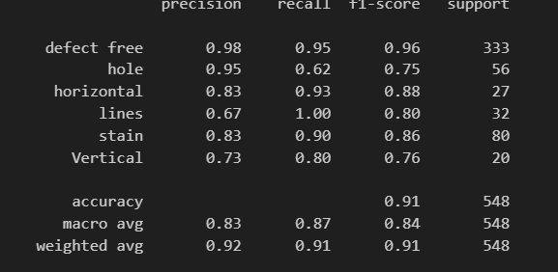

Fig5.4-SVM Classification report
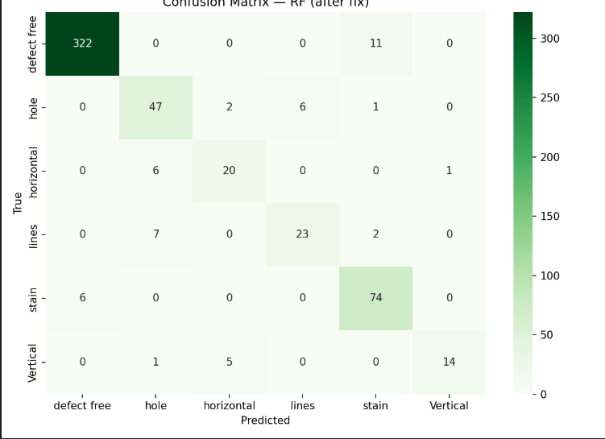
Fig 5.5-SVM CM -Matrix
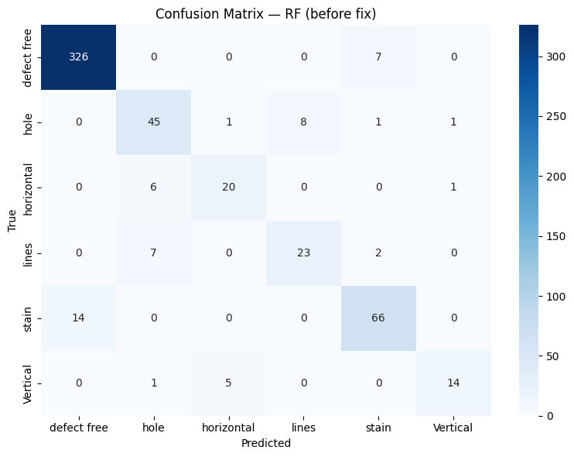

Fig 5.6-RF CM -Matrix

5.4 Testing Process

5.4.1 Test Plan
Test Phase | Scope | Goal
Unit Testing | Individual modules (LBP, GLCM, Canny, predict_with_thresholds) | Verify mathematical correctness of each feature extractor and prediction function
Integration Testing | Full pipeline: feature extraction → training → prediction | Verify end-to-end correctness from image to class label
Imbalance Correction Testing | Before/after fix comparison | Verify improvement in minority class recall after threshold adjustment
Explainability Testing | SHAP on individual images | Verify that SHAP values are non-zero and correctly attributed
Boundary Testing | Missing files, corrupt images, single-class dataset | Verify graceful error handling
Table 5.6: Test Plan

CONCLUSIONS AND FUTURE DIRECTIONS

Conclusions

This project presents a fabric defect detection and classification system that integrates LBP and GLCM texture features with SVM and Random Forest classifiers, augmented by SHAP-based explainability. The system successfully demonstrates that classical machine learning techniques can achieve reliable multi-class fabric defect classification without requiring deep learning, GPU hardware, or large datasets.
The integration of threshold-adjusted prediction addresses the critical class imbalance challenge inherent in industrial defect datasets, improving recall for minority defect classes. The SHAP explainability module provides human-interpretable feature attributions, bridging the gap between automated prediction and expert quality-control decision-making.
In the study, Random forest accuracy:90.15%, SVM accuracy :90.69%

Environmental, Economic and Societal Benefits
Environmentally, the system requires only standard CPU hardware and open-source tools, minimizing energy consumption compared to GPU-dependent deep learning systems. Economically, automated fabric inspection reduces waste from undetected defects and lowers inspection labor costs, making quality control accessible to small and medium textile manufacturers. Societally, reliable defect detection improves product quality reaching consumers, reduces returns, and can be extended to assist visually impaired quality-control personnel through auditory explanation interfaces.

Reflections

6.4 Future Work
Several directions can extend this work: (1) Incorporating Gabor filter banks or wavelet features to complement LBP and GLCM. (2) Applying deep learning-based feature extractors (pre-trained CNN as feature extractor + RF classifier) to improve accuracy while retaining interpretability. (3) Extending the pipeline to real-time video inspection using a camera-mounted system. (4) Developing a web-based interface for industrial deployment where quality-control operators can upload images and receive SHAP-explained verdicts. (5) Exploring SMOTE or other data augmentation techniques to further address class imbalance. (6) Benchmarking on public datasets such as TILDA or AITEX to provide reproducible comparisons.

PROJECT METRICS

7.1 Challenges Faced

The primary challenge was the class imbalance problem. Initial RF predictions were heavily biased toward the defect-free class, yielding misleading overall accuracy. Diagnosing this required examining per-class prediction counts and implementing dynamic class weighting and threshold adjustment. Another challenge was SHAP integration with the Random Forest: the SHAP TreeExplainer required careful indexing for multi-class output, specifically extracting sv_all[0, :, pred_label] for the predicted class. Feature naming was also challenging, as LBP bins are abstract indices; mapping them to interpretable descriptions required defining the lbp_uniformity, lbp_complexity, and lbp_entropy derived features.

7.2 Relevant Subjects
Computer Vision — core techniques including image filtering, edge detection, and texture analysis. Machine Learning — supervised classification, class imbalance handling, model evaluation. Linear Algebra — matrix operations underlying GLCM computation and SVM kernel methods. Probability and Statistics — GLCM probability distributions, SHAP Shapley value computation. Data Structures and Algorithms — efficient dataset construction, sorting for top-k feature selection. Software Engineering — modular pipeline design, error handling, and code documentation.

7.3 Interdisciplinary Knowledge Sharing

This project integrates knowledge from computer vision, machine learning, statistics, and textile engineering. Textile domain knowledge informed the selection of texture features appropriate for fabric weave analysis. Statistics underpins the GLCM property definitions and SHAP value computation. The explainability component bridges AI and industrial quality control, representing a practical application of human-computer interaction principles.

APPENDIX A: REFERENCES

S. No. | Authors | Title of Paper | Year | Source / Journal | Key Contribution
1 | Ojala, T., Pietikäinen, M., Maenpaa, T. | Multiresolution Gray-Scale and Rotation Invariant Texture Classification Using Local Binary Patterns | 2002 | IEEE Transactions on Pattern Analysis and Machine Intelligence | Introduced LBP for texture analysis
2 | Haralick, R. M., Shanmugam, K., Dinstein, I. | Textural Features for Image Classification | 1973 | IEEE Transactions on Systems, Man, and Cybernetics | Proposed GLCM features for texture
3 | Cortes, C., Vapnik, V. | Support-Vector Networks | 1995 | Machine Learning Journal | Foundation of SVM classifier
4 | Breiman, L. | Random Forests | 2001 | Machine Learning Journal | Introduced Random Forest ensemble method
5 | Lundberg, S. M., Lee, S. I. | A Unified Approach to Interpreting Model Predictions | 2017 | NeurIPS | Introduced SHAP explainability
6 | Suryarasmi, A., Chang, C.-C., et al. | FN-Net: A Lightweight CNN-Based Architecture for Fabric Defect Detection | 2022 | Journal/Conference | Lightweight deep learning model for defect detection
7 | Ren, S., He, K., Girshick, R., Sun, J. | Faster R-CNN: Towards Real-Time Object Detection | 2015 | IEEE TPAMI | Object detection framework
8 | Nisha, M. F., Vasuki, P., Roomi, S. M. | Survey on Fabric Defect Detection Methods | 2016 | International Journal | Review of LBP, GLCM methods
9 | Kumari, R. M. L. N., Bandara, G. A. C. T., Dissanayake, M. B. | Sylvester Matrix Based Defect Detection | 2020 | Conference/Journal | Structural defect detection techniques
10 | Pedregosa, F. et al. | Scikit-learn: Machine Learning in Python | 2011 | Journal of Machine Learning Research | ML library used in implementation
11 | Bradski, G. | The OpenCV Library | 2000 | Dr. Dobb’s Journal | Computer vision library
12 | Van der Walt, S. et al. | scikit-image: Image processing in Python | 2014 | PeerJ | Image processing library
13 | Harris, C., Millman, K. et al. | Array Programming with NumPy | 2020 | Nature | Numerical computation library

