Ello. this paper is in English, because it's easier to write it that way.

Here I need your input on which method of displaying the numbers will we use. I think using a lcd with a backlight will look good but normal led 7 segments are also possible.

Here I found different layouts of lcds. All of them are from Display Elektronik supplied through tme.

First, lcds are made in 3 variants  
- transmissive - needs a backlight  
- reflective - needs external light (ex. sunlight)  
- transflective - best of both worlds

Transmissive (M)

* Wide viewing angles
* Good visibility in the dark
* Bad in bright places
* Needs a backlight

Reflective (R)

* Like transmissive but has a mirror behind it (basically)
* Good in bright places
* Narrow viewing angle

Transflective (T)

* Like reflective but the “mirror” can have a backlight
* Has the positive features of the two other ones

These lcds also have a standard (S) or highstable (U) polarizer. I didn’t find what that means, but I guess that the display needs pull-ups. These should work on either 3 or 5V

First the “ctd & ctu” project

We need to display 5 numbers in this layout:  
8:88.88

1st digit will display minutes, the 2nd and 3rd are for seconds, and the last 2 are for milliseconds.

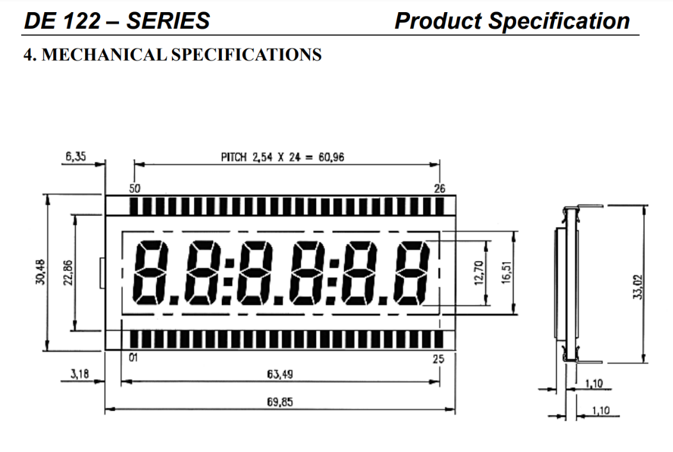I found these display series that could work

DE 122

- character height is 12.70mm

- RS; TU

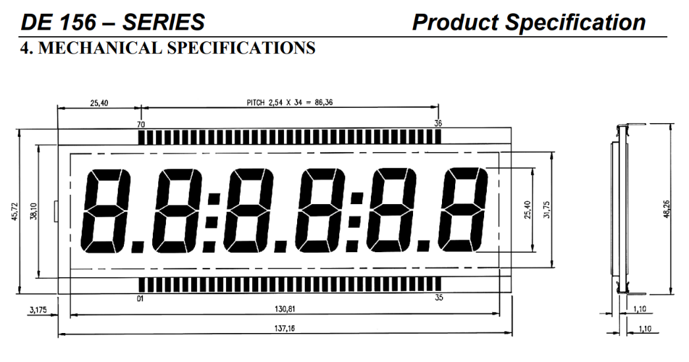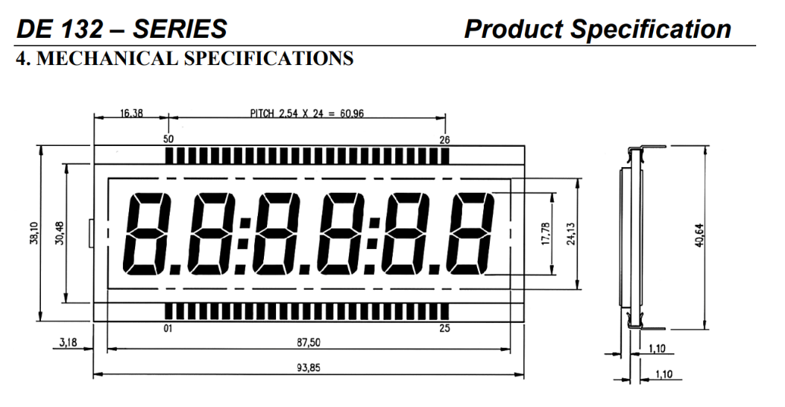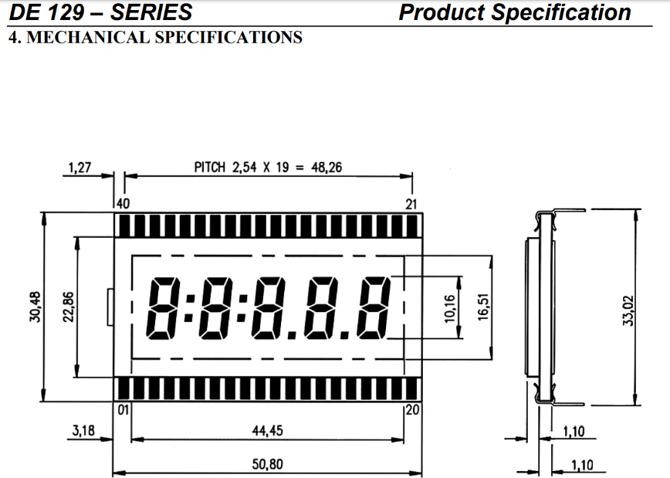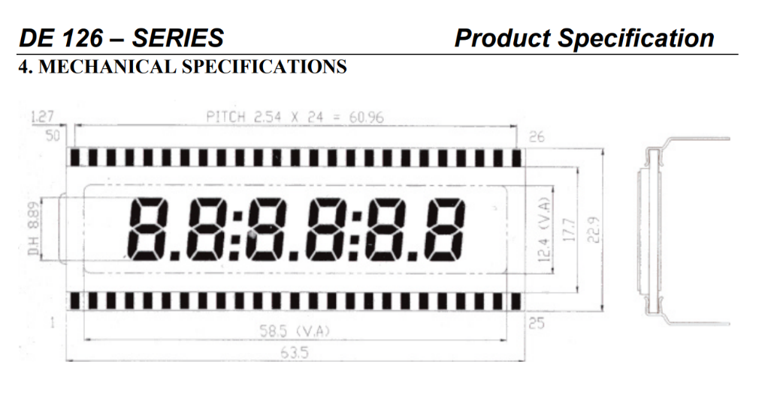

DE 156

- character height is 25.40mm

- RU, TU

DE 132

- character height is 17.78mm

- RS

DE 129

- character height is 10.16mm

- RS

DE 126

- character height is 8.89mm

- RS

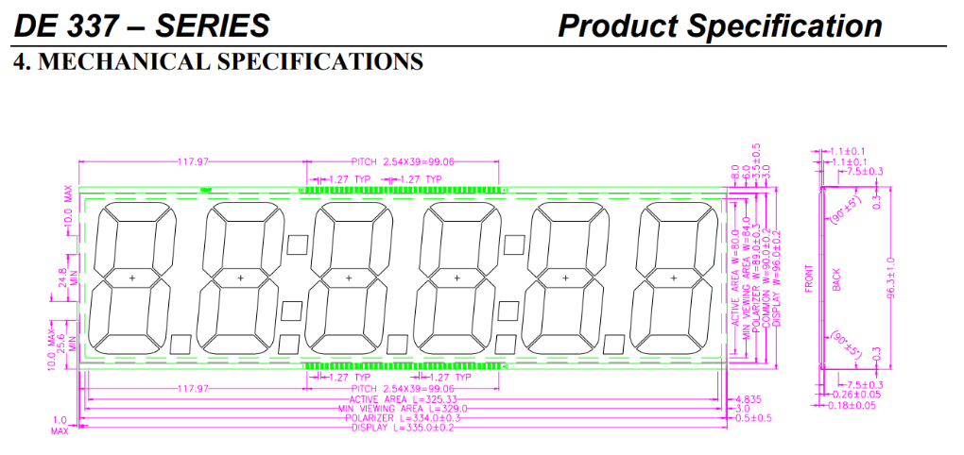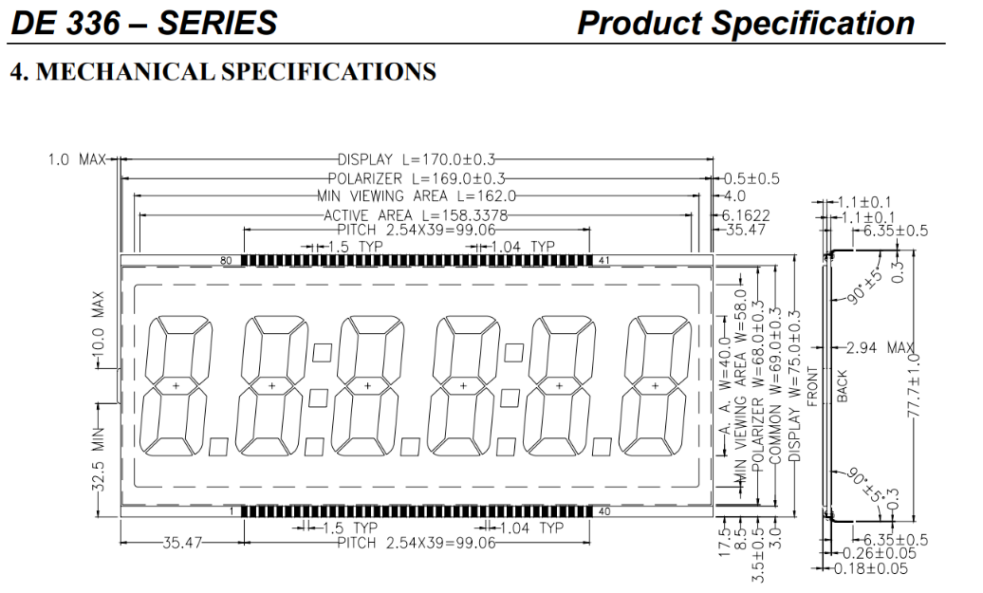I would probably use the DE 156 TU (13.20usd) or the DE 336 TU (special orders only)

DE 337

- character height is 80.0mm

- RU, TU

DE 336

- character height is 40.0mm

- RU, TU

Second the “ctu button” project

This needs either 2 displays or all numbers on one:  
88.88 888

Seconds and millis, and the count. 3 digits are maybe a bit overkill but it works out nicely to 8 chars with one to spare as a separator

DE 124

- character height is 6.00mm

- RS

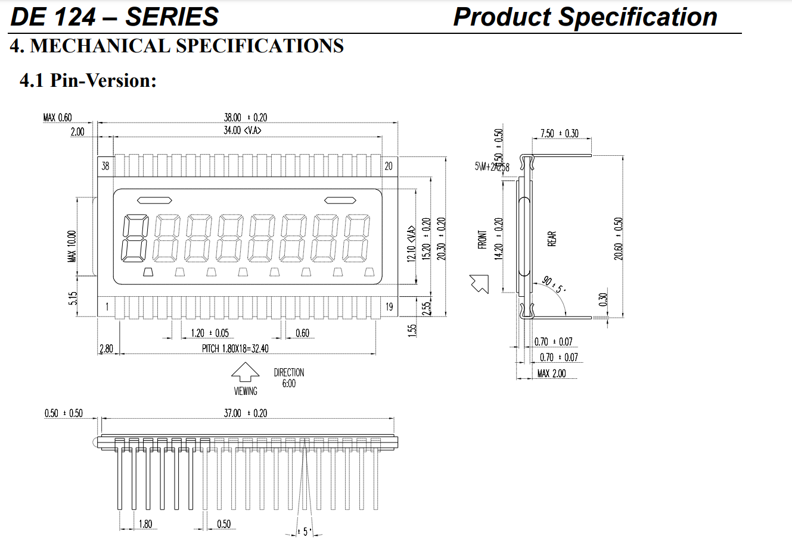I think that the right choice would be just one display

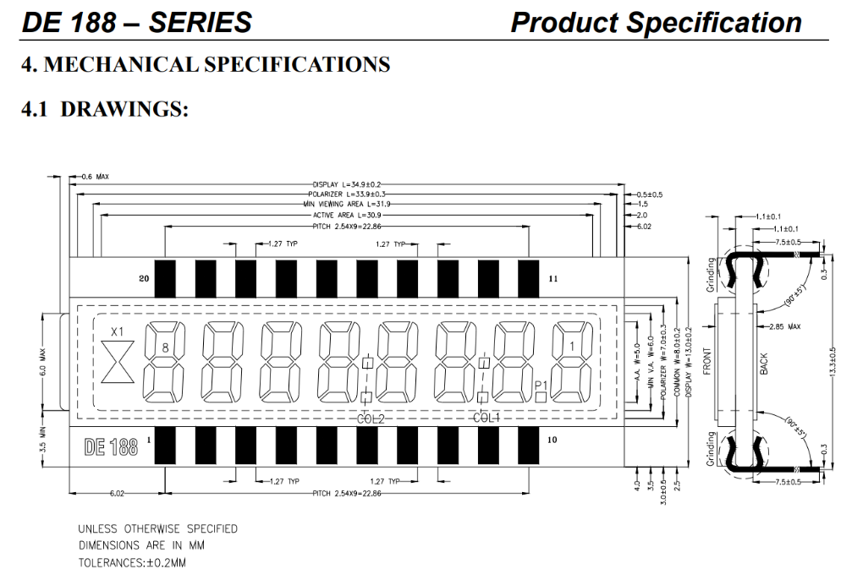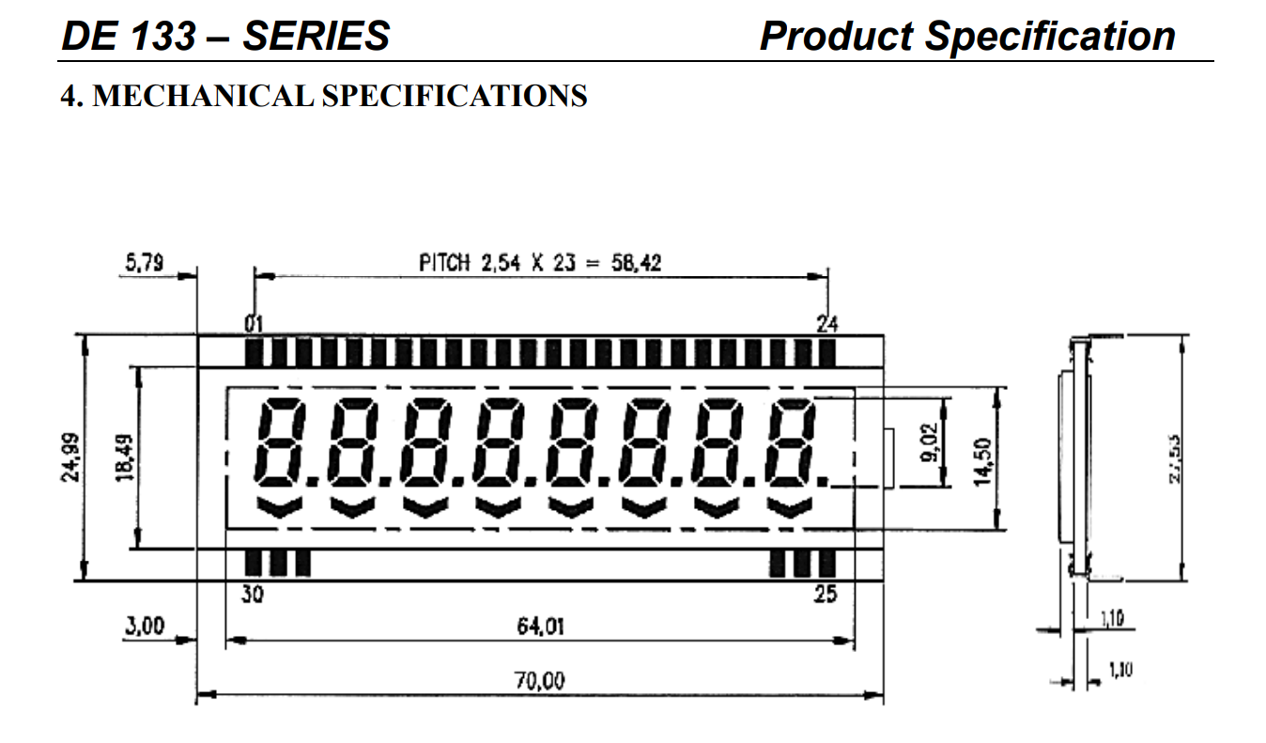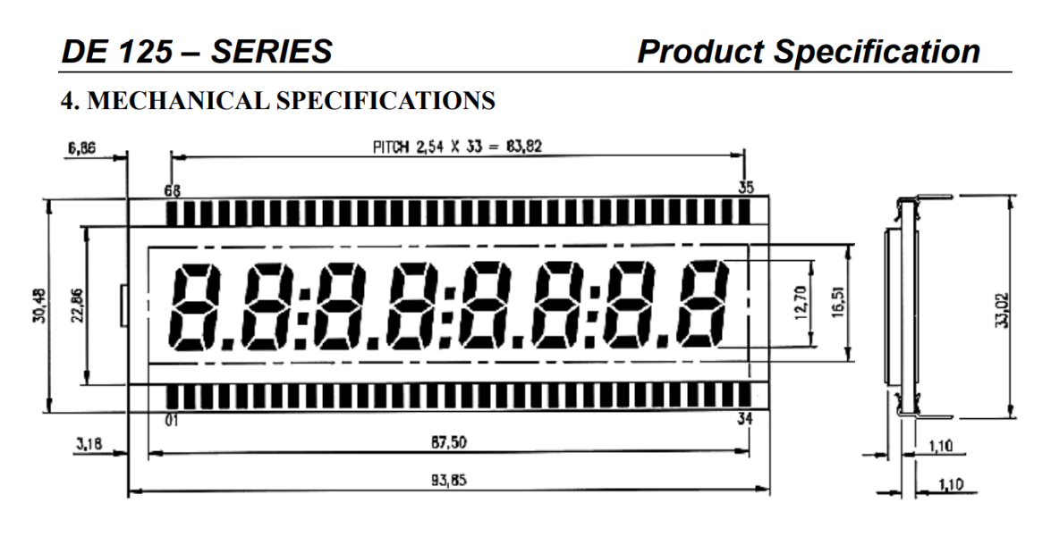

DE 188

- character height is 5.0mm

- RU

DE 133

- character height is 9.02mm

- RS

DE 125

- character height is 12.70mm

- RS, TU

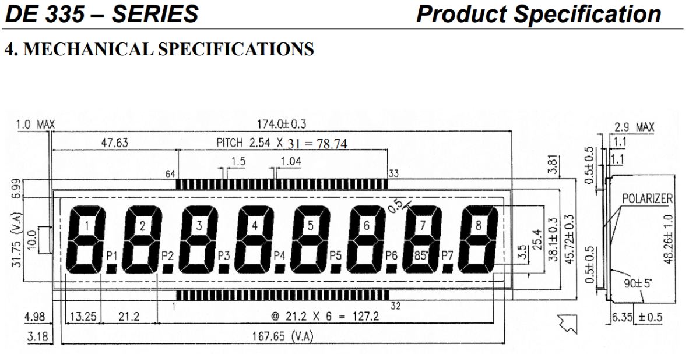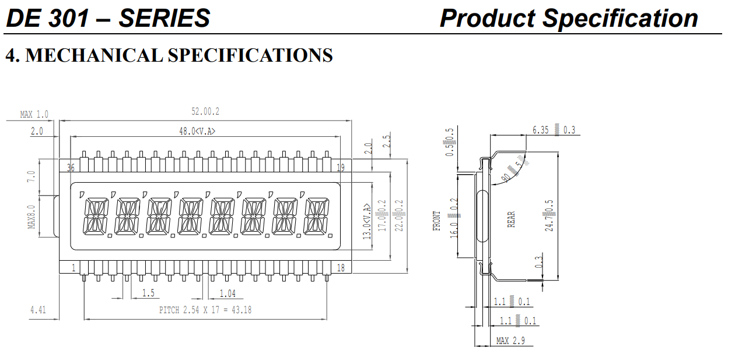I’d go with the DE 335 TU (16.30usd), because the chars are big enough and it’s just perfect for what we want

DE 335

- character height is 25.4mm

- RU, TU

DE 301

- character height is 7.1mm (aprox'd)

- RS, TU

The two display options are here

88.88

117 8.8. 8. 8 6.8

118 + 8.8[:.] 8. 8 8.00

119 8.8[:.] 8. 8 12.70

120 8.8[:.] 8. 8 17.78

127 8.8[:.] 8. 8 8.89

129 8:8: 8. 8.8 10.16

130 8.8. 8[:.] 8.8 17.78

152 8.8[:.] 8. 8 16.52

158 8.8[:.] 8. 8 25.40

161 8.8. 8. 8 12.3(aprox'd)

888

123 8.8.8 8.89

(or any of the "88.88")

but normal led 7segments are also an option, these just look good. (or maybe mixies/VFDs if we want to have cute portable high voltage cubes of death)

thank you for reading this - Natani :3