**1.Program to Sort strings**

import java.util.Scanner;

import java.util.Arrays;

public class sort {

public static void main(String[] args) {

int i,j;

Scanner sc = new Scanner(System.in);

System.out.println("Name: Athul Ajay");

System.out.println("Reg No: SJC22MCA-017");

System.out.println("Date: 28/03/2023");

System.out.println("Course code: 20MCA132");

System.out.println("Enter the number of words");

int num=sc.nextInt();

String word[]=new String[num];

sc.nextLine();

for( i=0;i<num;i++){

System.out.println("\nEnter a Word\n");

word[i]=sc.nextLine();

}

for( i=0;i<num-1;i++){

for( j=i+1;j<num;j++){

if(word[i].compareTo(word[j])>0){

String temp = word[i];

word[i]=word[j];

word[j]=temp;

}

}

}

System.out.println("Sorted Strings using CompareTo function ="+Arrays.toString(word));

System.out.println(word);

}}

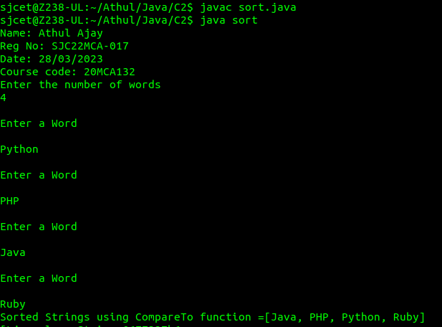

**2.Search an element in an array.**

import java.util.Scanner;

public class Search {

public static void main(String[] args) {

int i,j,x=0;

boolean state = false;

Scanner sc = new Scanner(System.in);

System.out.println("Name: Athul Ajay");

System.out.println("Reg No: SJC22MCA-017");

System.out.println("Date: 28/03/2023");

System.out.println("Course code: 20MCA132");

System.out.println("Enter the number of elemets in array");

int num=sc.nextInt();

String word[]=new String[num];

sc.nextLine();

for( i=0;i<num;i++){

System.out.println("\nEnter a Word\n");

word[i]=sc.nextLine();

}

System.out.println("Enter the element to Search");

String search = sc.nextLine();

for( i=0;i<num;i++){

if(word[i].equals(search)){

x = i;

state = true;

}

}

if(state){

System.out.println("Element found at position = "+x);

}

else{

System.out.println("Element found not found");

}

}

}

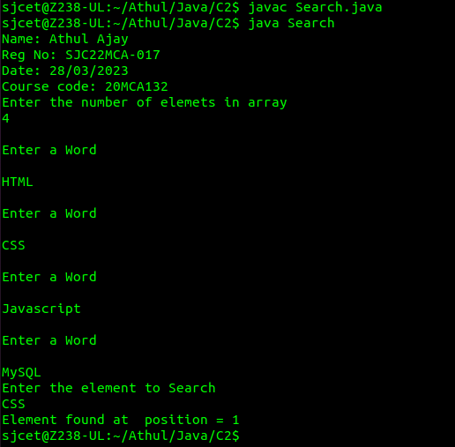

**3.Perform string manipulations**

import java.util.Scanner;

public class String_man{

public static void main(String[] args) {

System.out.println("Name: Athul Ajay");

System.out.println("Reg No: SJC22MCA-017");

System.out.println("Date: 28/03/2023");

System.out.println("Course code: 20MCA132");

System.out.println();

System.out.println("Enter The String");

Scanner sc = new Scanner(System.in);

String str1 = sc.nextLine();

System.out.println("Length of String = "+str1.length());

System.out.println("Character at First position = "+str1.charAt(1));

System.out.println("String Contains 'Col' sequence :"+str1.contains("Col"));

System.out.println("String ends with e : "+str1.endsWith("e"));

System.out.println("Replace'col' with 'kol' : "+str1.replaceAll("col","kol"));

System.out.println("LOWERCASE : "+str1.toLowerCase());

System.out.println("UPPERCASE : "+str1.toUpperCase());

}

}

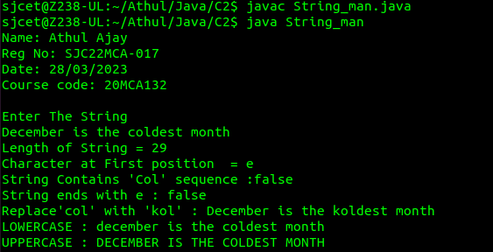

**4.Program to create a class for Employee having attributes eNo, eName eSalary. Read n employ information and Search for an employee given eNo, using the concept of Array of Objects.**

import java.util.Scanner;

public class Employee {

int eNo;

String eName;

double eSalary;

public Employee(int eNo, String eName, double eSalary) {

this.eNo = eNo;

this.eName = eName;

this.eSalary = eSalary;

}

public static void main(String[] args) {

System.out.println("Name: Athul Ajay");

System.out.println("Reg No: SJC22MCA-017");

System.out.println("Date: 28/03/2023");

System.out.println("Course code: 20MCA132");

System.out.println();

Scanner scanner = new Scanner(System.in);

System.out.print("Enter the number of employees: ");

int n = scanner.nextInt();

Employee[] employees = new Employee[n];

for (int i = 0; i < n; i++) {

System.out.println("Enter details for employee " + (i+1) + ":");

System.out.print("eNo: ");

int eNo = scanner.nextInt();

System.out.print("eName: ");

String eName = scanner.next();

System.out.print("eSalary: ");

double eSalary = scanner.nextDouble();

employees[i] = new Employee(eNo, eName, eSalary);

}

System.out.print("Enter the employee number to search: ");

int searchNo = scanner.nextInt();

boolean found = false;

for (Employee employee : employees) {

if (employee.eNo == searchNo) {

System.out.println("Employee found: eNo=" + employee.eNo + ", eName=" + employee.eName + ", eSalary=" + employee.eSalary);

found = true;

break;

}

}

if (!found) {

System.out.println("Employee not found.");

}

scanner.close();

}

}

