Q3) create a script for backup of database on every 2nd and 4th Friday of each month.

* First open AWS console go on EC2 service and create instance(launch instance)

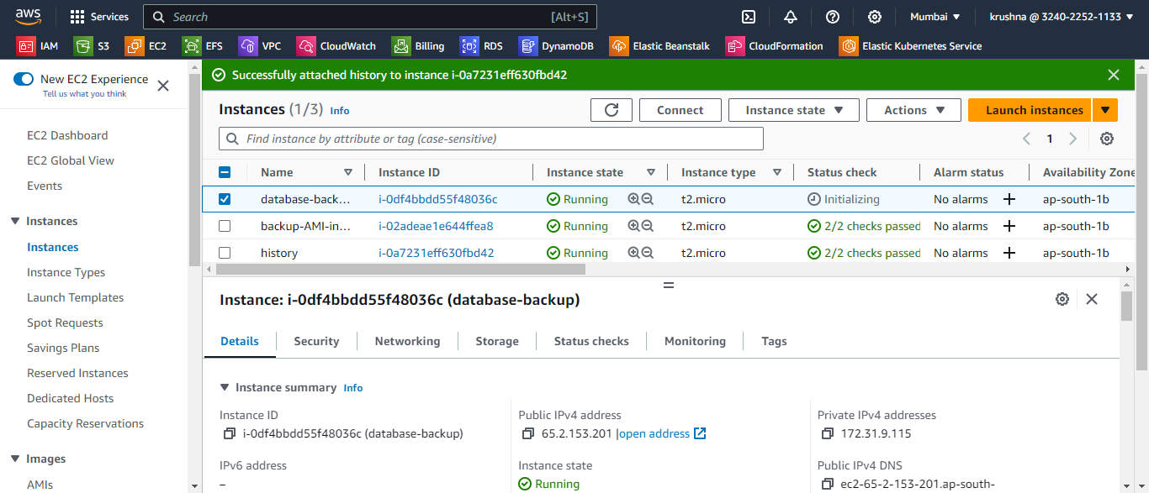

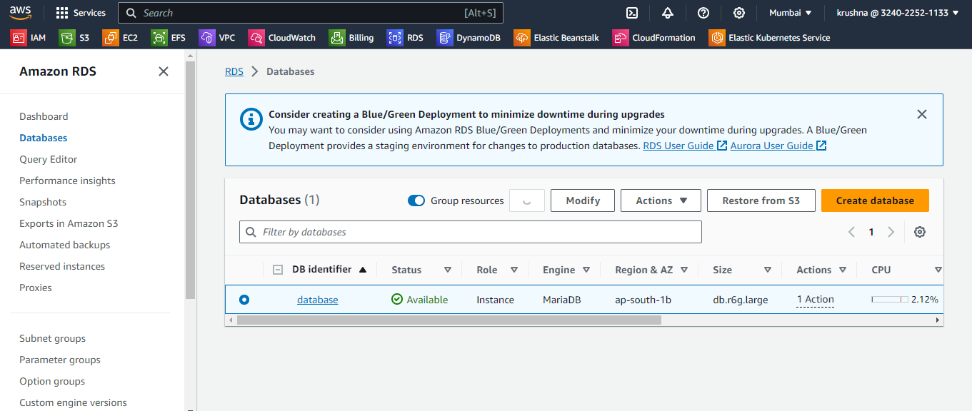

* Then take a access of created instance.
* Then create .sh file and write the script in .sh file

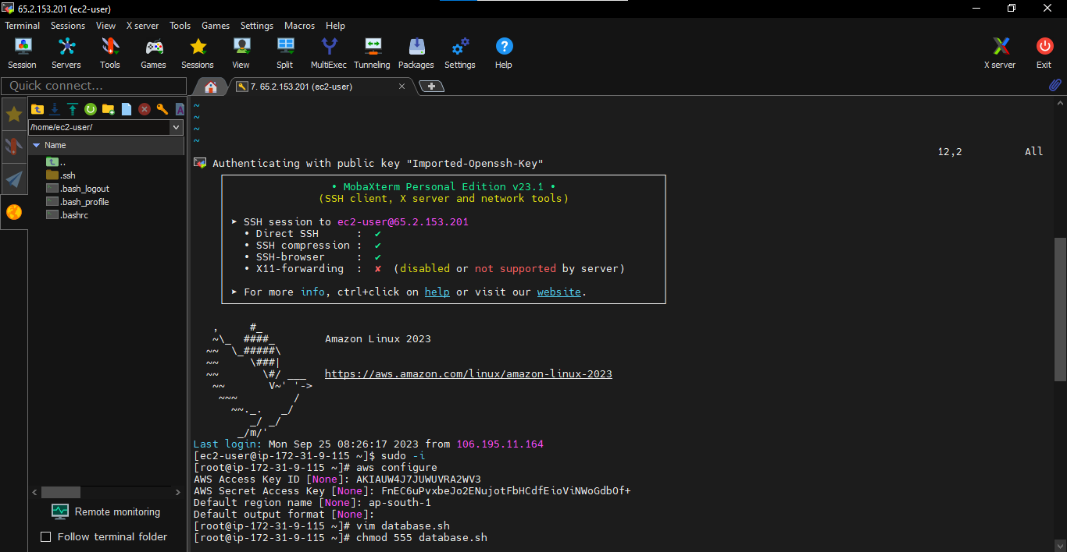

* In this script change --db-instance-identifier = put our db identifier name

--db-snapshot-identifier = give a name for our snapshot

* And save script and give execute permission of file.

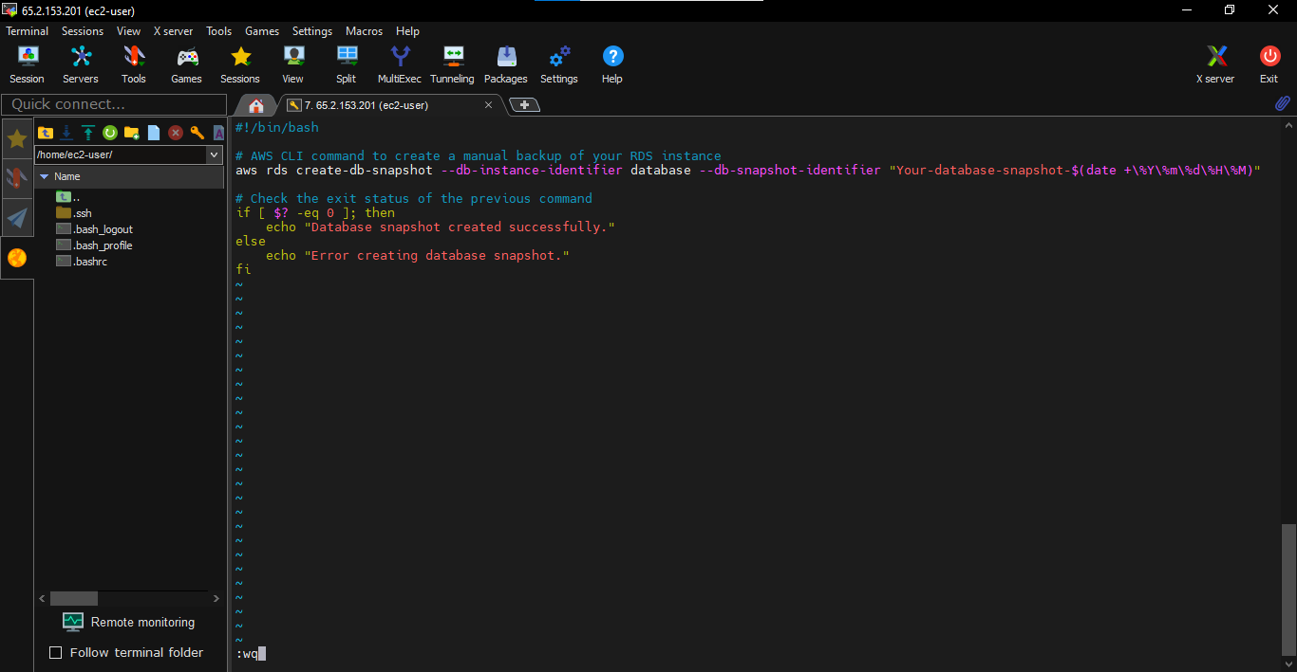

* Then install crontab for schedule crontab job.

And schedule a crontab job for create our snapshot.

