Q2) script of bash to copy history of every hr in specific file located in s3 bucket.

* Open AWS console and create instance.

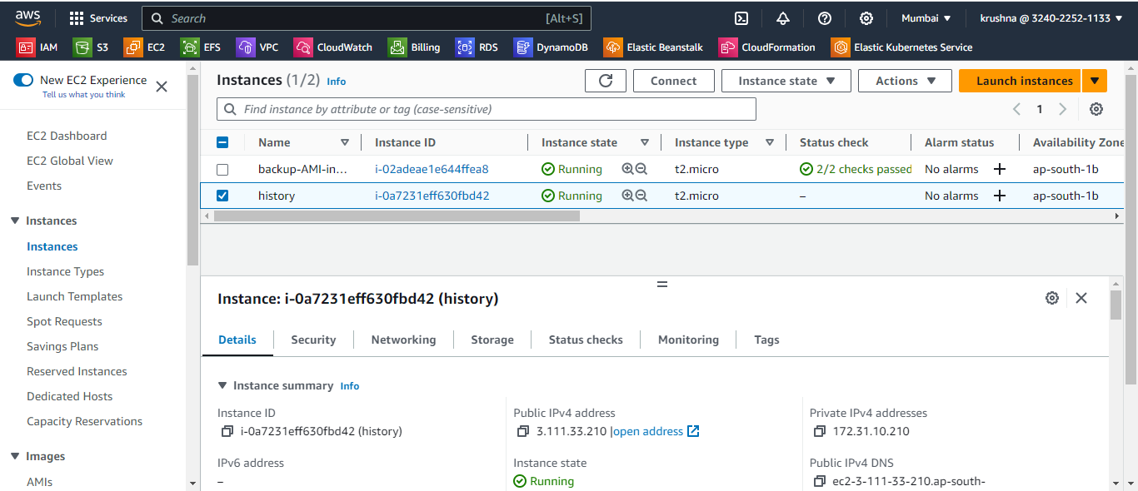

* Create s3 bucket for data collecting

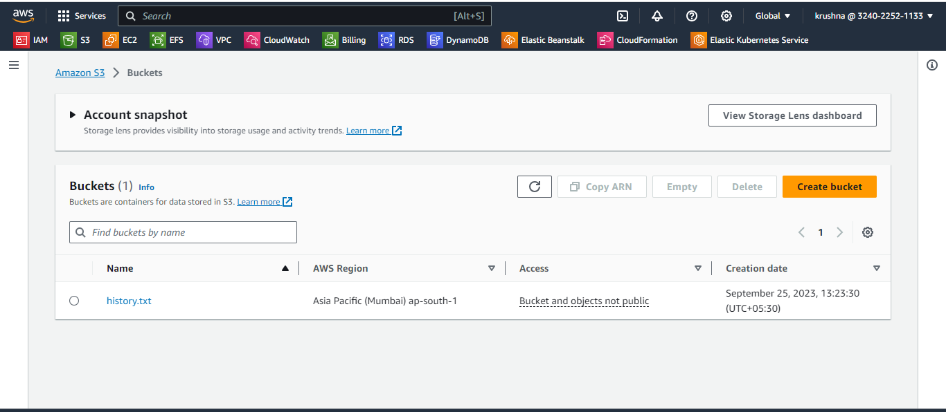

* Take a access of instance and write a script in .sh file

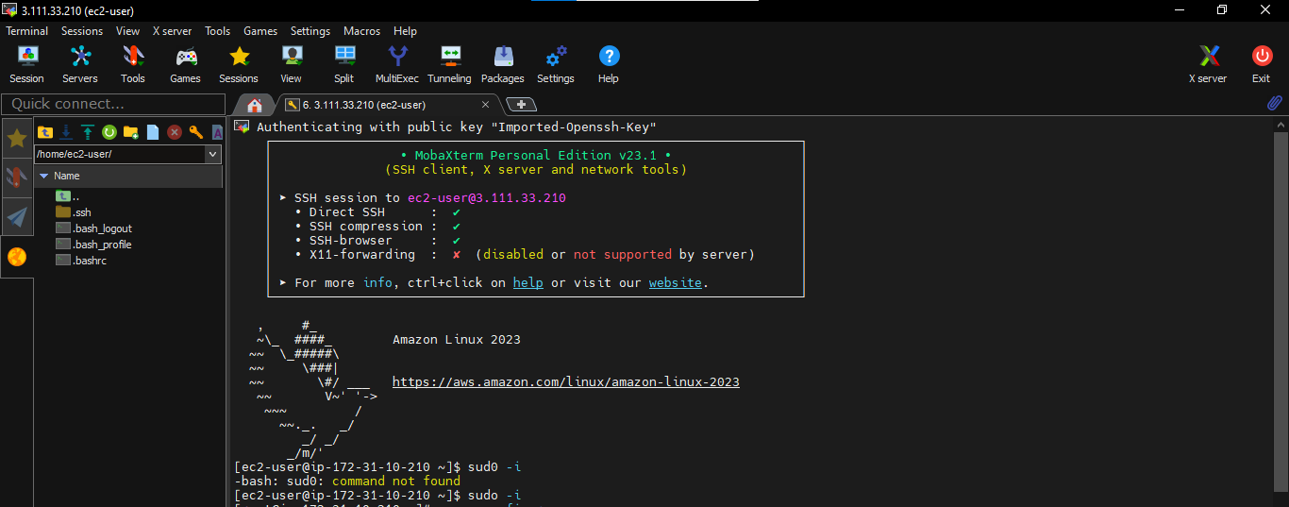

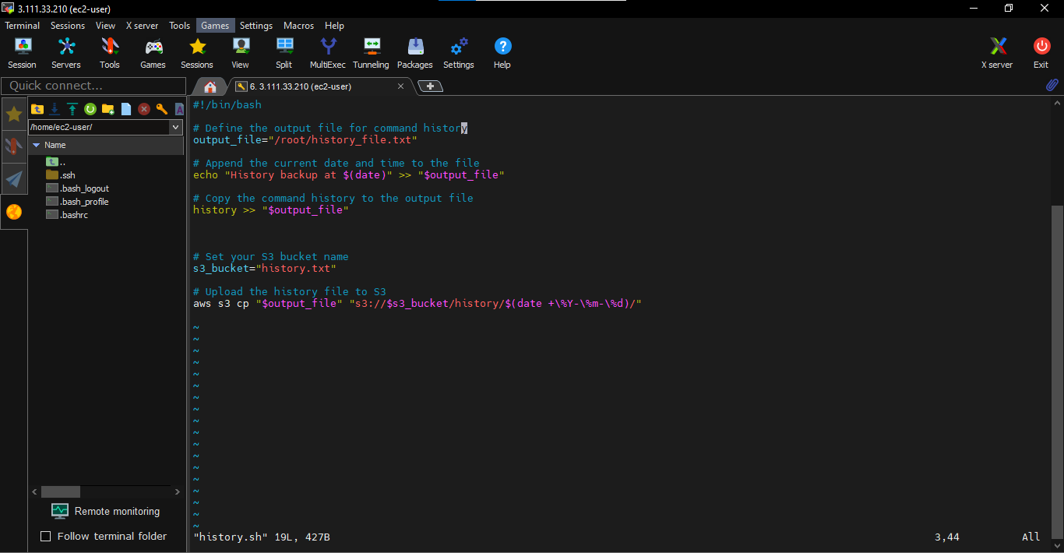

* Then give execute permission of file.

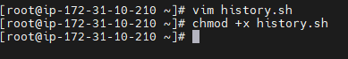

* Install crontab for scheduling job.

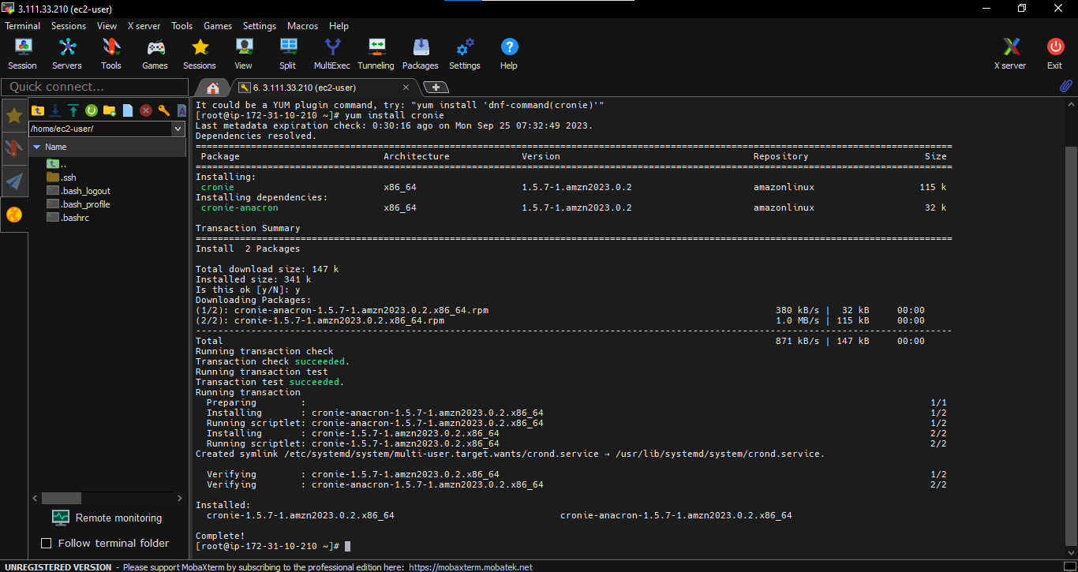

* Schedule a job for every hr.

