# Gulpfile.js failed to load in Task Runner Explorer(VS2015)

I got below error while trying to build through Task runner Explorer

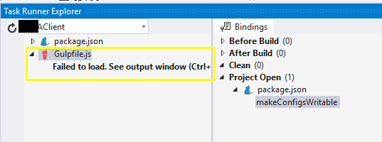

I fixed by following steps…..

1. Check all npm,node,yarn versions are correct.

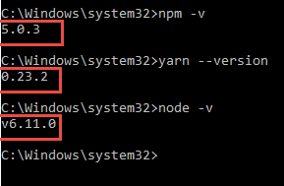

1. Check that all under TFS –>Tools—>Option section under Project solutions-🡪external web tools

The location paths are in correct order like below

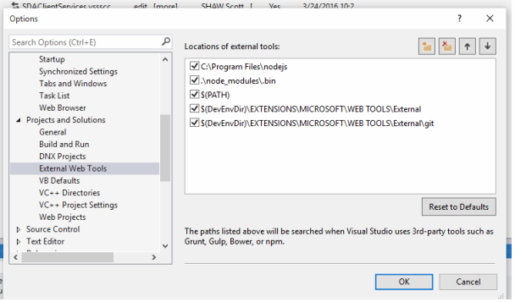

(3)Then delete the node_modules folder where local Angular seed folder is there and then install dependencies from Task Runner explorer.



1. You should get no error in the output window like below

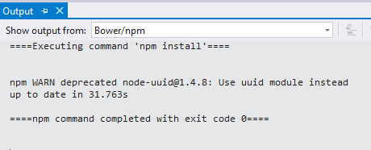

1. Now you restart the VS 2015 & you should able to get gulpfile.js loading all necessary files like below.

